Harrison Reid

10/31/2021

Database Structure

Capstone

I will use a hybrid database model with both a postgres relational database and a mongodb. I decided to split the data in to two different databases because:

The User (A table that describes each user and is used for logging in), Device(A table that describes each device and it’s current status), and Schedule(A table that describes each schedule and which device its tied to) tables have low amounts of numbers of creates and deletes and high relative number of relationships.

The Readings table has a high amount of CREATE operations done.

ER Diagram:

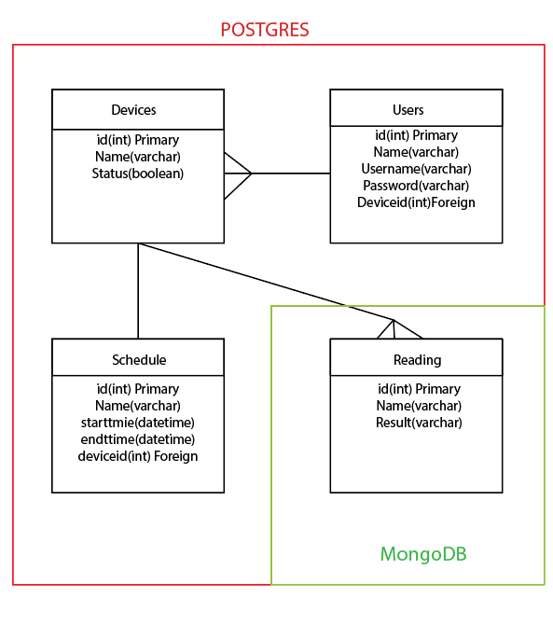

MongoDB JSON Structure:

Readings table:

{“Readings”:

{

“id(int)”: 120938, KEY

“Name(varchar)”:”Temp Sensor”,

“Result(varchar)”:98

}

}

The readings table is designed to record device readings at a 5 minute interval and create a new record each time.