ANASTASIIA MIKHAILOVA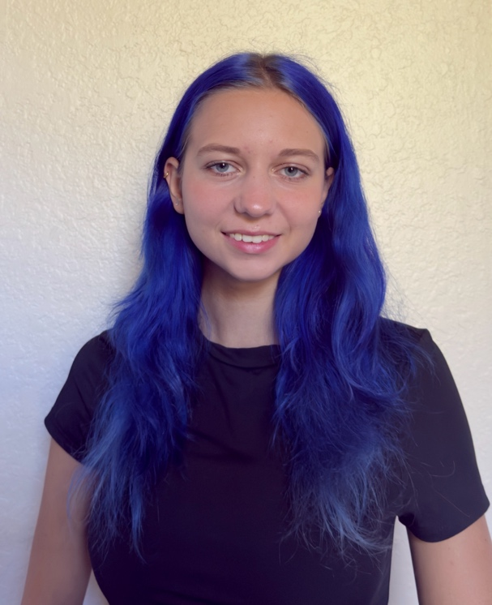
Orlando, FL | (407) 925-2312 | anastasiiamikhailova426@gmail.com
THEATER • ENTERTAINMENT • PERFORMANCE

PERFORMANCE PROFILE

Energetic performer with extensive youth theater experience and 14 years of dance training. Experienced in both lead and supporting roles, live stage performance, choreography, festivals, competitions, and ensemble work. Brings strong stage presence, musicality, movement skills, discipline, and confidence performing for live audiences.

THEATER EXPERIENCE

SCHOOL & YOUTH THEATER | Kindergarten - 9th Grade
- Performed in both lead and supporting roles in school and youth theatrical productions.
- Developed experience with character portrayal, script memorization, stage movement, rehearsals, and live performance.
- Worked collaboratively with casts and followed stage direction in ensemble productions.
- Built confidence and stage presence through many years of performance experience.

DANCE TRAINING

14 Years of Dance Training
Folk Dance | Ages 2-7 - 5 years
School Dance Program | Ages 7-9 - 2 years
Modern Dance | Ages 9-16 - 7 years
- Performed in concerts, festivals, and dance competitions.
- Earned first-place awards in dance competitions.
- Experienced in choreography, ensemble performance, musicality, coordination, stage presence, and flexibility.

ADDITIONAL PERFORMANCE & PROFESSIONAL EXPERIENCE

Previous Vocal Training | Introductory vocal instruction; open to further training
Discovery Cove | Deep Water Lifeguard | Sep 2026 - Present
Guest-facing role requiring confidence, clear communication, strong swimming ability, teamwork, situational awareness, and professionalism in a high-energy environment.
Restaurant Photographer | 2025 - Present
Experienced working directly with guests, giving posing direction, creating a positive experience, and communicating comfortably with diverse audiences. Also performing sales of printed out pictures to the guests.

SPECIAL SKILLS

Modern Dance • Folk Dance • Choreography • Stage Performance • Character Work • Strong Swimmer • Cycling • Basic Flexibility • Photography • Previous Vocal Training • Comfortable Performing for Live Audiences

CERTIFICATION & LANGUAGES

Certification: American Red Cross CPR Certification
Languages: English (Fluent - C1) • Russian (Native)

EDUCATION

Valencia College - Orlando, FL | College Student, 2026 - Present
High School Diploma | Graduated May 2026

