Problem with mounting Azure storage:

App interface:

Container running in docker:  
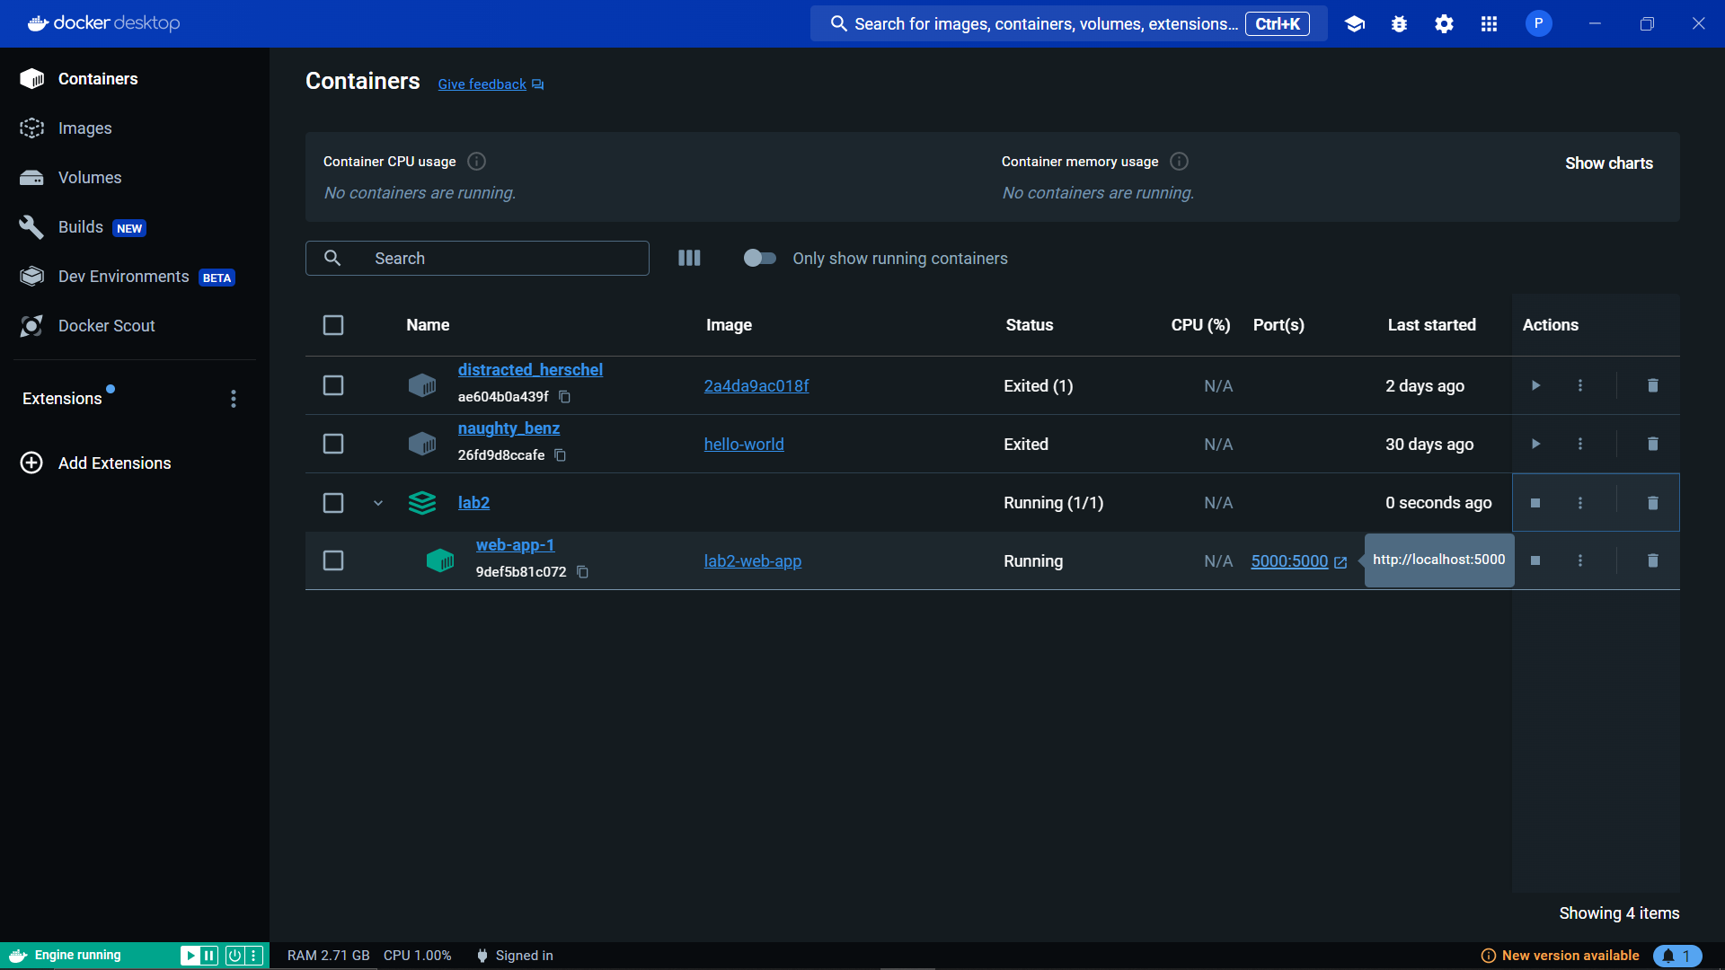

Commands used:

* docker compose build
* docker compose up