List of Topics

Internal registers 1
Memory Map 2
Signals EPP-1.9 3
Epp ports for programmers 4
Modes 5
Cycles 6
EXCHANGE N64 <> PC 7
Epp Time Diagramm 8
Block diagramm 9

- Internal registers

# |  | mode | Bits | name | Descriptions
0 | RG0 | R w | D[7..0] | a[7..0] | Support count address
1 | RG1 | R w | D[7..0] | a[15..8] | Only 0 bit support count address
2 | RG2 | R w | D[7..0] | a[23..16]
3 | RG3 | w | D[2..0] | a[26..24]
3 | RG3 | R | D3 | Don’t use
 |  |  | D4 | Pc | 1 = pc can work with DRAMM
 |  |  | D5 | Wcf | wcf 1 = was write cart b4000000-b7FFFFFF
 |  |  | D6 | Wdf | 1 = was write dramm
 |  |  | D7 | Rst | 1 = power on n64
4 | RG4 | R w | D[7..0] | Data | Read and write dramm
 | RG5 | w | D0 | Pc | 1 - enable PC mode, DRAMM connect to PC
 |  |  | D1 | Cart_on | 0 - cart ROM off from n64  1 - cart ROM on
 |  |  | D2 | Write_en | 0 – DRAMM read only  1 – DRAMM write enable
 |  |  | D[4..3] | Don’t use
 |  |  | D5 | Wcfset | 0 – clear wcf, 1 – set wcf
 |  |  | D6 | Wdfset | 0 – clear wdf, 1 – set wdf
 |  |  | D7 | Don’t use

- Memory Map

Mode | pc | Cart_on | Wcf | B0000000-B3FFFFFF | b4000000-b7FFFFFF
PC | 1 | 0 | 0 | Nothing | Nothing
PC | 1 | 0 | 1 | Cart | Cart
PC | 1 | 1 | 0 | Nothing | Cart
PC | 1 | 1 | 1 | Cart | Cart
N64 | 0 | 0 | 0 | Dramm | Dramm
N64 | 0 | 0 | 1 | Cart | Cart
N64 | 0 | 1 | 0 | Dramm | Cart
N64 | 0 | 1 | 1 | Cart | Cart

N.B. Wcf seting to 1 if you wrote to B4XXXXXX area and CART_ON = 1

- Signals EPP-1.9

PV-backup use standart EPP-1.9 protocol and epp_init is only reset of device.

Epp_write | 0 – write cycle 1 – read cycle
Epp_addr_stb | 0 – write addres
Epp_data_stb | 0 – write data
Epp_init | 0 – rest
Epp_busy | 0 – ready 1-wait
Epp_data[7..0] | Datas of EPP

- Epp ports for programmers

Base:=$378 {base addres of EPP}
const rga = 3 ; rgd = 4; rgc = 2; rgs = 1;
rg_addr:=base + rga {address register }
rg_data:=base + rgd {data register}
rg_cntr:=base + rgc {control register}
rg_stat:=base + rgs {status register}

In_reg (number of register) data
Rg_addr:=number of register
Result:=rg_data

Out_reg (number of register, data)
Rg_addr:=number of register
Rg_data:=data

Set_reg (number of register)
Rg_addr:=number of register

In_sec ()data
Result:=rg_data

Out_sec (data)
Rg_data:=data
Out_cntr (data)
Rg_cntr:=data
Out_stat (data)
Rg_stat:=data

- Modes

PV-backup can work in 3 diference modes.
- Game playing from cartrige
- Game playing from dramm
- Game playing from dramm but cartrige on
- Debug mode, in this mode n64 can read and write dramm, read cartrige and exchange information with PC.

- Cycles

Const
Mwrite_on = 4
Mcart_on = 2
Mpc = 1
Msetwcf = $20

Reset
Rg_cntr:=0
…
delay timeout
…
rg_cntr:=4

Pc_mode {DEBUG MODE write on, cart on}
Rg_stat:=1
Out_reg(rg5, mwrite_on + mcart_on +1 )

N64mode
Rg_stat:=1
Out_reg(rg5, mwrite_on + mcart_on)

Pc_mode {DRAM PLAY MODE}
Rg_stat:=1
Out_reg(rg5, 1 )

N64mode
Rg_stat:=1
Out_reg(rg5, 0)

Pc_mode {CART PLAY MODE cart on, wcf =1 }
Rg_stat:=1
Out_reg(rg5, msetwcf + mcart_on +1 )

N64mode
Rg_stat:=1
Out_reg(rg5, msetwcf + mcart_on)

Pc_mode {DRAM AND CART PLAY MODE cart on}
Rg_stat:=1
Out_reg(rg5, mcart_on +1 )

N64mode
Rg_stat:=1
Out_reg(rg5, mcart_on)

Set_pointer
Out_reg(0,addres[7..0])
Out_reg(1,addres[15..8])
Out_reg(2,addres[23..16])
Out_reg(3,addres[26..24])

Read_pointer
Addres:=in_reg(0) + in_reg(1) * $100 + in_reg(2) * $10000 + in_reg(3) * $1000000

Write_datas
Set_pointer
Set_reg(rg4)
Begin of loop
Out_sec(data)
End_loop

Read_datas
Set_pointer
Set_reg(rg4)
Begin of loop
Data:=in_sec
End_loop

Read_status
Status:=in_reg(rg3)

- EXCHANGE N64 <> PC

PC do | N64 do
Write data to dramm
Set n64 debug mode
Delay | N64 found dramm and work
……. | …..  …..
While wcf = 0 do {wait for wcf} | …..  …..
While wcf = 0 do {wait for wcf} | IN TO BREAK POINT
While wcf = 0 do {wait for wcf} | Read Write data to dramm
While wcf = 0 do {wait for wcf} | Write to b4XXXXXX
Set pc debug mode | While (b0XXXXXX is ROM) do {see N.B.}
Read write dramm | While (b0XXXXXX is ROM) do {see N.B.}
Set n64 debug mode | While (b0XXXXXX is ROM) do {see N.B.}
Goto line 3 | Dramm found
 | Read dramm
 | EXIT TO BREAK POINT

N.B. Checking of presents dramm in the b0XXXXXX area can be:

You can select for you word in cartrige who<> 0 and <>FFFF
For examle word b4FFFFFF = 55AA
You write inverse data to B3FFFFFF
($B3FFFFFF):=$AA55

And now, you can alltimes check dramm for busy (ROM)

IF ($B3FFFFFF)<>$AA55 THEN DRAMM is busy

- 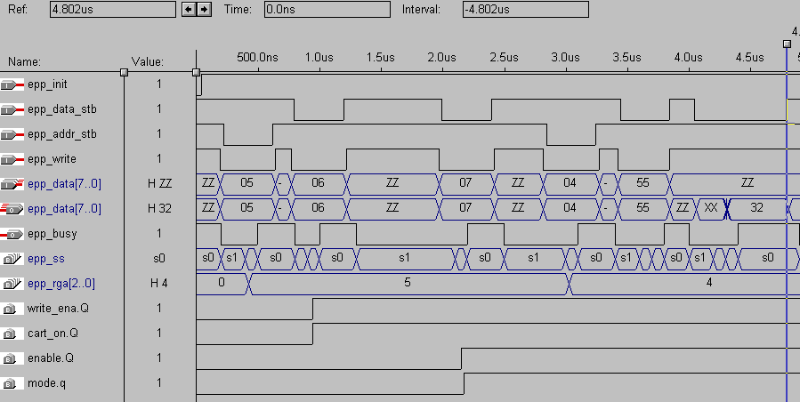Epp Time Diagramm

EPP_SS IS

S0 | S1,SA,S0 | S1,SD,S0 | S1,SD,S0 | S1,SA,S0 | S1,SR,SR1,S0 | S1,SR,SR1,S0
 | Wr addr | Wr data | Wr data | Wr addr | Wr dramm | Rd dramm

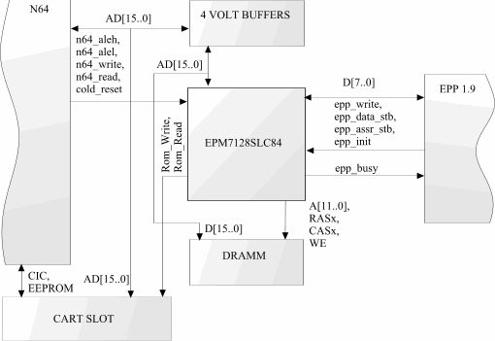
- BLOCK DIAGRAMM

EOF J

