The HOST interface for N64 console

Short description my job

The task and goal
We need to make the hardware-software unit witch runs our application for teaching music. We could manufacture hardware and publish software.
It should be not so expensive, probably like a game console with joystick. The device should have copy protection. The main function is the musical MIDI synthesizer. It should play files and show karaoke text on the screen. The user interface let change many values like tempo, note offset, and kind of sound bank. The device should has a voice of singer, that is why it must be sampler.

Complexity
The device should be sampler, it make the device more expensive. It is impossible to make that without samples. The first idea was that the bank size should not be more that 4MB.

Find simplest way
We had idea about to use any game console for this project. The console should have a cartridge and high quality sound synthesizer.
We found the target platform - Nintendo64. I look at web, I try find any developing tools for that console. In result I found several good reasons:
- It has Assembler
- It has the small FAQ for programmers
- The CPU is high documented
Worst things:
- No debugger
- The cartridge interface is unknown, has no pin out, have no time diagram.
Main point, we need to make decision: to buy the console and to do the back engineering or find another way.
My experience pushed me make decision – to buy еру the console and watch a time diagrams at the cartridge bus. купить The point was – if I could see time diagrams by my old and bad scope then I will have chance to understand all another details about the console.
Bought the console, capture all time diagrams. It showed that speed of bus is slow then it should be not difficult to do my job. And I was sure that it is possible to build cartridge for such bus!
I made schematic of the game cartridge.
I take all time diagrams by scope.
Now I can analyze information and recognize the pin’s names. In result I have first version of pin out.
Now the main program is - «How to code and debug the program?»

Отладка программы & HOST интерфейс

I should make HOST interface. And little software module, which redirect all fprint() to HOST computer. And HOST computer should send commands to N64.

I found at the Internet similar unit V64JR.

I could see the V64JR pcb and understood how that unit works. I understood allot of information about unit with FAQ. I also seen how should works HOST interface.

But! V64JR does not support bidirectional data transfer!!!

I designed schematic of dual ported EDO memory. One port is for N64, but second for EPP bus. I had decision to put all stuff in one PLD Altera.

Code PLD with AHDL.

I made prototype, and started it.

I used client soft for V64JR when I first time upload a program to N64!

I have changed the PLD for bidirectional exchange of data. Then I lost compatibility with V64JR.

I made own client. And little module for N64 with do fprint at PC’s monitor.

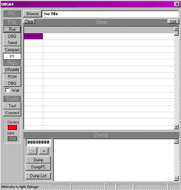

I seen good result of all my steps.

Programming

I choose the C-compiler and library which I may found at internet.

I understood what the library does. I code my own apps and debug it with my unit.

Then I designed GUI together with designer of our team.

The result is good and customer so happy. J

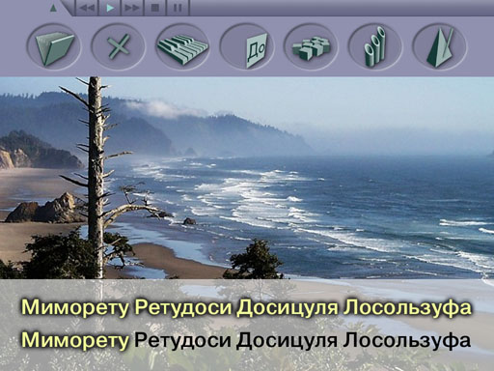

Manufacturing

Create schematic of custom cartridge. Then make request express PCB. The geometric size is especially for typical housing.

After when I received PCB, I sold it then check and start.

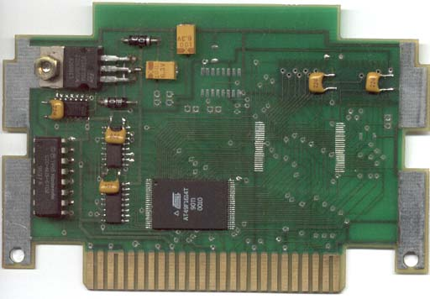

Create and sold PCB of programmer with AT90 microcontroller.

Create the program for microcontroller.

Create the host programmer in VB.

Program the custom cartridge.

Customer shows the device on the exhibition and had success!!!

All job was finished for 8-10 months.

