# Portable Wi-Fi Temperature Logger

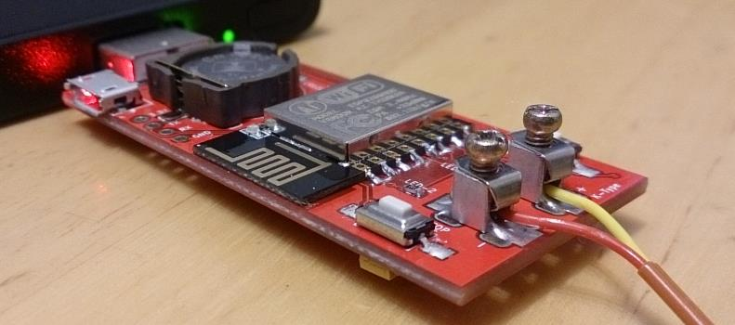

## Features

* Measurement Range -270°C to +700°C
* 14-bit 0.25°C Resolution
* Adjustable Sampling Rate from 100ms to 10s
* Easy Access the Logger by Web base UI
* No Software Install Required
* Support Window, Android, IOS and Mac
* Real Time Data Monitoring
* Most Common K-Type Thermocouple
* Thermocouple Probe Error Detection
* Logging Data with Real Time Clock.
* Support Wi-Fi Station and Access Point Mode
* Export CSV Function
* Online Firmware Update