**Group Project (Group 2)**

**Print Name(s): ___________________________________________________**

**(last, first)**

We certify that we have done this work totally within our group. We have not talked with any current or former students outside our group about the problems or reviewed answers with anyone outside our group. We have not looked at former students’ work on these or similar problems (sometimes called “files”). We have not used online sources that provide answers to specific questions. Any online sources that provided general tutorial information have been cited.

Signature(s): _________________________________________________

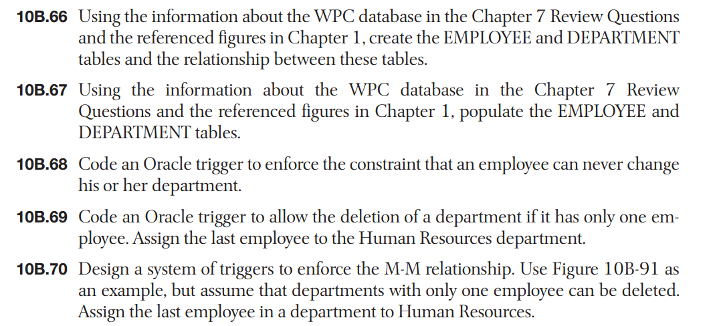

10B.66

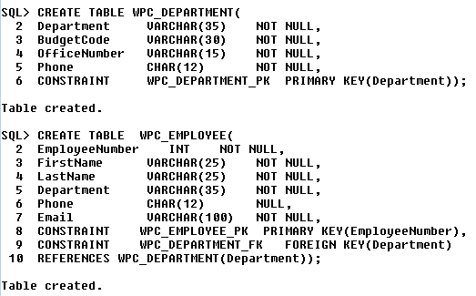

10B.67

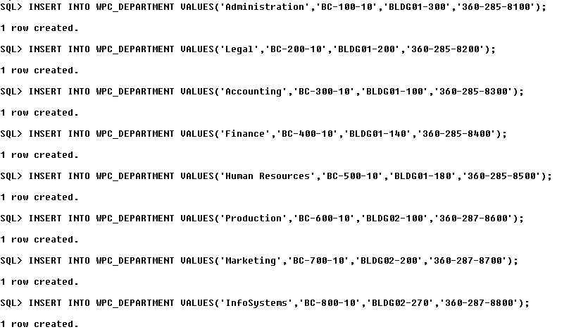



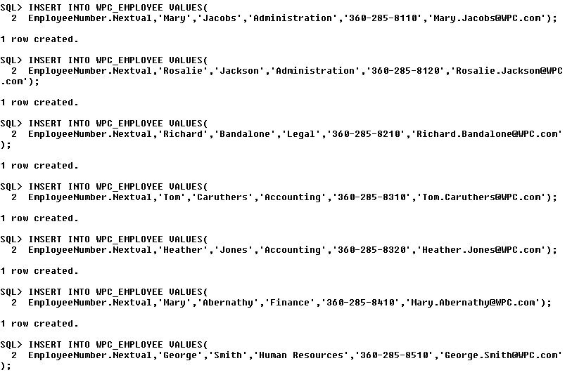

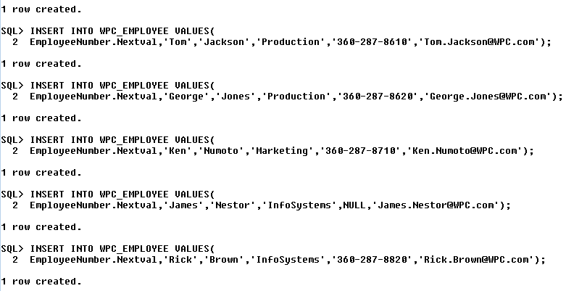

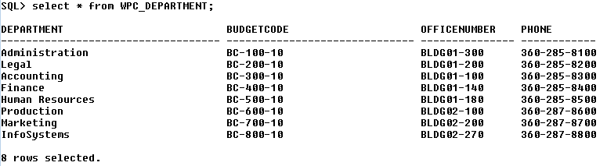

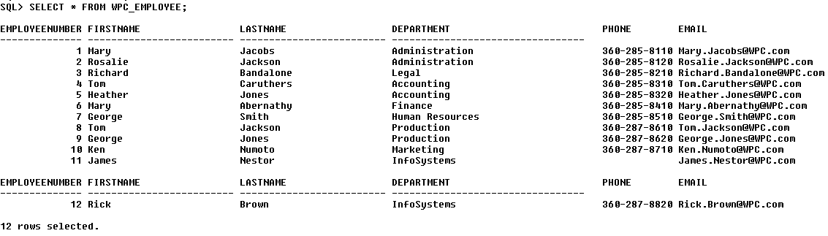

10B.68

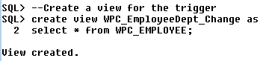

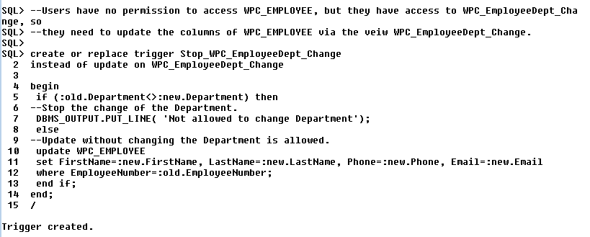

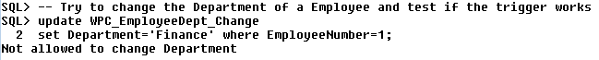

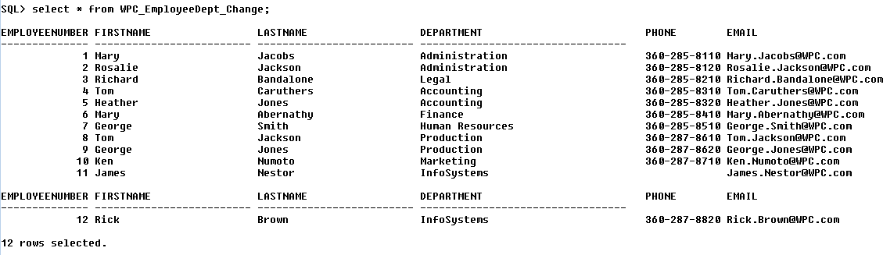

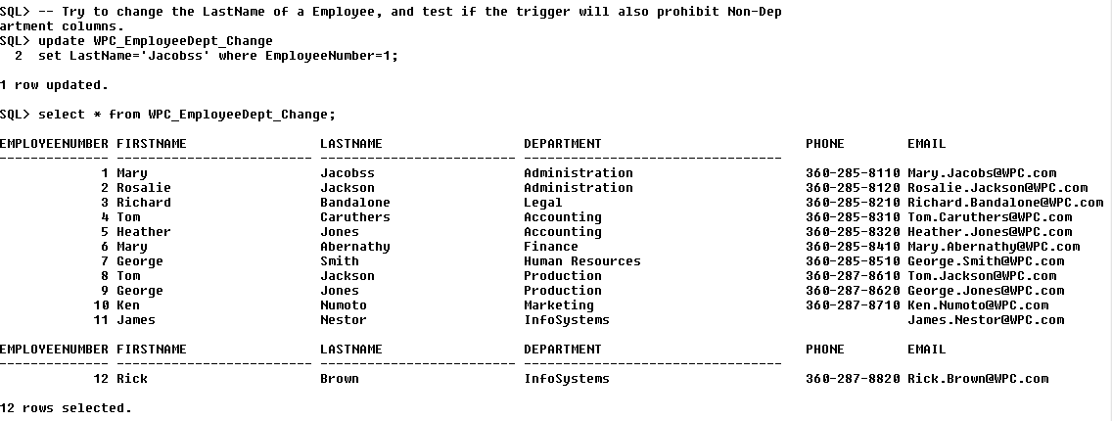

From the above test, we can see that the attempt to change the Department of Mary, whose EmployeeNumber is 1, has been prohibited. And the screenshot also proves that Mary’s Department remains Administration, which has not been changed to Finance. However, the action to change the Mary’s LastName has been committed. From the screenshot we can see that Mary’s lastName has been changed from Jacobs to Jacobss. Since we have tested both to update the Department column and the Non-Department column, the test cases are a thorough test to demonstrate that our trigger works well.

10B.69

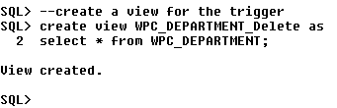

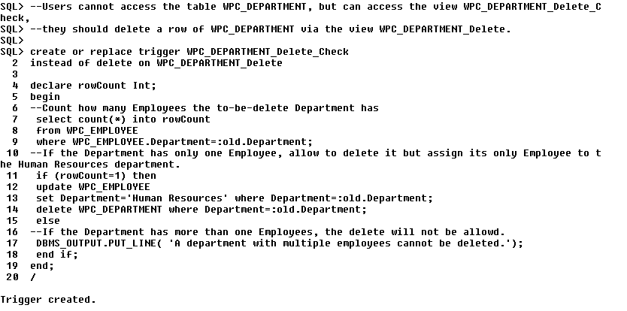



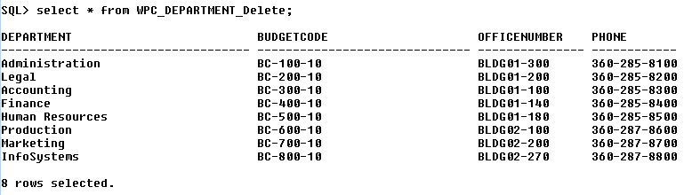

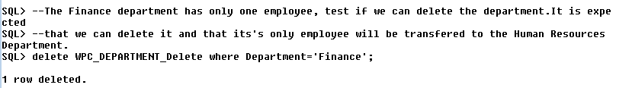

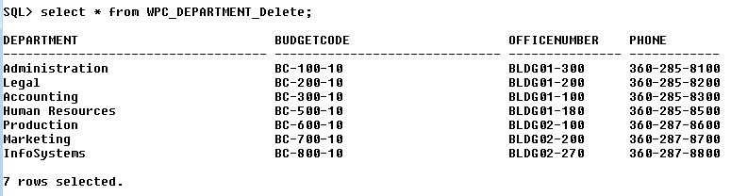

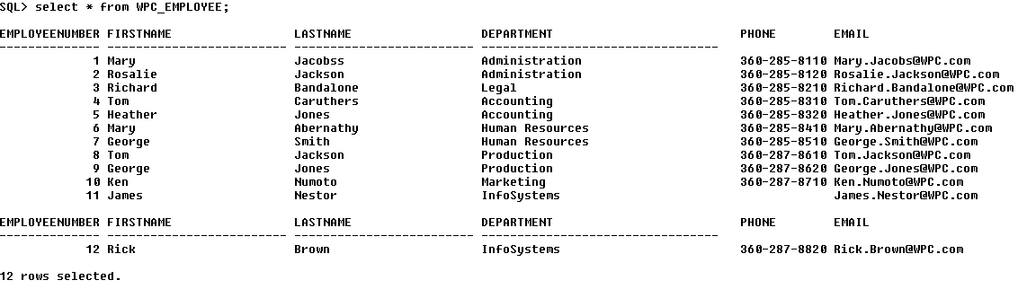

From the screenshots we can see that the test results are as expected. Firstly, the administration department cannot be deleted since it has two employees. Secondly, the finance department has been deleted, and its only Employee, whose EmployeeNumber is 6, has been assigned to Human Resources department. So, our trigger works well.

10B.70

The table below shows what actions are needed to enforce the M-M relationship.

|  |  |  |
| --- | --- | --- |
|  | **WPC_DEPARTMENT**  **[Parent]** | **WPC_EMPLOYEE**  **[Child]** |
| **INSERT** | Cell 1: Create row in WPC_DEPARTMENT by a trigger. | Cell 2: The new row must have a valid Department (enforced by DBMS). |
| **Modify Primary Key or Foreign Key** | Cell 3: Prohibit it by a trigger. | Cell 4: Prohibit (enforced by the trigger in 10B.68) |
| **DELETE** | Cell 5: Can only delete a row if it has only one child. In that case, after deletion, assign its only child to Human Resources department. (Enforced by the trigger in 10B.69) | Cell 6: Cannot delete the last child (enforced by a trigger). |

From the table, we can see that we still need to add 3 triggers in Cells 1, 3, and 6, respectively. Note that the above two triggers in 10B.68 and in 10B.69 are also necessary for the enforcement of this M-M relationship. Also note that users should use corresponding views to do those insert, modify, or delete actions. Because they usually do not have access to the tables. In the following contents, we will construct 3 triggers and test if they can work well.

**Cell 1**

1. We first create a view for the trigger.

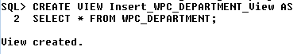

1. Then we construct the trigger to automatically insert a row in WPC_EMPLOYEE when a row is inserted into WPC_DEPARTMENT.

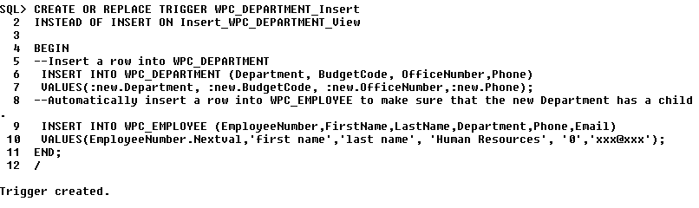

1. Then we need to test if the trigger works well. We can insert a row into WPC_DEPARTMENT via the view Insert_WPC_DEPARTMENT_VIEW. If the trigger works well, a row will be automatically inserted into WPC_EMPLOYEE.

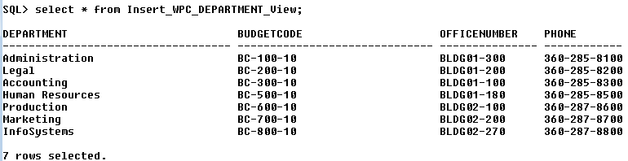

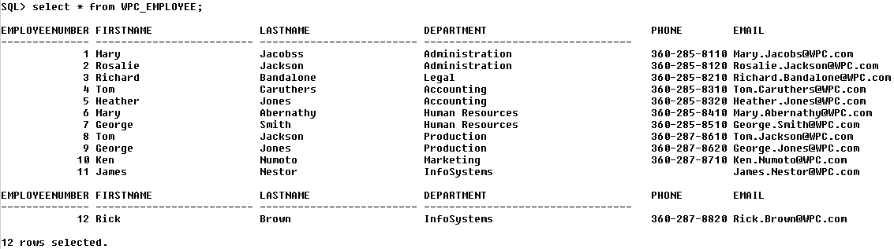



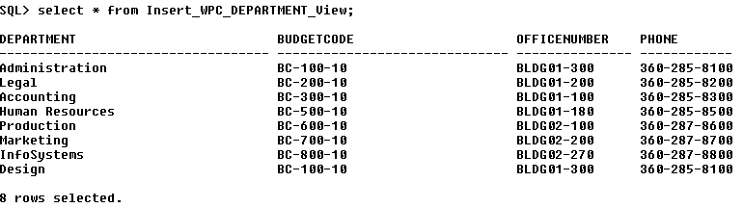

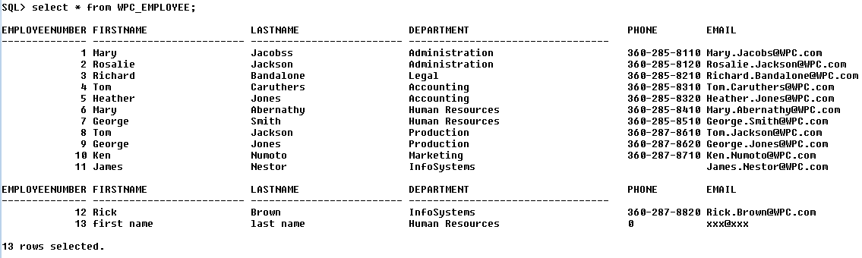

1. From the test, we can see that a Design department has been inserted into WPC_DEPARTMENT, and a row with EmployeeNumber 13 has been inserted automatically into WPC_EMPLOYEE. This test demonstrates that our trigger works well.

**Cell 3**

1. First, we create a view for the trigger.



1. Second, we construct a trigger to prohibit the change of the primary key of the WPC_DEPARTMENT.

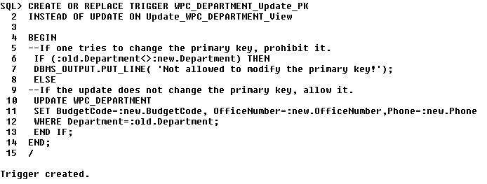

1. Then we need to test if the trigger works well. In the first test, we change the primary key of a row in WPC_DEPARTMENT. It is expected that the action will be prohibited. In the second test, we change a non-primary key column of a row in WPC_DEPARTMENT. It is expected that the action will be allowed.

Test 1:

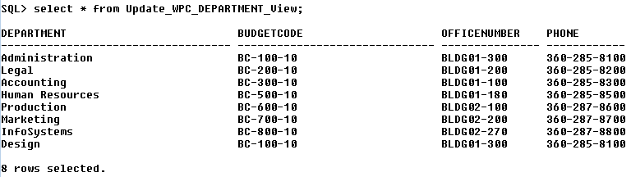



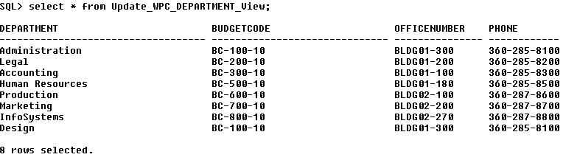

Test 2:

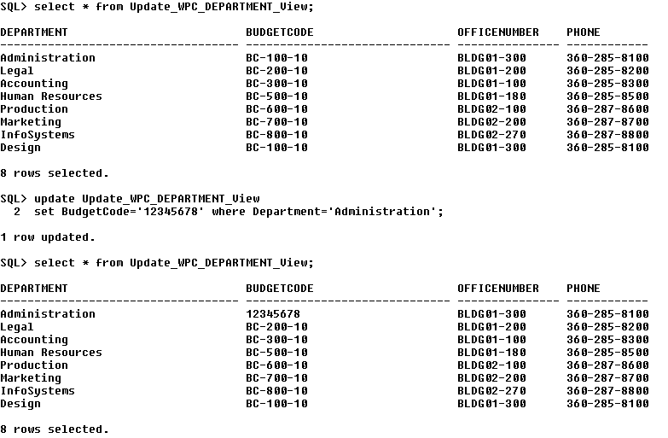

1. From Test 1, we can see that the attempt to change the primary key value has been prohibited and the table keeps the same. From Test 2, we can see that the BudgeCode of the Administration is allowed to be changed to 12345678. The two tests demonstrate that our trigger works well.

**Cell 6**

1. First, we need to create a view for the trigger.

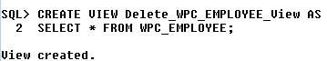

1. Second, we construct a trigger to stop the last child to be deleted.

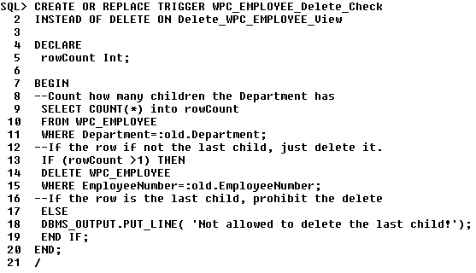

1. Then we need to check if the trigger works well. In Test 1, we will try to delete a row who is not the last child. It is expected that this action will be allowed. In Test 2, we will try to delete a row who is the last child. It is expected that the action will be prohibited.

Test 1:

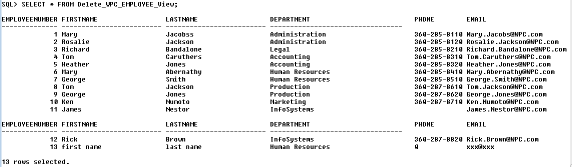

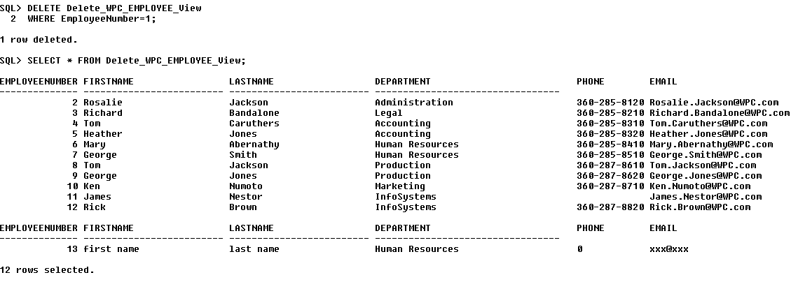

Test 2:

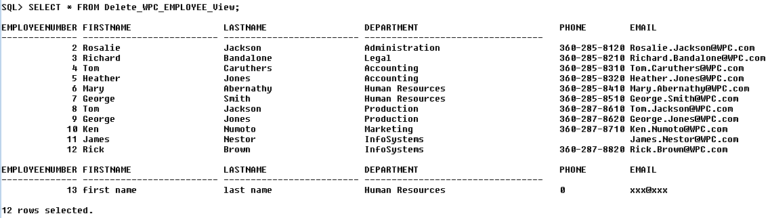

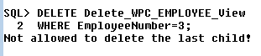

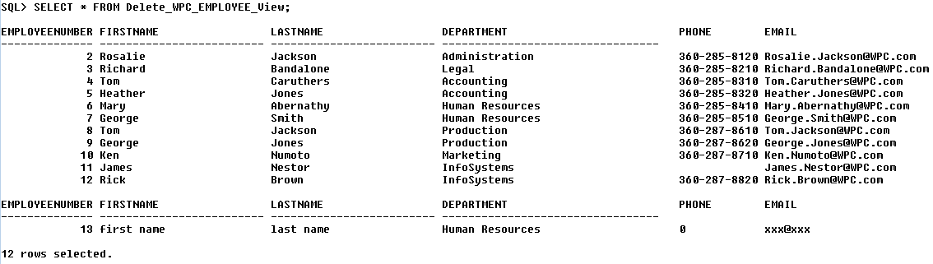

1. From Test 1, we can see that the employee whose EmployeeNumber is 1 has been deleted because the corresponding row is not the last child of WPC_DEPARTMENT. From Test 2, we can see that the employee whose EmployeeNumber is 3 hasn’t been deleted because the corresponding row is the last child of WPC_DEPARTMENT. The two tests demonstrate that our trigger work well.