Print Name: ___WU, HAO_______________
(last, first)
Individual Homework
I certify that I have done this work individually. I have not talked with any current or former students about the problems or reviewed answers with anyone. I have not looked at former students’ work on these or similar problems (sometimes called “files”). I have not used online sources that provide answers to specific questions. Any online sources that provided general tutorial information have been cited.

Signature: ___________________________

Recall the instructions from Homework 2 relative to screen shots: Use the picture editor to focus on just the portion of the screen you want to show and then compress all the screen shots.

1. In a PL/SQL procedure, what do the keywords IN, OUT, and IN OUT signify?

IN signifies that parameters are input parameters.
OUT signifies that it is an output parameters.
IN OUT signifies that the parameters can be used for both.

2. Explain how a Cursor is opened and obtains variables. Also explain how one exits from a loop that obtains variables using a Cursor.

This construct opens the cursor and fetches the first row. Then it iterates though all of the rows in the cursor and when there are no rows, it transfer control to the next statement after the FOR statement.

3. What statement is used to obtain a display of errors when compiling stored procedures and triggers?

RAISE_APPLICATION ERROR(<num>,<message>);

4. In the stored procedure in Fig. 10B-82, how are the values of the variables varTID and varAID used if there are no suitable TRANS rows in the database? How are they used if there is just one suitable TRANS row in the database?
When one qualifying row is found, then “tid” and “aid” will have the values needed to continue.
When zero or more than one qualifying rows are found, the transaction will be aborted, but neither “tid” or “aid” will be used.

5. Explain the purpose of BEFORE, AFTER, and INSTEAD OF triggers.

BEFORE and AFTER triggers are placed on tables. INSTEAD OF triggers are placed on views. Each trigger type can be fired on INSERT, UPDATE or DELETE commands.
The purpose of triggers:
- set default values,
- enforce required children
- update views.
- Perform referential integrity actions

6. When an update is in progress, how can the trigger code obtain the value of a column, say, C1, before the update began? How can the trigger code obtain the value that the column is being set to?

The prefix:old.C1 will be used to get the value of the column before the update.
The prefix:new.C1 will be used to get the value that the column is being changed to.

7. Explain why INSTEAD OF triggers are needed for join views.

Some information will be lost after the join. Then DBMS does not have sufficient information to associate the columns of the view to a particular table. Besides,
it is not possible for the DBMS to know how to update the tables that underlie the join. However, there may be application-specific knowledge that can be used to determine how to interpret requests to update a joined view.

8. What three levels of transaction isolation are supported by Oracle?

Oracle Read Committed; Serializable; Read-Only transaction isolation

9. Explain how Oracle uses the system change number to read data that are current at a particular point in time.

When a row is changed, the before image of the row is placed in a rollback segment, which is a section of memory maintained by oracle. The before image includes the SCN that was in the row prior to the change. Then, the reow is changed, Oracle increments the SCN and places the new SCN value in the changed row. This allows SQL statements to always read a consistent set of values, those that were committed at or before the time the statement was started.

10. Under what circumstances does Oracle read dirty data?

Oracle only reads committed changes, dirty reads are impossible.

NOTE: You are not required to run the Triggers in questions 11 & 12, but, if you do, there are 5 extra (bonus) points for each. You DO have to run the stored procedure of question 13. The code to build the database for questions 11 and 12, if you want to run the Triggers, is given below:

This database is a variant of three previous databases built in the end of chapter review questions and project questions in Chapter One and Chapter Seven.
Since we have an M-M relationship between HW10I_DEPARTMENT (Parent) and HW10I_EMPLOYEE (Child), we should analyze the required referential integrity enforcement actions. We will note that we will use the referential integrity actions ON DELETE NO ACTION from the analysis in the question on the foreign key HW10I_EmployeeFK1 in EMPLOYEE as we create the database. Recall that Oracle does not support ON UPDATE CASCADE.
To create the tables: (You can copy these lines into Notepad, if you wish.)
CREATE TABLE HW10I_DEPARTMENT(
Department Char(20) NOT NULL,
BudgetCode Varchar(20) NOT NULL,
CONSTRAINT HW10I_DepartmentPK PRIMARY KEY(Department)
);

CREATE TABLE HW10I_EMPLOYEE(
EmpNumber Integer NOT NULL,
EmpName Varchar(20) NOT NULL,
Department Char(20) NOT NULL,
Email Varchar(25) NOT NULL,
CONSTRAINT HW10I_EmployeePK PRIMARY KEY(EmpNumber),
CONSTRAINT HW10I_EmployeeFK1 FOREIGN KEY(Department)
REFERENCES HW10I_DEPARTMENT(Department)
);

CREATE SEQUENCE HW10I_EmpID INCREMENT BY 50 START WITH 10000;

Here is the data to populate the database:
INSERT INTO HW10I_DEPARTMENT VALUES('Administration', 'BC-100-10');
INSERT INTO HW10I_DEPARTMENT VALUES('Accounting', 'BC-200-10');
INSERT INTO HW10I_DEPARTMENT VALUES('Finance', 'BC-300-10');
INSERT INTO HW10I_DEPARTMENT VALUES('Human Resources', 'BC-400-10');
INSERT INTO HW10I_DEPARTMENT VALUES('Production', 'BC-500-10');
INSERT INTO HW10I_DEPARTMENT VALUES('InfoSystems', 'BC-600-10');

INSERT INTO HW10I_EMPLOYEE VALUES(
HW10I_EmpID.NextVal,
'Earl Jones', 'Administration', 'EJones@MyCorp.com');
INSERT INTO HW10I_EMPLOYEE VALUES(
HW10I_EmpID.NextVal,
'Barbara Knox', 'Administration', 'BKnox@MyCorp.com');
INSERT INTO HW10I_EMPLOYEE VALUES(
HW10I_EmpID.NextVal,
'Joseph Kelly', 'Accounting', 'JKelly@MyCorp.com');
INSERT INTO HW10I_EMPLOYEE VALUES(
HW10I_EmpID.NextVal,
'George Smith', 'Accounting', 'GSmith@MyCorp.com');
INSERT INTO HW10I_EMPLOYEE VALUES(
HW10I_EmpID.NextVal,
'George Jones', 'Accounting', 'GJones@MyCorp.com');
INSERT INTO HW10I_EMPLOYEE VALUES(
HW10I_EmpID.NextVal,
'Donna Evans', 'Finance', 'DEvans@MyCorp.com');
INSERT INTO HW10I_EMPLOYEE VALUES(
HW10I_EmpID.NextVal,
'Gene Owens', 'Production', 'GOwens@MyCorp.com');
INSERT INTO HW10I_EMPLOYEE VALUES(
HW10I_EmpID.NextVal,
'Steve Rodriguez', 'Production', 'SRodriguez@MyCorp.com');
INSERT INTO HW10I_EMPLOYEE VALUES(
HW10I_EmpID.NextVal,
'Len Nguyen', 'Production', 'LNguyen@MyCorp.com');
INSERT INTO HW10I_EMPLOYEE VALUES(
HW10I_EmpID.NextVal,
'Steve Jones', 'InfoSystems', 'SJones@MyCorp.com');
INSERT INTO HW10I_EMPLOYEE VALUES(
HW10I_EmpID.NextVal,
'Rick Brown', 'InfoSystems', 'RBrown@MyCorp.com');

To check your creation, you may find it useful to run SELECT statements to view the tables and you may find some Views helpful:

CREATE VIEW HW10I_EMP_DEPT_VIEW AS
SELECT * FROM HW10I_EMPLOYEE;

CREATE VIEW HW10I_DELETE_DEPT_VIEW AS
SELECT * FROM HW10I_DEPARTMENT;

You could then do a SELECT from HW10I_EMP_DEPT_VIEW to view the EmpID numbers that have been assigned, if you want to, and a select from HW10I_DELETE_DEPT_VIEW to see the departments and budget codes.

11. Using the hw10 and HW10I_DEPARTMENT tables described above, code an Oracle Trigger to enforce the constraint that an employee can never update the tables to change his or her department (i.e., the Department value). Assume the user has access to only the views, not to the underlying tables. However, a user request to update the View would become a request to update the underlying table. Oracle will not allow you to create a BEFORE Trigger on the View, so you will have to put it on the underlying table. HO 13 will be helpful in considering this.

To test this trigger [optional], use:
SET SERVEROUTPUT ON;

SELECT EmpNumber, Department
FROM HW10I_EMP_DEPT_VIEW
WHERE EmpNumber = 10100;

UPDATE HW10I_EMP_DEPT_VIEW
SET Department = 'Finance'
WHERE EmpNumber = 10100;

SELECT EmpNumber, Department
FROM HW10I_EMP_DEPT_VIEW
WHERE EmpNumber = 10100;

CREATE OR REPLACE TRIGGER Stop_Dept_Change
BEFORE UPDATE OF Department ON HW10I_EMPLOYEE
FOR EACH ROW
BEGIN
DBMS_OUTPUT.PUT_LINE('Can not change Department!');
DBMS_OUTPUT.PUT_LINE('Old value retained.');

RAISE_APPLICATION_ERROR(-20000,
'WARNING:Department change attempted.');

END;
/
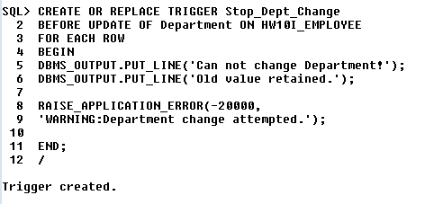
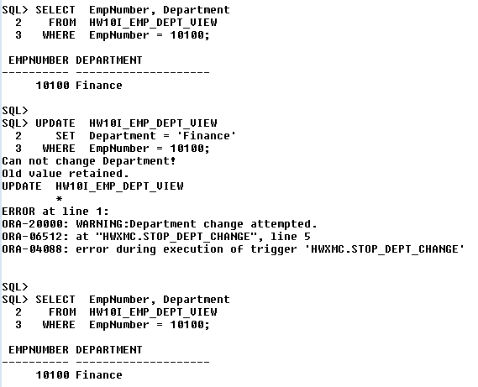
12. Using the HW10I_EMPLOYEE and HW10I_DEPARTMENT tables described above, code an Oracle Trigger to allow the deletion of a department if (and only if) it only has one employee -- i.e., we will NOT allow deletion if a department has more than one employee (we will do nothing and send a message to the user in that case). If there is exactly one employee, then delete the department and assign the last employee to the Human Resources Department. Assume the user has access only to the views, not to the underlying tables. The Trigger, of course, has access to both of the real tables -- and, in fact, will need to take actions on each underlying table in some situations. [Hints: See Fig. 7-29 for some of the logic (Fig. 7-29 doesn't include the reassignment of the last worker or the messages you need to print). The trigger will replace the Delete action that causes it to be invoked.]

Note that you are updating from a View that includes employees and the departments they are assigned to -- it works because the view has no computed columns and you are doing an INSTEAD OF trigger.

You can test your trigger by running the following code:
SET SERVEROUTPUT ON;

SELECT *
FROM HW10I_DELETE_DEPT_VIEW;

DELETE FROM HW10I_DELETE_DEPT_VIEW
WHERE Department = 'Accounting';

SELECT *
FROM HW10I_DELETE_DEPT_VIEW;

DELETE FROM HW10I_DELETE_DEPT_VIEW
WHERE Department = 'Finance';

SELECT *
FROM HW10I_DELETE_DEPT_VIEW;

SELECT *
FROM HW10I_DEPARTMENT;

CREATE OR REPLACE TRIGGER DEPARTMENT_DELETE
INSTEAD OF DELETE ON HW10I_DELETE_DEPT_VIEW

DECLARE
ROWCOUNT INT;
BEGIN
SELECT COUNT(*) INTO ROWCOUNT
FROM HW10I_EMPLOYEE
WHERE HW10I_EMPLOYEE.Department=:old.Department;
IF (ROWCOUNT=1) THEN
UPDATE HW10I_EMPLOYEE
SET DEPARTMENT='HUMAN RESOURCES'
WHERE Department=:old.Department;
DELETE HW10I_DEPARTMENT
WHERE HW10I_DEPARTMENT.Department=:old.Department;
ELSE
DBMS_OUTPUT.PUT_LINE('Send a message to user that a department has more than one employee');
END IF;
END;
/
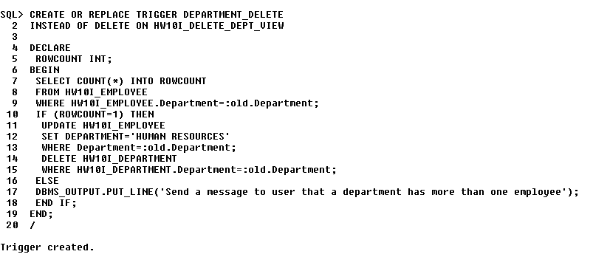
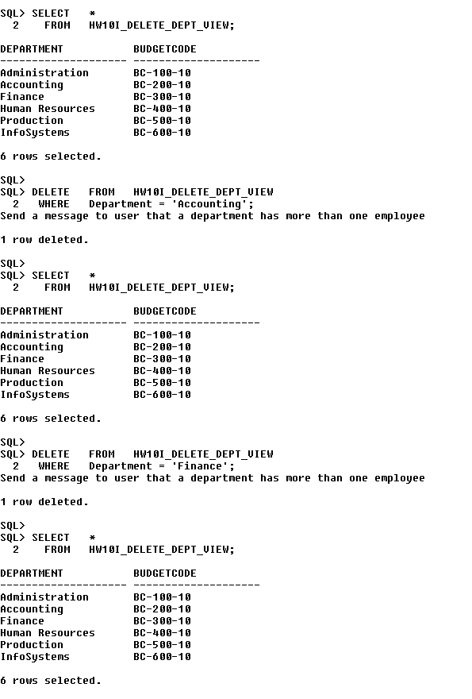
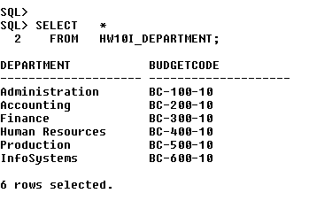
13. Consider the View Ridge Gallery database. Write a stored procedure named HW10I_Artist_Display to read the VRG_ARTIST table and display (using the DBMS_OUTPUT.PUT_LINE command) the LastName and Nationality of any artist whose LastName is input to the procedure. Be sure to execute SET SERVEROUTPUT ON before running the required test of the procedure.

Test your procedure with at least the following:
SET SERVEROUTPUT ON;
EXEC HW10I_Artist_Display('Miro');

CREATE OR REPLACE PROCEDURE HW10I_ARTIST_DISPLAY
(ArtistLASTNAME IN CHAR)
AS
ArtistNATION CHAR(20);
CURSOR ARTISTCURSOR IS
SELECT NATIONALITY FROM VRG_ARTIST
WHERE LASTNAME=ArtistLASTNAME;
BEGIN
DBMS_OUTPUT.PUT_LINE('LASTNAME:'|| ArtistLASTNAME);
OPEN ARTISTCURSOR;
LOOP
FETCH ARTISTCURSOR INTO ArtistNATION;
EXIT WHEN ARTISTCURSOR %NOTFOUND;
DBMS_OUTPUT.PUT_LINE('NATIONALITY:'|| ArtistNATION);
END LOOP;
CLOSE ARTISTCURSOR;
END;
/

