Print Name(s): ___Wu Hao__,Xinpeng Wei_____________
(last, first)
Group Project Homework
We certify that we have done this work totally within our group. We have not talked with any current or former students outside our group about the problems or reviewed answers with anyone outside our group. We have not looked at former students’ work on these or similar problems (sometimes called “files”). We have not used online sources that provide answers to specific questions. Any online sources that provided general tutorial information have been cited.

Signature(s): _________________________________________________

1. Create a new database named Project One, using Microsoft Access, with the following two tables:

DEPARTMENT (DepartmentName, BuildingWhereLocated, Phone)

EMPLOYEE (EmployeeName, EmailUserID, DepartmentName)

Note that EmployeeName may not be unique, but that a company's set of email userIDs is unique. Assume that all columns have text data and set the length of the text field to an appropriate value. Print a screen shot from Access of the relationship.
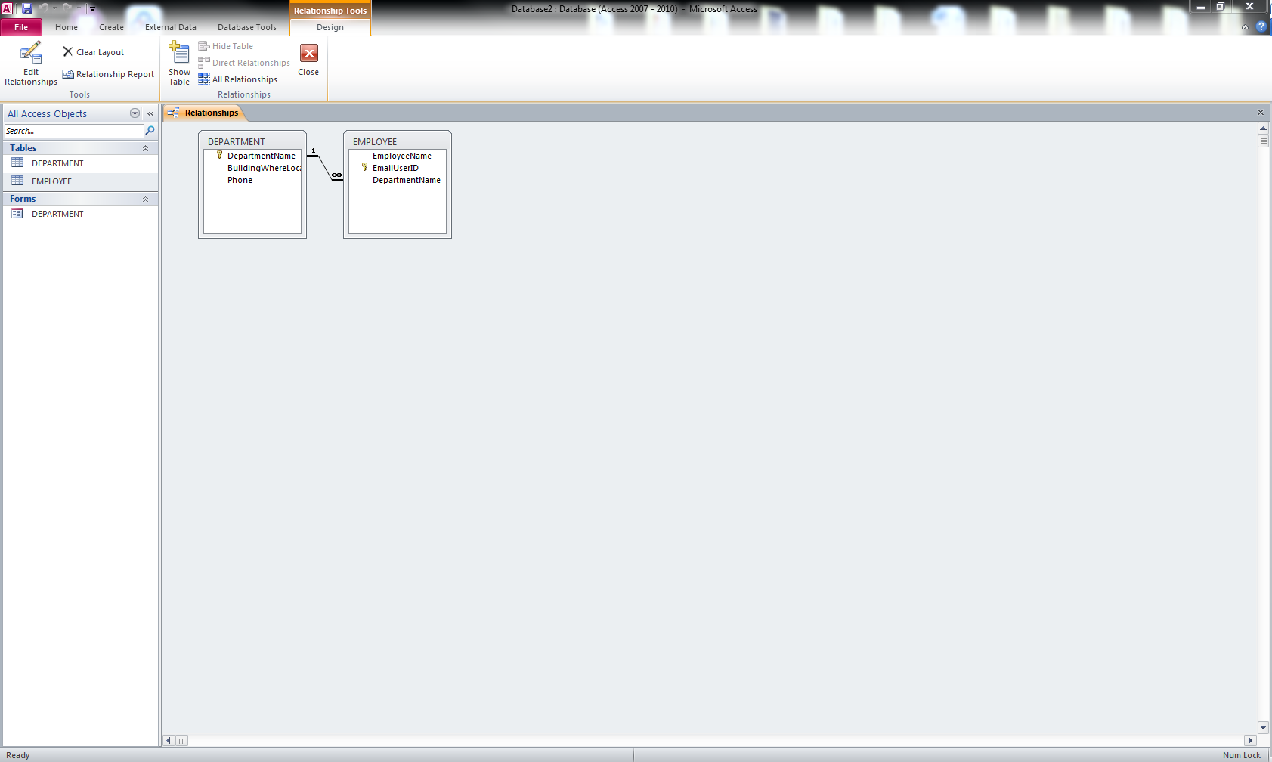

2. Add at least two rows of data to the DEPARTMENT table and at least five rows of data to the EMPLOYEE table. Ensure that all rows in the EMPLOYEE table have valid values for DepartmentName. Show the tables.
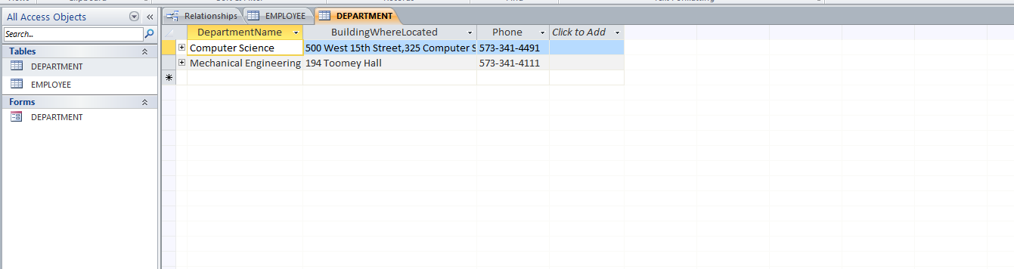
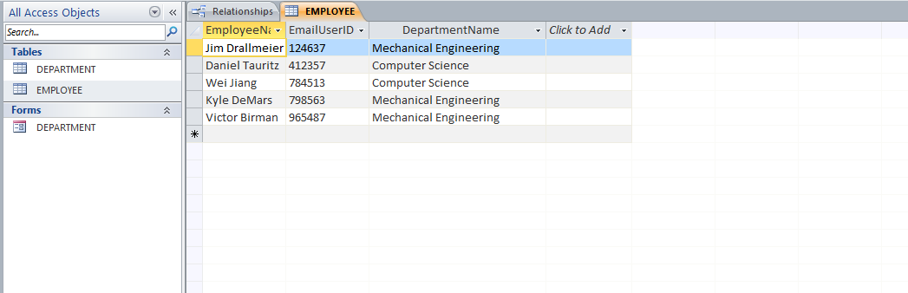

3. Using the Access form wizard, create a form that has all of the data from both tables. When asked how you want to view your data, select by DEPARTMENT. Choose the default options for other questions that the wizard asks. Open your form and page through your departments, taking screen shots of each and printing the screen shots.
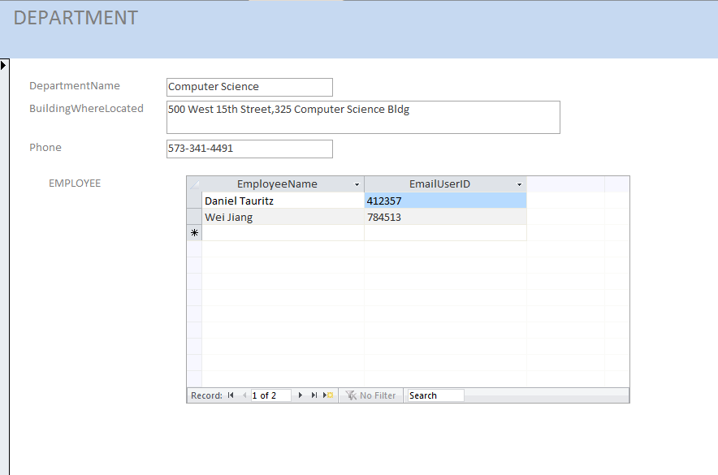
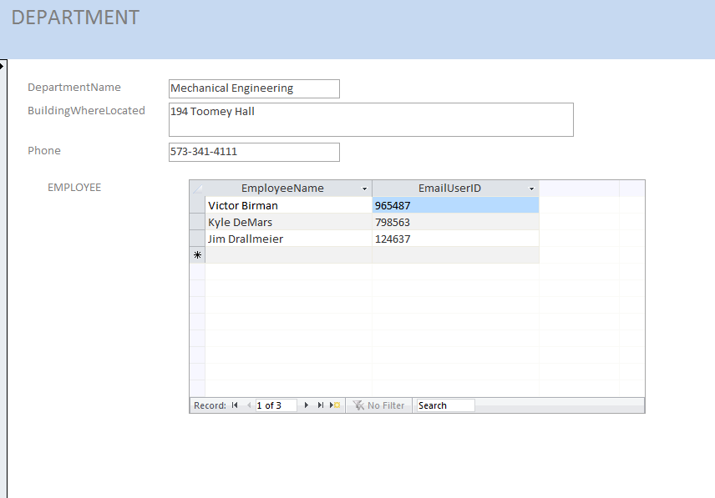

4. Using the Access report wizard, create a report that has all of the data from both tables. When asked how you want to view your data, select by DEPARTMENT. Choose the default options for other questions that the wizard asks. Print your report.
