Print Name(s): ___________________________________________________
(last, first)
Note: We are finished with Access at this point. Any work to be done with a database should now use Oracle -- true for HW 2 and following.

Note 2: This assignment can become very large, due to the screen shots. You should use the picture editor to focus on just the portion of the screen you want and then compress all the screen shots -- see information in Course Material.

Group Project Homework
We certify that we have done this work totally within our group. We have not talked with any current or former students outside our group about the problems or reviewed answers with anyone outside our group. We have not looked at former students’ work on these or similar problems (sometimes called “files”). We have not used online sources that provide answers to specific questions. Any online sources that provided general tutorial information have been cited.

Signature(s): _________________________________________________

Consider Marcia's Dry Cleaning: Marcia's Dry Cleaning is an upscale dry cleaner in a well-to-do suburban neighborhood. Marcia makes her business stand out from the competition by providing superior customer service. She wants to keep track of each of her customers and their orders. Ultimately, she wants to notify them that their clothes are ready via e-mail. To provide this service, she has developed an initial database with several tables. Three of those tables are the following:

CUSTOMER(CustomerID, FirstName, LastName, Phone, Email)
C_ORDER(InvoiceNumber, CustomerID, DateIn, DateOut, TotalAmount)
ORDER_ITEM(InvoiceNumber, ItemNumber, Item, Quantity, UnitPrice)

As in class, the primary keys are underlined and the foreign keys are shown in italic.
Marcia calls the database MDC. The column characteristics for the tables are given below:

CUSTOMER Characteristics:
Column Name | Type | Key | Required | Remarks
CustomerID | Integer | Primary Key | Yes
FirstName | VarChar(15) | No | Yes
LastName | VarChar(20) | No | Yes
Phone | VarChar(12) | No | No | 'ddd-ddd-dddd'
Email | VarChar(30) | No | No

C_ORDER Characteristics:
Column Name | Type | Key | Required | Remarks
InvoiceNumber | Integer | Primary Key | Yes
CustomerID | Integer | Foreign Key | Yes
DateIn | Date | No | Yes
DateOut | Date | No | No
TotalAmount | Number(5,2) | No | No | Currency

ORDER_ITEM Characteristics:
Column Name | Type | Key | Required | Remarks
InvoiceNumber | Integer | Primary Key, Foreign Key | Yes
ItemNumber | Integer | Primary Key | Yes
Item | VarChar(20) | No | Yes
Quantity | Integer | No | Yes
UnitPrice | Number(5,2) | No | No | Currency

The homework
Create the three tables described (the characteristics above, along with HO-4 and HO-5, should help), using SQL*Plus and Oracle. Preface table names with HW2G_, so your first table will be named HW2G_CUSTOMER.

Then load the sample data given in the tables below. Note that we will use date entries for Oracle like '04-OCT-12' in our database.

Data Table For CUSTOMER:
CustomerID | FirstName | LastName | Phone | Email
1 | Nikki | Kaccaton | 723-543-1233 | NKaccaton@somewhere.com
2 | Brenda | Catnazaro | 723-543-2344 | BCatnazaro@somewhere.com
3 | Bruce | LeCat | 723-543-3455 | BLeCat@somewhere.com
4 | Betsy | Miller | 723-654-3211 | BMiller@somewhere.com
5 | George | Miller | 723-654-4322 | GMiller@somewhere.com
6 | Kathy | Miller | 723-514-9877 | KMiller@somewhere.com
7 | Betsy | Miller | 723-514-8766 | BetsyMiller@elsewhere.com

Data Table For C_ORDER:
InvoiceNumber | CustomerID | DateIn | DateOut | TotalAmount
2009001 | 1 | 04-OCT-12 | 06-OCT-12 | 158.50
2009002 | 2 | 04-OCT-12 | 06-OCT-12 | 25.00
2009003 | 1 | 06-OCT-12 | 08-OCT-12 | 49.00
2009004 | 4 | 06-OCT-12 | 08-OCT-12 | 17.50
2009005 | 6 | 07-OCT-12 | 11-OCT-12 | 12.00
2009006 | 3 | 11-OCT-12 | 13-OCT-12 | 152.50
2009007 | 3 | 11-OCT-12 | 13-OCT-12 | 7.00
2009008 | 7 | 12-OCT-12 | 14-OCT-12 | 140.50
2009009 | 5 | 12-OCT-12 | 14-OCT-12 | 27.00

Data for ORDER_ITEM:
InvoiceNumber | ItemNumber | Item | Quantity | UnitPrice
2009001 | 1 | Blouse | 2 | 3.50
2009001 | 2 | Dress Shirt | 5 | 2.50
2009001 | 3 | Formal Gown | 2 | 10.00
2009001 | 4 | Slacks-Mens | 10 | 5.00
2009001 | 5 | Slacks-Womens | 10 | 6.00
2009001 | 6 | Suit-Mens | 1 | 9.00
2009002 | 1 | Dress Shirt | 10 | 2.50
2009003 | 2 | Slacks-Womens | 4 | 6.00
2009004 | 1 | Dress Shirt | 7 | 2.50
2009005 | 1 | Blouse | 2 | 3.50
2009005 | 2 | Dress Shirt | 2 | 2.50
2009006 | 1 | Blouse | 5 | 3.50
2009006 | 2 | Dress Shirt | 10 | 2.50
2009006 | 3 | Slacks-Mens | 10 | 5.00
2009006 | 4 | Slacks-Womens | 10 | 6.00
2009007 | 1 | Blouse | 2 | 3.50
2009008 | 1 | Blouse | 3 | 3.50
2009008 | 2 | Dress Shirt | 12 | 2.50
2009008 | 3 | Slacks-Mens | 8 | 5.00
2009008 | 4 | Slacks-Womens | 10 | 6.00
2009009 | 1 | Suit-Mens | 3 | 9.00

Finally, carry out steps A through Q, as stated below. Note: When we say "show" some SQL, we intend that you will include the SQL in your homework solution set, either as lines of text or as a screen shot from SQL*Plus. Before you start creating displays and taking screen shots, you may want to:
SET LINESIZE 110

A. Show SQL*Plus statements that would display all the data in each of the tables.
Provide screen shots that show the results of running your statements.
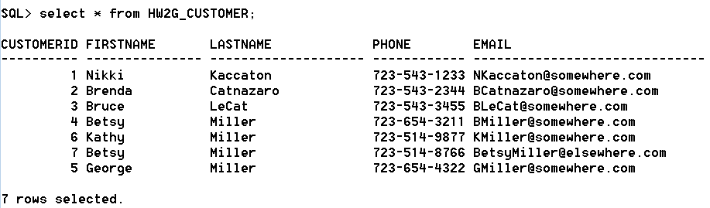
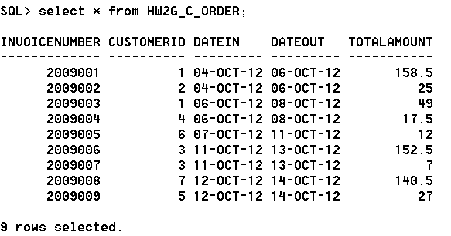
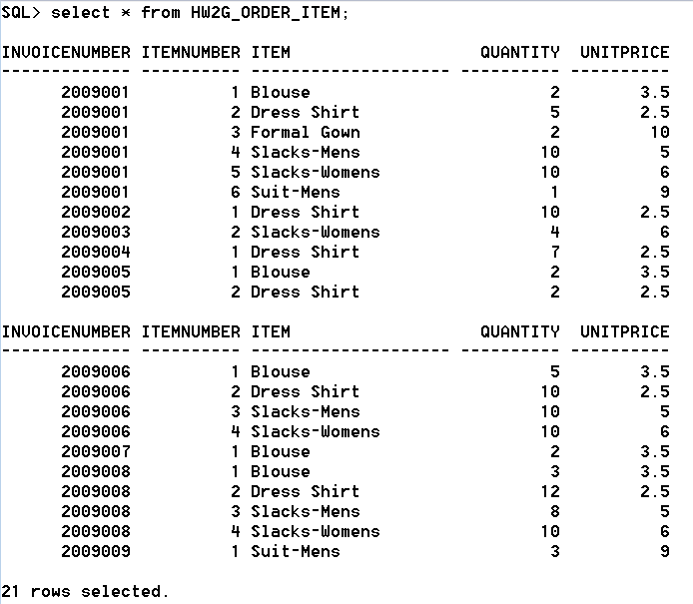
B. Show a SQL*Plus statement that would list the Phone and LastName of all customers.
Provide a screen shot that shows the results of running your statement.
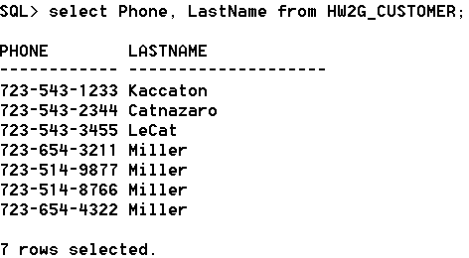
C. Show a SQL*Plus statement that would list the Phone and LastName for all customers with a FirstName of 'Nikki'.
Provide a screen shot that shows the results of running your statement.
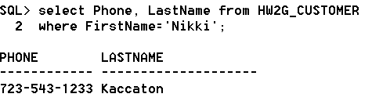
D. Show a SQL*Plus statement that would list the CustomerID, DateIn, and DateOut of all orders with a TotalAmount in excess of 100.
Provide a screen shot that shows the results of running your statement.
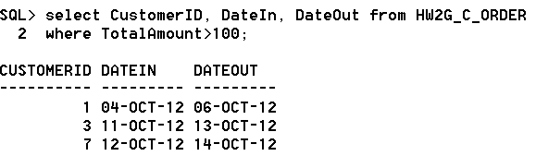
E. Show a SQL*Plus statement that would list the Phone and FirstName of all customers whose first name starts with 'B'.
Provide a screen shot that shows the results of running your statement.
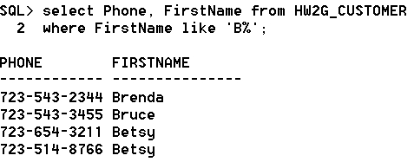
F. Show a SQL*Plus statement that would list the Phone and FirstName of all customers whose last name includes the characters: 'cat' or 'Cat'.
Provide a screen shot that shows the results of running your statement.
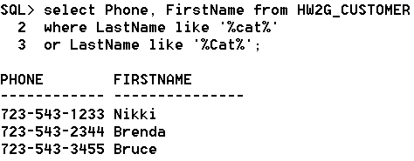
G. Show a SQL*Plus statement that would list the Phone, FirstName, and LastName for all customers with phone numbers whose second and third digits are 23. [Note: Phone number in this question means the entire number.]
Provide a screen shot that shows the results of running your statement.
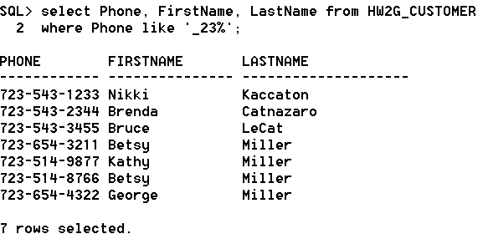
H. Show a SQL*Plus statement that would determine and display the maximum and minimum TotalAmount values, giving the displayed values appropriate names.
Provide a screen shot that shows the results of running your statement.
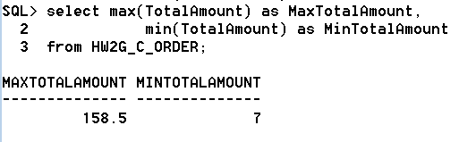
I. Show a SQL*Plus statement that would determine and display the average TotalAmount, giving the value displayed an appropriate name.
Provide a screen shot that shows the results of running your statement.
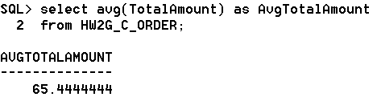
J. Show a SQL*Plus statement that would count and display the number of customers giving the value displayed an appropriate name.
Provide a screen shot that shows the results of running your statement.
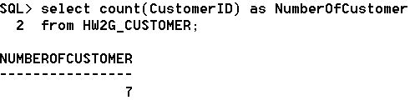
K. Show a SQL*Plus statement that would group customers by LastName and then by FirstName (and display the groups).
Provide a screen shot that shows the results of running your statement.
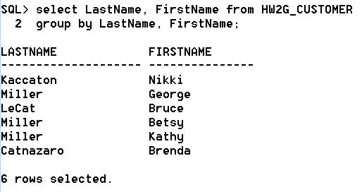
L. Show a SQL*Plus statement that would count and display the number of customers having each combination of LastName and FirstName.
Provide a screen shot that shows the results of running your statement.
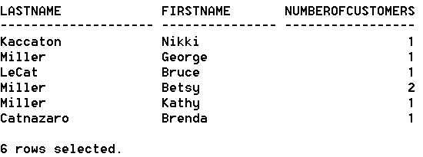
M. Show a SQL*Plus statement that would display the FirstName and LastName of all customers who have had an order with TotalAmount greater than 100. Use a subquery. Present the results sorted by LastName in ascending order and then FirstName in descending order.
Provide a screen shot that shows the results of running your statement.
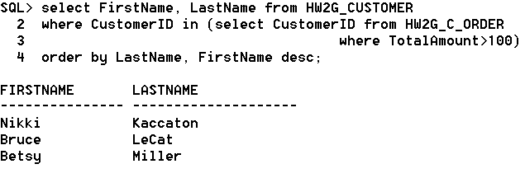
N. Show a SQL*Plus statement that would display the FirstName and LastName of all customers who have had an order with TotalAmount greater than 100. Use a join. Present results sorted by LastName in ascending order and then FirstName in descending order.
Provide a screen shot that shows the results of running your statement.
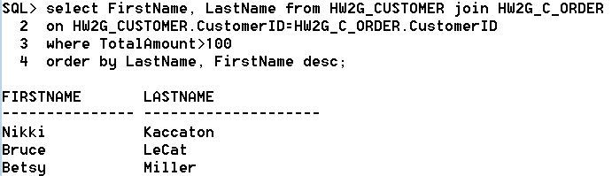
O. Show a SQL*Plus statement that would display the FirstName and LastName of all customers who have had an order with an Item named 'Dress Shirt'. Use a subquery. Present results sorted by LastName in ascending order and then FirstName in descending order.
Provide a screen shot that shows the results of running your statement.
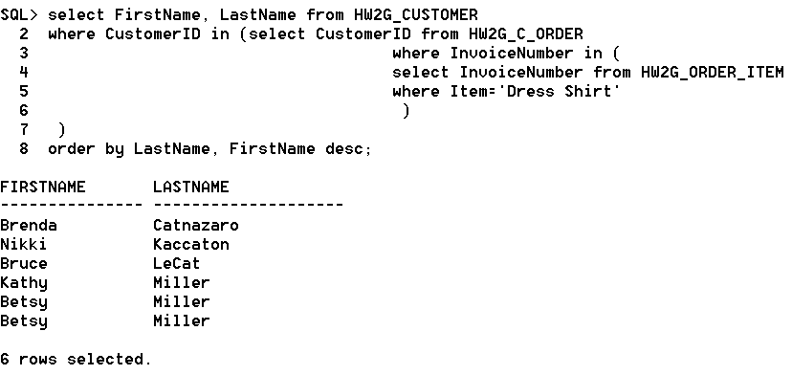
P. Show a SQL*Plus statement that would display the FirstName and LastName of all customers who have had an order with an Item named 'Dress Shirt'. Use a join. Present results sorted by LastName in ascending order and then FirstName in descending order.
Provide a screen shot that shows the results of running your statement.
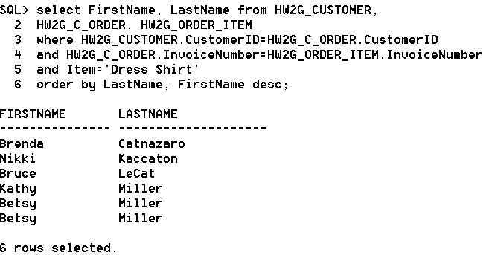
Q. Show a SQL*Plus statement that would display the FirstName, LastName, and TotalAmount of all customers who have had an order with an Item named 'Dress Shirt'. Use a join with a subquery. Present results sorted by LastName in ascending order and then FirstName in descending order. [Hint: Data in a table without displayed fields can still be brought into a JOIN query with a subquery.]
Provide a screen shot that shows the results of running your statement.
