Print Name: ___Wu Hao____________________
(last, first)
Note: We are finished with Access at this point. Any work to be done with a database should now use Oracle -- true for HW 2 and following.

Note 2: This assignment can become very large, due to the screen shots. You should use the picture editor to focus on just the portion of the screen you want and then compress all the screen shots -- see information in Course Material.

Individual Homework
I certify that I have done this work individually. I have not talked with any current or former students about the problems or reviewed answers with anyone. I have not looked at former students’ work on these or similar problems (sometimes called “files”). I have not used online sources that provide answers to specific questions. Any online sources that provided general tutorial information have been cited.

Signature: ___________________________

1. What is an ad-hoc query?
A query created by a user as and when needed, as compared to a predefined and stored query.

2. Explain how enterprise-class DBMS products use SQL.
Enterprise-class DBMS products, which include Microsoft SQL Server, Oracle Corporation’s Oracle Database and MySQL, and IBM’s DB2, require you to know and use SQL. All data manipulation is expressed in SQL in these products. For example, applications can connect between the users and client/server, E-commerce applications, web portal, XML web services and mobile apps. All of these database applications read and write database by sending SQL statements to the DBMS.

3. Explain, in general terms, the relationships among the RETAIL_ORDER, ORDER_ITEM, and SKU_DATA tables of Fig. 2-5 -- what relates to what and how?
The primary key in RETAIL_ORDER is OrderNumber, the primary key in SKU_DATA is SKU and the foreign keys in ORDER_ITEM are OrderNumber and SKU. The relationship between RETAIL_ORDER and ORDER_ITEM is linked by OrderNumber. The relationship between ORDER_ITEM and SKU_DATA is linked by SKU.

For the remaining questions, use the following INVENTORY and WAREHOUSE relations, with the characteristics specified in the tables below them.

INVENTORY (SKU, WarehouseCity, SKU_Description, QuantityOnHand, QuantityOnOrder)
WAREHOUSE (WarehouseCity, Manager, SquareFeet)

INVENTORY Characteristics:
Column Name | Type | Key | Required | Remarks
SKU | Integer | Primary Key, Foreign Key | Yes | Surrogate Key
WarehouseCity | VarChar(15) | Primary Key, Foreign Key | Yes
SKU_Description | VarChar(30) | No | Yes
QuantityOnHand | Integer | No | No
QuantityOnOrder | Integer | No | No

WAREHOUSE Characteristics:
Column Name | Type | Key | Required | Remarks
WarehouseCity | VarChar(15) | Primary Key | Yes
Manager | VarChar(15) | No | No
SquareFeet | Integer | No | No

You will be provided with files to load the sample sets of data into the INVENTORY and WAREHOUSE tables. Run those files to create and load the INVENTORY and WAREHOUSE tables. Use only the INVENTORY table for questions 4 through 10; use both tables for questions 11 and 12. The prefix HW2I_ is affixed to these files, so they are named HW2I_INVENTORY, etc. Note that you'll need other tables as well and that the order of creation is important.

Before starting work, run the following two SQL*PLUS directives:
SET LINESIZE 110;
SET PAGESIZE 50;
*****

4. Write and run a SQL statement to display SKU and SKU_Description. Show your SQL statement and also show a screen shot of your results.
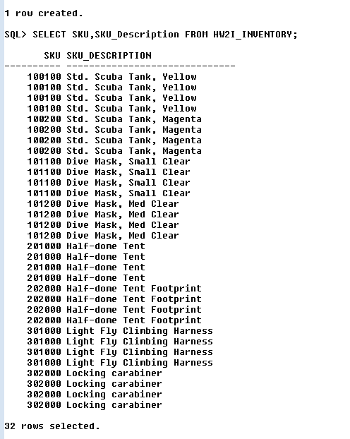
5. Write and run a SQL statement to display WarehouseCity with no duplications. Show your SQL statement and a screen shot of your results.
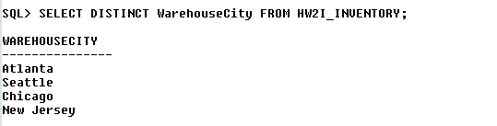
6. Write and run a SQL statement to display all of the columns without using *. Show your SQL statement and a screen shot of your results.
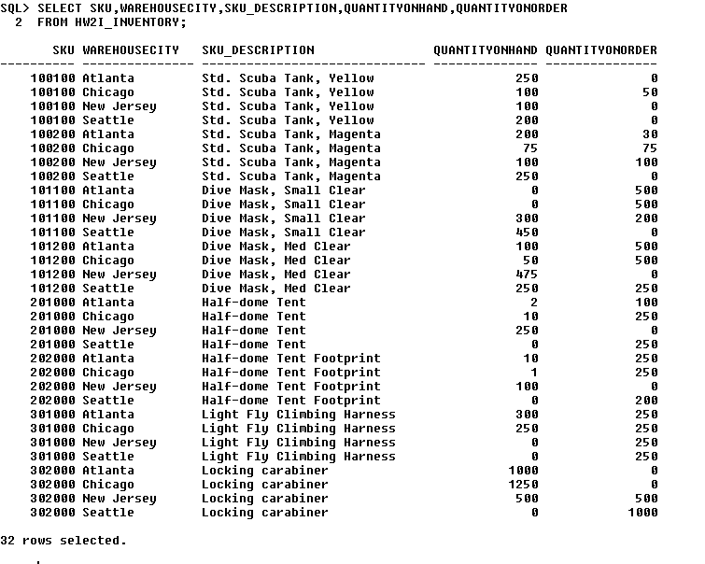
7. Write and run a SQL statement to display the SKU and SKU_Description of all items stored in the Seattle, Chicago, or New Jersey warehouses. Do not use IN. Show your SQL statement and a screen shot of your results.
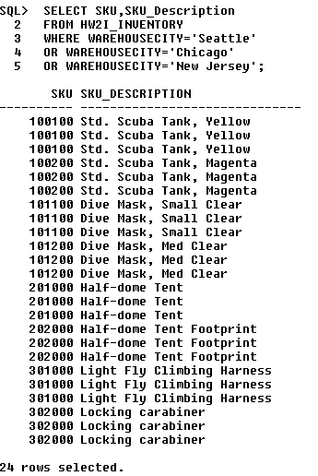
8. Write and run a SQL statement to display the SKU and SKU_Description of all items stored in the Seattle, Chicago, or New Jersey warehouses. Use IN. Show your SQL statement and a screen shot of your results.
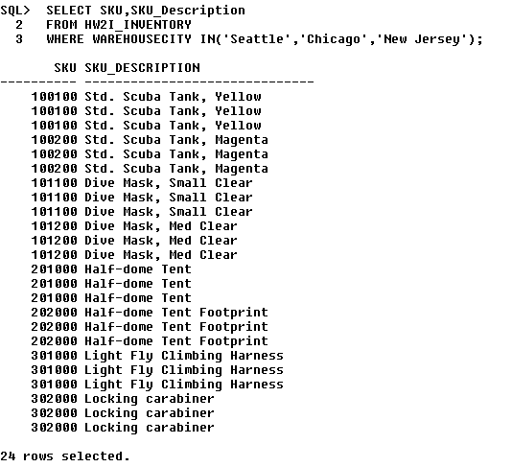
9. Write and run a SQL expression to display the WarehouseCity and the sum of QuantityOnHand, grouped by WarehouseCity. Name the sum TotalItemsOnHand and display the results in descending order of TotalItemsOnHand. Show your SQL statement and a screen shot of your results.
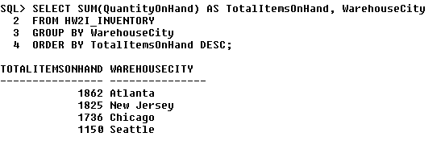
10. Write and run a SQL expression to display the WarehouseCity and the sum of QuantityOnHand grouped by WarehouseCity. Omit all items that have a QuantityOnHand greater than 2. Show only groups having fewer than 2 item counts (i.e., a number of records (rows or individual items) fewer than 2). Name the sum TotalItemsOnHand and display the results in descending order of TotalItemsOnHand.
[Hints:
Think of using COUNT inside a HAVING clause.
Order of clauses:
SELECT, FROM, WHERE, GROUP BY, HAVING, ORDER BY]
Show your SQL statement and a screen shot of your results.
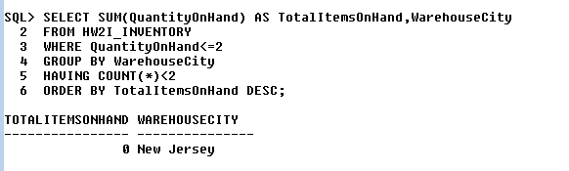

11. Write and run a SQL statement to show the SKU and SKU_Description of all items stored in a warehouse managed by 'Smith'. Use a subquery. Show your SQL statement and a screen shot of your results.
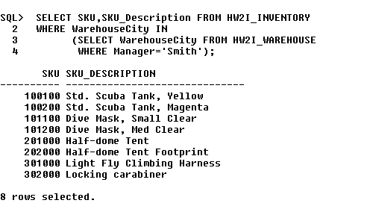

12. Write and run a SQL statement to show the SKU and SKU_Description of all items stored in a warehouse managed by 'Smith'. Use a join. Show your SQL statement and a screen shot of your results.
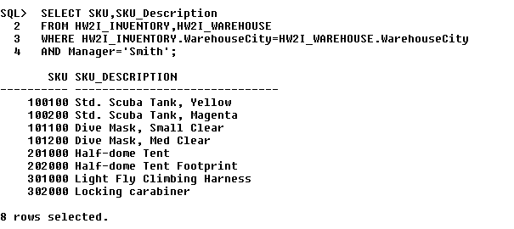
13. Write and run a SQL statement to show the SKU and SKU_Description of all items stored in a warehouse managed by 'Smith'. Use JOIN….ON. Show your SQL statement and a screen shot of your results.
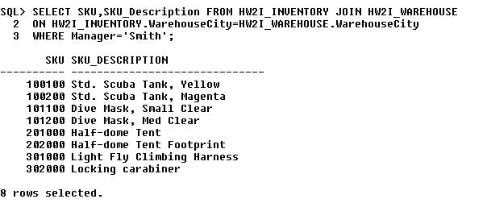
14. Explain how subqueries and joins differ.
A query can contain a subquery, and only data from fields in the table used in the top-level query can be included in the SELECT statement. If data from fields from other tables are also needed, a join must be used. Correlated subqueries do not have an equivalent join structure.

15. Distinguish between the HAVING clause and the WHERE clause.
The SQL WHERE clauses specifies which rows will be used to determine the groups
The SQL HAVING clauses specifies which groups will be used in the final result.
16. Oracle does not have an EXCEPT set operator. How do you get around that problem if you need that functionality?
We can use SQL MINUS operator to replace the functionality of EXCEPT set operator

