Print Name(s): ______WU HAO WEI XINPENG_______
(last, first)
Group Project Homework
We certify that we have done this work totally within our group. We have not talked with any current or former students outside our group about the problems or reviewed answers with anyone outside our group. We have not looked at former students’ work on these or similar problems (sometimes called “files”). We have not used online sources that provide answers to specific questions. Any online sources that provided general tutorial information have been cited.

Signature(s): _________________________________________________

Suppose that you have been hired by Marcia's Dry Cleaning to create a database application to track customers, orders, and items. Marcia also wants to start a "Frequent Cleaner's Club," whereby she will offer a 50 percent discount on every 10th customer order.

Answer parts A and B as stated below.

A. Using your knowledge, create a data model for Marcia's business. Name each entity, describe its type, and indicate all attributes and identifiers. Name each relationship, describe its type, and specify minimum and maximum cardinalities.

[Hints:
You may want to consider an entity named DISCOUNT_AWARD.
In Group HW 7, we will deal with relation structures similar to:
CUSTOMER (CustomerID, FirstName, LastName, Phone, Email)
ORDER (InvoiceNumber, CustomerID, DateIn, DateOut,
Subtotal, Tax, TotalAmount)
ORDER_ITEM (InvoiceNumber, ItemNumber, Service, Quantity,
UnitPrice, ExtendedPrice)
SERVICE (Service, Description, UnitPrice)
But note that our model will not have foreign keys and that some aspects of
the two problems are very different.
Look carefully at Figure 5-33, but realize that Marcia provides services, not
items and there's no need to keep information about salespeople. ]

Before you create the data model (Crow's Foot diagram), create a table of Relationship and Cardinality, like this:
Relationship |  |  | Cardinality
Parent | Child | Type | Max | Min
... | ... | ... | ... | ...
The table can help create the Crow's Foot model.
In the model, specify identifiers, attributes, and relationship name(s).

The following table details the relationships, their type and cardinalities:
Relationship |  |  | Cardinality
Parent | Child | Type | Max | Min
CUSTOMER | ORDER | Strong | 1:N | M-O
CUSTOMER | DISCOUNT_AWARD | Weak | 1:N | M-O
DISCOUNT_AWARD | ORDER | Weak | 1:10 | M-O
ORDER | ORDER_ITEM | ID-Dependent | 1:N | M-O
SERVICE | ORDER_ITEM | Strong | 1:N | M-O

The models are as follows:
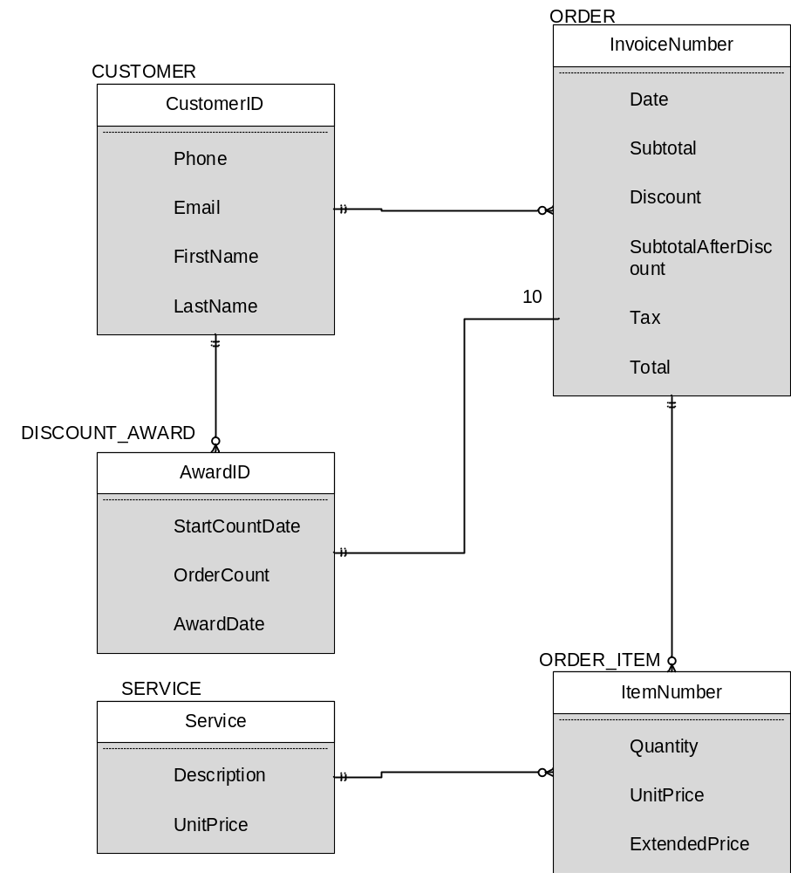
B. List any item in your answer to A that you believe should be checked out with Marcia and/or her employees. Also list any places where application logic will be needed to implement some part of the database.
[Hint: You have probably assumed that there are no multivalued dependencies, so that might be one area to consider.]
1. check out the composite identifier(FirstName, LastName)
2. check for multivalued dependency (CustomerID→→Phone)and (Firstname,LastName)→→Phone
3.check for multivalued dependency (Phone→→CustomerID)and Phone→→(FirstName,LastName)
4. check for multivalued dependency (CustomerID→→Email)and
(FirstName,LastName)→→Email

