Print Name: ___WU HAO________________
(last, first)
Individual Homework
I certify that I have done this work individually. I have not talked with any current or former students about the problems or reviewed answers with anyone. I have not looked at former students’ work on these or similar problems (sometimes called “files”). I have not used online sources that provide answers to specific questions. Any online sources that provided general tutorial information have been cited.

Signature: ___________________________

1. Explain the difference between an entity class and an entity instance.
An entity class is a group of entities of the same type,i.e.Vehicle. An entity instance
is a particular entity,i.e. Vehicle 42139
2. What is a binary relationship?
The number of entity classes in the relationship is the degree of the relationship. Relationships of degree two are refered to as binary relationship.

3. What does "cardinality" mean?
Cardinality refers to the number of instance of one entity class which relate to instance f another entity class.

4. Define the terms maximum cardinality and minimum cardinality.
The maximum cardinality is the maximum number of entity instances that can participate in a relationship instance. The minimum cardinality is the minimum number of entity instances that must participate in a relationship instance.

5. What is an ID-dependent entity?
An ID-dependent entity is an entity whose identifier includes the identifier of another entity.

6. Explain how to determine the minimum cardinality of both sides of an ID-dependent relationship.
The ID-dependent entity cannot exist unless the parent exists.
The minimum cardinality from the ID-dependent entity to the parent is always one. Whether the parent is required to have an ID dependent entity depends on the application requirements.

7. What is an identifying relationship? How is it used?
An identifying relationship is a special type of relationship. It is used to represent ID-dependent. Most data modeling products use a solid line to represent an identifying relationship and a dashed line to represent a non-identifying relationship.

8. What is a weak entity? How do weak entities relate to ID-dependent entities?
A weak entity is an entity whose existence depends on another entity. All ID-dependent entities are weal entities, but not all weak entities are ID-dependent.

9. Explain the difference between IS-A and HAS-A relationships.
The relationship between a supertype and its subtype is called an IS-A relationship.
Entities with an IS-A relationship should have the same identifier because they represent different aspects of the same thing, Entities with HAS-A relationships represent different things and thus have different identifiers. These relationships do not involve subtypes.

10. Explain why two forms or reports are usually needed to infer maximum cardinality.
Each form or report only shows the maximum cardinality in one direction between the entities. Therefore, to know the cardinalities in both directions requires two forms or reports.

11. What entity type should come to mind when you see the words "For use by" in a form?
Subtype entities.
12. Examine the subscription form shown below.
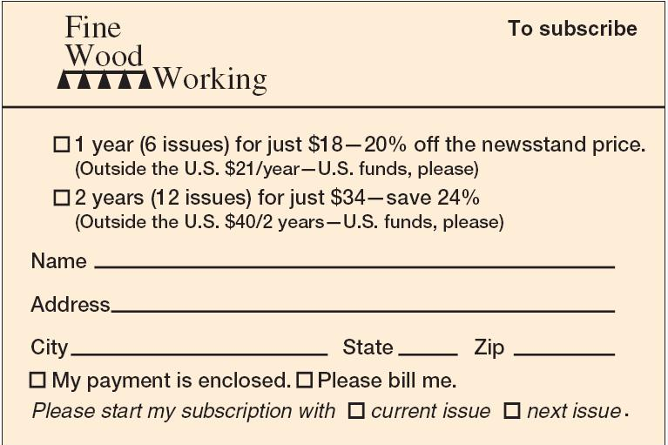
You may have to infer some things that are not specified in the figure -- e.g., SubscriptionNumber, start and end dates. Using the structure of this form, do the following:
a. Create a model with one entity class. Specify the identifier and attributes.
b. Create a Crow's Foot model with two entity classes, one for customer and a second for subscription.
Create a table of Relationship and Cardinality, like this:
Relationship |  |  | Cardinality
Parent | Child | Type | Max | Min
Customer | Subscription | Strong | 1:N | M-O
The table can help create the Crow's Foot model.
In the model, specify identifiers, attributes, and relationship name(s).
a.
SubNumber
LastName
FirstName
Start Date
End Date
AmtDue
Address
City
State
Zip
PaymentCode
The identifier is SubscriptionNumber, attributes are Start Date,End Date, AmtDue, LastName, FirstName, Address, City, State, Zip, Paymentcode.

b. The SUBSCRIPTION is weak, but not ID-dependent entity.

