Print Name(s): __WU,HAO WEI,XINPENG______________________
(last, first)
Group Project Homework
We certify that we have done this work totally within our group. We have not talked with any current or former students outside our group about the problems or reviewed answers with anyone outside our group. We have not looked at former students’ work on these or similar problems (sometimes called “files”). We have not used online sources that provide answers to specific questions. Any online sources that provided general tutorial information have been cited.

Signature(s): _________________________________________________

Review your solution to the Marcia's Dry Cleaning project in HW 5.

Assume your solution is modified to be based on the following data chart:

RELATIONSHIP |  |  | CARDINALITY
PARENT | CHILD | TYPE | MAX | MIN
CUSTOMER | ORDER | Strong | 1:N | M-O
CUSTOMER | DISCOUNT_AWARD | Weak | 1:N | M-O
DISCOUNT_AWARD | ORDER | Weak | 1:10 | O-O
ORDER | ORDER_ITEM | ID-Dependent | 1:N | M-O
SERVICE | ORDER_ITEM | Strong | 1:N | M-O

Design a database for the model specified in the chart above.
• Your design should include a specification of tables and attributes as well as primary, candidate, and foreign keys. We expect to see a diagram that indicates all the entities and the relationships between them, with the keys and other attributes shown on the diagram. You may put the specifications for attributes in the diagram as well (example below). Show which attributes are Foreign Keys by putting (FK) behind the attribute.
• Also specify how you will enforce minimum cardinality. For the relationship between CUSTOMER and ORDER, put referential integrity actions on the relationship lines in the diagram; for the other relationships, put the referential integrity actions into table form.
• If there are any required children, describe how you will handle them in accordance with Fig. 6-29(b).

Example entity documentation with attribute specifications
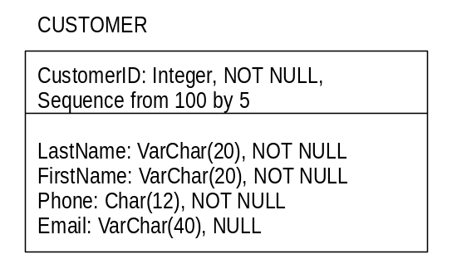
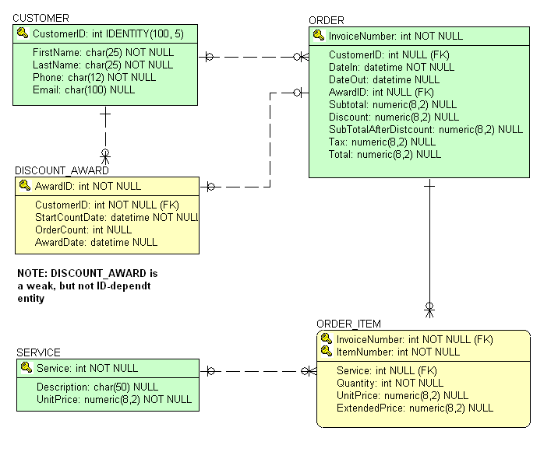
There are no required children in the database design

The minimum cardinalities are M-O and O-O. We need to consider the cases for M-O,
which means that all referential integrity actions will be handled by referential
integrity constraints.
CUSTOMER  Parent Required | Action on  CUSTOMER | Action on  ORDER
Insert | None, just insert | Trigger to get a CUSTOMER by setting the new ORDER’s foreign key to a standard value.
Modify key/foreign key | Cascade updates | Allow, if CustomerID matches value in CUSTOMER  Prohibit, if not
Delete | Prohibit | None, just delete

Parent Required  CUSTOMER | Action on Parent | Action on Child  DISCOUNT_AWARD
Insert | None, just insert | Trigger to get a CUSTOMER by setting the new DISCOUNT_AWARD’s foreign key to a standard value
Modify key/foreign key | Cascade the update | Allow, if CustomerID matches a value in CUSTOMER
Delete | Prohibit | None,just delete

Parent Required  ORDER | Action on Parent | Action on Child  ORDER_ITEM
Insert | None, just insert | Trigger to get a ORDER by setting the new ORDER_ITEM’s foreign key to a standard value
Modify key/foreign key | Cascade updates | Allow, if InvoiceNumber matches a value in ORDER
Delete | Cascade delete | None, just delete

Parent Required  SERVICE | Action on Parent | Action on Child  ORDER_ITEM
Insert | None, just insert | Trigger to get a new SERVICE by setting the new ORDER_ITEM’s foreign key to a standard value
Modify key/foreign key | Cascade updates | Allow, if Service matches a value in SERVICE
Delete | Prohibit | None, just delete

