Print Name(s): ___WU ,HAO WEI,XINPENG_______________________
(last, first)
Group Project Homework
We certify that we have done this work totally within our group. We have not talked with any current or former students outside our group about the problems or reviewed answers with anyone outside our group. We have not looked at former students’ work on these or similar problems (sometimes called “files”). We have not used online sources that provide answers to specific questions. Any online sources that provided general tutorial information have been cited.

Signature(s): _________________________________________________

Note: This assignment can become very large, due to the screen shots. Use trimming and compression to keep it at a manageable size.

Suppose that you have designed a database for Marcia's Dry Cleaning that has the following tables:
CUSTOMER (CustomerID, FirstName, LastName, Phone, Email)
ORDER (InvoiceNumber, CustomerID, DateIn, DateOut, Subtotal, Tax, TotalAmount)
ORDER_ITEM (InvoiceNumber, ItemNumber, Service, Quantity, UnitPrice, ExtendedPrice)
SERVICE (Service, Description, UnitPrice)

Add the prefix "HW7G_" to each table name.

Do parts A through M as given below. Those that involve SQL should be written
in SQL*Plus and run, unless indicated otherwise.
Include screen shots of the results of your runs, unless otherwise specified.
Note: This database has unnecessary duplicated data, which the owner wants to keep.

Here is a crow's foot diagram of the relationships that helps answer some parts:

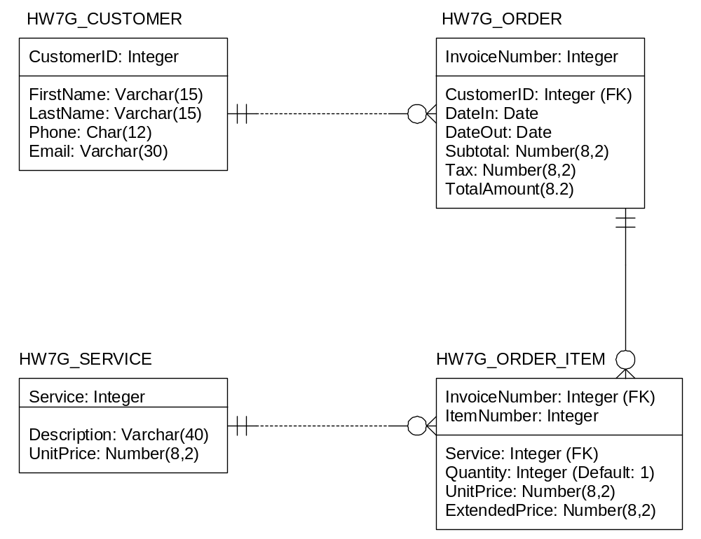

A. Specify NULL/NOT NULL constraints for each table column. Also specify alternate keys, if any. Use the following table form.
(Note: This table has over 20 rows, since every column of every table appears as a row.)
Table | Column | NULL/NOT NULL | Alternate Key?
HW7G_CUSTOMER | CustomerID | NOT NULL | PK
HW7G_CUSTOMER | FirstName | NOT NULL | AK1:1
HW7G_CUSTOMER | LastName | NOT NULL | AK1:2
HW7G_CUSTOMER | Phone | NOT NULL | No
HW7G_CUSTOMER | Email | NULL | Yes,if fully populated, email address are unique
HW7G_ORDER | InvoiceNumber | NOT NULL | PK
HW7G_ORDER | CustomerID | NOT NULL | No
HW7G_ORDER | DateIn | NULL | No
HW7G_ORDER | DateOut | NULL | No
HW7G_ORDER | Subtotal | NULL | No
HW7G_ORDER | Tax | NULL | No
HW7G_ORDER | TotalAmout | NULL | No
HW7G_SERVICE | Service | NOT NULL | PK
HW7G_SERVICE | Description | NOT NULL | No
HW7G_SERVICE | UnitPrice | NULL | No
HW7G_ORDER_ITEM | InvoiceNumber | NOT NULL | PK
HW7G_ORDER_ITEM | ItemNumber | NOT NULL | PK
HW7G_ORDER_ITEM | Service | NOT NULL | No
HW7G_ORDER_ITEM | Quantity | NOT NULL | No
HW7G_ORDER_ITEM | UnitPrice | NULL | No
HW7G_ORDER_ITEM | ExtendedPrice | NULL | No

B. State relationships as implied by foreign keys and specify the maximum and minimum cardinality of each relationship. Justify your choices. Use the following table format:
(Note: Your justification should come after the table.)

Relationship |  |  | Cardinality
Parent | Child | Type | Max | Min
HW7G_CUSTOMER | HW7G_ORDER | Strong | 1:N | M-O
HW7G_ORDER | HW7G_ORDER_ITEM | ID-Dependent | 1:N | M-O
HW7G_SERVICE | HW7G_ORDER_ITEM | Strong | 1:N | M-O

C. Explain how you will enforce the minimum cardinalities in your answer to part B. Use referential integrity actions for required parents, if any. Use Figure 6-29(b) as a boilerplate for required children, if any. Note that you do not have to write any code for this part, just explain what must be done.

All the minimum cardinalities are M-O. This means that almost all referential integrity actions will be handed by referential integrity constraints on the database. Thus we will generally use ON UPDATE CASCADE and ON DELETE CASCADE as necessary. Little application code (i.e., triggers) will have to be written.
The relationship between CUSTOMER AND ORDER is strong entity non-identifying relationship. Further, CUSTOMER has a surrogate primary key. For such strong entity relationships, we do NOT implement either ON UPDATE CASCADE or ON DELETE CASCADE, so the constraint will be ON UPDATE NO ACTION and ON DELETE ON ACTION. We will have to write a trigger to be sure that a CustomerID exists in CUSTOMER when an ORDER is placed.

The relationship between ORDER AND ORDER ITEM is an identifying ID-dependent relationship. For ID-dependent relationships, we do implement both ON UPDATE CASCADE and ON DELETE CASCADE, so the constraint will be on UPDATE CASCADE and ON DELETE CASCADE.
The relationship between SERVICE and ORDER ITEM is a non-identifying relationship. However, we need to update the non-surrogate primary key of SERVICE, but we do not want to delete record in ORDER_ITEM if we delete a corresponding record in SERVICE. Therefore, we implement only ON UPDATE CASCADE, so the contraint will be ON UPDATE CASCADE and ON DELETE ON ACTION.

D. Write CREATE TABLE statements for each of the tables, using your answers to parts A to C as necessary. Use FOREIGN KEY constraints to create appropriate referential integrity constraints. Set UPDATE and DELETE behavior in accordance with your referential integrity action design, remembering that Oracle does not allow U:C, so an Application or Trigger will be needed in that case -- i.e., we won't have the referential integrity action in the CREATE TABLE statement. Write a constraint that SERVICE.UnitPrice be between 1.50 and 10.00. Also write a Sequence named HW7G_CustID that starts at 100 and increments by 5 for later use in creating CustomerID values. Note that tables must be created in a specific order. We expect to see five screen shots here -- one for each table creation and one for the sequence creation.
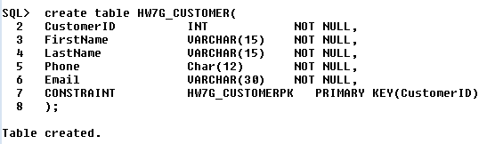

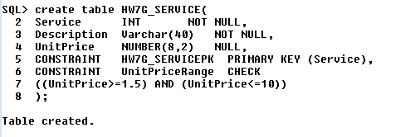
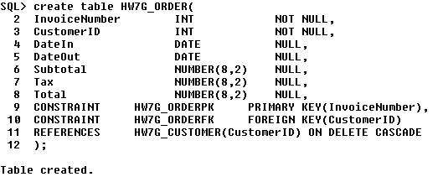

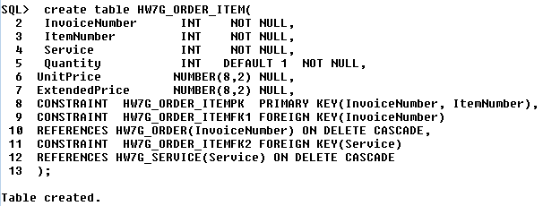

E. Explain how you would enforce the data constraint that HW7G_ORDER_ITEM.UnitPrice be equal to HW7G_SERVICE.UnitPrice, where HW7G_ORDER_ITEM.Service = HW7G_SERVICE.Service. Again, no code at this time, just an explanation.

We need to writer a trigger to do this. We would use an INSTEAD OF INSERT on HW7G_ORDER ITEM that would use the value of HW7G_ORDER_ITEM.service to get the correct value of HW7G_SERVICE.UnitPrice and insert it into HW7G_ORDER_ITEM.UnitPrice.

F. Insert all of the following data into the tables, using the CustID Sequence where appropriate:

The data used here is essentially the same data used in Chapter Two. Note that a Sales Tax Rate is needed for calculating the ORDER.Total. This data set (as given) uses 7.90% (.079). Note that dates are not in Oracle style, so you'll have to change them when you enter them.

TABLE OF CUSTOMER DATA:

CustomerID | FirstName | LastName | Phone | Email
100 | Nikki | Kaccaton | 723-543-1233 | NKaccaton@somewhere.com
etc., | Brenda | Catnazaro | 723-543-2344 | BCatnazaro@somewhere.com
as specified | Bruce | LeCat | 723-543-3455 | BLeCat@somewhere.com
by the | Betsy | Miller | 725-654-3211 | BMiller@somewhere.com
sequence | George | Miller | 725-654-4322 | GMiller@somewhere.com
 | Kathy | Miller | 723-514-9877 | KMiller@somewhere.com
 | Betsy | Miller | 723-514-8766 | BMiller@elsewhere.com

TABLE OF SERVICES:

Service | Description | UnitPrice
10 | Mens Shirt | 1.50
11 | Dress Shirt | 2.50
15 | Womens Shirt | 1.50
16 | Blouse | 3.50
17 | Dress Blouse | 4.50
20 | Mens Slacks | 5.00
25 | Womens Slacks | 6.00
30 | Skirt | 5.00
31 | Dress Skirt | 6.00
40 | Mens Suit | 9.00
45 | Womens Suit | 8.50
50 | Tuxedo | 10.00
60 | Formal Gown | 10.00

TABLE OF ORDER DATA: [Note: A Sales Tax Rate is needed for calculating the ORDER.Total. This data uses 7.90% (.079).]

InvoiceNumber | CustomerID | DateIn | DateOut | Subtotal | Tax | Total
2016001 | 100 | 10/4/2016 | 10/6/2016 | 158.50 | 12.52 | 171.02
2016002 | 105 | 10/4/2016 | 10/6/2016 | 25.00 | 1.98 | 26.98
2016003 | 100 | 10/6/2016 | 10/8/2016 | 49.00 | 3.87 | 52.87
2016004 | 115 | 10/6/2016 | 10/8/2016 | 17.50 | 1.38 | 18.88
2016005 | 125 | 10/7/2016 | 10/11/2016 | 12.00 | 0.95 | 12.95
2016006 | 110 | 10/11/2016 | 10/13/2016 | 152.50 | 12.05 | 164.55
2016007 | 110 | 10/11/2016 | 10/13/2016 | 7.00 | 0.55 | 7.55
2016008 | 130 | 10/12/2016 | 10/14/2016 | 140.50 | 11.10 | 151.60
2016009 | 120 | 10/12/2016 | 10/14/2016 | 27.00 | 2.13 | 29.13

TABLE OF ORDER ITEMS:

InvoiceNumber | ItemNumber | Service | Quantity | UnitPrice | ExtendedPrice
2016001 | 1 | 16 | 2 | 3.50 | 7.00
2016001 | 2 | 11 | 5 | 2.50 | 12.50
2016001 | 3 | 50 | 2 | 10.00 | 20.00
2016001 | 4 | 20 | 10 | 5.00 | 50.00
2016001 | 5 | 25 | 10 | 6.00 | 60.00
2016001 | 6 | 40 | 1 | 9.00 | 9.00
2016002 | 1 | 11 | 10 | 2.50 | 25.00
2016003 | 1 | 20 | 5 | 5.00 | 25.00
2016003 | 2 | 25 | 4 | 6.00 | 24.00
2016004 | 1 | 11 | 7 | 2.50 | 17.50
2016005 | 1 | 16 | 2 | 3.50 | 7.00
2016005 | 2 | 11 | 2 | 2.50 | 5.00
2016006 | 1 | 16 | 5 | 3.50 | 17.50
2016006 | 2 | 11 | 10 | 2.50 | 25.00
2016006 | 3 | 20 | 10 | 5.00 | 50.00
2016006 | 4 | 25 | 10 | 6.00 | 60.00
2016007 | 1 | 16 | 2 | 3.50 | 7.00
2016008 | 1 | 16 | 3 | 3.50 | 10.50
2016008 | 2 | 11 | 12 | 2.50 | 30.00
2016008 | 3 | 20 | 8 | 5.00 | 40.00
2016008 | 4 | 25 | 10 | 6.00 | 60.00
2016009 | 1 | 40 | 3 | 9.00 | 27.00

Show all the INSERT statements. You do not have to show screen shots of the runs that insert the values, since the screen shots you will do next will show insertion results.

HW7G_CUSTOMER data
INSERT INTO HW7G_CUSTOMER VALUES(
100, 'Nikki', 'Kaccaton', '723-543-1233', 'NKaccaton@somewhere.com');
INSERT INTO HW7G_CUSTOMER VALUES(
105, 'Brenda', 'Catnazaro', '723-543-2344', 'BCatnazaro@somewhere.com');
INSERT INTO HW7G_CUSTOMER VALUES(
110, 'Bruce', 'LeCat', '723-543-3455', 'BLeCat@somewhere.com');
INSERT INTO HW7G_CUSTOMER VALUES(
115, 'Betsy', 'Miller', '725-654-3211', 'BMiller@somewhere.com');
INSERT INTO HW7G_CUSTOMER VALUES(
120, 'George', 'Miller', '725-654-4322', 'GMiller@somewhere.com');
INSERT INTO HW7G_CUSTOMER VALUES(
125, 'Kathy', 'Miller', '723-514-9877', 'KMiller@somewhere.com');
INSERT INTO HW7G_CUSTOMER VALUES(
130, 'Betsy', 'Miller', '723-514-8766', 'BMiller@elsewhere.com');

HW7G_SERVICE data
INSERT INTO HW7G_SERVICE VALUES(10, 'Mens Shirt', 1.50);
INSERT INTO HW7G_SERVICE VALUES(11, 'Dress Shirt', 2.50);
INSERT INTO HW7G_SERVICE VALUES(15, 'Women''s Shirt', 1.50);
INSERT INTO HW7G_SERVICE VALUES(16, 'Blouse', 3.50);
INSERT INTO HW7G_SERVICE VALUES(17, 'Dress Blouse', 4.50);
INSERT INTO HW7G_SERVICE VALUES(20, 'Slacks–Men''s', 5.00);
INSERT INTO HW7G_SERVICE VALUES(25, 'Slacks–Women''s', 6.00);
INSERT INTO HW7G_SERVICE VALUES(30, 'Skirt', 5.00);
INSERT INTO HW7G_SERVICE VALUES(31, 'Dress Skirt', 6.00);
INSERT INTO HW7G_SERVICE VALUES(40, 'Suite–Men''s', 9.00);
INSERT INTO HW7G_SERVICE VALUES(45, 'Suite–Women''s', 8.50);
INSERT INTO HW7G_SERVICE VALUES(50, 'Tuxedo', 10.00);
INSERT INTO HW7G_SERVICE VALUES(60, 'Formal Gown', 10.00);

HW7G_ORDER data
INSERT INTO HW7G_ORDER VALUES(
2016001, 100, '04-Oct-09', '06-Oct-16', 158.50, 12.52, 171.02);
INSERT INTO HW7G_ORDER VALUES(
2016002, 105, '04-Oct-09', '06-Oct-16', 25.00, 1.98, 26.98);
INSERT INTO HW7G_ORDER VALUES(
2016003, 100, '06-Oct-09', '08-Oct-16', 49.00, 3.87, 52.87);
INSERT INTO HW7G_ORDER VALUES(
2016004, 115, '06-Oct-09', '08-Oct-16', 17.50, 1.38, 18.88);
INSERT INTO HW7G_ORDER VALUES(
2016005, 125, '07-Oct-09', '11-Oct-16', 12.00, 0.95, 12.95);
INSERT INTO HW7G_ORDER VALUES(
2016006, 110, '11-Oct-09', '13-Oct-16', 152.50, 12.05, 164.55);
INSERT INTO HW7G_ORDER VALUES(
2016007, 110, '11-Oct-09', '13-Oct-16', 7.00, 0.55, 7.55);
INSERT INTO HW7G_ORDER VALUES(
2016008, 130, '12-Oct-09', '14-Oct-16', 140.50, 11.10, 151.60);
INSERT INTO HW7G_ORDER VALUES(
2016009, 120, '12-Oct-09', '14-Oct-16', 27.00, 2.13, 29.13);

HW7G_ORDER_ITEM data
INSERT INTO HW7G_ORDER_ITEM VALUES(2016001, 1, 16, 2, 3.50, 7.00);
INSERT INTO HW7G_ORDER_ITEM VALUES(2016001, 2, 11, 5, 2.50, 12.50);
INSERT INTO HW7G_ORDER_ITEM VALUES(2016001, 3, 50, 2, 10.00, 20.00);
INSERT INTO HW7G_ORDER_ITEM VALUES(2016001, 4, 20, 10, 5.00, 50.00);
INSERT INTO HW7G_ORDER_ITEM VALUES(2016001, 5, 25, 10, 6.00, 60.00);
INSERT INTO HW7G_ORDER_ITEM VALUES(2016001, 6, 40, 1, 9.00, 9.00);
INSERT INTO HW7G_ORDER_ITEM VALUES(2016002, 1, 11, 10, 2.50, 25.00);
INSERT INTO HW7G_ORDER_ITEM VALUES(2016003, 1, 20, 5, 5.00, 25.00);
INSERT INTO HW7G_ORDER_ITEM VALUES(2016003, 2, 25, 4, 6.00, 24.00);
INSERT INTO HW7G_ORDER_ITEM VALUES(2016004, 1, 11, 7, 2.50, 17.50);
INSERT INTO HW7G_ORDER_ITEM VALUES(2016005, 1, 16, 2, 3.50, 7.00);
INSERT INTO HW7G_ORDER_ITEM VALUES(2016005, 2, 11, 2, 2.50, 5.00);
INSERT INTO HW7G_ORDER_ITEM VALUES(2016006, 1, 16, 5, 3.50, 17.50);
INSERT INTO HW7G_ORDER_ITEM VALUES(2016006, 2, 11, 10, 2.50, 25.00);
INSERT INTO HW7G_ORDER_ITEM VALUES(2016006, 3, 20, 10, 5.00, 50.00);
INSERT INTO HW7G_ORDER_ITEM VALUES(2016006, 4, 25, 10, 6.00, 60.00);
INSERT INTO HW7G_ORDER_ITEM VALUES(2016007, 1, 16, 2, 3.50, 7.00);
INSERT INTO HW7G_ORDER_ITEM VALUES(2016008, 1, 16, 3, 3.50, 10.50);
INSERT INTO HW7G_ORDER_ITEM VALUES(2016008, 2, 11, 12, 2.50, 30.00);
INSERT INTO HW7G_ORDER_ITEM VALUES(2016008, 3, 20, 8, 5.00, 40.00);
INSERT INTO HW7G_ORDER_ITEM VALUES(2016008, 4, 25, 10, 6.00, 60.00);
INSERT INTO HW7G_ORDER_ITEM VALUES(2016009, 1, 40, 3, 9.00, 27.00);

After running the INSERT statements, create and run SQL statements to display each of the tables and include screen shots of the results. You may want to set linesize first in order to make this look better. (Suggestion: Linesize to 110 and Pagesize to 50. We expect to see four screen shots here, one for each table.)
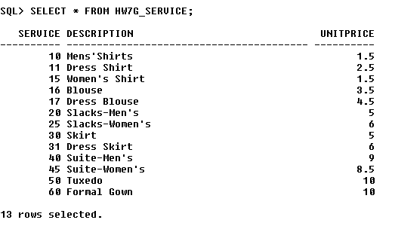
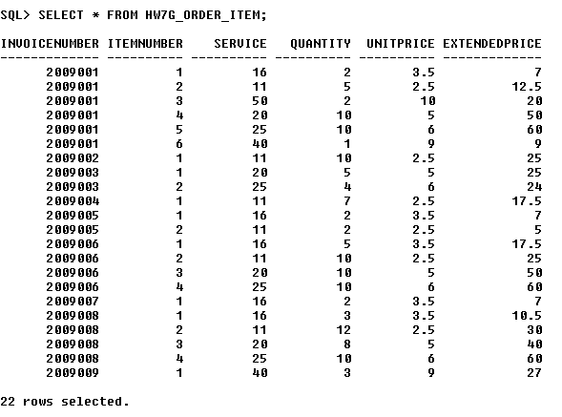

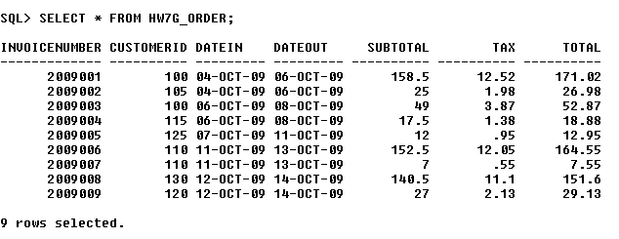
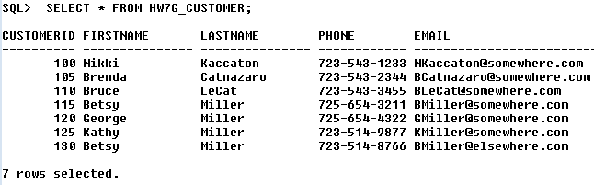
G. Write an UPDATE statement to change values of HW7G_SERVICE.Description from Mens Suit to Mens' Suits. Show a screen shot of running your statement.
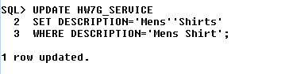
H. Write a single DELETE statement to delete a SALES_ORDER and all of the items on that SALES_ORDER. Note that we have set ON DELETE CASCADE between SALES_ORDER and ORDER_ITEM. Therefore, if we DELETE a record in SALES_ORDER, all associated records in ORDER_ITEM will also be deleted. This means we just use a simple DELETE statement on SALES_ORDER.

Pick Invoice number 2016010 as the one to delete. Insert it first, as shown below, and test by displaying periodically, also as shown below. Include screen shots of the results, as indicated:

INSERT INTO HW7G_ORDER
(InvoiceNumber, CustomerID, DateIn)
VALUES(2016010, 120, '15-Oct-16');
INSERT INTO HW7G_ORDER_ITEM
(InvoiceNumber, ItemNumber, Service, Quantity, UnitPrice)
VALUES (2016010, 1, 16, 3, 3.50);
INSERT INTO HW7G_ORDER_ITEM
(InvoiceNumber, ItemNumber, Service, Quantity, UnitPrice)
VALUES (2016010, 2, 11, 12, 2.50);

SELECT *
FROM HW7G_ORDER_ITEM;

<Include a screen shot here, showing the above sequence and results>
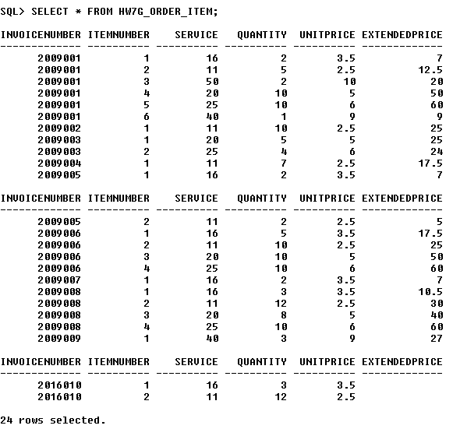
Now run your DELETE statement as specified in part H and then run the following:

SELECT *
FROM HW7G_ORDER_ITEM;

<Include another screen shot here, showing the results of your DELETE and the SELECT after it.>
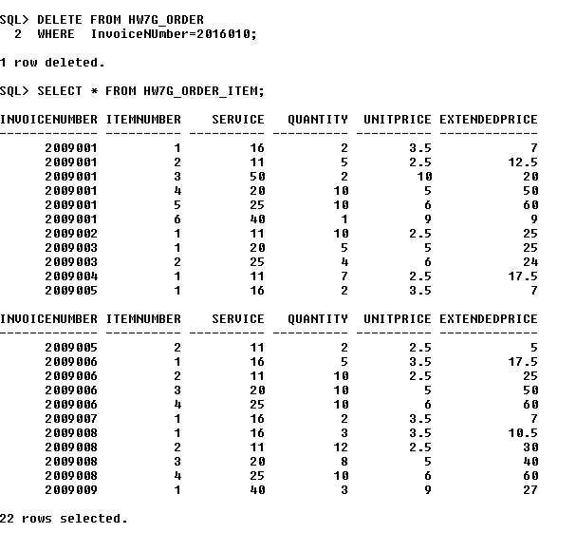

I. Create a view named HW7G_OrderSummaryView that contains InvoiceNumber and DateIn from HW7G_ORDER as well as ItemNumber, Service, and ExtendedPrice from HW7G_ORDER_ITEM. Show a screen shot of your creation step and, to test the view, also show a screen shot of running the following command -- you can include both on the same screen shot:

SELECT *
FROM HW7G_OrderSummaryView;
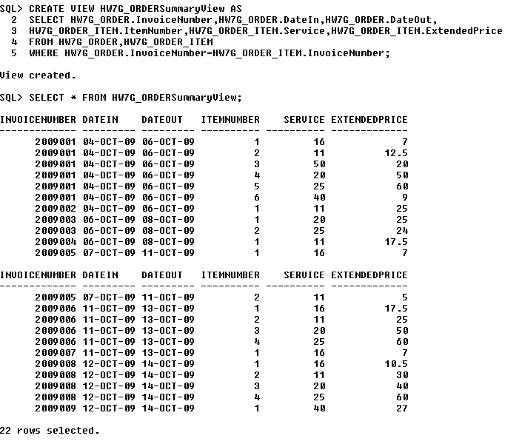

J. Create a view named HW7G_CustomerOrderSummaryView that contains HW7G_ORDER.InvoiceNumber, then FirstName, LastName, and Phone from HW7G_CUSTOMER, then DateIn, DateOut, and SubTotal from HW7G_ORDER, and, finally, ItemNumber, Service, and Extended Price from HW7G_ORDER_ITEM. Show a screen shot of your creation step and, to test the view, also show a screen shot of running the following command -- again, a single screen shot is OK:

SELECT *
FROM HW7G_CustomerOrderSummaryView
WHERE ROWNUM < 6
/* Oracle way to get first 5 records */
;

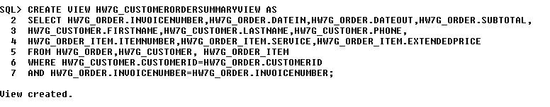
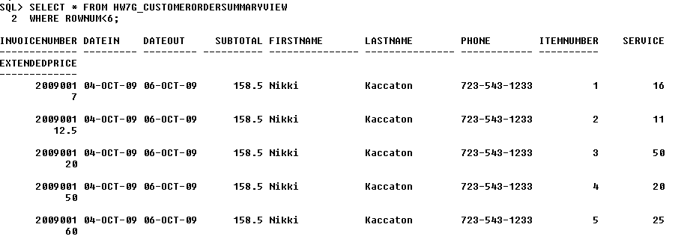

K. Create a view named HW7G_CustomerOrderHistoryView that includes all the columns of HW7G_CustomerOrderSummaryView except Phone, DateIn, ItemNumber and Service; and that sums and averages ExtendedPrice for each customer. Use the keyword "AS" to rename the ExtendedPrice column in this view to EP, and use the names TotEP and AvgEP for the sum and average.

Hint: To mix column selections with functions operating on the columns, you need to create groups (a GROUP BY clause) -- your group might include all the columns.

Show a screen shot of your creation step and, to test the view, also show a screen shot that displays the table generated by the view -- again, a single screen shot is OK:
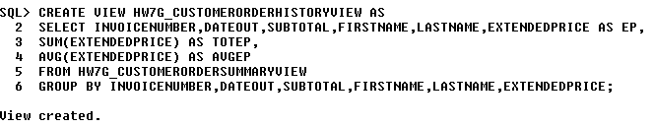
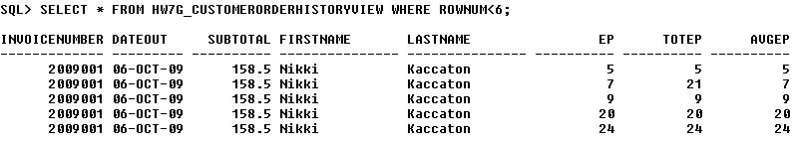
L. Create a view named HW7G_CustomerOrderCheckView that uses HW7G_CustomerOrderHistoryView, except that the column order is switched to put LastName, FirstName, and InvoiceNumber at the front, followed by Subtotal and the sum of ExtendedPrice, and that the view will show any customers for whom the sum of HW7G_ORDER_ITEM.ExtendedPrice is not equal to HW7G_ORDER.Subtotal. Show a screen shot of your creation step and, to test the view, also show a screen shot of running the following command -- again, a single screen shot is OK:

SELECT *
FROM HW7G_CustomerOrderCheckView
ORDER BY LastName, FirstName, InvoiceNumber;
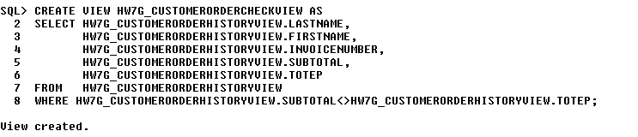
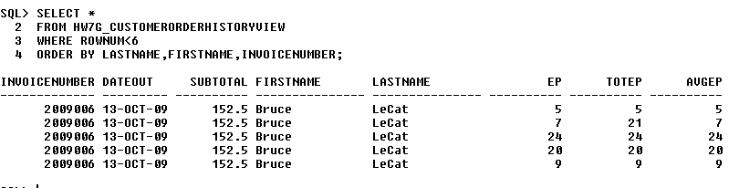

[Note: For the customers who had only one item in their order, the sum of ORDER_ITEM.ExtendedPrice will equal ORDER.Subtotal. Everyone else should show up here.]

M. Explain, in general terms, how you will use triggers to enforce minimum cardinality actions as required by your design. You need not write the triggers now, just specify which triggers you need and describe, in general terms, their logic.

We will need an INSTEAD OF INSERT trigger on ORDER to ensure that a CUSTOMER record exists for ORDER. The logic of this trigger is that it will ask for a customer FirstName and LastName and check for a CustomerID to insert into ORDER. If none exists, the application will prompt for new CUSTOMER data, insert a new record in CUSTOMER and then use the new CustomerID in ORDER.
In Oracle, we will have to write an AFTER UPDATE trigger on SERVICE to implement an equivalent of an ON UPDATE CASCADE referential integrity constraint. This is necessary in case we change the primary key SERVICE.Service. We will take the old and new values of Service, check for the old value in every record of ORDER_ITEM and update the necessary records.

