Print Name: ___WU,HAO__________________
(last, first)
Individual Homework [100 pts]
I certify that I have done this work individually. I have not talked with any current or former students about the problems or reviewed answers with anyone. I have not looked at former students’ work on these or similar problems (sometimes called “files”). I have not used online sources that provide answers to specific questions. Any online sources that provided general tutorial information have been cited.

Signature: ___________________________

Note: This assignment can become very large, due to the screen shots. Use trimming and compression to keep it at a manageable size.

Consider the following relations:
HW7I_EMPLOYEE( EmpNumber, LastName, FirstName, EAddress )
HW7I_PROJECT( ProjectName, Description, StartDate, EndDate )
HW7I_ASSIGNMENT( EmpNumber, ProjectName, TotalHoursWorked )

Assume that the relationships from HW7I_EMPLOYEE to HW7I_ASSIGNMENT and from HW7I_PROJECT to HW7I_ASSIGNMENT are 1:N, M-O.
Referential Integrity Actions: Cascade deletions from HW7I-PROJECT to HW7I-ASSIGNMENT.
Some of the characteristics are given in the following tables:

HW7I_EMPLOYEE
Column Name | Type | Required | Notes
EmpNumber | Integer | Yes | PK
LastName | Varchar(20) | Yes | AK1.1
FirstName | Varchar(15) | Yes | AK1.2
EAddress | Varchar(25) | No

HW7I_PROJECT
Column Name | Type | Required | Notes
ProjectName | Varchar(20) | Yes | PK
Description | Varchar(40) | No
StartDate | Date | No
EndDate | Date | No

HW7I_ASSIGNMENT
Column Name | Type | Required | Notes
EmpNumber | Integer | Yes | PK1.1, FK
ProjectName | Varchar(20) | Yes | PK1.2, FK
TotalHoursWorked | Number(5,2) | No | Default 3.5

1. Write a SQL*Plus CREATE TABLE statement for the HW7I_EMPLOYEE relation. Run your statement and include a screen shot of your run.
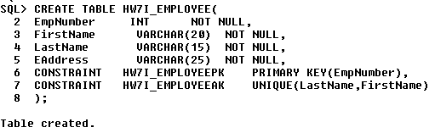

2. Run the following SQL statement and provide a screen shot of the result:
DESCRIBE HW7I_EMPLOYEE;
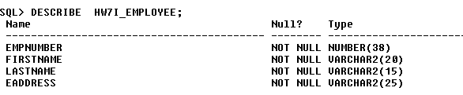

3. Write a SQL*Plus CREATE TABLE statement for the HW7I_PROJECT relation. Run your statement and include a screen shot of your run.
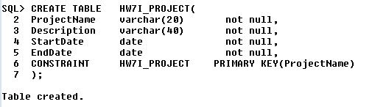
4. Run the following SQL statement and provide a screen shot of the result:
DESCRIBE HW7I_PROJECT;
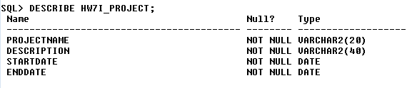

5. Write a SQL*Plus CREATE TABLE statement for the HW7I_ASSIGNMENT relation. Run your statement and include a screen shot of your run. Do NOT include the default value for TotalHoursWorked in your creation SQL (instead, see #6).
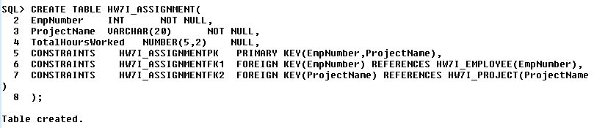
6. After creation of HW7I_ASSIGNMENT, use the ALTER TABLE statement to set the default value for TotalHoursWorked. Include a screen shot of your execution of this statement.
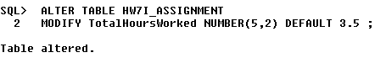
7. Run the following SQL statement and provide a screen shot of the result:
DESCRIBE HW7I_ASSIGNMENT;
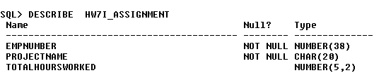
8. Create a relation named HW7I_PROJECT2 that is a revised version of HW7I_PROJECT. In this revised relation, include the constraint that StartDate be prior to EndDate. Also, constrain ProjectNames to the values 'Red', 'Blue', or 'Green'. Run your create statement for this revised table and include a screen shot of your run.
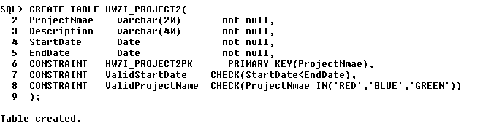
9. Run the following SQL statement and provide a screen shot of the result:
DESCRIBE HW7I_PROJECT2;
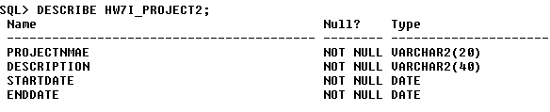
10. Create a relation named HW7I_ASSIGNMENT2 that is like HW7I_ASSIGNMENT, but makes the relationship between HW7I_EMPLOYEE and HW7I_ASSIGNMENT2 a 1:1 relationship. Put the default value for TotalHoursWorked into the create statement. Run your create statement for this revised table and include a screen shot of your run.
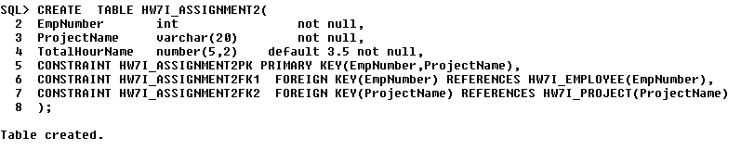
11. Create a copy of the HW7I_EMPLOYEE table and name it HW7I_EMPLOYEE2. Use SQL CREATE TABLE statements from your creation of the HW7I_EMPLOYEE table, modified to use the name HW7I_EMPLOYEE2 (be sure to change the names of the constraints to reflect EMPLOYEE2 as well, since we'll refer to them later). Run your create statement for this revised table and include a screen shot of your run.
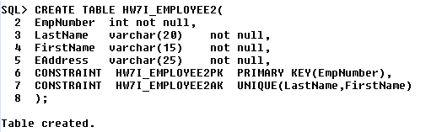
12. Write a SQL*Plus ALTER statement to add the column Phone to HW7I_EMPLOYEE2. Assume that Phone is not required and that we can treat Phone as 12 characters. Run your ALTER statement and include a screen shot of your run.
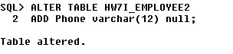
13. Write a SQL*Plus ALTER statement to remove the column EAddress from HW7I_EMPLOYEE2. Run your statement and include a screen shot of your run.
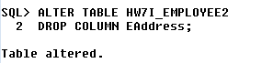
14. Write a SQL*Plus ALTER statement to make Phone an alternate key in HW7I_EMPLOYEE2. Run your statement and include a screen shot of your run.
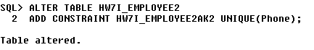
15. Write a SQL*Plus ALTER statement to drop the constraint that Names be unique in HW7I_EMPLOYEE2. Run your statement and include a screen shot of your run.
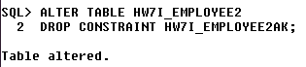

*** From here on, we will use the HW7I_EMPLOYEE and HW7I_ASSIGNMENT relations, with their original formats. ***

16. Write a SQL*Plus INSERT statement to add the row (12345, 'Jones', 'James', 'Jones@MyCorp.com') to HW7I_EMPLOYEE. Run your statement and include a screen shot of your run.
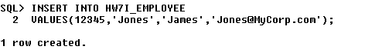
17. Run the following SQL statement and provide a screen shot of the result:
SELECT *
FROM HW7I_EMPLOYEE;
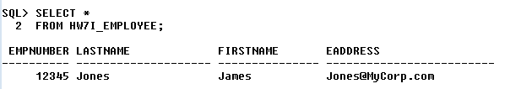
18. Write a SQL*Plus UPDATE statement to change the LastName of the employee named 'Jones' to 'Smith'. Run your statement and include a screen shot of your run.
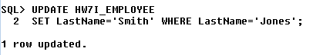
19. Run the following SQL statement and provide a screen shot of the result:
SELECT *
FROM HW7I_EMPLOYEE;
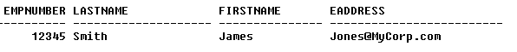
20. Write one SQL*Plus DELETE statement that would delete all data for project 'BLUE' and all of its rows in HW7I_ASSIGNMENT. Show your statement, but you do not need to run this statement. [Hint: Think about the parent of HW7I_ASSIGNMENT and the referential integrity actions on the relationship.]

DELETE FROM HW7I_ ASSIGNMENT
WHERE ProjectName=’BLUE’;

21. Write and show a SQL*Plus DELETE statement that would delete the row for the employee named 'Smith' from HW7I_EMPLOYEE. You do not need to run this statement. What happens if this employee has rows in HW7I_ASSIGNMENT

DELETE FROM HW7I_EMPLOYEE
WHERE LastName=’Smith’;

22. Write and show a SQL*Plus statement to join HW7I_EMPLOYEE, HW7I_ASSIGNMENT, and HW7I_PROJECT, using the JOIN ON syntax. You do not need to run this statement.

SLECT *
FROM HW7I_EMPLOYEE JOIN HW7I_ASSIGNMENT
ON HW7I_EMPLOYEE.EmpNumber=HW7I_ASSIGNMNET.EmpNumber
JOIN HW7I_PROJECT
ON HW7I_ASSIGNMENT.ProjectName=HW7I_PROJECT.ProjectName;

23. What is a SQL view? What purposes do views serve?
In SQL, a view is a virtual table based on the result-set of an SQL statement.
A view contains rows and columns, just like a real table. The fields in a view are fields from one or more real tables in the database.You can add SQL functions, WHERE, and JOIN statements to a view and present the data as if the data were coming from one single table.

24. What is the limitation on SELECT statements used in SQL views in the SQL-92 standard and how does Oracle differ?

In the SQL-92 standard, the only limitation on the SQL statements that are used to create views was that they could not contain an ORDER BY clause, which on the other hand could be used in the Oracle.

25. Use SQL*Plus to create the View Ridge Gallery database. Some SQL to help with this is available on Canvas.

In order to avoid problems with large cut and paste operations, you may need to do the insert operations on the VRG_WORK table in two pieces -- perhaps down to the two works titled "Farmer's Market #2" in a first set and the rest in a second set. Similarly, you may want to do the insert operations into the VRG_TRANS table in three operations, perhaps down to the first time WorkID 510 shows up in the first operation, then from the next Work down to the first time WorkID 520 shows up in the second operation, and then the remaining Works in a third cut-and-paste operation.
Once you have created the database, set Linesize to 120 and Pagesize to 50 and then give screen shots as described below (include the SQL statement as well as the result of the statement):

- A display of the first 5 rows of the VRG_CUSTOMER table.
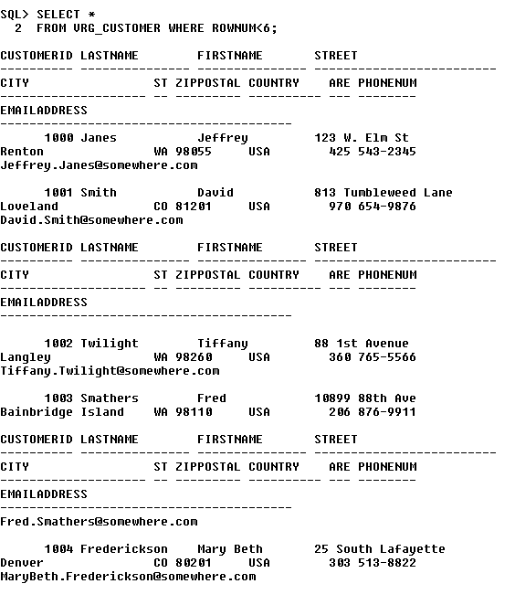

- A display of the VRG_ARTIST table.
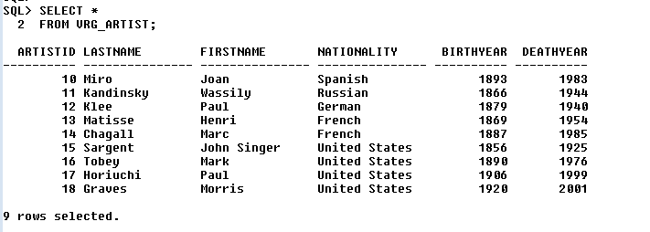

- A display of the VRG_CUSTOMER_ARTIST_INT table.
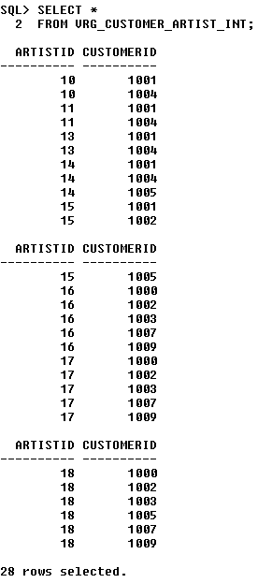
- A display of WorkID, Title, and ArtistID for all entries in the VRG_WORK table that have a copy description of "Unique."
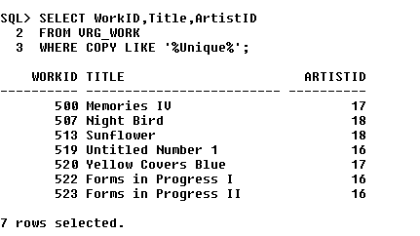

e) A display of the VRG_TRANS table.(35 rows)
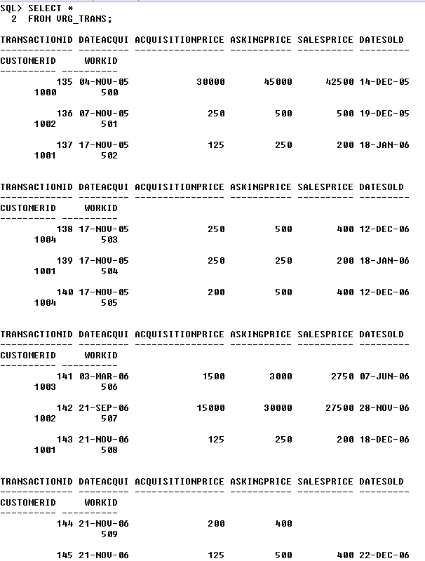
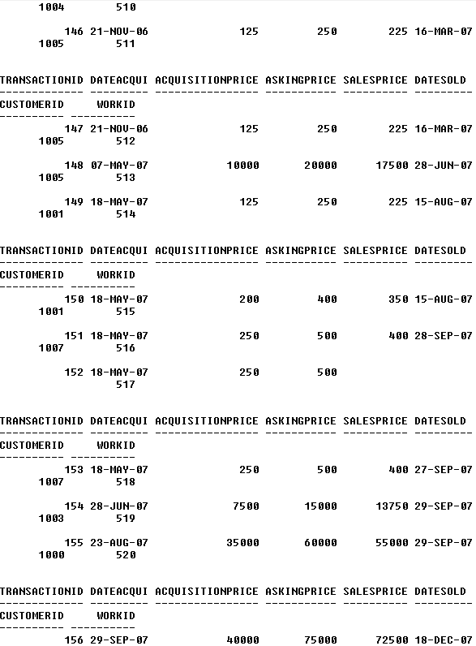

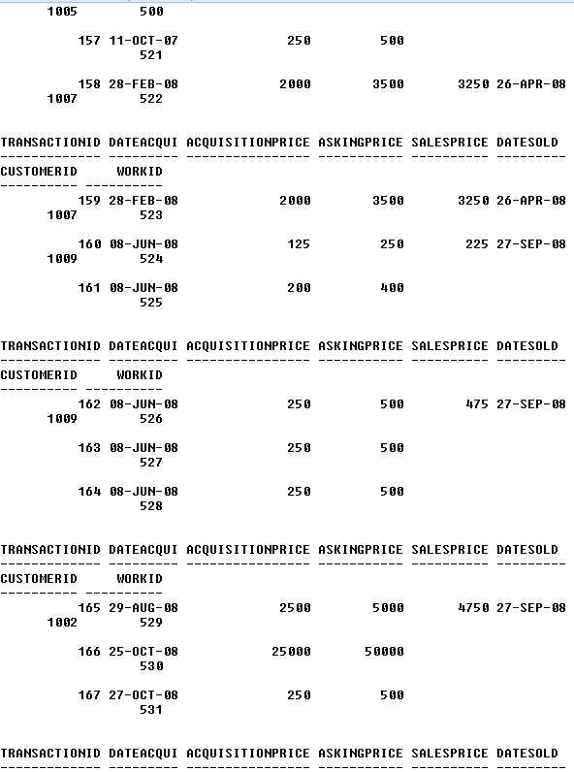
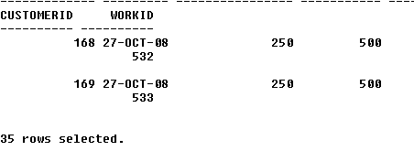
26. Write and run a SQL*Plus statement to create a view named CustomerStateView that shows the values of VRG_CUSTOMER.State. Include a screen shot of the results of your creation run of the view.
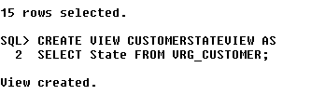

27. Run the following SQL statement and provide a screen shot of the result:
SELECT *
FROM CustomerStateView;
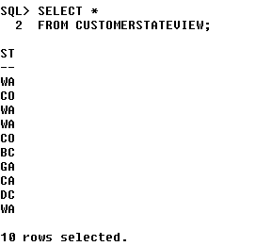
28. Write and run a SQL*Plus statement to create a view named CustomerInfo_CO_View that shows LastName, FirstName, City, and State from VRG_CUSTOMER for customers in Colorado. Include a screen shot showing the results of running your statement to create the view.
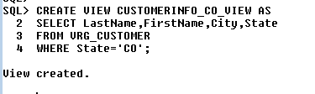
29. Write and run a SQL*Plus statement to create a view named ArtistWorkDescView that shows VRG_ARTIST.LastName, VRG_ARTIST.FirstName, VRG_ARTIST.Nationality, VRG_WORK.Title, and VRG_WORK.Description. Include a screen shot showing the results of running your creation statement.
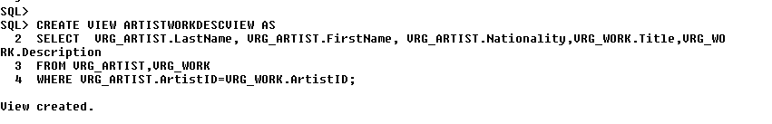
30. Describe how views are used to provide an alias for tables. Why is this useful?
Since any applications written against the view would use the view name, we can change the name of (1) any the underlying tables together with (2) the names of these tables in the view definition without effecting any application. For example, if ProductPriceView currently uses the table PRICE and we later need to use a new table PRICE_2, we can simply change table name in the definition of ProductPriceView. Any and all applications written against the view stay exactly the same.

31. Explain how views can be used to improve data security.
Sometimes views are constructed to give different sets of processing permissions to the same table. Two views could be defined for a table, one with read only permission and one with read and update permission.

32. What is a trigger?
A trigger is a special type of stored procedure that automatically executes when an event occurs in the database server. DML triggers execute when a user tries to modify data through a data manipulation language (DML) event. DML events are INSERT, UPDATE, or DELETE statements on a table or view.

33.What is the relationship between a trigger and a table or view?
A trigger is a specific program that is kept inside a DBMS. It waits for a specific event to take place and as it takes place, the trigger program is executed. A trigger is associated with only one table or view and not more than that. The trigger program is executed when it notics any update made to the table the trigger is asscosiated with.

34. What is a stored procedure? How do stored procedures differ from triggers?
A stored procedure is a user defined piece of code written in the local version of PL/SQL, which may return a value (making it a function) that is invoked by calling it explicitly.A trigger is a stored procedure that runs automatically when various events happen (eg update, insert, delete).
Some differences between triggers and procedures: We can execute a stored procedure whenever we want with the help of the exec command, but a trigger can only be executed whenever an event (insert, delete, and update) is fired on the table on which the trigger is defined

