[94 pts., plus up to 30 Bonus pts. max]
Print Name(s): __WU,HAO WEI,XINPENG_________________________
(last, first)
Group Project Homework
We certify that we have done this work totally within our group. We have not talked with any current or former students outside our group about the problems or reviewed answers with anyone outside our group. We have not looked at former students’ work on these or similar problems (sometimes called “files”). We have not used online sources that provide answers to specific questions. Any online sources that provided general tutorial information have been cited.

Signature(s): _________________________________________________

1. Describe the process of changing a table name -- 5 steps.

- First, create the new table with all attendant structures with new name
- Alter the constraint, triggers and views that could be affected
- Copy and move all data from old table to new table
- Create a new foreign key constraints
- Drop old table

2. Explain how to transform a 1:N relationship into an N:M relationship -- 3 steps.

- Create the new intersection table with appropriate foreign key constraints;
- fill it with data;
- drop the old foreign key column.

3. Suppose that you finished the design of a database for Marcia's Dry Cleaning as in HW7 and you have the following tables, with a prefix of HW7G_ for each name:
CUSTOMER (CustomerID, FirstName, LastName, Phone, Email)
ORDER (InvoiceNumber, CustomerID, DateIn, DateOut, Subtotal, Tax, TotalAmount)
ORDER_ITEM (InvoiceNumber, ItemNumber, Service, Quantity, UnitPrice, ExtendedPrice)
SERVICE (Service, Description, UnitPrice)

You probably want to refer back to your solutions from Chapter 7, especially to parts D and F.

Now work parts A through L as given below. You can choose to not run those that involve SQL (but you still must write them).

However, up to an extra 30 Group Homework points will be given if you do run them successfully, using correct names, and include screen shots of the results of your runs. Remember to use the picture editor and to compress as in Homework 2.

Parts A to L:

A. Create a dependency graph that shows dependencies among these tables. Then, explain how you need to extend this graph for views and other database constructs such as triggers and stored procedures. Use the table names as given above for this chart (without the HW7G prefix at this point, even though you will use different names later and you used different view names in HW7G.:
CUSTOMER, ORDER, ORDER_ITEM, SERVICE

CUSTOMER
ORDER
ORDER_ITEM

SERVICE

B. Now, we will switch briefly to using the names we used in HW7G. Describe the tasks necessary to change the name of the HW7G_ORDER table to HW8G_ORDER. Assume that the other names of HW7G tables remain for now as they were (HW7G_CUSTOMER, HW7G_ORDER_ITEM, and HW7G_SERVICE). [Hint: Note problem 1, above, which you are specializing to this particular problem.]

C. Write SQL statements to make the name change described in part B -- identify each step as you show the SQL for it. When you are finished, you will have changed a constraint name in HW7G_ORDER_ITEM and replaced HW7G_ORDER with HW8G_ORDER, so you will be operating with:
HW7G_CUSTOMER
HW8G_ORDER
HW7G_ORDER_ITEM (modified)
HW7G_SERVICE

SQL statements:
CREATE TABLE HW8G_ORDER(
InvoiceNumber int not null,
CustomerID int not null,
DateIn date not null,
DateOut date not null,
Subtotal number(8,2) null,
Tax number(8,2) null,
Total number(8,2) null,
CONSTRAINT HW8G_ORDER_PK PRIMARY KEY (InvoiceNumber),
CONSTRAINT HW7G_CUSTOMER_FK FOREIGN KEY (CustomerID)
REFERENCES HW7G_CUSTOMER(CustomerID));

INSERT INTO HW8G_ORDER(InvoiceNumber, CustomerID, DateIn, DateOut, Subtotal, Tax, Total)
SELECT InvoiceNumber, CustomerID, DateIn, DateOut, Subtotal, Tax, Total
FROM HW7G_ORDER

ALTER TABLE HW7G_ORDER_ITEM
DROP CONSTRIANT HW7G_ORDER_ITEMFK1;

ALTER TABLE HW7G_ORDER_ITEM
ADD CONSTRIANT HW7G_ORDER_ITEMFK1 FOREIGN KEY(InvoiceNumber)
REFERENCES HW8G_ORDER ON DELETE CASCADE

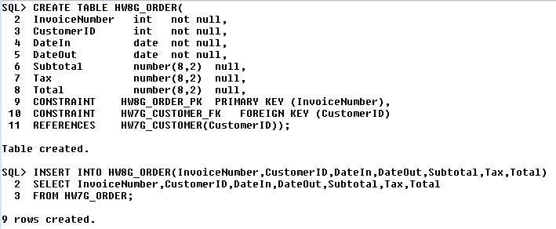
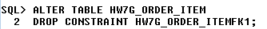
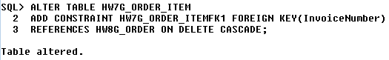
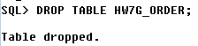

D. Take your SQL statements that created HW7G_CUSTOMER and HW7G_SERVICE and modify them to create the same tables, only named HW8G_CUSTOMER and HW8G_SERVICE. Note that, in addition to the name changes for the tables themselves, you will have to modify the names of the constraints in these tables to include the HW8G_ prefix. Show the modified SQL create statements.

SQL statements:
CREATE TABLE HW8G_CUSTOMER(
CustomerID INT NOT NULL,
FirstName VARCHAR(15) NOT NULL,
LastName VARCHAR(15) NOT NULL,
Phone CHAR(12) NOT NULL,
Email VARCHAR(30) NOT NULL,
CONSTRAINT HW8G_CUSTOMERPK PRIMARY KEY(CustomerID)
);

CREATE TABLE HW8G_SERVICE(
Service INT NOT NULL,
Description VARCHAR(40) NOT NULL,
UnitPrice NUMBER(8,2) NULL,
CONSTRAINT HW8G_SERVICEPK PRIMARY KEY(Service),
CONSTRAINT UnitPriceRange1 CHECK
((UnitPrice>=1.5) AND (UnitPrice<=10))
);

);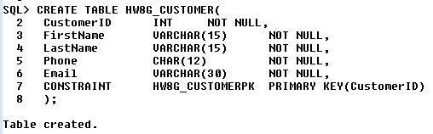
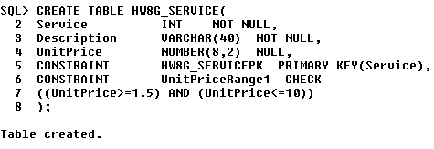

E. Show the SQL to copy all the data from HW7G_CUSTOMER to HW8G_CUSTOMER and from HW7G_SERVICE to HW8G_SERVICE.
SQL statements:
INSERT INTO HW8G_CUSTOMER(CustomerID,FirstName,LastName,Phone,Email)
SELECT CustomerID,FirstName,LasrName,Phone,Email
FROM HW7G_CUSTOMER;
INSERT INTO HW8G_SERVICE(Service,Description,UnitPrice)
SELECT Service,Description,UnitPrice
FROM HW7G_SERVICE;

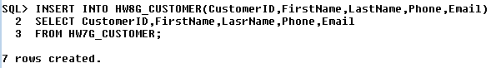
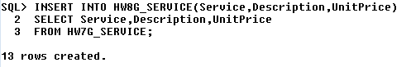

F. Show the SQL to ALTER table HW8G_ORDER (as created in part C) to drop any constraints referencing HW7G_CUSTOMER or HW7G_SERVICE and to add equivalent constraints referencing HW8G_CUSTOMER and/or HW8G_SERVICE. After this point, you will be operating with tables HW8G_CUSTOMER, HW8G_ORDER, HW8G_SERVICE, and HW7G_ORDER_ITEM (as modified in part C).

SQL statements:
ALTER TABLE HW8G_ORDER
DROP CONSTRAINT HW7G_CUSTOMER_FK;

ALTER TABLE HW8G_ORDER
ADD CONSTRAINT HW8G_CUSTOMER_FK FOREIGN KEY(CustoemrID)
REFERENCES HW8G_CUSTOMER(CustomerID);

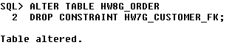
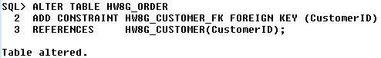

G. Now, finally, let's change from HW7G_ORDER_ITEM to HW8G_ORDER_ITEM. The first step would be to create HW8G_ORDER_ITEM (using modifications of the SQL you used to create HW7G_ORDER_ITEM). The constraints can now reference the HW8G_ tables, since they all exist. A second step would be to copy the data. Show the SQL for both of these steps.
SQL statements:
CREATE TABLE HW8G_ORDER_ITEM(
InvoiceNumber INT NOT NULL,
ItemNumber INT NOT NULL,
Service INT NOT NULL,
Quantity INT DEFAULT 1 NOT NULL,
UnitPrice NUMBER(8,2) NULL,
ExtendedPrice NUMBER(8,2) NULL,
CONSTRAINT HW8G_ORDER_ITEMPK PRIMARY KEY(InvoiceNumber,ItemNumber),
CONSTRAINT HW8G_ORDER_ITEMFK1 FOREIGN KEY(InvoiceNumber)
REFERENCES HW8G_ORDER(InvoiceNumber) ON DELETE CASCADE,
CONSTRAINT HW8G_ORDER_ITEMFK2 FOREIGN KEY(Service)
REFERENCES HW8G_SERVICE(Service) ON DELETE CASCADE
);

INSERT INTO HW8G_ORDER_ITEM(InvoiceNumber,ItemNumber,Service,Quantity,
UnitPrice,ExtendedPrice)
SELECT InvoiceNumber,ItemNumber,Service,Quantity,UnitPrice,ExtendedPrice
FROM HW7G_ORDER_ITEM;

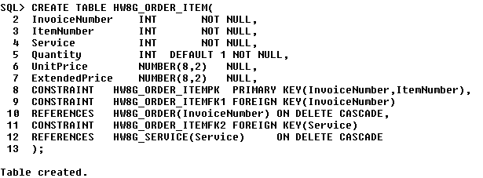
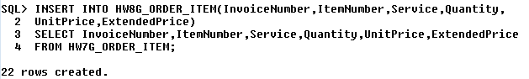

H. We are now operating with tables with HW8G_ prefixes. So now suppose that Marcia decides to allow multiple customers per order (for customers' spouses, for example). Describe the steps to modify the design of these tables (3 steps, specialized to this situation). Assume that the name changes through part G have been made. If you plan to create any new tables, be sure to give them the HW8G_ prefix. [Hint: Note problem 2, above, which you are specializing to this particular requirement.]

- Create an intersection table that will have CustomerID and InvoiceNumber.
- Insert data into the intersection table using data from HW8G_ORDER.
- Drop foreign key constraint in HW8G_ORDER and drop CustomerID column from HW8G_ORDER.

- Write SQL statements to redesign the database, as described in your answer to part H -- identify each step as you show the SQL for it.

SQL statements:
CREATE TABLE HW8G_CUST_ORDER_INT(
CustomerID INT NOT NULL,
InvoiceNumber INT NOT NULL,
CONSTRAINT HW8G_CUST_ORDER_INTPK PRIMARY KEY(CustomerID,InvoiceNumber),
CONSTRAINT HW8G_CUST_ORDER_INTFK1 FOREIGN KEY(CustomerID)
REFERENCES HW8G_CUSTOMER(CustomerID),
CONSTRAINT HW8G_CUST_ORDER_INTFK2 FOREIGN KEY(InvoiceNumber)
REFERENCES HW8G_ORDER(InvoiceNumber)
);

INSERT INTO HW8G_CUST_ORDER_INT(CustomerID,InvoiceNumber)
SELECT CustomerID,InvoiceNumber
FROM HW8G_ORDER;

ALTER TABLE HW8G_ORDER
DROP CONSTRAINT HW8G_CUSTOMER_FK;

ALTER TABLE HW8G_ORDER
DROP COLUMN CustomerID;
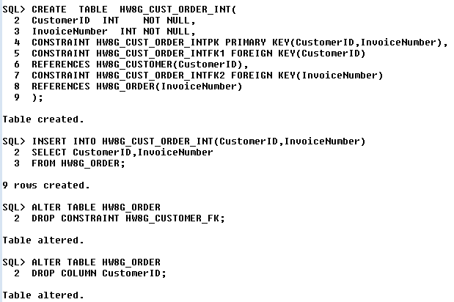
J. Suppose that Marcia considers changing the primary key of HW8G_CUSTOMER to (FirstName, LastName). Write correlated subqueries to display any data that indicate that this change is not justifiable.

SQL statements:
SELECT C1.FirstName,C1.LastName
FROM HW8G_CUSTOMER C1
WHERE C1.FirstName IN
(SELECT C2.FirstName
FROM HW8G_CUSTOMER C2
WHERE C1.FirstName=C2.FirstName
AND C1.CustomerID<>C2.CustomerID)
AND C1.LastName IN
(SELECT C2.LastName
FROM HW8G_CUSTOMER C2
WHERE C1.LastName=C2.LastName
AND C1.CustomerID<>C2.CustomerID);
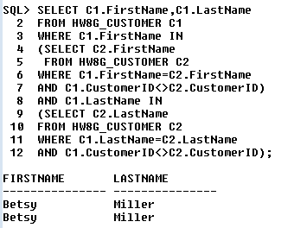

K. Suppose that (FirstName, LastName) can be made the primary key of HW8G_CUSTOMER. If you found in part J that this won't work, then first make simple changes to the data (e.g., changing a first name -- describe the changes and the SQL to carry them out -- and run the SQL, if you are creating screen shots) that would enable it to work -- your changes should not delete any data. Assume all previous changes (through I) have already been made. Describe the appropriate changes to the overall table design with (FirstName, LastName) as a new primary key, following this outline:

First, any changes to the database to make (FirstName, LastName) work.

Firstly, we should add the columns FirstName and LastName as NULL to HW8G_CUST_ORDER_INT and insert the data from HW8G_CUSTOEMR. Furtherly set the FirstName and LastName NOT NULL.
Secondly, drop the primary key and define a new table (FirstName,LastName,InvoiceNumber). Drop the foreign key HW8G_CUST_ORDER_INTFK1 from the table HW8G_CUST_ORDER_INT. Then add foreign key HW8G_CUST_ORDER_INTFK1 with FirstName,LastName
Thirdly, drop primary key HW8G_CUSTOMERPK from HW8G_CUSTOMER and define a new primary key LastName,FirstName as the primary key in HW8G_CUSTOMER. Finally, drop the column CustomerID .

Then state the existing Data Structures (after part I):
[Hint: HW8G_CUSTOMER (CustomerID, FirstName, LastName, Phone, Email)
is the first one.]
HW8G_CUSTOMER(CustomerID, FirstName,LastName, Phone,Email)
HW8G_ORDER(InvoiceNumber, DateIn,DateOut,Subtotal,Tax,Total)
HW8G_Service(Service,Description,UnitPrice)
HW8G_Order_ITEM(InvoiceNumber,ItemNumber.Service,Quantity,UnitPrice,ExtendedPrice)
HW8G_CUST_ORDER_INT(CustomerID,InvoiceNumber)

Next, without moving the locations of existing columns in the schema (table design), but perhaps adding, deleting, or replacing columns, if we make (FirstName, LastName) the primary key of HW8G_CUSTOMER, state the revised Data Structures:
[Hint: HW8G_CUSTOMER (FirstName, LastName, Phone, Email) is the first one.]
HW8G_CUSTOMER(FirstName,LastName, Phone,Email)
HW8G_ORDER(InvoiceNumber, DateIn,DateOut,Subtotal,Tax,Total)
HW8G_Service(Service,Description,UnitPrice)
HW8G_Order_ITEM(InvoiceNumber,ItemNumber.Service,Quantity,UnitPrice,ExtendedPrice)
HW8G_CUST_ORDER_INT(FirstName,LastName,InvoiceNumber)

L. Write SQL statements to implement the changes of part K. This should involve 7 or 8 steps -- you should state each step before giving the SQL for it (the 8th step would remove CustomerID from HW8G_CUSTOMER and from HW8G_CUSTOMER_ORDER_INT and is optional). Note that you'll need to add columns that are initially NULL, then fill them by getting them from other tables, then change them to NOT NULL. Recall that Oracle uses MODIFY rather than ALTER COLUMN to change from NULL to NOT NULL.

SQL statements:
ALTER TABLE HW8G_CUST_ORDER_INT
ADD FirstName VARCHAR(15) NULL,

ALTER TABLE HW8G_CUST_ORDER_INT
ADD FirstName VARCHAR(15) NULL;

UPDATE HW8G_CUST_ORDER_INT
SET FirstName =
(SELECT FirstName FROM HW8G_CUSTOMER W
WHERE W.CustomerID=HW8G_CUST_ORDER_INT.CustomerID);

UPDATE HW8G_CUST_ORDER_INT
SET LastName =
(SELECT LastName FROM HW8G_CUSTOMER W
WHERE W.CustomerID=HW8G_CUST_ORDER_INT.CustomerID);

ALTER TABLE HW8G_CUST_ORDER_INT
MODIFY FirstName VARCHAR(15) NOT NULL;

ALTER TABLE HW8G_CUST_ORDER_INT
MODIFY LastName VARCHAR(15) NOT NULL;

ALTER TABLE HW8G_CUST_ORDER_INT
DROP CONSTRAINT HW8G_CUST_ORDER_INTPK;

ALTER TABLE HW8G_CUST_ORDER_INT
ADD CONSTRAINT HW8G_CUST_ORDER_INTPK PRIMARY KEY(FirstName,LastName,InvoiceNumber);

ALTER TABLE HW8G_CUST_ORDER_INT
DROP CONSTRAINT HW8G_CUST_ORDER_INTFK1;

ALTER TABLE HW8G_CUST_ORDER_INT
DROP COLUMN CustomerID;

ALTER TABLE HW8G_CUSTOMER
DROP CONSTRAINT HW8G_CUSTOMERPK;

ALTER TABLE HW8G_CUSTOMER
DROP COLUMN CustomerID;

ALTER TABLE HW8G_CUSTOMER
ADD CONSTRAINT HW8G_CUSTOMERPK PRIMARY KEY(FirstName,LastName);

