Print Name: _____WU, HAO__________________
(last, first)
Individual Homework
I certify that I have done this work individually. I have not talked with any current or former students about the problems or reviewed answers with anyone. I have not looked at former students’ work on these or similar problems (sometimes called “files”). I have not used online sources that provide answers to specific questions. Any online sources that provided general tutorial information have been cited.

Signature: ___________________________

Some SQL files are available on Blackboard for use with this assignment. You are
not required to use them, but up to 10 Bonus Points can be earned if you use the given
SQL files to create and run your solution statements. Use the naming conventions of
Handout 11.

1. Suppose that a table named HW8I_ADVISOR contains two non-key columns: AdvisorName and AdvisorPhone. Further, suppose that you suspect that
AdvisorPhone →AdvisorName. Explain how to visually examine the data to
determine if this supposition is true.

In order to visually check the relationship between AdvisorPhone and AdvisorName, we can see if one AdvisorPhone only related to one AdvisorName.

2. Write a correlated subquery to determine whether the data support the supposition in question 1. You do not have to run this with SQL*Plus, but may use the given files to do so if you wish (and earn a Bonus Point).

Select A1.AdvisorName, A1.AdvisorPhone
From HW8I_ADVISOR A1
WHERE A1.AdvisorPhone IN
(SELECT A2.AdvisorPhone
FROM HW8I_ADVISOR A2
WHERE A1.AdvisorPhone = A2.AdvisorName
AND A1.AdvisorName<>A2.AdvisorName);
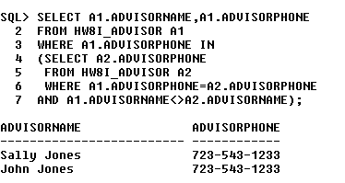
3. Explain (and list) the dependencies for WORK in the graph in Figure 8-3.
[Hint: Look at what WORK is dependent upon and then at what database constructs are dependent on WORK.]

The constraint that defines the relationship from WORK to TRANS;
The constraint that defines the relationship from WORK to ARTIST;
WORK contains the data which is used in the ArtistWorkNetView;
WORK shares the same trigger with TRANS_CheckSalesPrice;

4. Show a SQL statement to add an integer column C1 to the table HW8I_T2. Assume that C1 is NULL. You do not have to run this with SQL*Plus, but may use the given files to do so if you wish.

ALTER TABLE HW8I_T2
ADD C1 INTEGER NULL;
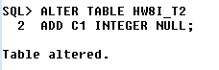

5. Show a SQL statement to drop the column C1 from table HW8I_T2, assuming that a table named HW8I_T2 exists and has a column named C1. You do not have to run this with SQL*Plus, but may use the given files to do so if you wish.

ALTER TABLE HW8I_T2
DROP COLUMN C1;
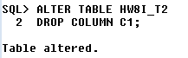
6. In general terms, what must be done to add a new relationship to existing tables?

First of all, we need to create a table, and then a primary key of one table should be added into another table.

7. Suppose that tables HW8I_T1 and HW8I_T2 have a 1:N relationship, with HW8I_T2 as the child. Show the SQL statements necessary to remove table HW8I_T1, but keep most of HW8I_T2. Assume we have used the conventions of HO 11 for the names of keys and foreign keys. You do not need to run this with SQL*Plus, but may use the given files to do so if you wish.

ALTER TABLE HW8I_T2
DROP CONSTRAINT HW8I_T2FK;
DROP TABLE HW8I_T1
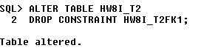
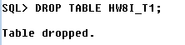
8. Consider the following table and functional dependencies:
TASK( EmployeeID, EmpLastName, EmpFirstName, Phone,
OfficeNumber, ProjectName, Sponsor, WorkDate, HoursWorked)
where
EmployeeID → (EmpLastName, EmpFirstName, Phone,
OfficeNumber)
ProjectName → Sponsor

Write SQL statements to display the values of any rows that violate the functional dependencies. You do not need to run these with SQL*Plus, but may use the given files to do so if you wish.

SELECT W1.EmployeeID, W1.EmpLastName, W1.EmpFirstName, W1.Phone, W1.OfficeNumber
FROM TASK AS W1
WHERE W1.EmployeeID IN
(SELECT W2.EmployeeID
FROM TASK AS W2
WHERE W1.EmployeeID = W2.EmployeeID
AND W1.EmpLastName <> W2. EmpLastName
AND W1.EmpFirstName <> W2. EmpFirstName
AND W1.Phone <> W2. Phone
AND W1.OfficeNumber <> W2.OfficeNumber);

SELECT W1.ProjectName, W1.Sponsor
FROM TASK AS W1
WHERE W1.ProjectName IN
(SELECT W2.ProjectName
FROM TASK AS W2
WHERE W1. ProjectName=W2. ProjectName
AND W1.Sponsor <> W2.Sponsor);

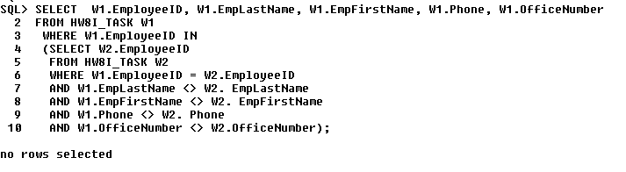
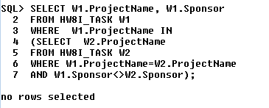

9. For the table and functional dependencies of #8, assume that the functional dependencies are true or that the data have been corrected, as necessary, to reflect them. Code all SQL statements necessary to redesign this table into a set of tables in BCNF and 4NF. Assume that the table does have data values that must be appropriately transformed to the new design.
[Hint: First, state the correct relation structures and referential integrity constraints. Then, write the SQL statements to create the set of tables. (Be sure to think about how to handle deletions of parent rows and reflect that in child constraints.) Finally, write the SQL statements to fill the tables, adding "HW8I_Q9_" as a prefix for the tables.

Table:
HW8I_EMPLOYEE(EmployeeID, EmpLastName, EmpFirstName, Phone, OfficeNumber);
HW8I_PROJECT(ProjectName,Sponsor);
HW8I_TASK(EmployeeID,ProjectName, WorkDate, HoursWorked);

Constraint:
HW8I_TASK.EmployeeID must exist in HW8I_EMPLOYEE.EmployeeID;
HW8I_TASK.ProjectName must exist in HW8I_PROJECT.ProjectName;

CREATE TABLE HW8I_EMPLOYEE(
EmployeeID INT NOT NULL,
EmpLastName VARCHAR(15) NOT NULL,
EmpFirstName VARCHAR(15) NOT NULL,
Phone CHAR(12) NOT NULL,
OfficeNumber NUMBER(2,0) NOT NULL
CONSTRAINT HW8I_EMPLOYEEPK PRIMARY KEY(EmployeeID)
);
CREATE TABLE HW8I_PROJECT(
ProjectName char(4) NOT NULL,
Sponsor char(5) NOT NULL,
CONSTRAINT HW8I_PROJECTPK PRIMARY KEY(ProjectName)
);
CREATE TABLE HW8I_TASK(
EmployeeID INT NOT NULL,
ProjectName char(4) NOT NULL,
WorkDate date NOT NULL,
HoursWorked number(3,1) NULL,
CONSTRAINT HW8I_TASKPK PRIMARY KEY (EmployeeID,ProjectName)
CONSTRAINT HW8I_TASKFK1 FOREIGN KEY(EmployeeID)
REFERENCES HW8I_EMPLOYEE(EmployeeID) ON DELETE CASCADE,
CONSTRAINT HW8I_TASKFK2 FOREIGN KEY(ProjectName)
REFERENCES HW8I_PROJECT(ProjectName) ON DELETE CASCADE
);
