

1. Schematic diagram of the O\*NET Content Model



1. Flowchart of the vocation warehouse construction method

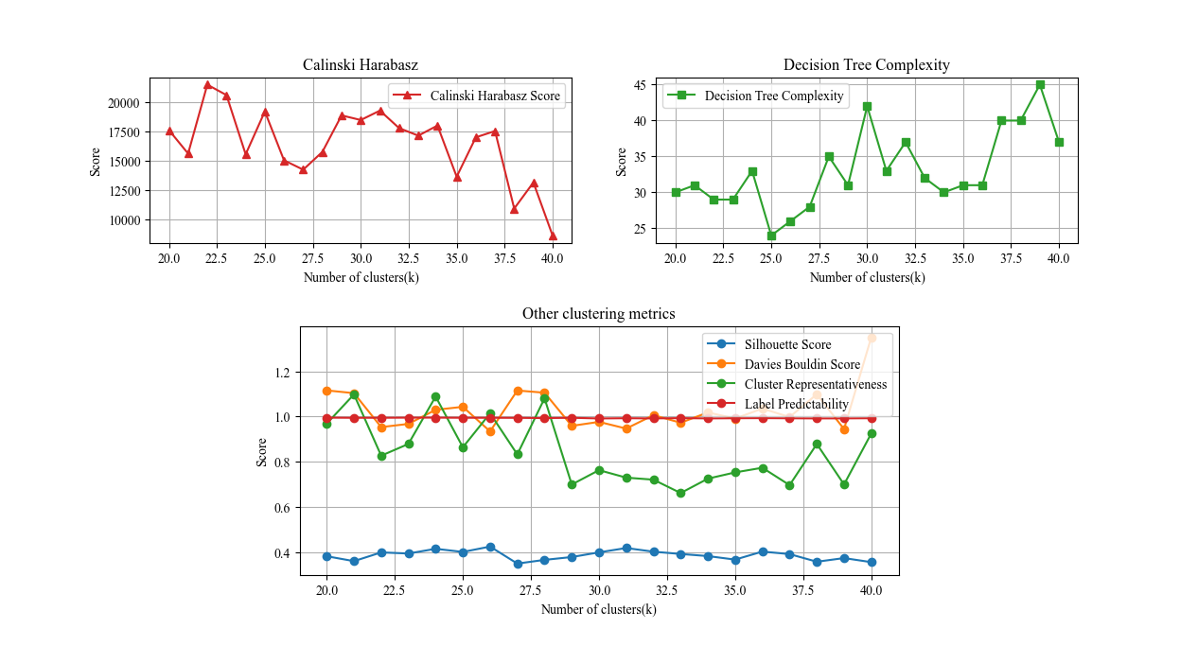

1. Clustering Performance Evaluation of Typical Job Positions for Engineering and Technical Personnel

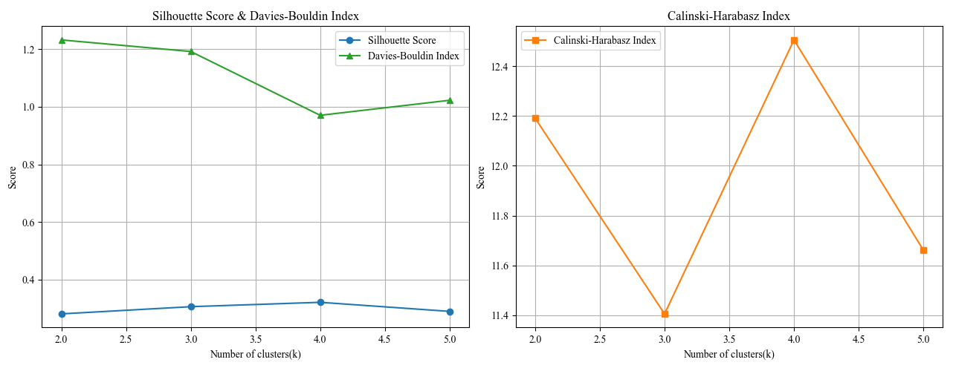

1. Clustering Performance Evaluation of Work Activities for Engineering and Technical Personnel

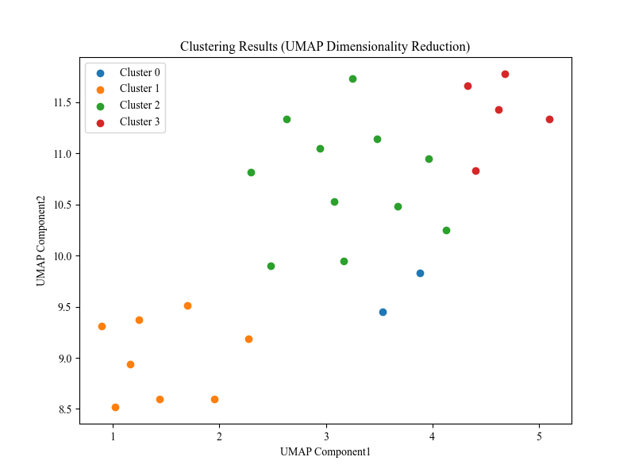

1. Work Activity Clustering Visualization for Engineering and Technical Personnel