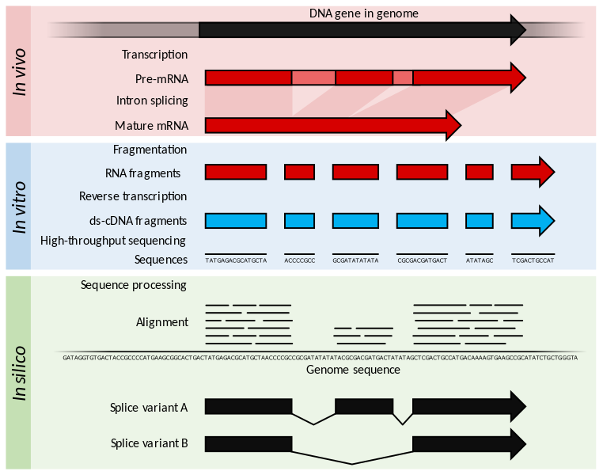
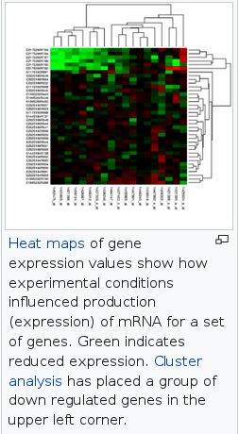
https://www.ebi.ac.uk/training/online/course/functional-genomics-ii-common-technologies-and-data-analysis-methods/rna-sequencing

