ExeScanner 1.0

License Agreement:

ExeScanner is free software; you can redistribute it and/or modify it provided that you agree to the following terms and conditions:

1. The software should always contain this license agreement
2. The source code should always contain the given copyright notice.
3. Use of software or source code for commercial purposes or for making profit requires permissions from Vishalsinh Jhala.
4. This software is not to be used in any way to illegally modify it or other softwares.

Disclaimer:

THE SOFTWARE IS PROVIDED "AS-IS" AND WITHOUT WARRANTY OF ANY KIND, EXPRESS, IMPLIED OR OTHERWISE, INCLUDING WITHOUT LIMITATION, ANY WARRANTY OF MERCHANTABILITY OR FITNESS FOR A PARTICULAR PURPOSE.

IN NO EVENT SHALL VISHALSINH JHALA BE LIABLE FOR ANY SPECIAL, INCIDENTAL, INDIRECT OR CONSEQUENTIAL DAMAGES OF ANY KIND, OR ANY DAMAGES WHATSOEVER RESULTING FROM LOSS OF USE, DATA OR PROFITS, WHETHER OR NOT ADVISED OF THE POSSIBILITY OF DAMAGE, AND ON ANY THEORY OF LIABILITY, ARISING OUT OF OR IN CONNECTION WITH THE USE OR PERFORMANCE OF THIS SOFTWARE.

Index

ExeScanner 1.0 1
Index 2
Overview 3
PE 4
Scan PE 4
Action 5
Import 5
Export 7
Legend 8
Tools 9
Dos/Win Header 9
Future Plans 10

Overview

ExeScanner is a program that scans PE WIN32 Executable files, parses their objects and displays them in a hierarchical tree view on the left. Input file can be any valid EXE, DLL or OCX.

Program has the capability to display the property and visual representation of the objects in a Portable Executable files. Most of such objects can be extracted out of PE and also be modified.

ExeScanner 1.0 primarily concentrates on resources present in PE. Future versions will also be able to show disassembly and even modify them.

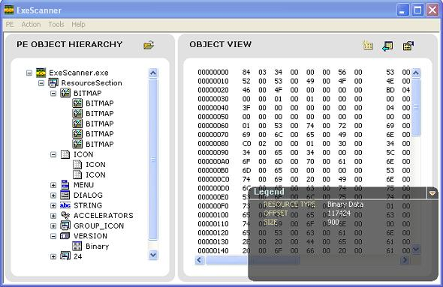

PE

Scan PE

This action can be invoked from
Menu: PE->Scan PE.
Click Icon on Left tree (show image)

Keyboard shortcut is Ctrl+O.

On selecting this action, program lets you select a PE file. On selection, it parses the objects present in the file and displays then on the left tree.

Action

Import
This action can be invoked from
Menu: Action->Import.
Click Icon on Right Detail View (show image)

Keyboard shortcut is Ctrl+I.

On selecting this action, program lets you modify the existing objects in PE file. Depending upon the object selected on the left tree, user is posed with different dialogs to let him modify the PE file/object.

Once modified, there is no way to undo the action. So be careful before you modify and back up your file before any modification is done.

Binary and String resources cannot be imported directly. However they can be modified by clicking on them. Dialogs that will appear for Binary and string resource modification are:

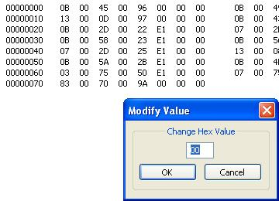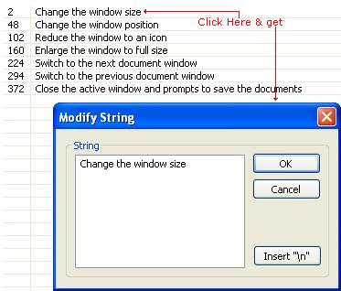

Export

This action can be invoked from
Menu: Action->Export.
Click Icon on Right Detail View (show image)

Keyboard shortcut is Ctrl+E.

On selecting this action, program lets you modify the extract objects in PE file. Depending upon the object selected on the left tree, user is posed with save dialog to save the object to file system.

Legend

This action can be invoked from
Menu: Action->Legend.
Click Icon on Right Detail View (show image)

Keyboard shortcut is Alt+Enter.

On selecting this action, program shows you the properties (Legend) of the object selected on the left tree. Legend also includes the dirty Hex offsets and size of the object along with other parameters.

Tools

Dos/Win Header

Displays a dialog which allows examining the Dos and windows Header of the current PE file opened.

Future Plans

ExeScanner 1.1 Will allow modify/extract all kinds of resources.

ExeScanner 2.0 Will have an inbuilt resource script compiler/decompiler.

ExeScanner 2.1 Will allow in-place-edit for most of the resources.

ExeScanner 3.1 Facility to view/modify all kinds of objects present in PE.

ExeScanner 3.2 Facility to view disassembly of PE and modify instructions.

