**Appendix**

**Predicting Fracture Risk in Younger Postmenopausal Women: Comparison of the Garvan and FRAX Risk Calculators in the Women’s Health Initiative Study**

|  |
| --- |
| **Supplemental Item** |
| Appendix Figure 1. STROBE Flowchart of Analytic Sample |
| Appendix Figure 2. Receiver Operating Characteristic (ROC) curve for identifying major osteoporotic fracture over 10 years |
| Appendix Figure 3. Receiver Operating Characteristic (ROC) curve for identifying any clinical fracture over 10 years |
| Appendix Table 1. Selected characteristics of participants included in and excluded from the study |
| Appendix Table 2. Observed versus predicted 10 year probability of hip fracture according to Garvan and Fracture Risk Assessment (FRAX) tools |
| Appendix Table 3. Sensitivity analysis: Specificity and positive predictive value corresponding to sensitivity values ≥80% after exclusion of participants who used osteoporosis medication or estrogen therapy during the follow-up period |
| Appendix Table 4. Area under the receiver operating characteristic curve (AUC) values for the prediction of incident hip fracture, by racial/ethnic group |
| Appendix Table 5. Sensitivity, specificity, and Area Under the Receiver Operating Characteristic Curve (AUC) of the Garvan and Fracture Risk Assessment Tool (FRAX) tools for identifying incident hip fractures at 5 and 10 years – cut points defined by maximum area under the curve |
| Appendix Table 6. Sensitivity, specificity, and Area Under the Receiver Operating Characteristic Curve (AUC) of the Garvan and Fracture Risk Assessment Tool (FRAX) tools for identifying any incident clinical fracture after 10 years, stratified by baseline age; cut-points within each age group selected to maximize area under the curve |
| Appendix Table. 7. Appendix Table 7. Area Under the Receiver Operating Characteristic Curve (AUC) Values for the Prediction of Incident Major Osteoporotic Fracture, by Racial/Ethnic Group |

**Appendix Figure 1. Flow Chart of Analytic Sample[1]**

1111 participants reported using bisphosphonates (N = 955), calcitonin (N = 125), selective estrogen receptor modulators (N=20), somatostatin agents (N=1), combination osteoporosis medications (N=8), or for whom data were missing regarding medication data at baseline (N=2)

83939 participants for whom we had complete information regarding osteoporosis risk factors

5714 participants for whom information required for calculation of one or more risk assessment tools was incomplete

62723, 63621, 64739 participants for hip, major osteoporotic fracture, and clinical fracture outcomes respectively for whom information regarding osteoporosis risk factors was available and who either experienced an event or 10 years of exposure time

19200 participants with no event and less than 10 years of exposure time

161808 participants of the Women’s Health Initiative Observational Study and Clinical Trials

90764 participants aged 50-64 years

71044 participants aged ≥ 65 years

89653 not using osteoporosis medications (bisphosphonates, calcitonin, parathyroid hormone), selective estrogen receptor modulators, luteinizing hormone releasing-hormone agents, and somatostatin agents

**Appendix Figure 2a. Receiver Operating Characteristic (ROC) curve for identifying major osteoporotic fracture over 10 years by Garvan tool**

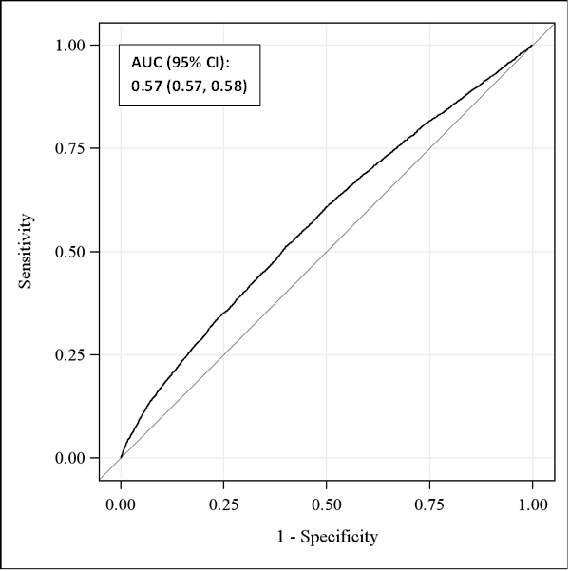

**Appendix Figure 2b. Receiver Operating Characteristic (ROC) curve for identifying major osteoporotic fracture over 10 years by the Fracture Risk Assessment (FRAX) tool**

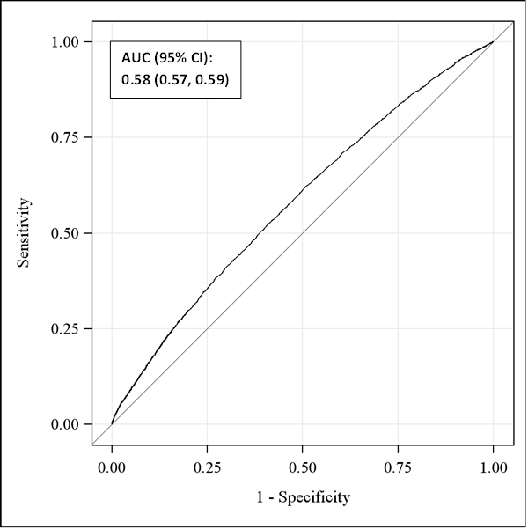

**Appendix Figure 3a. Receiver Operating Characteristic (ROC) curve for identifying any clinical fracture over 10 years by Garvan tool**

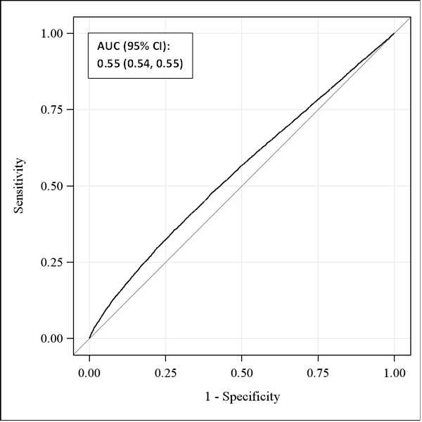

**Appendix Figure 3b. Receiver Operating Characteristic (ROC) curve for identifying any clinical fracture over 10 years by the Fracture Risk Assessment (FRAX) tool**

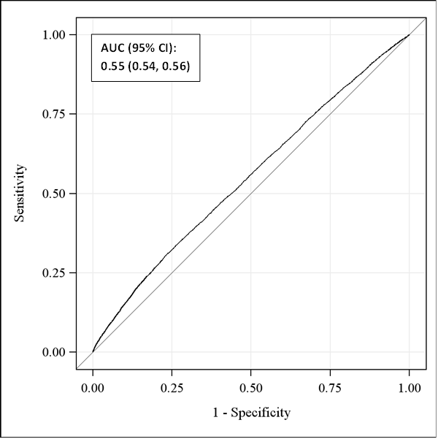

**Appendix Table 1. Selected characteristics of participants included in and excluded from the study**

|  |  |  |
| --- | --- | --- |
| Baseline characteristic | Excluded Participants | Included Participants |
|  | No. (%) of Participants | No. (%) of Participants |
| Age, years |  |  |
| 50-54 | 6343 (24.4) | 15221 (23.5) |
| 55-59 | 8904 (34.2) | 23086 (35.7) |
| 60-64 | 10778 (41.4) | 26432 (40.8) |
| Body mass index, kg/m2 |  |  |
| < 25 | 7815 (30.0) | 22986 (35.5) |
| 25 - < 30 | 8423 (32.4) | 21698 (33.5) |
| ≥ 30 | 9329 (35.8) | 19703 (30.4) |
| Missing | 458 (1.8) | 352 (0.5) |
| Race/Ethnicity |  |  |
| Black | 4021 (15.5) | 5719 (8.8) |
| Hispanic | 2354 (9.0) | 2376 (3.7) |
| White | 18125 (69.6) | 54102 (83.6) |
| Other / unknown | 1525 (5.9) | 2542 (3.9) |
| History of corticosteroid use |  |  |
| Yes | 233 (0.9) | 402 (0.6) |
| No | 25790 (99.1) | 64337 (99.4) |
| Missing | 2 (0.0) | 0 (0.0) |
| Rheumatoid arthritis |  |  |
| Yes | 1165 (4.5) | 2612 (4.0) |
| No | 22509 (86.5) | 61725 (95.3) |
| Missing | 2351 (9.0) | 402 (0.6) |
| Smoking |  |  |
| Never smoker | 12541 (48.2) | 31634 (48.9) |
| Past smoker | 10309 (39.6) | 27720 (42.8) |
| Current smoker | 2793 (10.7) | 4786 (7.4) |
| Missing | 382 (1.5) | 599 (0.9) |
| Number of fractures[2] ≥ age 55 |  |  |
| 0 | 15038 (57.8) | 46600 (72.0) |
| 1 | 873 (3.4) | 2699 (4.2) |
| 2 | 65 (0.2) | 201 (0.3) |
| ≥3 | 5 (0.0) | 18 (0.0) |
| Participant < age 55 | 6343 (24.4) | 15221 (23.5) |
| Missing | 3701 (14.2) | 0 (0.0) |
| Falls in past year |  |  |
| None | 14429 (55.4) | 43994 (68.0) |
| 1 time | 4467 (17.2) | 12644 (19.5) |
| 2 times | 1851 (7.1) | 5314 (8.2) |
| 3 or more times | 1043 (4.0) | 2787 (4.3) |
| Missing | 4235 (16.3) | 0 (0.0) |
| Current menopausal hormone therapy |  |  |
| Yes | 12532 (48.2) | 35969 (55.6) |
| No | 13472 (51.8) | 28725 (44.4) |
| Missing | 21 (0.1) | 45 (0.1) |
| ≥ 3 alcoholic drinks per day |  |  |
| Yes | 245 (0.9) | 762 (1.2) |
| No | 25594 (98.3) | 63822 (98.6) |
| Missing | 186 (0.7) | 762 (1.2) |
| Parental hip fracture |  |  |
| Yes | 2403 (9.2) | 7901 (12.2) |
| No | 22057 (84.8) | 54457 (84.1) |
| Missing | 1565 (6.0) | 2381 (3.7) |

**Appendix Table 2. Observed versus predicted 10 year probability of hip fracture according to Garvan and Fracture Risk Assessment (FRAX) tools[3]**

|  |  |  |  |  |  |  |  |
| --- | --- | --- | --- | --- | --- | --- | --- |
|  |  | Garvan 10 Year Expected | | FRAX 10 Year Expected | | Observed | |
|  | n | Events | Percent | Events | Percent | Events | Percent |
| All participants | 62723 | 129 | 0.2 | 430 | 0.7 | 468 | 0.7 |
| Age |  |  |  |  |  |  |  |
| 50-54 | 14768 | 16 | 0.1 | 40 | 0.3 | 48 | 0.3 |
| 55-59 | 22442 | 38 | 0.2 | 118 | 0.5 | 143 | 0.6 |
| 60-64 | 25513 | 76 | 0.3 | 272 | 1.1 | 277 | 1.1 |
| HT Use |  |  |  |  |  |  |  |
| No | 27617 | 56 | 0.2 | 189 | 0.7 | 227 | 0.8 |
| Yes | 35065 | 73 | 0.2 | 240 | 0.7 | 241 | 0.7 |
| Years of HT Use |  |  |  |  |  |  |  |
| 0 Years | 12250 | 27 | 0.2 | 90 | 0.7 | 91 | 0.7 |
| 5+ Years | 18762 | 40 | 0.2 | 133 | 0.7 | 87 | 0.5 |
| Race/Ethnicity |  |  |  |  |  |  |  |
| White | 52536 | 111 | 0.2 | 396 | 0.8 | 437 | 0.8 |
| African American | 5475 | 7 | 0.1 | 13 | 0.2 | 13 | 0.2 |
| Hispanic | 2262 | 5 | 0.2 | 7 | 0.3 | 8 | 0.4 |
| Other/Unknown | 2450 | 6 | 0.2 | 13 | 0.5 | 10 | 0.4 |

**Appendix Table 3. Sensitivity analysis: Specificity and positive predictive value corresponding to sensitivity values ≥80% after exclusion of participants who used osteoporosis medication or estrogen therapy during the follow-up period[4]**

|  |  |  |  |  |  |
| --- | --- | --- | --- | --- | --- |
| **Outcome** | **Tool** |  |  |  |  |
| **Hip Fracture** | **Garvan** | *Sensitivity (95% CI)* | *Specificity (95% CI)* | *PPV (95% CI)* | *AUC (95% CI)[5]* |
| 66 Events | ≥ 0.097 | 72.7 (61.7-83.8) | 31.0 (30.1-31.9) | 0.7 (0.5-0.9) | 0.55 (0.50-0.61) |
|  | ≥ 0.079 | 80.3 (70.5-90.2) | 24.0 (23.2-24.8) | 0.7 (0.5-0.9) | 0.55 (0.50-0.60) |
|  | ≥ 0.065 | 89.4 (81.8-97.0) | 18.3 (17.6-19.1) | 0.7 (0.5-0.9) | 0.56 (0.51-0.61) |
|  | ≥ 0.036 | 93.9 (88.0-99.9) | 8.4 (7.9-9.0) | 0.7 (0.5-0.8) | 0.54 (0.50-0.59) |
|  | ≥ 0.012 | 100.0 (-) | 1.9 (1.6-2.1) | 0.7 (0.5-0.8) | 0.54 (0.51-0.58) |
|  | **FRAX** | *Sensitivity (95% CI)* | *Specificity (95% CI)* | *PPV (95% CI)* | *AUC (95% CI)* |
|  | ≥ 0.430 | 72.7 (61.7-83.8) | 41.7 (40.7-42.7) | 0.8 (0.6-1.0) | 0.59 (0.54-0.65) |
|  | ≥ 0.350 | 80.3 (70.5-90.2) | 32.0 (31.1-32.9) | 0.8 (0.6-1.0) | 0.59 (0.53-0.64) |
|  | ≥ 0.280 | 89.4 (81.8-97.0) | 22.5 (21.7-23.4) | 0.7 (0.6-0.9) | 0.59 (0.54-0.64) |
|  | ≥ 0.210 | 93.9 (88.0-99.9) | 13.7 (13.0-14.3) | 0.7 (0.5-0.9) | 0.57 (0.52-0.61) |
|  | ≥ 0.090 | 100.0 (-) | 1.8 (1.5-2.1) | 0.7 (0.5-0.8) | 0.54 (0.51-0.58) |
| **MOF** | **Garvan** | *Sensitivity (95% CI)* | *Specificity (95% CI)* | *PPV (95% CI)* | *AUC (95% CI)* |
| 960 Events | ≥ 7.371 | 82.3 (79.9-84.7) | 25.6 (24.7-26.5) | 10.1 (9.4-10.8) | 0.55 (0.53-0.56) |
|  | ≥ 6.863 | 87.4 (85.3-89.5) | 18.9 (18.1-19.7) | 9.9 (9.3-10.5) | 0.54 (0.53-0.56) |
|  | ≥ 6.365 | 91.5 (89.7-93.2) | 12.5 (11.8-13.2) | 9.6 (9.0-10.2) | 0.53 (0.52-0.54) |
|  | ≥ 5.686 | 95.8 (94.6-97.1) | 6.5 (6.0-7.0) | 9.4 (8.9-10.0) | 0.53 (0.51-0.54) |
|  | ≥ 4.405 | 98.9 (98.2-99.5) | 1.4 (1.2-1.7) | 9.3 (8.7-9.8) | 0.52 (0.51-0.53) |
|  | **FRAX** | *Sensitivity (95% CI)* | *Specificity (95% CI)* | *PPV (95% CI)* | *AUC (95% CI)* |
|  | ≥ 4.800 | 81.7 (79.2-84.1) | 27.7 (26.8-28.6) | 10.3 (9.6-11.0) | 0.55 (0.54-0.57) |
|  | ≥ 4.330 | 87.1 (85.0-89.2) | 22.5 (21.6-23.3) | 10.3 (9.6-10.9) | 0.56 (0.54-0.57) |
|  | ≥ 3.750 | 91.5 (89.7-93.2) | 16.4 (15.6-17.1) | 10.0 (9.4-10.6) | 0.55 (0.54-0.56) |
|  | ≥ 2.980 | 96.4 (95.2-97.5) | 9.3 (8.7-9.9) | 9.8 (9.2-10.4) | 0.54 (0.53-0.55) |
|  | ≥ 1.790 | 99.6 (99.2-100.0) | 1.6 (1.3-1.8) | 9.3 (8.8-9.9) | 0.52 (0.51-0.53) |

**Appendix Table 4. Area Under the Receiver Operating Characteristic Curve (AUC) Values for the Prediction of Incident Hip Fracture, by Racial/Ethnic Group**

**Tool Race/Ethnicity AUC (95%CI)**

Garvan Overall 0.62 (0.59, 0.65)

White 0.61 (0.59, 0.64)

African American 0.58 (0.39, 0.76)

Hispanic 0.53 (0.33, 0.73)

Other/Unknown 0.61 (0.42, 0.80)

FRAX Overall 0.68 (0.65, 0.70)

White 0.66 (0.64, 0.69)

African American 0.54 (0.36, 0.73)

Hispanic 0.53 (0.30, 0.76)

Other/Unknown 0.74 (0.58, 0.89)

**Appendix Table 5. Sensitivity, specificity, and Area Under the Receiver Operating Characteristic Curve (AUC) of the Garvan and Fracture Risk Assessment Tool (FRAX) tools for identifying incident hip fractures at 5 and 10 years – cut points defined by maximum area under the curve**

|  |  |  |  |
| --- | --- | --- | --- |
|  | | | |
| All participants | Sensitivity (95% CI) | Specificity (95% CI) | AUC |
| Overall (n=62723) |  |  |  |
| Garvan 5-year ≥ 0.321 | 8.0 (4.0-12.1) | 96.7 (96.6-96.9) | 0.56 (0.52-0.59) |
| Garvan 10-year ≥ 0.462 | 16.0 (12.7-19.4) | 93.5 (93.3-93.7) | 0.58 (0.55-0.60) |
| FRAX 10-year ≥ 0.706 | 59.2 (54.7-63.7) | 67.6 (67.2-67.9) | 0.65 (0.62-0.67) |
| 50-54 years (n=14768) | Sensitivity (95% CI) | Specificity (95% CI) | AUC |
| Garvan 5-year ≥ 0.321 | 0.0 (0.0-100.0) | >99.9 (99.9-100.0) | 0.58 (0.48-0.68) |
| Garvan 10-year ≥ 0.462 | 0.0 (0.0-100.0) | 99.7 (99.7-99.8) | 0.54 (0.49-0.60) |
| FRAX 10-year ≥ 0.706 | 10.4 (1.5-19.4) | 98.1 (97.9-98.3) | 0.58 (0.52-0.65) |
| 55-59 years (n=22442) | Sensitivity (95% CI) | Specificity (95% CI) | AUC |
| Garvan 5-year ≥ 0.321 | 7.4 (0.2-14.6) | 98.6 (98.5-98.8) | 0.60 (0.54-0.66) |
| Garvan 10-year ≥ 0.462 | 5.6 (1.8-9.4) | 96.9 (96.7-97.1) | 0.56 (0.52-0.60) |
| FRAX 10-year ≥ 0.706 | 34.3 (26.4-42.1) | 81.2 (80.7-81.7) | 0.61 (0.56-0.65) |
| 60-64 years (n=25513) | Sensitivity (95% CI) | Specificity (95% CI) | AUC |
| Garvan 5-year ≥ 0.321 | 12.6 (6.1-19.1) | 93.2 (92.9-93.5) | 0.57 (0.53-0.61) |
| Garvan 10-year ≥ 0.462 | 24.2 (19.1-29.3) | 86.9 (86.5-87.3) | 0.60 (0.57-0.63) |
| FRAX 10-year ≥ 0.706 | 80.5 (75.8-85.2) | 37.7 (37.1-38.3) | 0.62 (0.59-0.65) |

**Appendix Table 6. Sensitivity, specificity, and Area Under the Receiver Operating Characteristic Curve (AUC) of the Garvan and Fracture Risk Assessment Tool (FRAX) tools for identifying any incident clinical fracture after 10 years, stratified by baseline age; cut-points within each age group selected to maximize area under the curve[6]**

|  |  |  |  |
| --- | --- | --- | --- |
|  | | | |
|  | Sensitivity (95% CI) | Specificity (95% CI) | AUC |
| 50-54 years (n=15221) |  |  |  |
| Garvan ≥8.522 | 18.1 (16.5-19.6) | 87.4 (86.9-88.0) | 0.54 (0.53-0.56) |
| FRAX ≥5.174 | 22.4 (20.7-24.0) | 80.7 (80.0-81.4) | 0.53 (0.52-0.54) |
| 55-59 years (n=23086) |  |  |  |
| Garvan ≥10.060 | 26.8 (25.5-28.2) | 80.9 (80.4-81.5) | 0.55 (0.54-0.56) |
| FRAX ≥7.652 | 23.2 (21.8-24.5) | 83.2 (82.7-83.8) | 0.54 (0.53-0.55) |
| 60-64 years (n=26432) |  |  |  |
| Garvan ≥13.756 | 24.4 (23.3-25.6) | 83.0 (82.5-83.5) | 0.55 (0.54-0.56) |
| FRAX ≥9.528 | 34.0 (32.7-35.3) | 74.6 (74.1-75.2) | 0.55 (0.55-0.56) |

**Appendix Table 7. Area Under the Receiver Operating Characteristic Curve (AUC) Values for the Prediction of Incident Major Osteoporotic Fracture, by Racial/Ethnic Group**

**Tool Race/Ethnicity AUC (95%CI)**

Garvan Overall 0.57 (0.57, 0.58)

White 0.57 (0.56, 0.58)

African American 0.54 (0.50, 0.58)

Hispanic 0.57 (0.53, 0.62)

Other/Unknown 0.56 (0.51, 0.60)

FRAX Overall 0.58 (0.57, 0.59)

White 0.57 (0.56, 0.58)

African American 0.53 (0.49, 0.57)

Hispanic 0.57 (0.53, 0.62)

Other/Unknown 0.61 (0.56, 0.65

1. The hip fracture outcome set consists of 62723 participants with either a hip fracture event or 10 years of follow-up time prior to death or loss to follow-up. The major osteoporotic fracture outcome set consists of 63621 participants with either a major osteoporotic fracture event or 10 years of follow-up time prior to death or loss to follow-up. The clinical fracture outcome set consists of 64739 participants with either a clinical fracture event or 10 years of follow-up time prior to death or loss to follow-up.
2. Only one fracture is counted at each body site
3. Observed 10-year hip fracture probability was 0.8% for white women (n = 52536), 0.2% for African American women (n = 5475), 0.4% for Hispanic women (n = 2262), and 0.4% for women who reported other or unknown race (n = 2450). Observed 10-year MOF probability was 8.9% for white women (n = 53261), 4.5% for African American women (n = 5553), 8.0% for Hispanic women (n=2319), and 6.9% for women who reported other or unknown race (n = 2488). Observed 10-year probability of any clinical fracture was 18.2% for white women (n = 54102), 13.7% for African American women (n = 5719), 16.4% for Hispanic women (n=2376), and 15.5% for women who reported other or unknown race (n = 2542).
4. FRAX denotes the Fracture Risk Assessment Tool. Sensitivity thresholds were chosen to reflect thresholds of clinical relevance (i.e. sensitivity ≥80%). Includes participants of the Hormone Therapy Clinical Trial and Observational Study.
5. Logistic models to calculate AUC are additionally adjusted for WHI hormone therapy and calcium/vitamin D interventions
6. There were 11,412 clinical fracture events during study follow-up.