Lab 8: Istio Traffic Management Lab Guide
Experiment Objectives
This experiment aims to master Istio's core traffic management functions through practice, including traffic shifting, request routing, fault injection, and circuit breaking mechanisms, understanding how to manage service version deployment and migration in a microservices architecture.
Prerequisites
1. Kubernetes cluster has been deployed and is running normally
2. Istio has been installed into the Kubernetes cluster
3. Istio Sidecar auto-injection has been enabled
4. Necessary command-line tools have been installed: `kubectl`, `istioctl`
Experiment Content
1. Traffic Shifting
2. Request Routing
3. Fault Injection
4. Circuit Breaking
1. Traffic Shifting
Experiment Objectives
Learn how to gradually shift traffic from one service version to another.
Experiment Steps
1.1 Deploy Bookinfo Application
```powershell
Create namespace and enable Sidecar auto-injection
kubectl create namespace bookinfo
kubectl label namespace bookinfo istio-injection=enabled
Deploy Bookinfo application
kubectl apply -f https://raw.githubusercontent.com/istio/istio/release-1.28/samples/bookinfo/platform/kube/bookinfo.yaml -n bookinfo
Verify deployment status
kubectl get pods -n bookinfo
kubectl get services -n bookinfo
```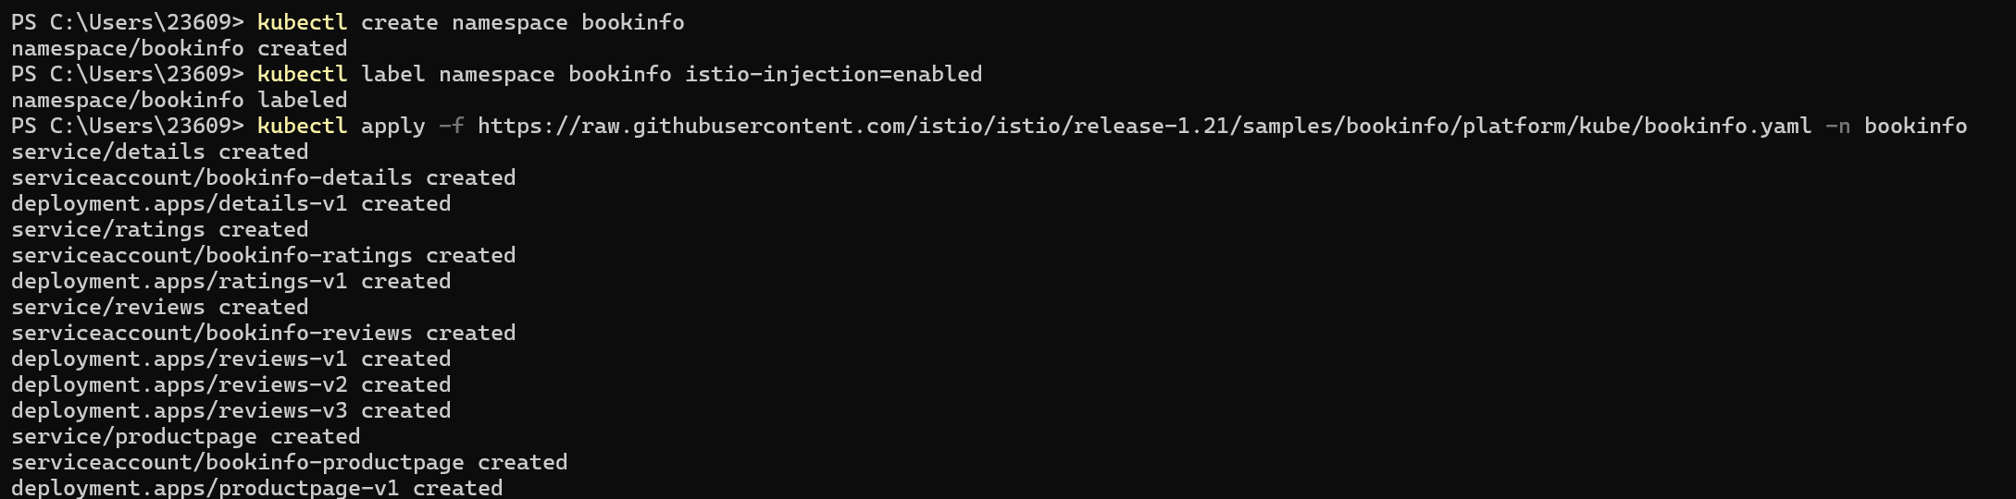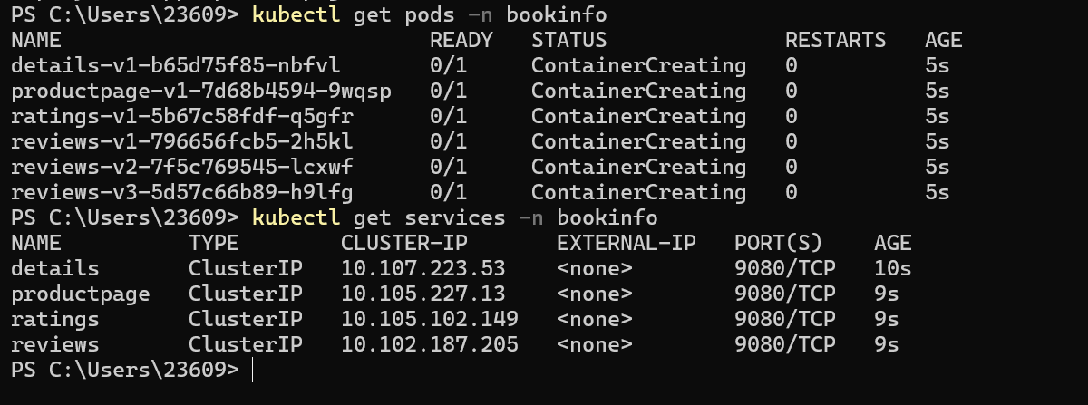
1.2 Configure Gateway and VirtualService
```powershell
Deploy Gateway
kubectl apply -f https://raw.githubusercontent.com/istio/istio/release-1.28/samples/bookinfo/networking/bookinfo-gateway.yaml -n bookinfo
Verify Gateway status
istioctl analyze -n bookinfo
```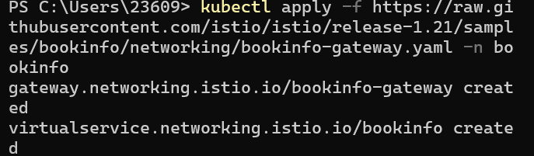
1.3 Deploy v1 and v2 versions of the reviews service
```powershell
Bookinfo application already includes reviews v1/v2/v3 by default, no need for separate deployment
```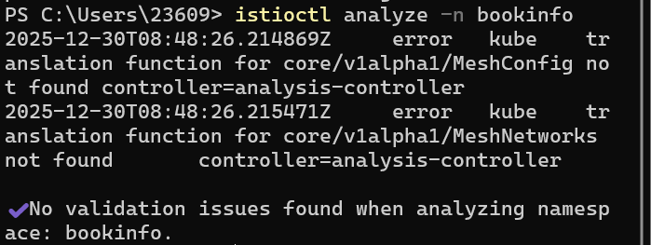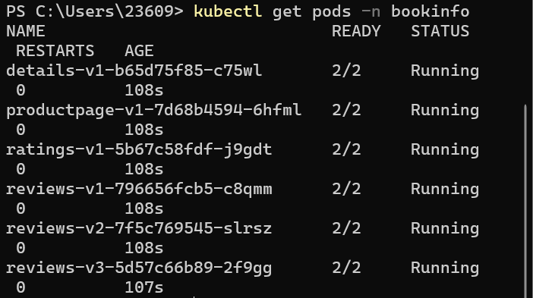
1.4 Configure initial traffic routing (100% to v1)
```powershell
Apply default routing configuration
kubectl apply -f https://raw.githubusercontent.com/istio/istio/release-1.28/samples/bookinfo/networking/virtual-service-all-v1.yaml -n bookinfo
Verify configuration
kubectl get virtualservices -n bookinfo
kubectl get destinationrules -n bookinfo
```
1.5 Test initial configuration
```powershell
Get Istio Ingress Gateway IP and port
Method 1: Use LoadBalancer IP (if available)
try {
$INGRESS_HOST = kubectl -n istio-system get service istio-ingressgateway -o jsonpath='{.status.loadBalancer.ingress[0].ip}'
$INGRESS_PORT = kubectl -n istio-system get service istio-ingressgateway -o jsonpath='{.spec.ports[?$@.name=="http2"$].port}'
if ($INGRESS_{H}OST−ne$null -and $INGRESS_HOST -ne "") {
$env:GATEWAY_URL = "${INGRESS_HOST}:${INGRESS_PORT}"
} else {
Method 2: Use NodePort (commonly used in local environments)
$NODE_PORT = kubectl -n istio-system get service istio-ingressgateway -o jsonpath='{.spec.ports[?$@.name=="http2"$].nodePort}'
$env:GATEWAY_URL = "localhost:${NODE_PORT}"
}
} catch {
Method 3: Use fixed port (port forwarding)
$env:GATEWAY_URL = "localhost:8080"
}
Verify Gateway URL
Write-Output "Gateway URL: $env:GATEWAY_URL"
Send request test
(Invoke-WebRequest -Uri "http://$env:GATEWAY_URL/productpage" -UseBasicParsing).Content -match "<title>$.∗$</title>" | Out-Null
Write-Output "Page title: $($matches[1])"
```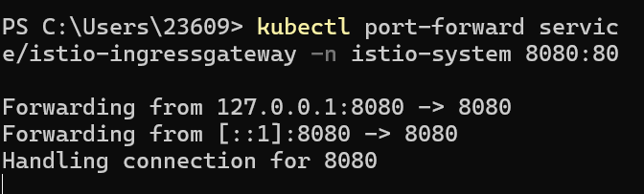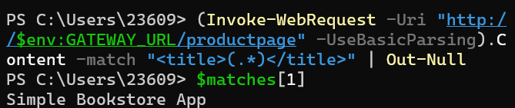
1.6 Configure traffic shifting (50% to v2)
```powershell
Apply traffic shifting configuration
kubectl apply -f https://raw.githubusercontent.com/istio/istio/release-1.28/samples/bookinfo/networking/virtual-service-reviews-50-v3.yaml -n bookinfo
Verify configuration
kubectl get virtualservice reviews -n bookinfo -o yaml
```
1.7 Test traffic shifting
```powershell
Send multiple requests to observe traffic distribution
for ($i=1;$i -le 10; $i++) {
$response = Invoke-WebRequest -Uri "http://$env:GATEWAY_URL/productpage" -UseBasicParsing
if ($response.Content -match "reviews-v([0-9])") {
Write-Output "Request ${i}: reviews-v$($matches[1])"
}
}
```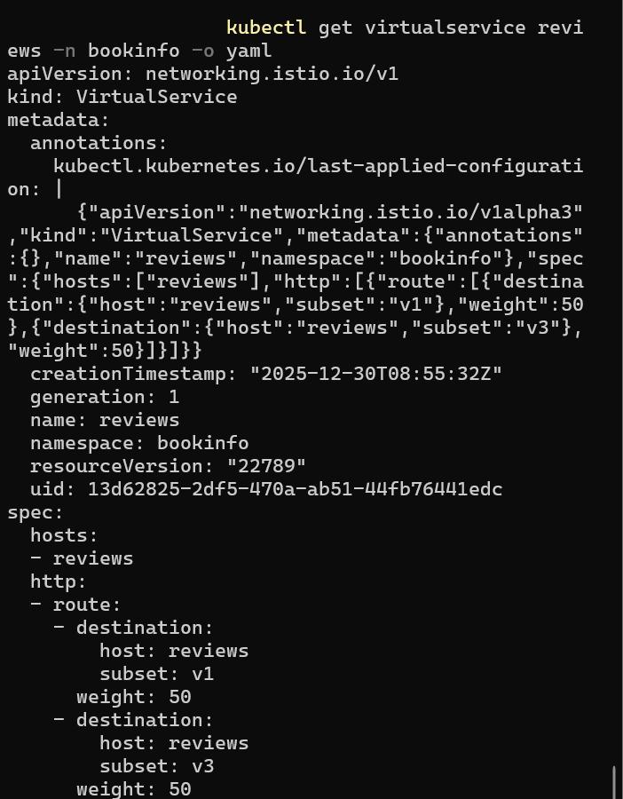
1.8 Fully shift to v2
```powershell
Apply 100% to v2 configuration
kubectl apply -f https://raw.githubusercontent.com/istio/istio/release-1.28/samples/bookinfo/networking/virtual-service-reviews-v3.yaml -n bookinfo
Verify configuration
kubectl get virtualservice reviews -n bookinfo -o yaml
Test all traffic flows to v2
for ($i=1;$i -le 10; $i++) {
$response = Invoke-WebRequest -Uri "http://$env:GATEWAY_URL/productpage" -UseBasicParsing
if ($response.Content -match "reviews-v([0-9])") {
Write-Output "Request ${i}: reviews-v$($matches[1])"
}
}
```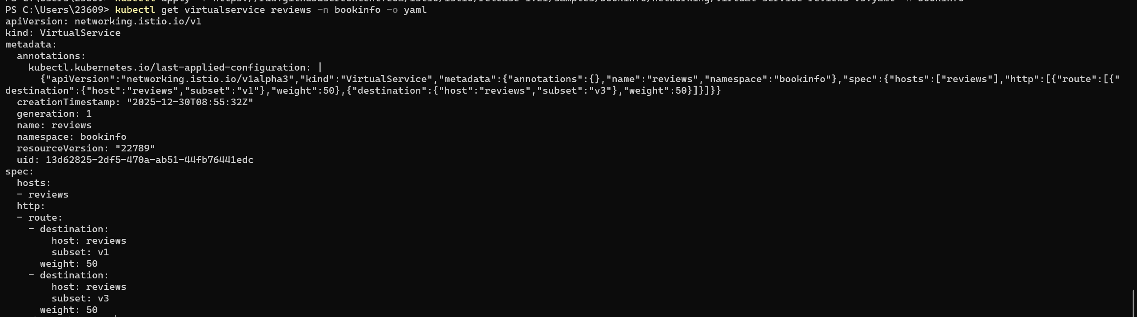
2. Request Routing
Experiment Objectives
Learn how to route traffic to different service versions based on request attributes (such as user identity).
Experiment Steps
2.1 Deploy Bookinfo application
2.2 Configure user-based routing
```powershell
Apply user-based routing configuration
kubectl apply -f https://raw.githubusercontent.com/istio/istio/release-1.28/samples/bookinfo/networking/virtual-service-reviews-test-v2.yaml -n bookinfo
Verify configuration
kubectl get virtualservice reviews -n bookinfo -o yaml
```
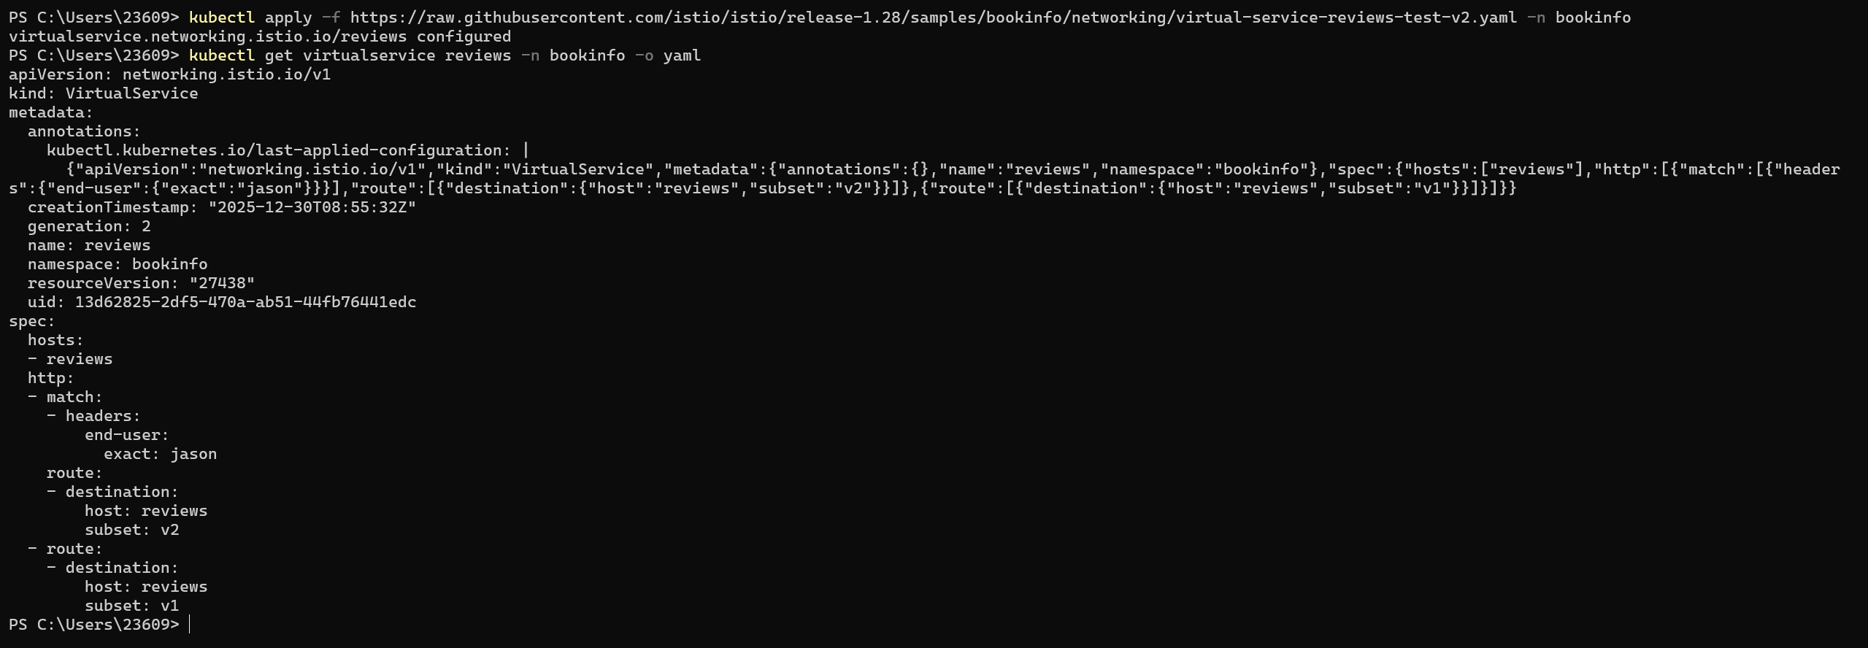
3. Fault Injection
Experiment Objectives
Learn how to inject faults to test service resilience and fault tolerance.
Experiment Steps
3.1 Deploy Bookinfo application
3.2 Configure delay fault
```powershell
Create delay fault configuration
@"
apiVersion: networking.istio.io/v1alpha3
kind: VirtualService
metadata:
name: reviews
namespace: bookinfo
spec:
hosts:
- reviews
http:
- match:
- headers:
end-user:
exact: jason
fault:
delay:
percentage:
value: 100.0
fixedDelay: 7s
route:
- destination:
host: reviews
subset: v2
- route:
- destination:
host: reviews
subset: v1
"@ | Out-File -FilePath virtual-service-reviews-delay.yaml -Encoding UTF8
Apply configuration
kubectl apply -f virtual-service-reviews-delay.yaml -n bookinfo
Verify configuration
kubectl get virtualservice reviews -n bookinfo -o yaml
```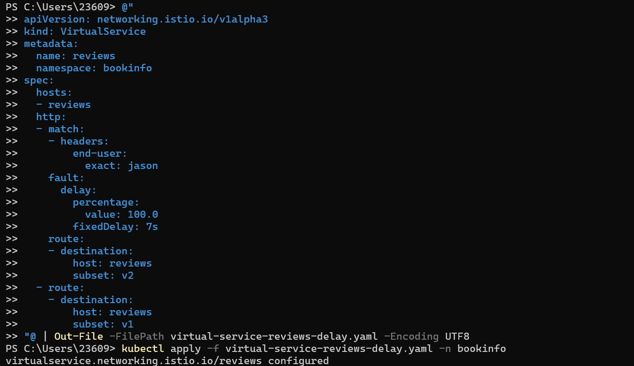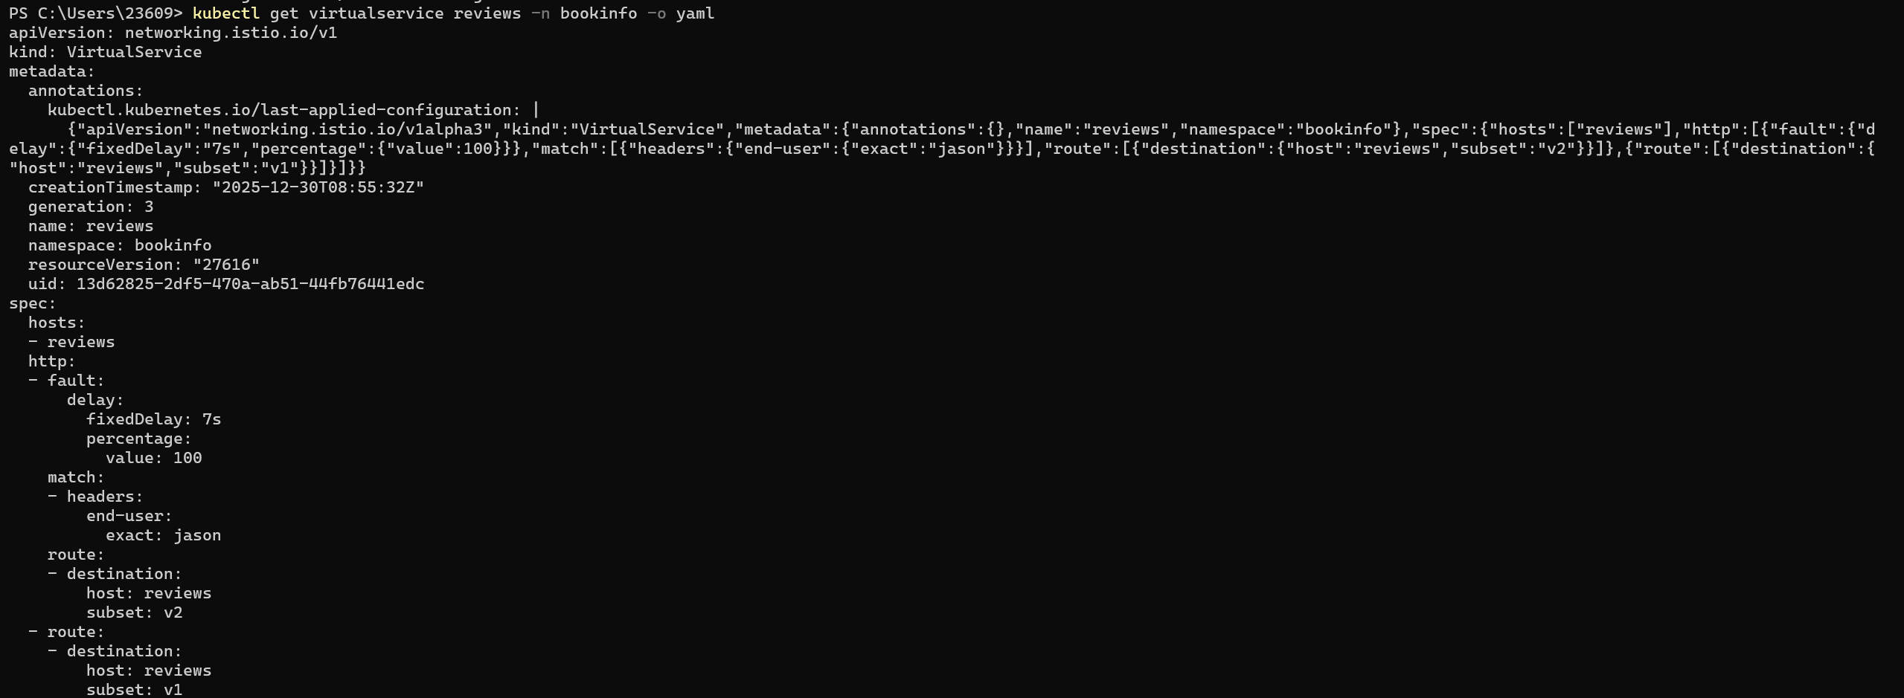
3.3 Test delay fault
```powershell
Test unlogged-in user (should not have delay)
Write-Output "Testing unlogged-in user:"
Measure-Command {
$response = Invoke-WebRequest -Uri "http://$env:GATEWAY_URL/productpage" -UseBasicParsing -ErrorAction SilentlyContinue
if ($response.Content -match "reviews-v([0-9])") {
Write-Output " Result: reviews-v$($matches[1])"
}
}
Test logged-in user jason (should have 7s delay)
Write-Output "\nTesting logged-in user jason:"
Measure-Command {
$response = Invoke-WebRequest -Uri "http://$env:GATEWAY_URL/productpage" -Headers @{"Cookie"="user=jason"} -UseBasicParsing -ErrorAction SilentlyContinue
if ($response.Content -match "reviews-v([0-9])") {
Write-Output " Result: reviews-v$($matches[1])"
}
}
```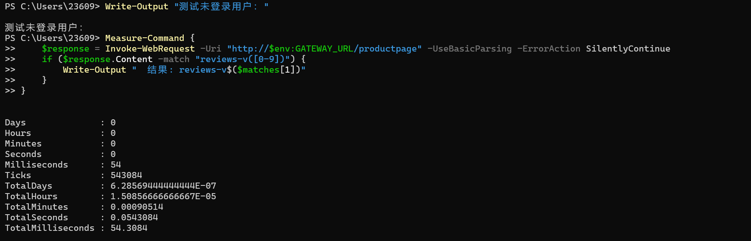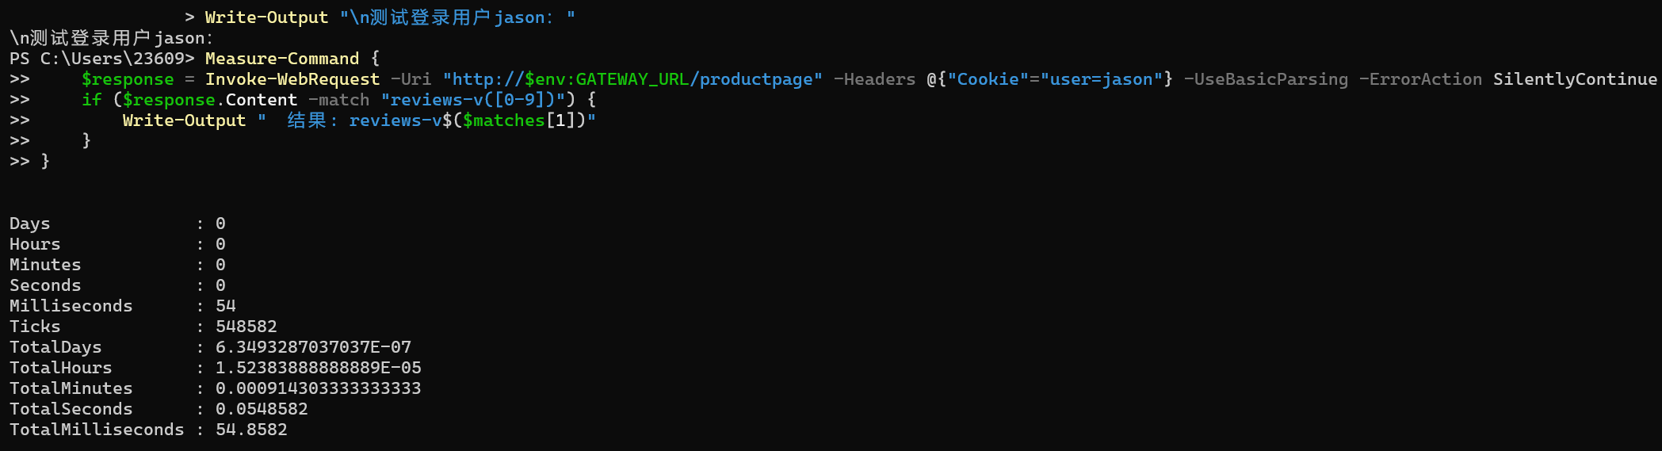
3.4 Configure error fault
```powershell
Create error fault configuration
@"
apiVersion: networking.istio.io/v1alpha3
kind: VirtualService
metadata:
name: reviews
namespace: bookinfo
spec:
hosts:
- reviews
http:
- match:
- headers:
end-user:
exact: jason
fault:
abort:
percentage:
value: 100.0
httpStatus: 500
route:
- destination:
host: reviews
subset: v2
- route:
- destination:
host: reviews
subset: v1
"@ | Out-File -FilePath virtual-service-reviews-error.yaml -Encoding UTF8
Apply configuration
kubectl apply -f virtual-service-reviews-error.yaml -n bookinfo
Verify configuration
kubectl get virtualservice reviews -n bookinfo -o yaml
```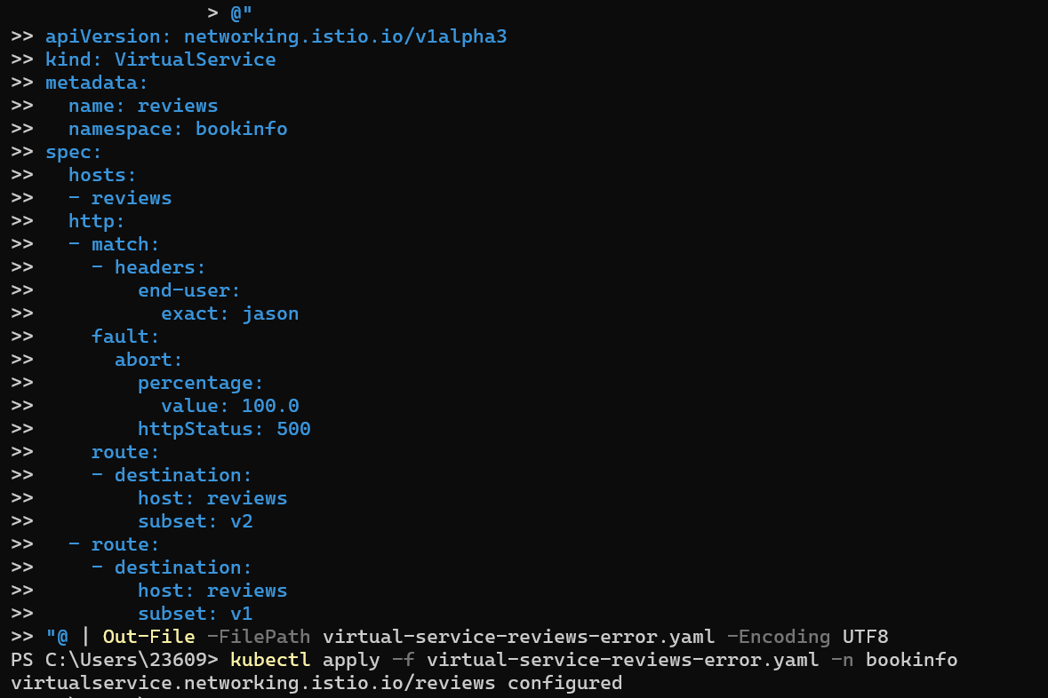
3.5 Test error fault
```powershell
Test unlogged-in user (should respond normally)
Write-Output "Unlogged-in user HTTP status code:"
(Invoke-WebRequest -Uri "http://$env:GATEWAY_URL/productpage" -UseBasicParsing -ErrorAction SilentlyContinue).StatusCode
Test logged-in user jason (should return 500 error)
Write-Output "\nLogged-in user jason HTTP status code:"
try {
(Invoke-WebRequest -Uri "http://$env:GATEWAY_URL/productpage" -Headers @{"Cookie"="user=jason"} -UseBasicParsing).StatusCode
} catch {
Write-Output $_.Exception.Response.StatusCode.Value__
}
```
4. Circuit Breaking
Experiment Objectives
Learn how to configure circuit breaking mechanisms to protect services from cascading failures.
Experiment Steps
4.1 Deploy Bookinfo application
4.2 Configure DestinationRule
```powershell
Create DestinationRule with circuit breaking configuration
@"
apiVersion: networking.istio.io/v1alpha3
kind: DestinationRule
metadata:
name: reviews
namespace: bookinfo
spec:
host: reviews
subsets:
- name: v1
labels:
version: v1
- name: v2
labels:
version: v2
- name: v3
labels:
version: v3
trafficPolicy:
connectionPool:
tcp:
maxConnections: 1
http:
http1MaxPendingRequests: 1
maxRequestsPerConnection: 1
outlierDetection:
consecutive5xxErrors: 1
interval: 1s
baseEjectionTime: 3m
"@ | Out-File -FilePath destination-rule-reviews-circuit-breaking.yaml -Encoding UTF8
Apply configuration
kubectl apply -f destination-rule-reviews-circuit-breaking.yaml -n bookinfo
Verify configuration
kubectl get destinationrule reviews -n bookinfo -o yaml
```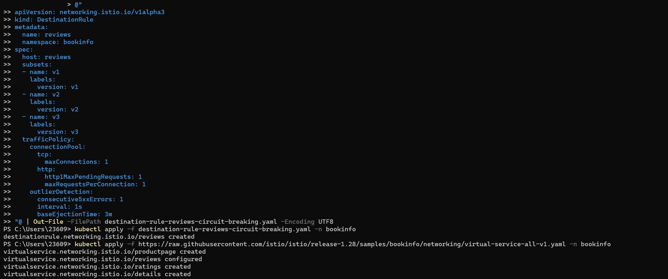
4.3 Configure routing to v1 version
```powershell
Apply routing configuration
kubectl apply -f https://raw.githubusercontent.com/istio/istio/release-1.28/samples/bookinfo/networking/virtual-service-all-v1.yaml -n bookinfo
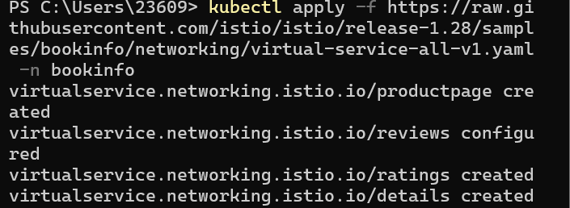
Verify configuration
kubectl get virtualservice reviews -n bookinfo -o yaml
```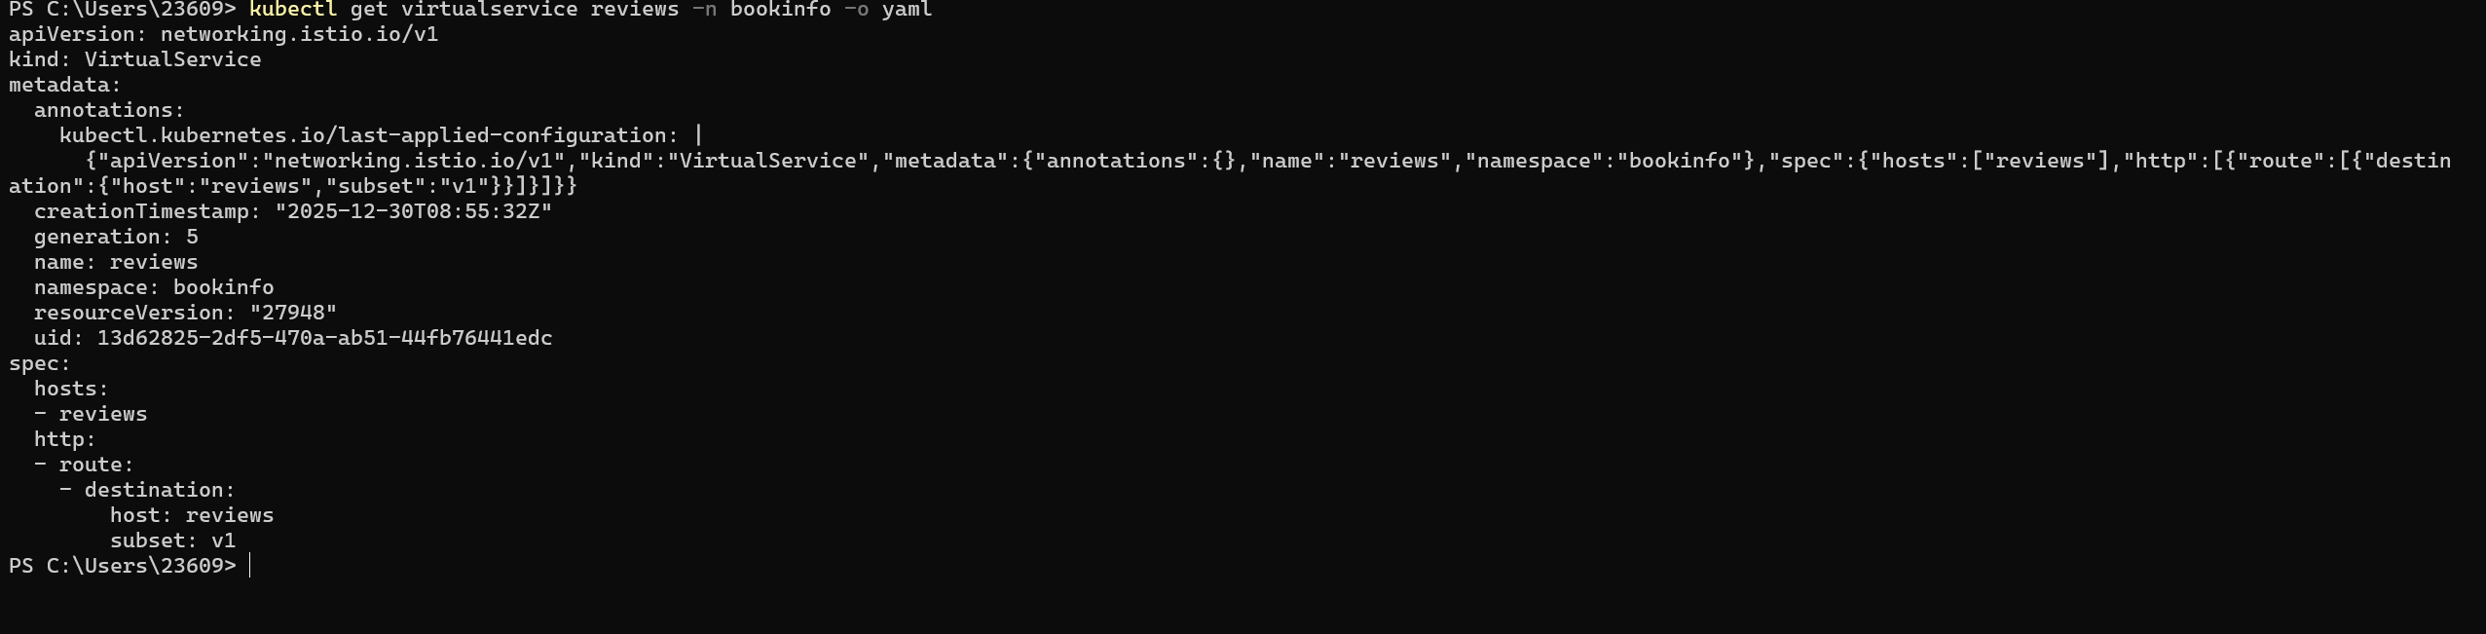
4.4 Deploy fortio tool to test circuit breaking
```powershell
Deploy fortio
kubectl apply -f https://raw.githubusercontent.com/istio/istio/release-1.28/samples/httpbin/sample-client/fortio-deploy.yaml -n istio-system
Enter fortio pod
$FORTIO_POD = kubectl get pods -n istio-system -l app=fortio -o jsonpath='{.items[0].metadata.name}'
kubectl exec "$FORTIO_POD" -n istio-system -c fortio -- /usr/bin/fortio load -c 2 -qps 0 -n 20 -loglevel Warning http://reviews.bookinfo:9080/reviews/0
```
4.5 Test circuit breaking effect
```powershell
Run high concurrency test
kubectl exec "$FORTIO_POD" -n istio-system -c fortio -- /usr/bin/fortio load -c 3 -qps 0 -n 30 -loglevel Warning http://reviews.bookinfo:9080/reviews/0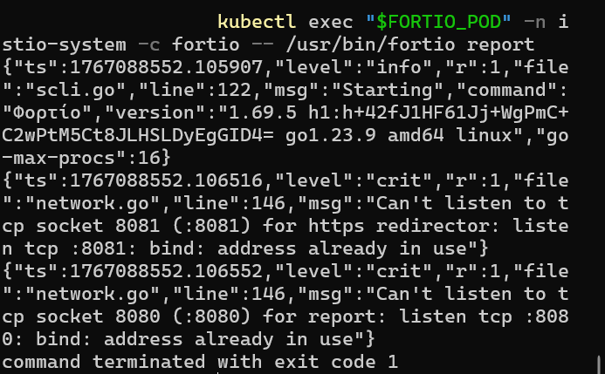
View circuit breaking statistics
kubectl exec "$FORTIO_POD" -n istio-system -c fortio -- /usr/bin/fortio report
```
4.6 Verify circuit breaking status
```powershell
Use istioctl to view circuit breaking status
istioctl pc destination "$FORTIO_POD" -n istio-system --name reviews.bookinfo.svc.cluster.local:9080
```
Experiment Summary
Through this experiment, you should have mastered the following Istio traffic management functions:
1. Traffic Shifting: Learned how to gradually shift traffic from one service version to another, achieving smooth service upgrades.
2. Request Routing: Learned how to route traffic to different service versions based on request attributes (such as user identity, HTTP headers), achieving fine-grained traffic control.
3. Fault Injection: Learned how to inject delay and error faults to test service resilience and fault tolerance, ensuring the system can run stably under abnormal conditions.
4. Circuit Breaking Mechanism: Learned how to configure circuit breaking rules to protect services from cascading failures, improving the overall reliability of the system.

