Lab 9 - Knative Experiment Guide
experiment overview
this experiment will provide hands-on experience in building, deploying, and managing serverless cloud-native applications on Kubernetes using Knative.
experiment requirements
complete the following three topics and submit a Word or PDF document containing screenshots of key steps:
1. Knative Functions
2. Knative Serving
3. Knative Eventing
Knative Functions
experiment steps
1. install Knative Functions CLI (func)
manual installation steps
Download func CLI
- visit GitHub release page: https://github.com/knative/func/releases/latest
- download Windows version: func_windows_amd64.exe
- add to system path

2. func verify installation
```powershell
func version
```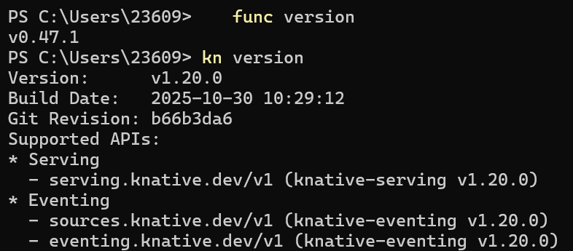
3. create a new function project
```powershell
# create function directory
mkdir -Force $HOME\knative-functions
cd $HOME\knative-functions
# initialize function project
func create -l python my-function
# enter function directory
cd my-function
```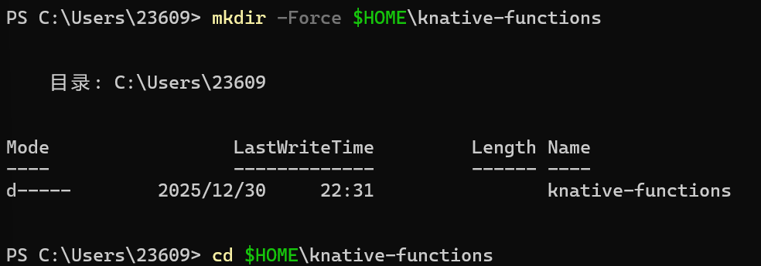
4. view function project structure
```powershell
Get-ChildItem -Force
```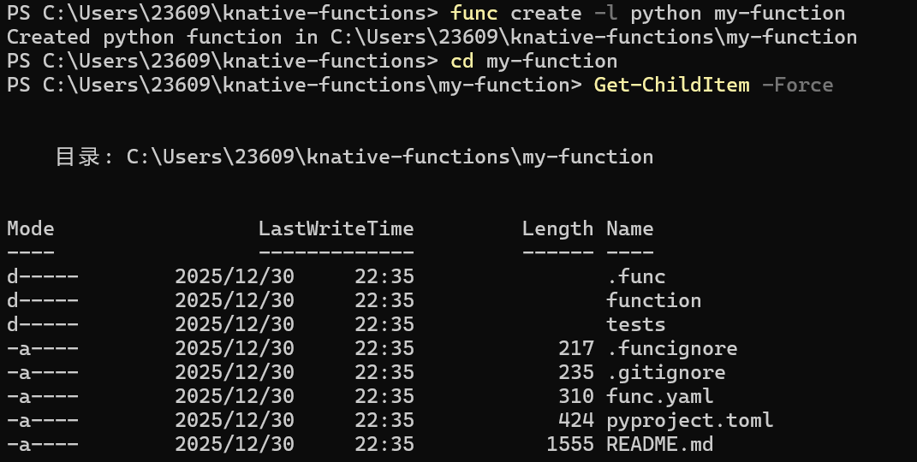
5. view function code
```powershell
Get-Content function/func.py
```
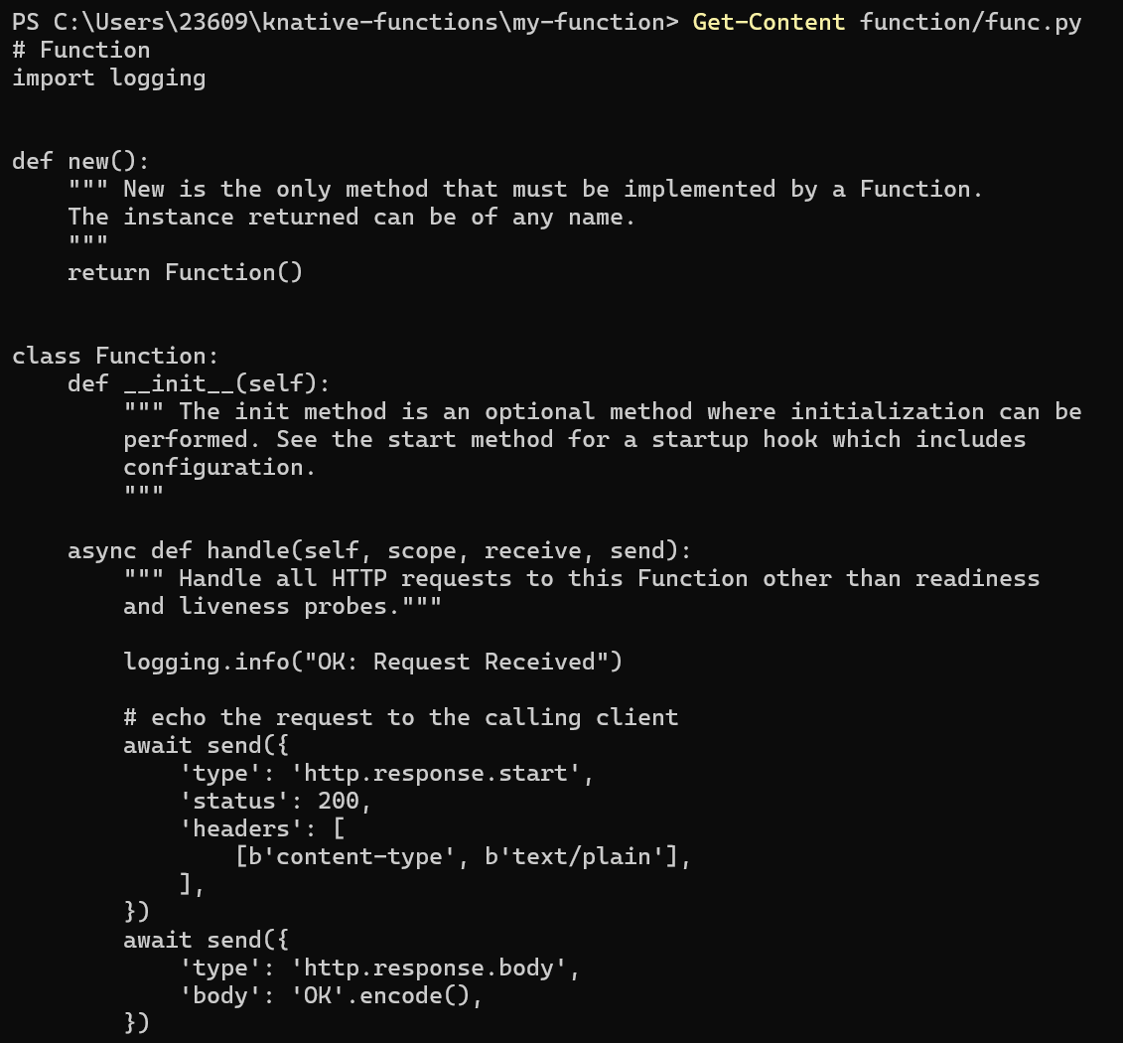
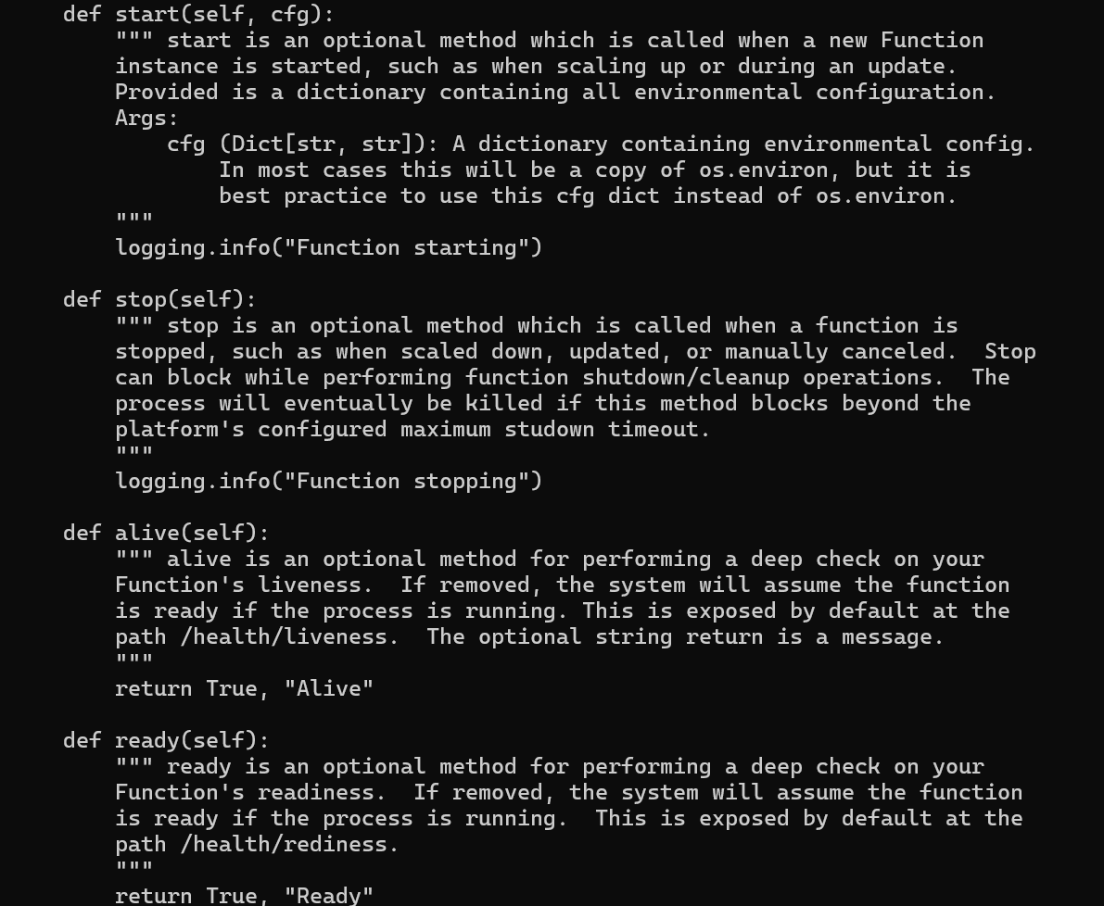
6. build function image (using local registry)
```powershell
# use local registry (port 5000) to build image
# note: func build uses -i or --image parameter, not -t
func build -i localhost:5000/my-function:latest
```
7. verify image has been built
```powershell
docker images | findstr my-function
```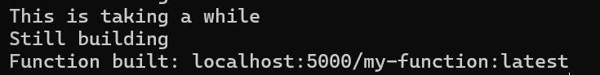
8. test function local run
```powershell
func run
```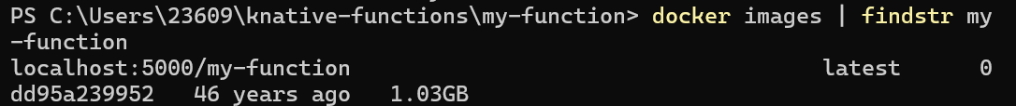
9. test function call
in another terminal:
```powershell
# use PowerShell's Invoke-WebRequest
Invoke-WebRequest -Uri http://localhost:8080 -UseBasicParsing
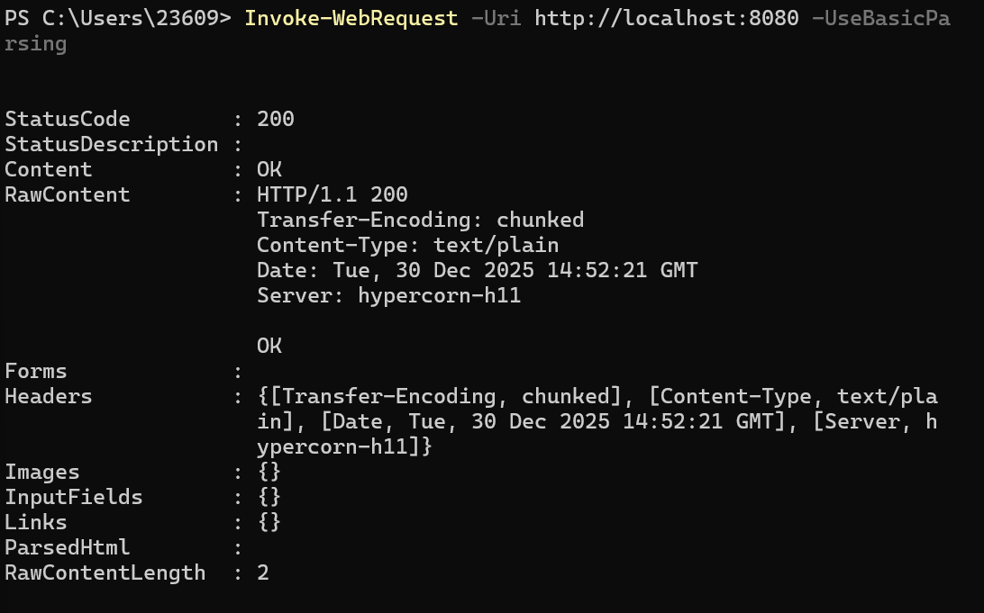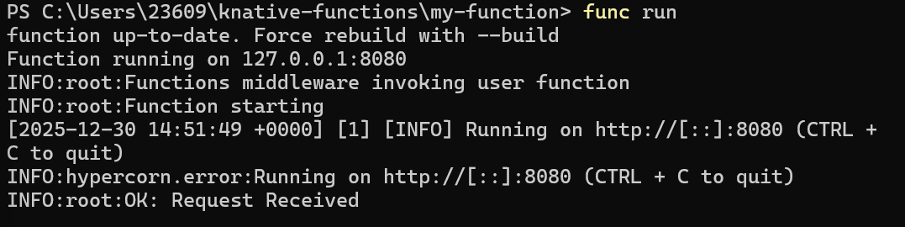
Knative Serving
experiment steps
1. check Knative Serving components
```powershell
kubectl get pods -n knative-serving
```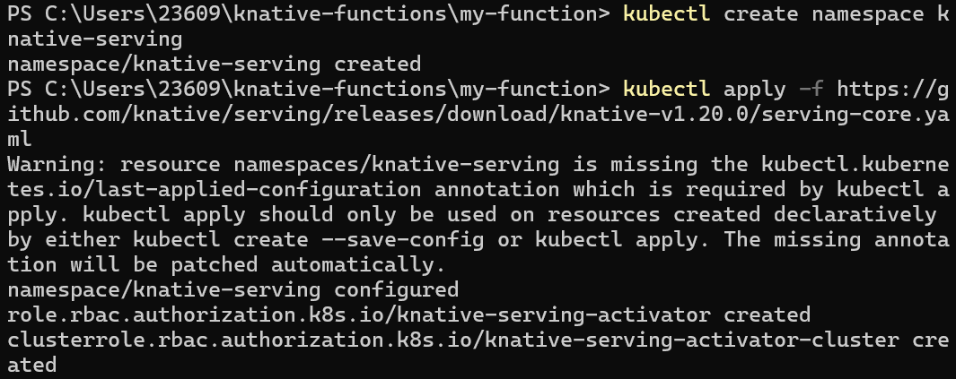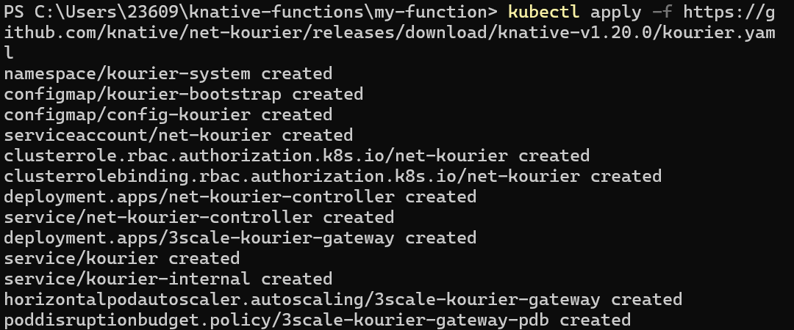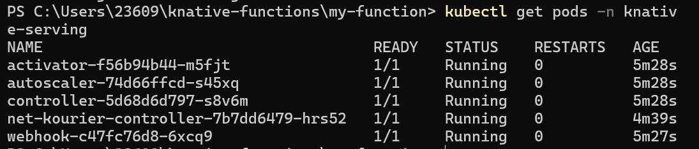
2. deploy first Knative Service
```powershell
kn service create hello `
--image ghcr.io/knative/helloworld-go:latest `
--port 8080 `
--env TARGET=World
```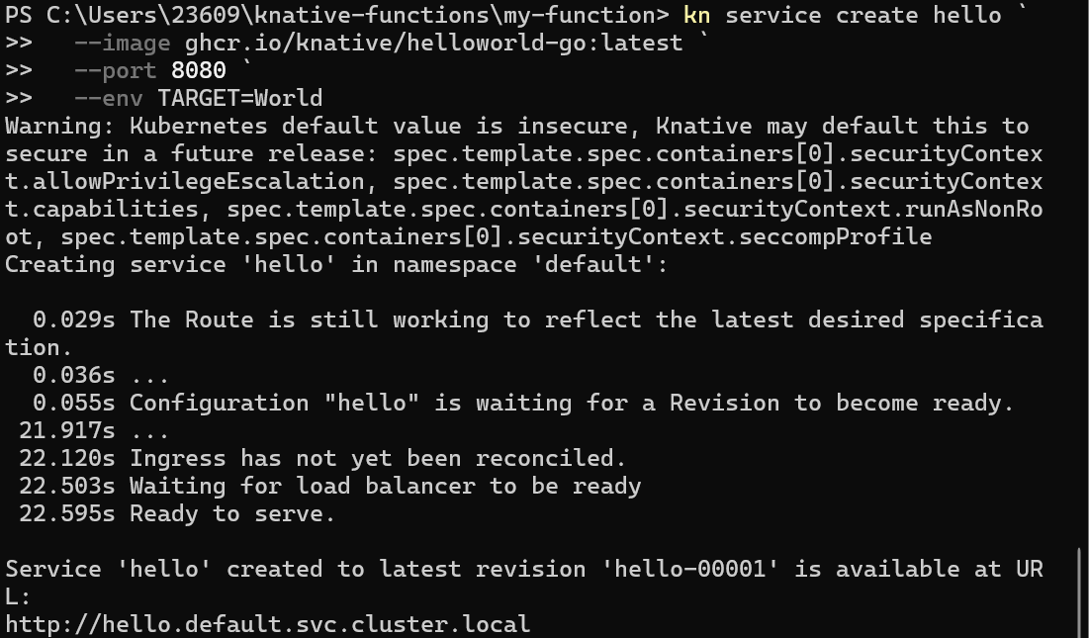
3. view deployed Service
```powershell
kn service list
```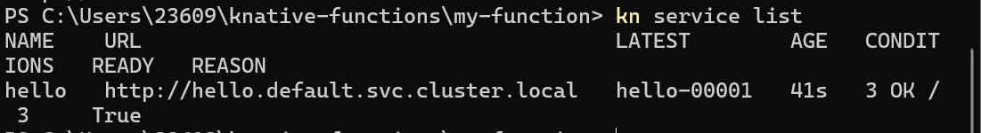
4. check Service status
```powershell
kubectl get ksvc hello -o yaml
```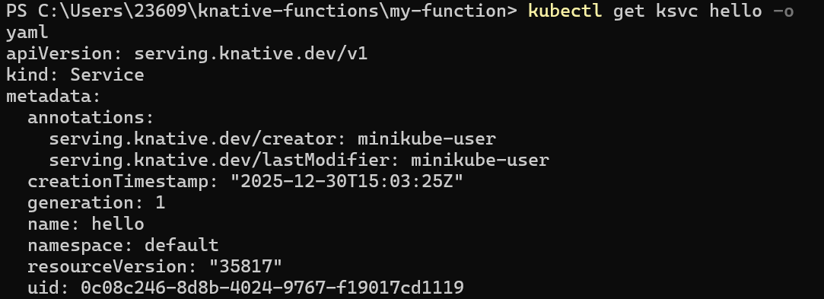
5. access Service
```powershell
# get Service URL
$SERVICE_URL = kn service describe hello -o url
# use PowerShell's Invoke-WebRequest
Invoke-WebRequest -Uri $SERVICE_URL -UseBasicParsing
# or use curl.exe (if installed)
curl.exe $SERVICE_URL
```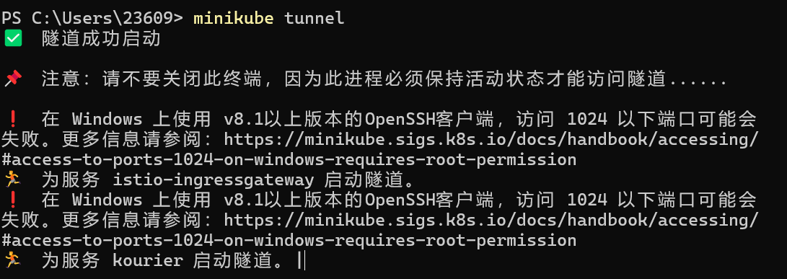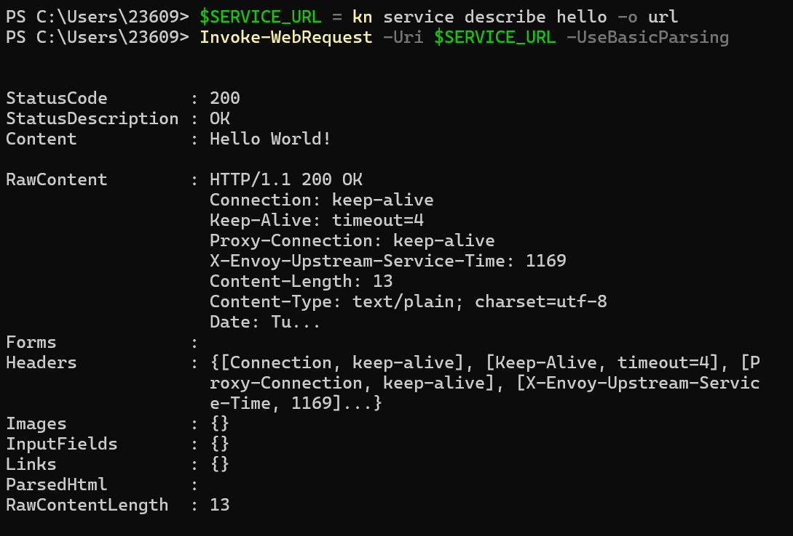
6. extend Service configuration
```powershell
kn service update hello --env TARGET=Knative
```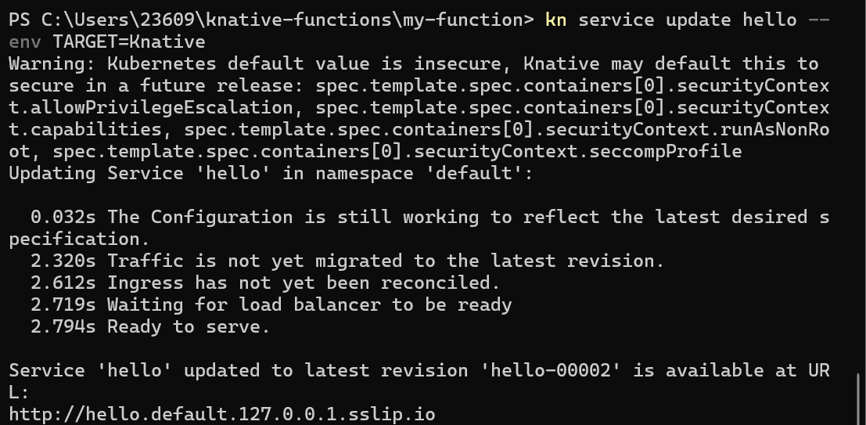
7. access Service again, verify update
```powershell
# use PowerShell's Invoke-WebRequest
Invoke-WebRequest -Uri $SERVICE_URL -UseBasicParsing
# or use curl.exe (if installed)
curl.exe $SERVICE_URL
```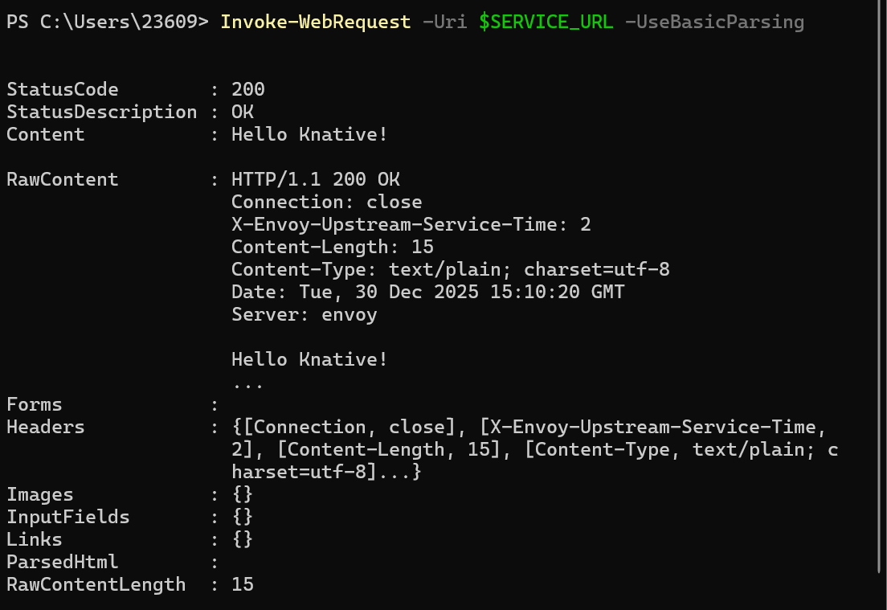
8. view Service revisions
```powershell
kn revision list
```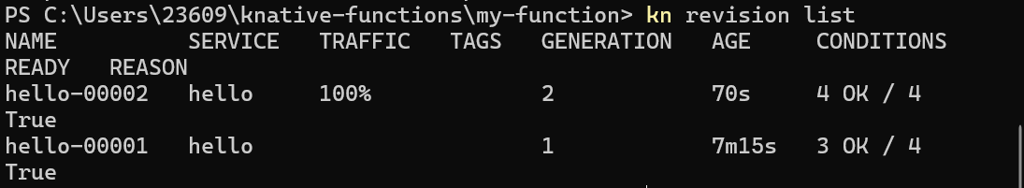
Knative Eventing
experiment steps
1. check Knative Eventing components
```powershell
kubectl get pods -n knative-eventing
```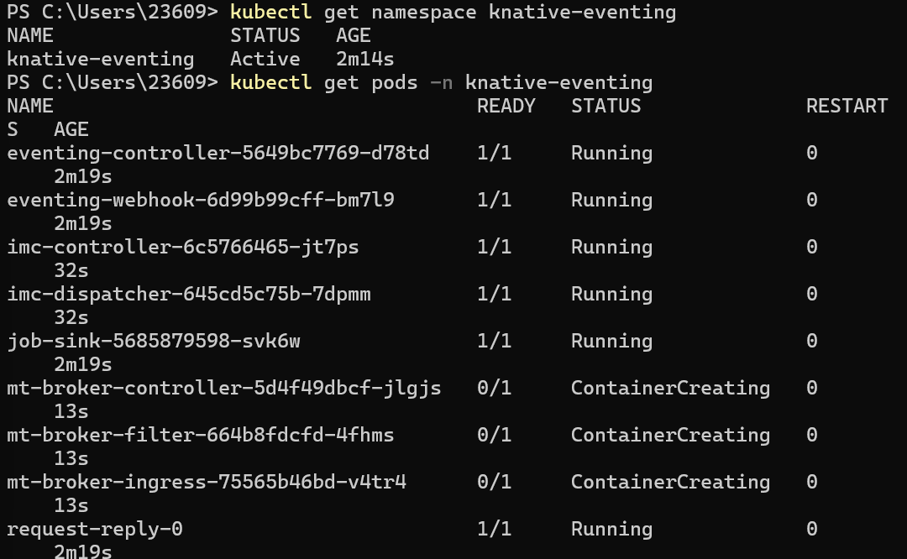
2. create namespace
```powershell
kubectl create namespace knative-eventing-demo
```
3. create event source (PingSource)
```powershell
# create temporary YAML file
$pingSourceYaml = @'
apiVersion: sources.knative.dev/v1
kind: PingSource
metadata:
name: test-ping-source
namespace: knative-eventing-demo
spec:
schedule: "*/1 * * * *"
contentType: "application/json"
data: '{"message": "Hello from PingSource!"}'
sink:
ref:
apiVersion: serving.knative.dev/v1
kind: Service
name: event-display
namespace: knative-eventing-demo
'@
# write to file
$pingSourceYaml | Out-File -FilePath ping-source.yaml -Encoding ASCII
# apply YAML file
kubectl apply -f ping-source.yaml
# clean up temporary file
Remove-Item ping-source.yaml
```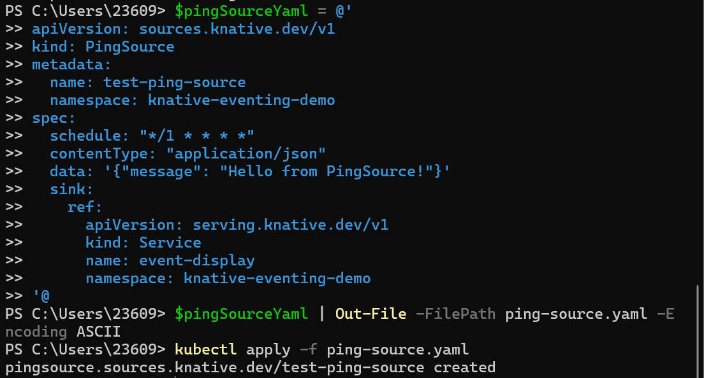
4. create event display service
```powershell
kn service create event-display `
--image gcr.io/knative-releases/knative.dev/eventing/cmd/event_display `
--namespace knative-eventing-demo
```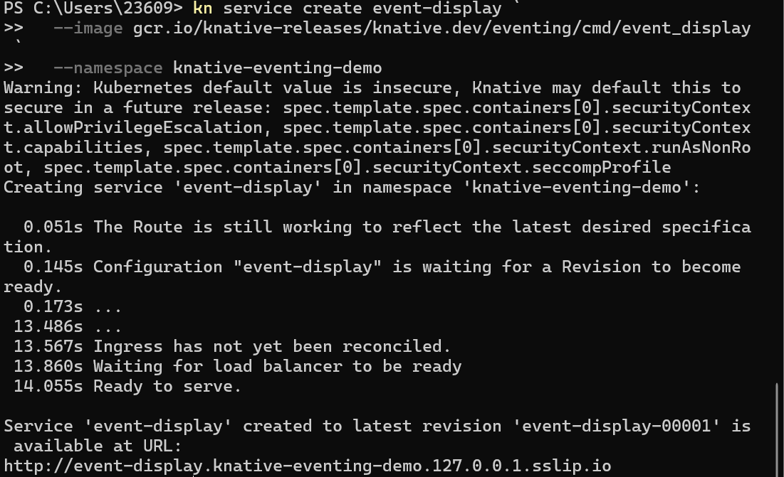
5. view event source and service status
```powershell
kubectl get pingsource -n knative-eventing-demo
kn service list -n knative-eventing-demo
```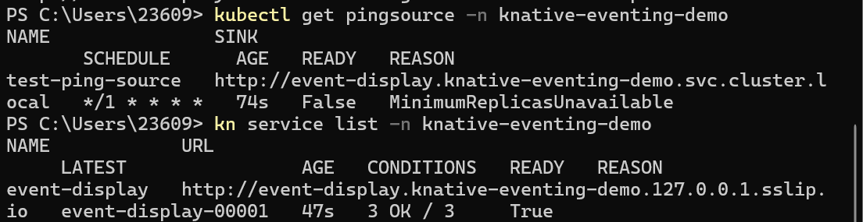
6. view event display service logs
```powershell
kubectl logs -l serving.knative.dev/service=event-display -n knative-eventing-demo -c user-container -f
```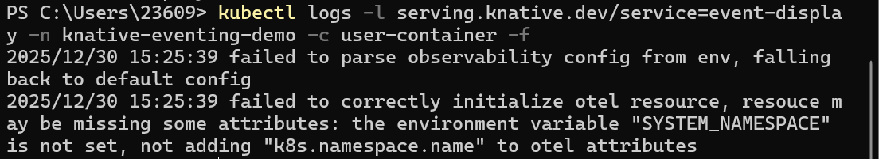
7. observe event reception
wait for about 1 minute, observe if events are sent from PingSource to event-display service
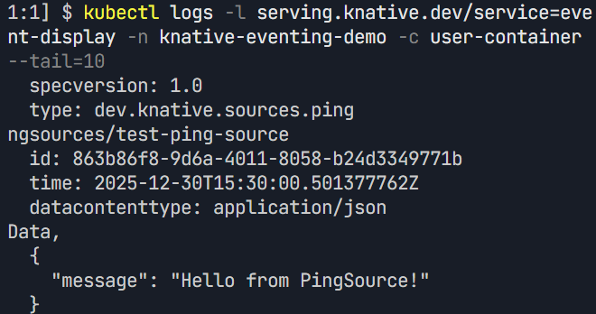
8. create another event source (ApiServerSource)
```powershell
# create temporary YAML file
$apiServerSourceYaml = @'
apiVersion: v1
kind: ServiceAccount
metadata:
name: events-sa
namespace: knative-eventing-demo
---
apiVersion: rbac.authorization.k8s.io/v1
kind: ClusterRole
metadata:
name: event-watcher
rules:
- apiGroups: [""]
resources: ["events"]
verbs: ["get", "list", "watch"]
---
apiVersion: rbac.authorization.k8s.io/v1
kind: ClusterRoleBinding
metadata:
name: k8s-ra-event-watcher
roleRef:
apiGroup: rbac.authorization.k8s.io
kind: ClusterRole
name: event-watcher
subjects:
- kind: ServiceAccount
name: events-sa
namespace: knative-eventing-demo
---
# create ApiServerSource
apiVersion: sources.knative.dev/v1
kind: ApiServerSource
metadata:
name: test-api-server-source
namespace: knative-eventing-demo
spec:
serviceAccountName: events-sa
mode: Resource
resources:
- apiVersion: v1
kind: Event
sink:
ref:
apiVersion: serving.knative.dev/v1
kind: Service
name: event-display
namespace: knative-eventing-demo
'@
# write to file
$apiServerSourceYaml | Out-File -FilePath api-server-source.yaml -Encoding ASCII
# apply YAML file
kubectl apply -f api-server-source.yaml
# clean up temporary file
Remove-Item api-server-source.yaml
```
11. clean up resources
```powershell
# delete namespace, clean up all resources
kubectl delete namespace knative-eventing-demo
```
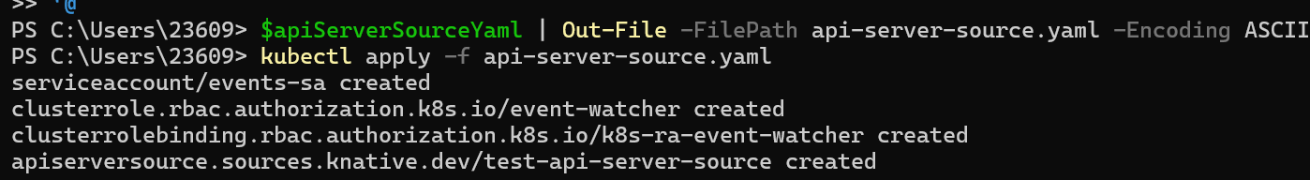
experiment summary
completed content
1. Knative Functions：create, build, and test functions locally
2. Knative Serving：deploy, update, and test services
3. Knative Eventing：configure event sources and event display services

