Istio Getting Started Guide

Experiment Overview
This experiment is based on the Istio official documentation's Getting Started guide, which describes in detail the installation, configuration, and usage process of the Istio service mesh.

Prerequisites
- Kubernetes cluster (version 1.23+)
- kubectl command-line tool configured
- At least 4GB of available memory
- 2 CPU cores

1. Install Istio CLI

1.1 Download Istio

Method: Manual download on Windows system
Add the directory containing istioctl.exe to the system PATH environment variable
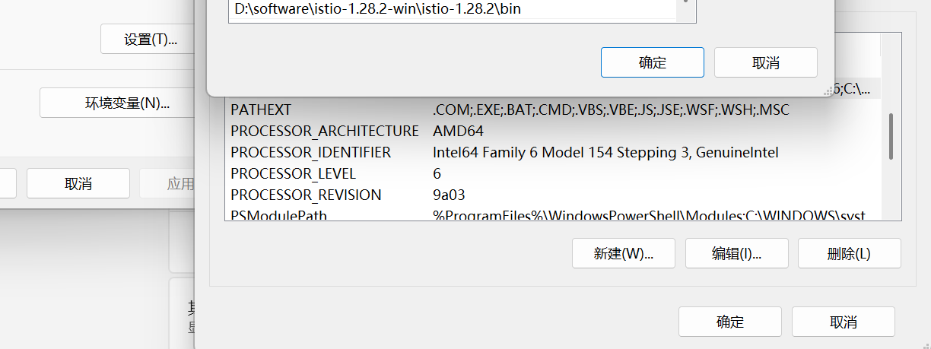

1.2 Verify Installation
```powershell
# Execute in command line
istioctl version
```

2. Install Istio Control Plane

2.1 Check Cluster Status
```powershell
kubectl get nodes
```

2.2 Install Istio using istioctl
```powershell
# Install using demo profile, suitable for testing and demonstration
istioctl install --set profile=demo -y
```
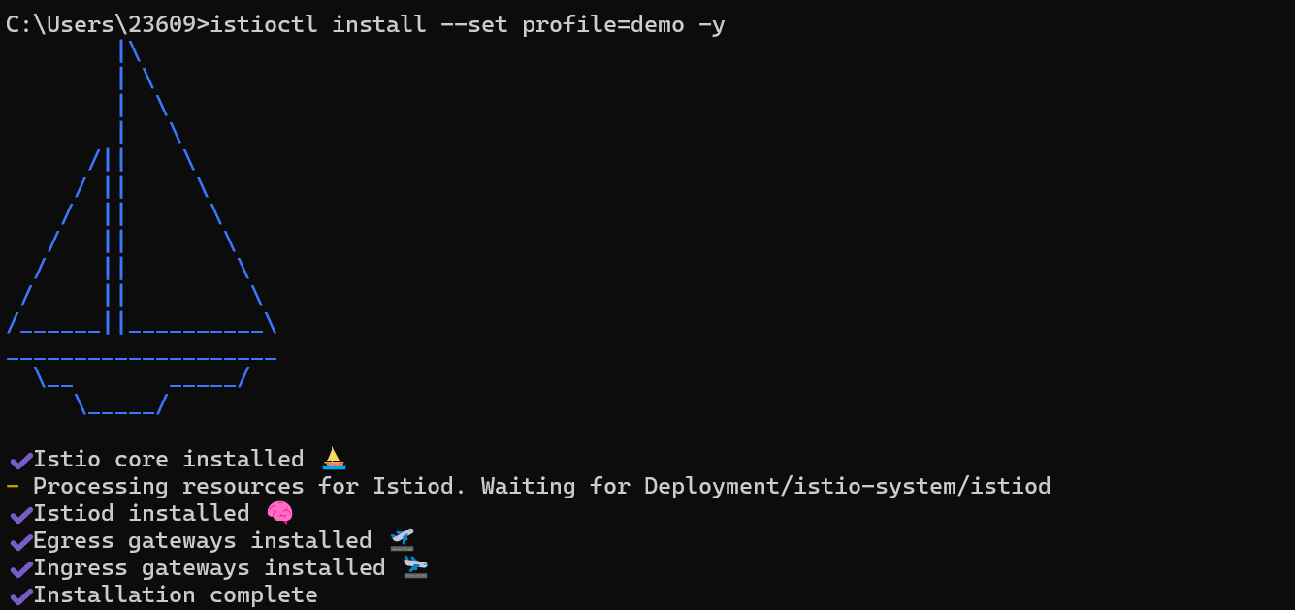

3. Deploy Sample Application (Bookinfo)

3.1 Enable Automatic Injection
```powershell
# Enable automatic injection for the default namespace
kubectl label namespace default istio-injection=enabled
```
3.2 Deploy Bookinfo Application
Execute in the Istio distribution root directory (recommended)
1. First navigate to the Istio distribution root directory:
```powershell
# Windows PowerShell
cd D:\software\istio-1.27.2-win\istio-1.27.2
```
2. Then execute the deployment command:
```powershell
kubectl apply -f samples/bookinfo/platform/kube/bookinfo.yaml
```
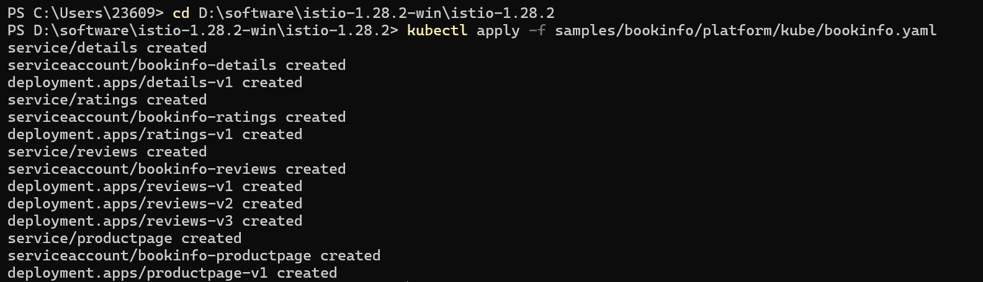
3.3 Verify Application Deployment
```powershell
# Check Pod status
kubectl get pods

# Check services
kubectl get svc
```
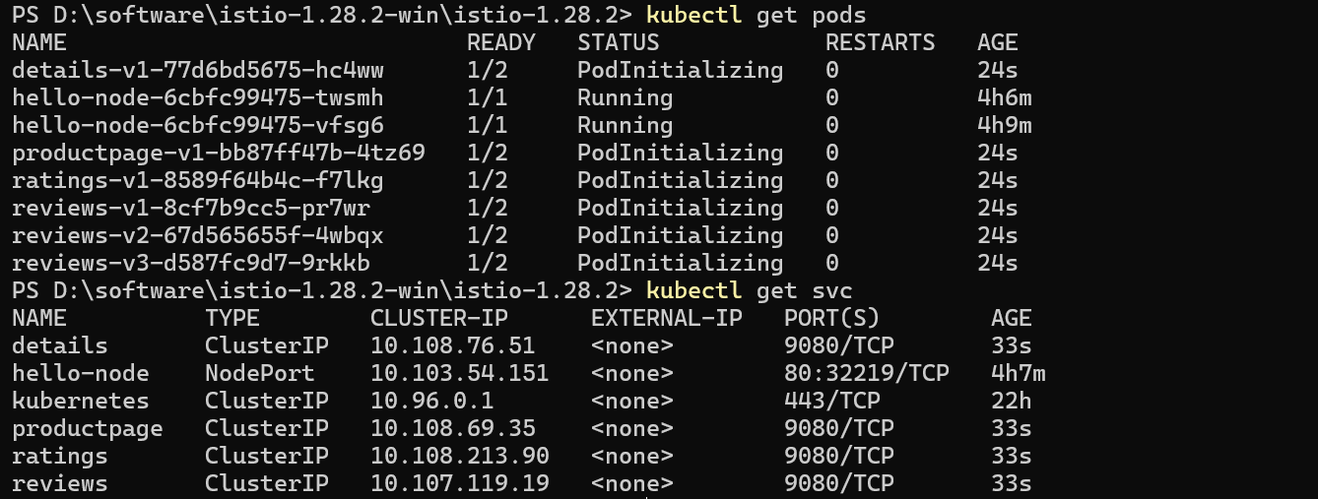
Verify if the application is running properly

In Windows PowerShell
```powershell
$podName = kubectl get pod -l app=ratings -o jsonpath='{.items[0].metadata.name}'
kubectl exec $podName -c ratings -- curl -sS productpage:9080/productpage | Select-String -Pattern "<title>.*</title>" -AllMatches | ForEach-Object {$_.Matches.Value}
```
4. Configure Ingress Gateway

4.1 Deploy Gateway and VirtualService

Execute in the Istio distribution root directory
```powershell
kubectl apply -f samples/bookinfo/networking/bookinfo-gateway.yaml
```

4.2 Verify Gateway Configuration
```powershell
kubectl get gateway
kubectl get virtualservice
```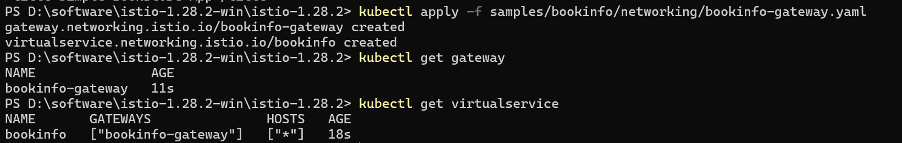

5. Configure Traffic Management

5.1 Set Default Destination Rules

Execute in the Istio distribution root directory
```powershell
kubectl apply -f samples/bookinfo/networking/destination-rule-all.yaml
```
5.2 Configure All Traffic to Point to v1 Version

Execute in the Istio distribution root directory
```powershell
kubectl apply -f samples/bookinfo/networking/virtual-service-all-v1.yaml
```
5.3 Configure User-Based Routing

Execute in the Istio distribution root directory
```powershell
kubectl apply -f samples/bookinfo/networking/virtual-service-reviews-test-v2.yaml
```

6. Configure Fault Injection

6.1 Inject Delay Fault

Execute in the Istio distribution root directory
```powershell
kubectl apply -f samples/bookinfo/networking/virtual-service-ratings-test-delay.yaml
```
6.2 Test Fault

In Windows PowerShell
```powershell
# Access as jason user, should see delay
Invoke-WebRequest -Uri "http://$GATEWAY_URL/productpage" -UseBasicParsing -Headers @{"Cookie"="user=jason"} | Select-Object -ExpandProperty Content
```

6.3 Remove Fault Injection

Execute in the Istio distribution root directory
```powershell
kubectl delete -f samples/bookinfo/networking/virtual-service-ratings-test-delay.yaml
```
7. Configure Circuit Breaking

7.1 Set Destination Rules to Enable Circuit Breaking

Execute in the Istio distribution root directory
```powershell
kubectl apply -f samples/bookinfo/networking/destination-rule-reviews.yaml
```
7.2 Configure Circuit Breaking Policy

Execute in the Istio distribution root directory
```powershell
kubectl apply -f samples/bookinfo/networking/virtual-service-reviews-fault.yaml
```

8. Clean Up Resources

8.1 Delete Bookinfo Application

Execute in the Istio distribution root directory
```powershell
# Delete application resources
kubectl delete -f samples/bookinfo/platform/kube/bookinfo.yaml
# Delete Gateway and VirtualService
kubectl delete -f samples/bookinfo/networking/bookinfo-gateway.yaml
# Delete destination rules
kubectl delete -f samples/bookinfo/networking/destination-rule-all.yaml
# Remove automatic injection label
kubectl label namespace default istio-injection-"
```
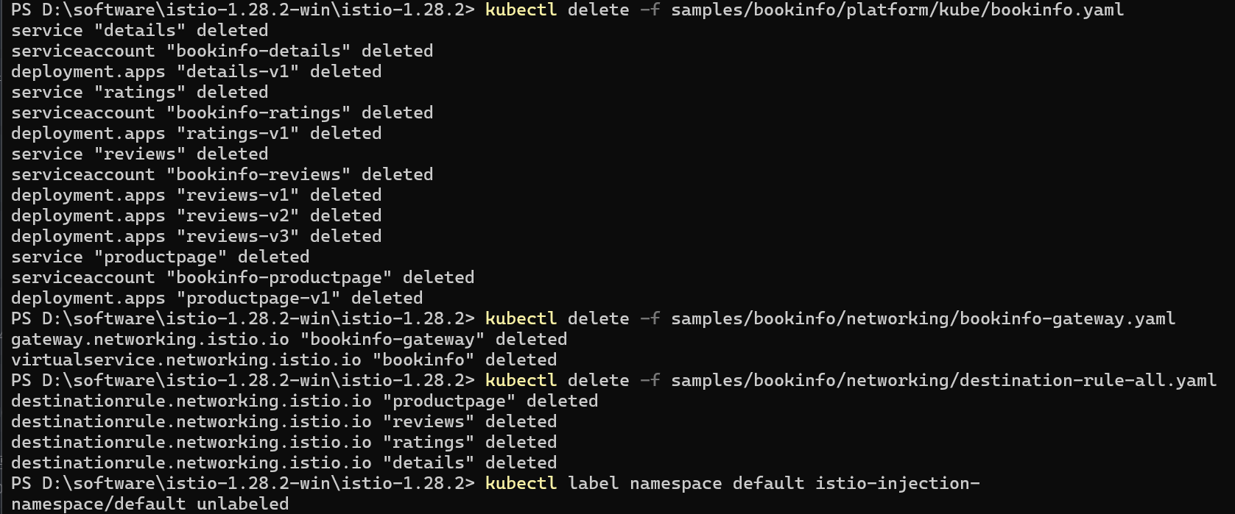
8.2 Uninstall Istio
```powershell
istioctl uninstall -y --purge
kubectl delete namespace istio-system
```
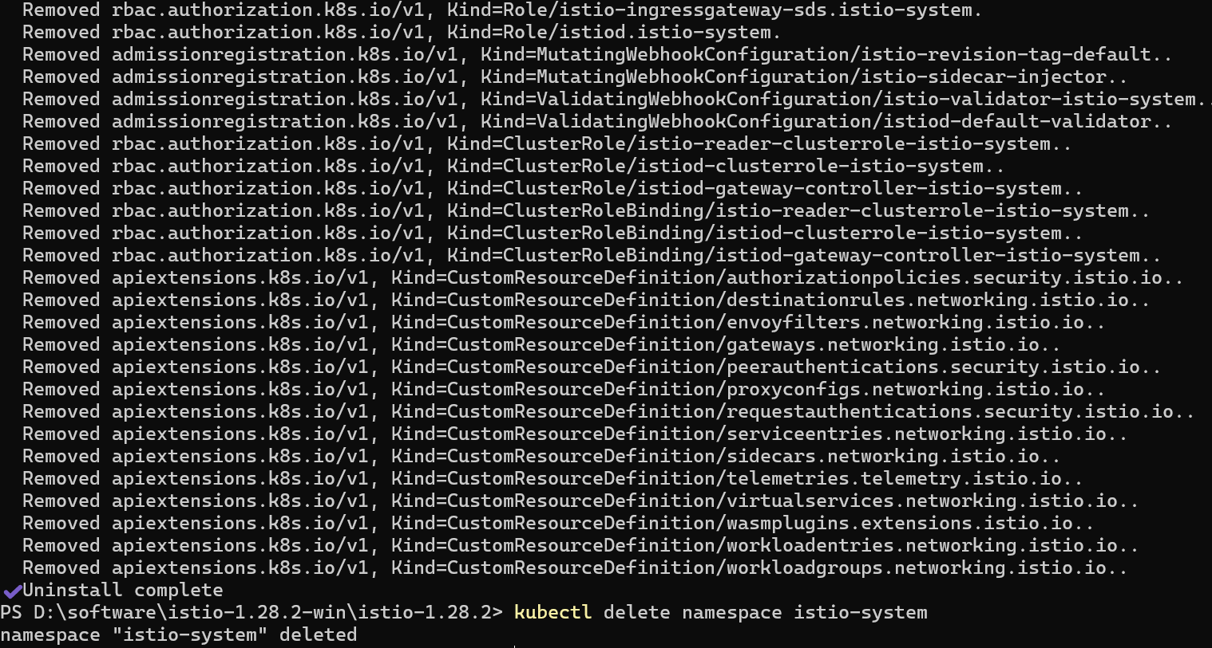
9. Experiment Summary

Through this experiment, you have completed:
1. Installation and configuration of Istio
2. Deployment of sample applications
3. Configuration of Ingress Gateway
4. Implementation of traffic management strategies
5. Testing of fault injection and circuit breaking
6. Usage of telemetry features

Istio provides powerful service mesh capabilities that can help you manage traffic, security, observability, and other aspects in microservice architectures. It is recommended that you further explore advanced features of Istio, such as:
- Security policy configuration
- Advanced traffic management
- Custom telemetry
- Multi-cluster deployment

10. Reference Links

- Istio official documentation: https://istio.io/latest/docs/
- Istio Getting Started: https://istio.io/latest/docs/setup/getting-started/
- Bookinfo application example: https://istio.io/latest/docs/examples/bookinfo/
- Istio traffic management: https://istio.io/latest/docs/concepts/traffic-management/
- Istio security: https://istio.io/latest/docs/concepts/security/
- Istio observability: https://istio.io/latest/docs/concepts/observability/

