Lab.10: Deploying Predictive Models with KServe on Minikube
Environment Requirements
- Windows PowerShell
- Docker
- kubectl
- Minikube
1. Installing and Configuring KServe on Minikube
Step 1: Start Minikube Cluster
```powershell
Start Minikube cluster with 4GB memory and 2 CPUs
minikube start --memory=4096 --cpus=2
```
Step 2: Enable Necessary Minikube Addons
```powershell
Enable metrics-server addon
minikube addons enable metrics-server
```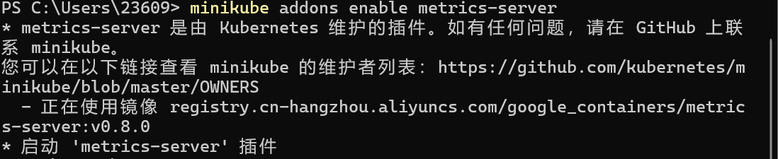
3. Verify Installation
```powershell
Check installed KServe CRDs
kubectl get crd | Select-String -Pattern kserve
Check KServe controller status
kubectl get pods -n kserve
```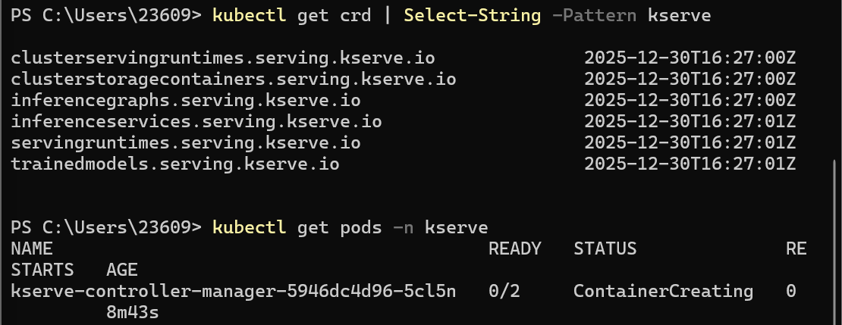
2. Deploying Predictive Model using KServe InferenceService
Step 1: Create Test Namespace
```powershell
Create namespace named kserve-test
kubectl create namespace kserve-test
```
Step 2: Prepare Model Deployment File
Run the following commands in PowerShell to create the `sklearn-iris.yaml` file:
```powershell
Define YAML content
$yamlContent = @"
apiVersion: serving.kserve.io/v1beta1
kind: InferenceService
metadata:
name: sklearn-iris
namespace: kserve-test
spec:
predictor:
model:
modelFormat:
name: sklearn
storageUri: gs://kfserving-examples/models/sklearn/1.0/model
"@
Write content to file
$yamlContent | Out-File -FilePath .\sklearn-iris.yaml -Encoding UTF8
View file content
Get-Content .\sklearn-iris.yaml
```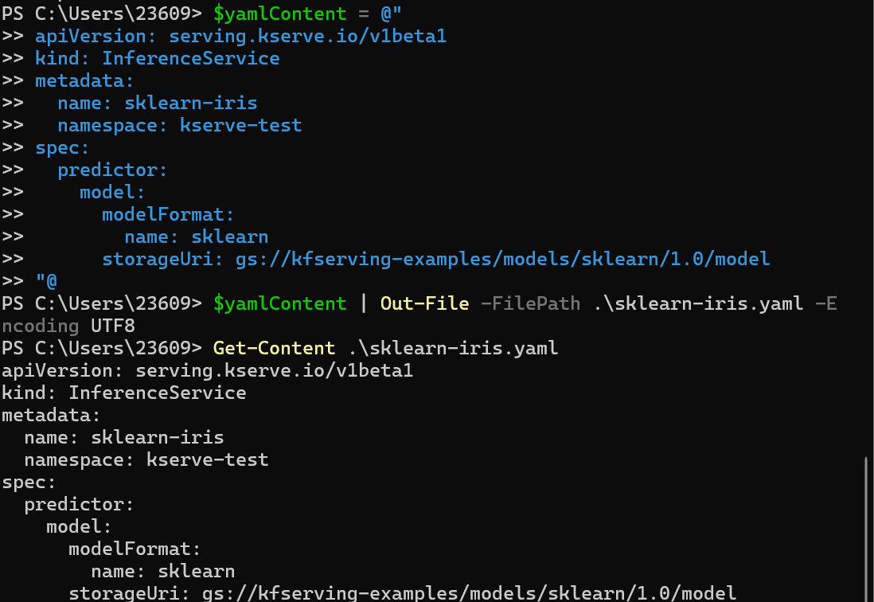
Step 3: Deploy Model
```powershell
Apply deployment file
kubectl apply -f sklearn-iris.yaml
Check deployment status
kubectl get isvc sklearn-iris -n kserve-test
```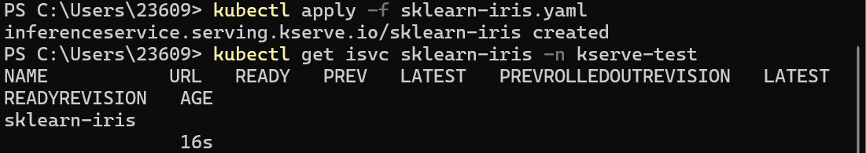
Step 4: Verify Deployment
```powershell
Wait for deployment to complete
kubectl get isvc sklearn-iris -n kserve-test -w
Check detailed status
kubectl describe isvc sklearn-iris -n kserve-test
```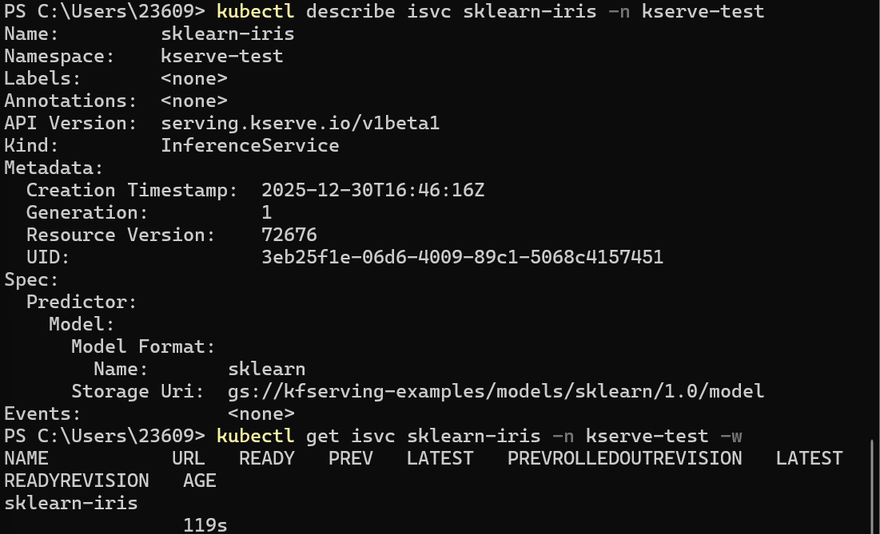
3. Monitoring Service Status and Debugging
Step 1: Check InferenceService Status
```powershell
kubectl apply -f simple_deployment.yaml
```
View Deployment Status
```powershell
Check deployment status
kubectl get deployment sklearn-iris-simple -n kserve-test
Check Pod status
kubectl get pods -n kserve-test
Check service status
kubectl get svc sklearn-iris-simple-service -n kserve-test
```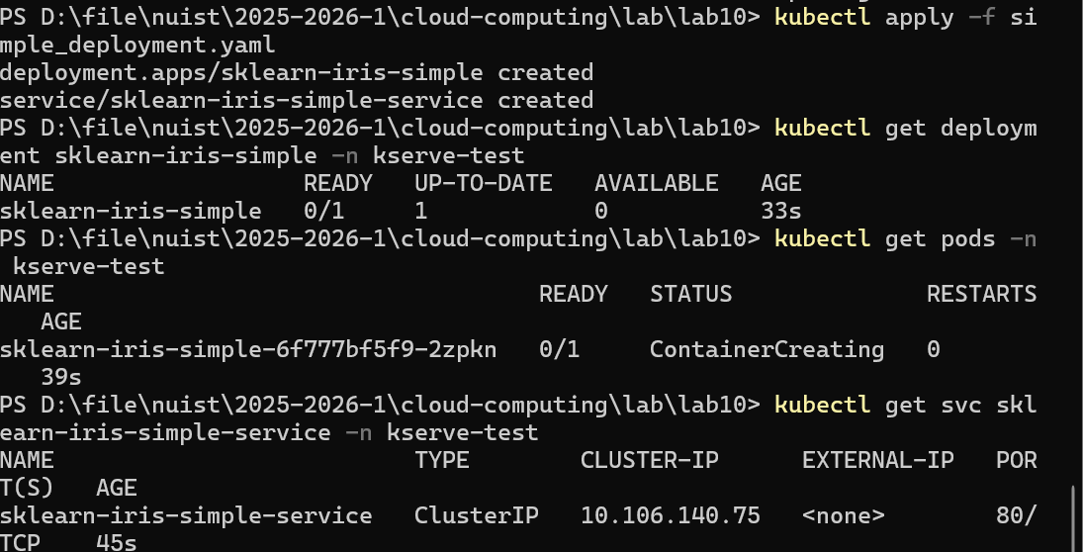
Step 2: View Logs for Debugging
```powershell
Get Pod name
$podName = kubectl get pods -n kserve-test -o jsonpath='{.items[0].metadata.name}'
View Pod logs
kubectl logs $podName -n kserve-test
Check detailed events
kubectl describe isvc sklearn-iris -n kserve-test
```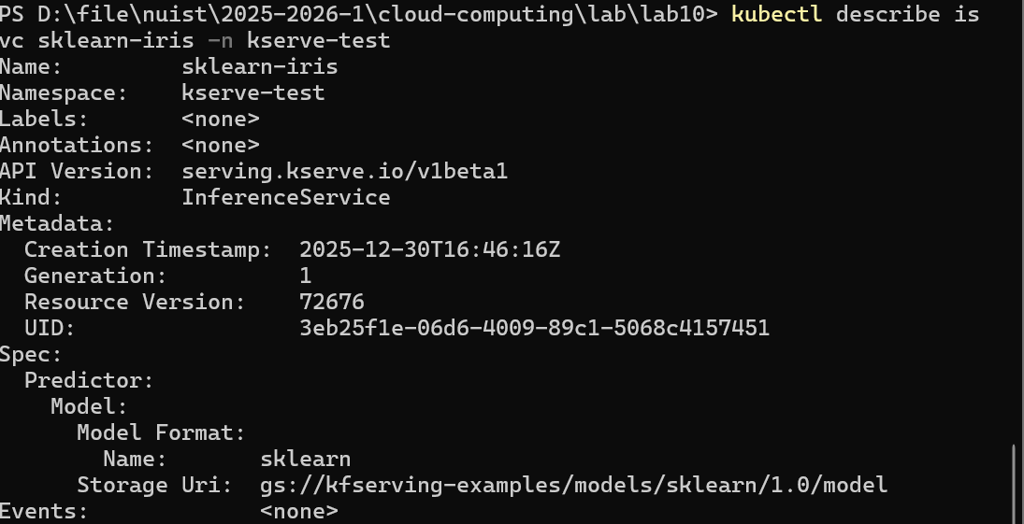
4. Accessing Service from Outside the Cluster
```powershell
Set namespace
$NAMESPACE="kserve-test"
Port forward to local machine (port 8080)
kubectl port-forward service/sklearn-iris-simple-service 8080:80 -n $NAMESPACE
```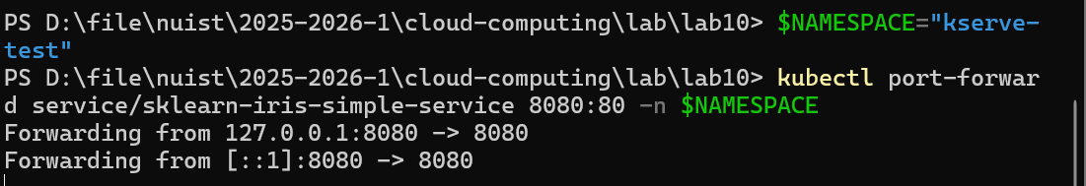
5. Sending Inference Requests and Interpreting Results
Step 1: Prepare Test Data
Run the following simple commands in PowerShell:
```powershell
Create test data file (one-liner)
'{"instances": [[6.8, 2.8, 4.8, 1.4], [6.0, 3.4, 4.5, 1.6]]}' > iris-input.json
Verify file creation
get-content iris-input.json
```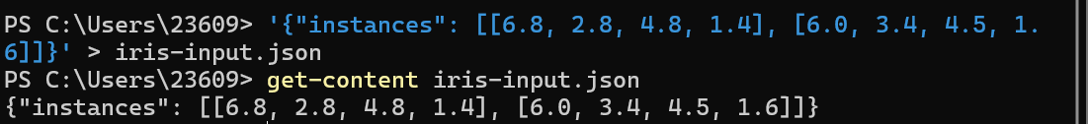
Step 2: Send Inference Request
```powershell
Set variable
$url = "http://localhost:8080/v1/models/model:predict"
Send request
Invoke-RestMethod -Uri $url -Method Post -ContentType "application/json" -Body (Get-Content .\iris-input.json -Raw)
```
Step 3: Interpret Results
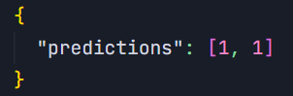
Result Interpretation:
- The prediction result `[1, 1]` indicates both test samples are classified as class 1
- In the Iris dataset, class 1 represents versicolor iris
Cleanup After Experiment
Step 1: Delete InferenceService
```powershell
Delete deployed model
kubectl delete isvc sklearn-iris -n kserve-test
```
Step 2: Stop Minikube Cluster
```powershell
minikube stop
```
Reference Links
- [KServe Quickstart Guide](https://kserve.github.io/website/docs/getting-started/quickstart-guide)
- [KServe Predictive Model Deployment](https://kserve.github.io/website/docs/getting-started/predictive-first-isvc)
- [KServe Video Tutorial](https://futurelei.com/KServe.mov)

