Docker Lab5 Command Record

- Run Your First Container
```bash
docker run hello-world
```
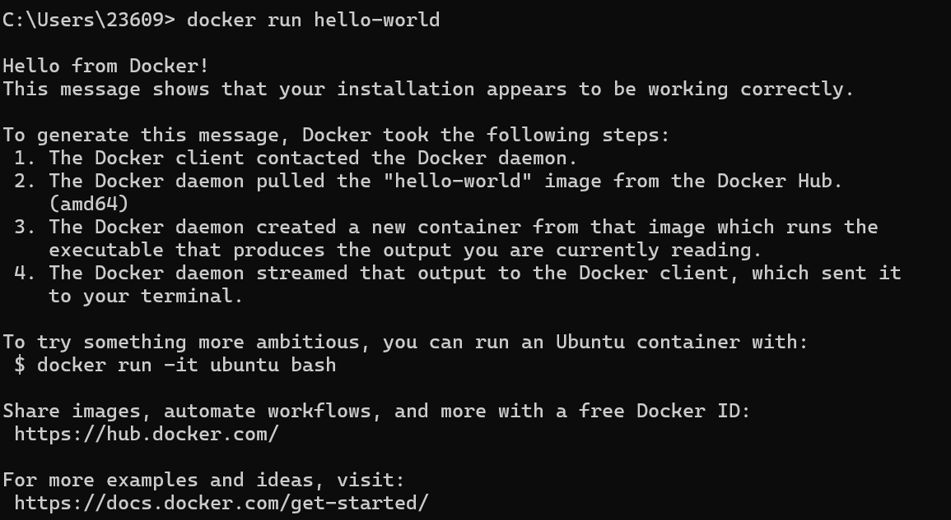
- Image Management
```bash
docker images
docker search nginx
docker pull nginx:latest
docker images
```
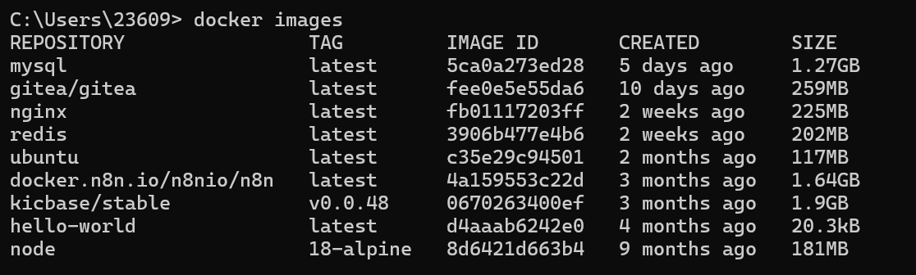
- Docker Compose Multi-container Application
```bash
# Create docker-compose.yml file
# Refer to previous configuration for content
docker-compose up -d
docker-compose ps
docker-compose down
```
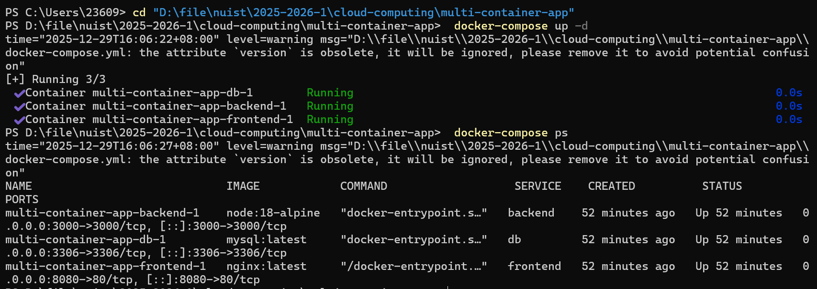
- Port Mapping Demonstration
```bash
docker run -d --name nginx-port-test -p 8081:80 nginx:latest
docker ps
docker stop nginx-port-test
docker rm nginx-port-test
```

- Override Container Default Configuration
```bash
docker run --rm ubuntu:latest echo 'Hello from custom command'
docker run -d --name nginx-custom-config -e NGINX_HOST=localhost -e NGINX_PORT=80 -p 8082:80 nginx:latest
docker exec nginx-custom-config env | Select-String -Pattern "NGINX"
docker ps
docker stop nginx-custom-config
docker rm nginx-custom-config
```

- Persist Container Data
```bash
docker volume create mysql_data
docker run -d --name mysql-test -e MYSQL_ROOT_PASSWORD=password -e MYSQL_DATABASE=testdb -e MYSQL_USER=testuser -e MYSQL_PASSWORD=testpass -v mysql_data:/var/lib/mysql -p 3306:3306 mysql:latest
docker ps
docker stop mysql-test
docker rm mysql-test
```

- Share Local Files
```bash
mkdir -p shared_files
echo 'Initial content from host' > shared_files/test.txt
docker run -d --name shared-file-test -v ${PWD}/shared_files:/app/shared -p 8083:80 nginx:latest
docker exec shared-file-test cat /app/shared/test.txt
echo 'Content added from container' >> shared_files/test.txt
docker exec shared-file-test cat /app/shared/test.txt
cat shared_files/test.txt
docker stop shared-file-test
docker rm shared-file-test
```

- Complete Multi-container Application
```bash
# Create project structure and files
# Refer to previous multi-container-app directory structure
cd multi-container-app
docker-compose up -d
docker-compose ps
docker-compose logs -f backend --tail 20

# Execute in a new terminal
Invoke-WebRequest -Uri http://localhost:3000 -UseBasicParsing
Invoke-WebRequest -Uri http://localhost:3000/data -UseBasicParsing | ConvertFrom-Json
```
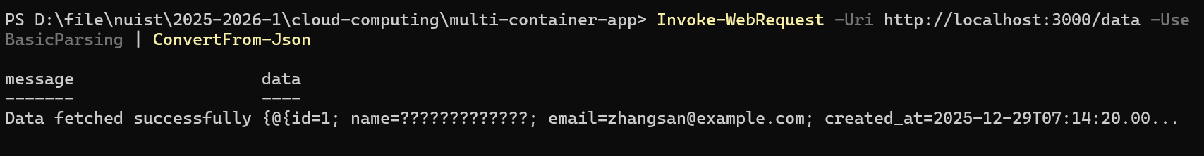
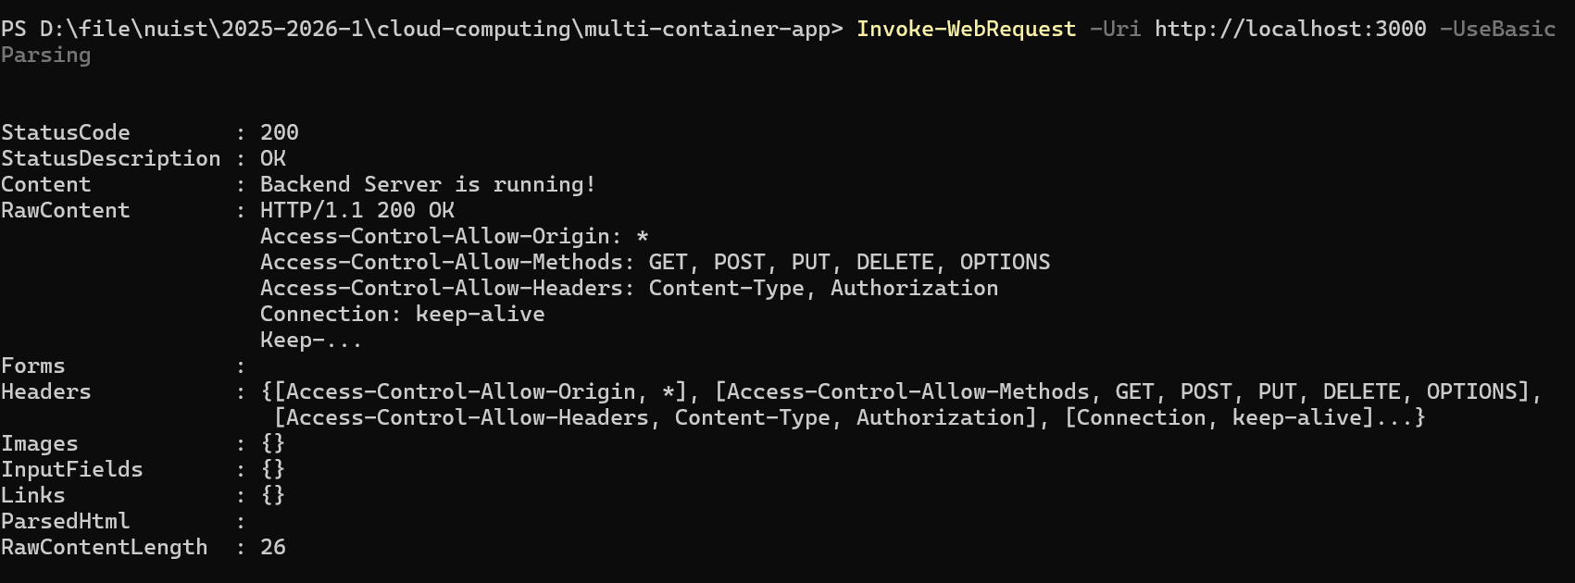
- Clean Up Resources
```bash
docker-compose down
docker volume prune -f
docker image prune -f
```
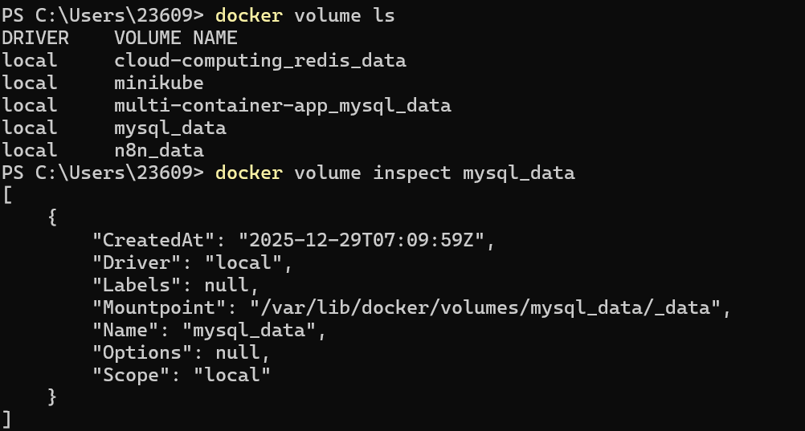
- Other Useful Docker Commands
```bash
# List running containers
docker ps

# List all containers (including stopped ones)
docker ps -a

# View container logs
docker logs <container_name>

# Enter container shell
docker exec -it <container_name> /bin/bash

# View container details
docker inspect <container_name>

# Remove all stopped containers
docker container prune -f
```

