Kubernetes Basics Tutorial Experiment Report

- Experiment Objective
Complete the six core modules in the official Kubernetes basics tutorial https://kubernetes.io/docs/tutorials/kubernetes-basics/ and master the basic concepts and operations of Kubernetes.
- Environment Preparation
- Operating System : Windows 11
- Kubernetes Version : v1.34.0
- minikube Version : v1.37.0
- kubectl Version : 1.32.2

- Experiment Content

  - Module 1: Create a Cluster

Objective : Understand the basic concepts and architecture of Kubernetes clusters, learn how to create and access Kubernetes clusters.

Steps :
    - Start minikube cluster :
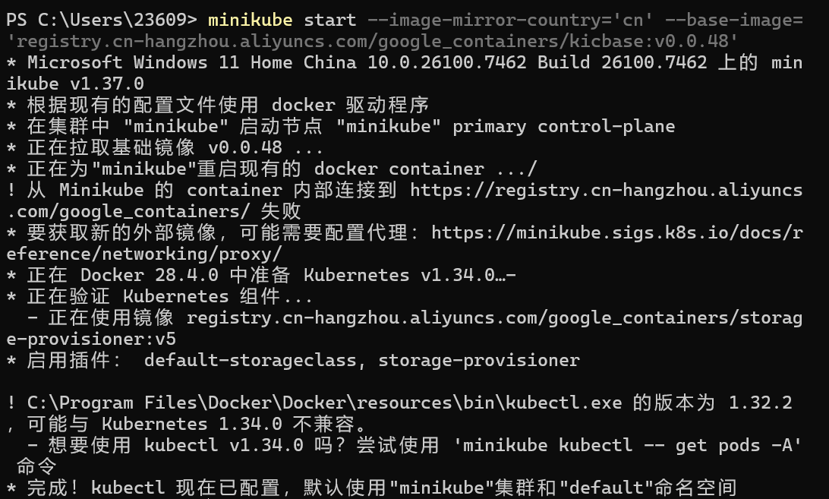
    - Verify cluster status :
```bash
minikube status
```
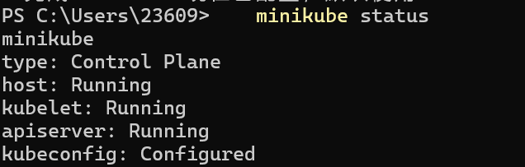
    - Check cluster nodes :
```bash
kubectl get nodes
```
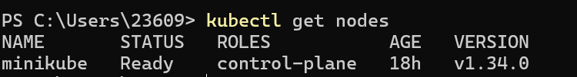
    - Access cluster information :
```bash
kubectl cluster-info
```
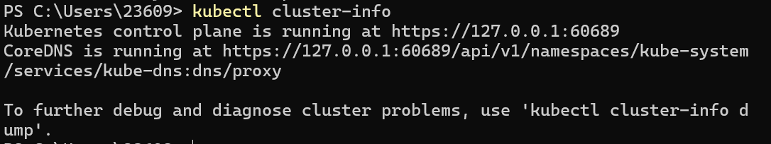 Core Concepts :
- Kubernetes clusters consist of a control plane and worker nodes
- minikube is a single-node Kubernetes cluster for local development
- kubectl is the command-line tool for interacting with Kubernetes clusters

  - Module 2: Deploy an Application
Objective : Learn how to deploy containerized applications to Kubernetes clusters.

Steps :
    - Create Deployment :
    - View Deployment status :
    - View Pod status :
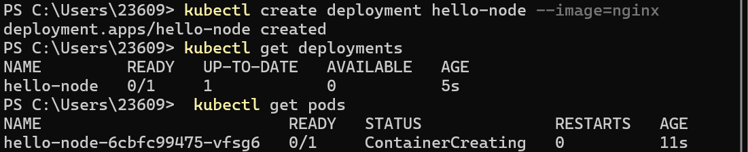
    - View Deployment details :
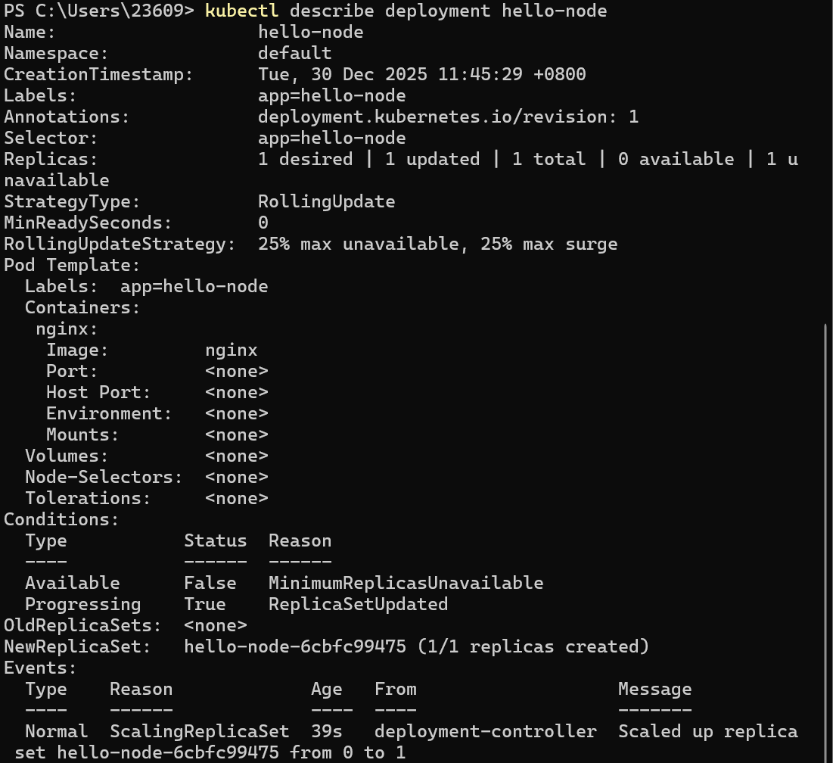

Core Concepts :
- Deployment is a Kubernetes resource for managing Pod replicas
- Deployment ensures that the specified number of Pod replicas are always running
- Pod is the smallest deployment unit in Kubernetes

  - Module 3: Expose the Application

Objective : Learn how to expose applications to external access through Services.

Steps :
    - Create Service :
```bash
kubectl expose deployment hello-node --type=NodePort --port=80
```
    - View Service :
```bash
kubectl get services
```
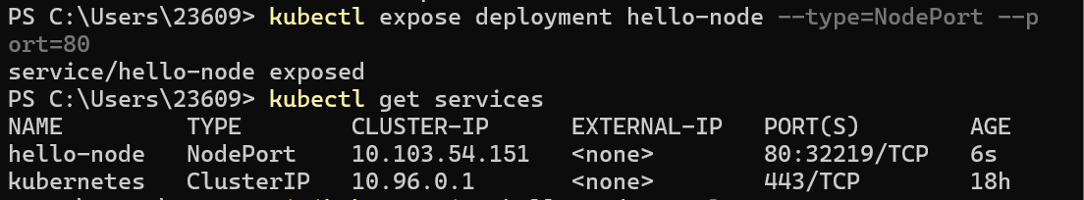

    - Access the application:
- Access the above URL in a browser
- Or use curl command:
```bash
curl $(minikube service hello-node --url)
```
Core Concepts :
- Service is a Kubernetes resource for exposing applications
- NodePort type Service maps container ports to node ports
- Applications can be accessed through node IP and port

  - Module 5: Scale the Application
Objective : Understand how to horizontally scale application replicas.
Steps :
    - View current replicas :
```bash
kubectl get deployment hello-node
```

    - Scale replicas :
```bash
kubectl scale deployment hello-node --replicas=3
```
    - Verify replicas :
```bash
kubectl get deployment hello-node
```
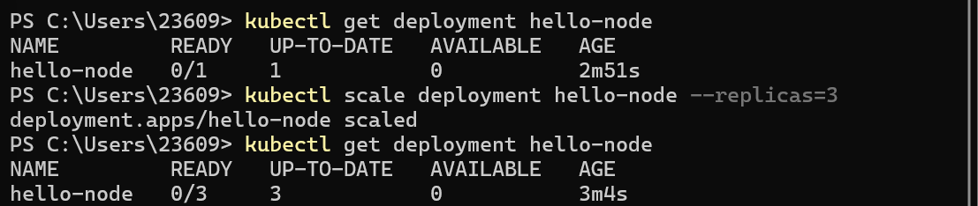
    - View all Pods :
```bash
kubectl get pods -o wide
```
    - Reduce replicas :
```bash
kubectl scale deployment hello-node --replicas=2
```
Core Concepts :
- Horizontal scaling improves application availability and performance by increasing Pod replicas
- Deployment controllers automatically manage replica creation and deletion
- Replicas can be dynamically adjusted to adapt to traffic changes

  - Module 6: Update the Application
Objective : Master how to perform rolling updates of application versions.

Steps :
    - View current image :
```bash
kubectl get deployment hello-node -o yaml | grep image
```
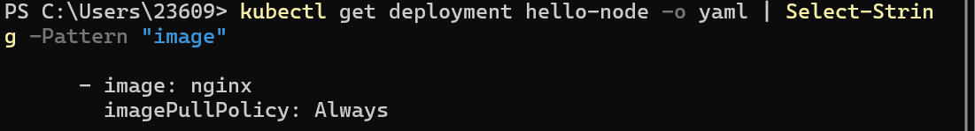

Core Concepts :
- Rolling updates allow updating applications without service interruption
- Kubernetes creates new Pods first, then gradually replaces old Pods
- You can roll back to previous versions to handle update failures

Experiment Summary

By completing the six modules of the Kubernetes basics tutorial, I have mastered:

1. Cluster Management : Create and access Kubernetes clusters
2. Application Deployment : Deploy containerized applications using Deployment
3. Application Exploration : View Pod logs and execute commands
4. Service Exposure : Expose applications to external access through Service
5. Horizontal Scaling : Adjust application replicas to improve availability and performance
6. Rolling Updates : Update application versions without service interruption

Problems Encountered and Solutions

1. Problem : minikube container cannot access external image repositories
Solution : Use minikube built-in images or pull images on the host first and then import to minikube

2. Problem : kubectl version is incompatible with Kubernetes version
Solution : Use minikube's built-in kubectl command: `minikube kubectl -- <command>`

3. Problem : Pod image pull failure
Solution : Check network connection, use domestic image sources, or use built-in images

Learning Insights

Kubernetes is a powerful container orchestration platform. Through learning the basics tutorial, I have understood its core concepts and operation methods. In actual use, I need to pay attention to:

- Understand the declarative API design concept of Kubernetes
- Master the use of core resources (Pod, Deployment, Service)
- Learn how to monitor and debug applications
- Understand Kubernetes best practices and design patterns

Through continuous practice and learning, I will further master Kubernetes' advanced features and application scenarios.

