


《爬虫期末考试》

题 目： Django
分 院： 理工分院
班 级： 16计算机科学与技术四班
姓 名： 缪克佩
学 号： 16219111402
完成日期： 2019年6月17日

温州大学瓯江学院教务部
二○一二年十一月制

实验环境：Windows 10 Python 3.6 VScode
实验代码：
豆瓣250：
from urllib import request
import re
import pymysql

class MovieTop(object):
def __init__(self):
self.start = 0
self.param = '&filter'
self.headers = {"User-Agent" : "Mozilla/5.0 (Windows NT 10.0; WOW64) "
"AppleWebKit/537.36 (KHTML, like Gecko) "
"Chrome/65.0.3325.146 Safari/537.36"}
self.movieList = []
self.filePath = './DoubanTop250.txt'

def get_page(self):
try:
url = 'https://movie.douban.com/top250?start=' + str(self.start) + '&filter='
myRequest = request.Request(url, headers=self.headers)
response = request.urlopen(myRequest)
page = response.read().decode('utf-8')
print('正在获取第' + str((self.start+25)//25) + '页数据...')
self.start += 25
return page
except request.URLError as e:
if hasattr(e, 'reason'):
print('获取失败，失败原因：', e.reason)

def get_page_info(self):
patern = re.compile(u'<div.*?class="item">.*?'
+ u'<div.*?class="pic">.*?'
+ u'<em.*?class="">(.*?)</em>.*?'
+ u'<div.*?class="info">.*?'
+ u'<span.*?class="title">(.*?)</span>.*?'
+ u'<span.*?class="other">(.*?)</span>.*?'
+ u'<div.*?class="bd">.*?'
+ u'<p.*?class="">.*?'
+ u'导演:\s(.*?)\s.*?<br>'
+ u'(.*?)&nbsp;/&nbsp;'
+ u'(.*?)&nbsp;/&nbsp;(.*?)</p>.*?'
+ u'<div.*?class="star">.*?'
+ u'<span.*?class="rating_num".*?property="v:average">'
+ u'(.*?)</span>.*?'
+ u'<span>(.*?)人评价</span>.*?'
+ u'<span.*?class="inq">(.*?)</span>'
, re.S)

while self.start <= 225:
page = self.get_page()
movies = re.findall(patern, page)
for movie in movies:
self.movieList.append([movie[0],
movie[1],
movie[2].lstrip('&nbsp;/&nbsp;'),
movie[3],
movie[4].lstrip(),
movie[5],
movie[6].rstrip(),
movie[7],
movie[8],
movie[9]])

def write_page(self):
file = open(self.filePath, 'w', encoding='utf-8')
try:
for movie in self.movieList:
file.write('电影排名：' + movie[0] + '\n')
file.write('电影名称：' + movie[1] + '\n')
file.write('电影别名：' + movie[2] + '\n')
file.write('导演：' + movie[3] + '\n')
file.write('上映年份：' + movie[4] + '\n')
file.write('制作国家/地区：' + movie[5] + '\n')
file.write('电影类别：' + movie[6] + '\n')
file.write('评分：' + movie[7] + '\n')
file.write('参评人数：' + movie[8] + '\n')
file.write('简短影评：' + movie[9] + '\n')
file.write('\n')
print('成功写入文件，共有%d条记录...' % len(self.movieList))
except Exception as e:
print(e)
finally:
file.close()

def upload(self):
db = pymysql.connect("localhost", "root", "123456", "myweb", charset='utf8')
cursor = db.cursor()
cursor.execute('DELETE FROM web_movie')

insertStr = "INSERT INTO web_movie(name, director,Country)VALUES ('%s','%s','%s')"

try:
for movie in self.movieList:
insertSQL = insertStr % ( str(movie[1]), str(movie[3]),str(movie[5]))
cursor.execute(insertSQL)
db.commit()
print('成功上传至数据库...')
except Exception as e:
print(e)
db.rollback()
finally:
db.close()

def main(self):
print('开始抓取豆瓣电影TOP250...')
self.get_page_info()
print('成功获取豆瓣电影TOP250...')
print('开始写入文件...')
self.write_page()
print('开始上传至数据库...')
self.upload()

douban = MovieTop()
douban.main()
最新_36k：

from selenium import webdriver
import os
import time
import pymysql.cursors

class Crawler(object):
def __init__(self):
self.Chromedriver = "C:/Program Files (x86)/Google/Chrome/Application/chromedriver.exe"
os.environ["webdriver.chrome.driver"] = self.Chromedriver
self.Chrome = webdriver.Chrome(self.Chromedriver)

self.MySql = pymysql.connect(host='localhost',
user='root',
password='123456',
db='myweb',
charset='utf8',
cursorclass=pymysql.cursors.DictCursor)

def crawling36kr(self):
url = "https://www.36kr.com/information/web_news"

self.Chrome.get(url)
cookie = { "name" : "new_user_guidance", "value" : "true", "domain" : ".36kr.com"}
self.Chrome.add_cookie(cookie)
self.Chrome.get(url)
time.sleep(3)

item_list = self.Chrome.find_elements_by_class_name("kr-shadow-content")
print("item_list = ", len(item_list))
index = 0
while index < len(item_list) - 1:
item = item_list[index]
index += 1
item.location_once_scrolled_into_view
imgSrc = item.find_element_by_class_name("scaleBig").get_attribute("src")
title = item.find_element_by_class_name("article-item-title")
path = title.get_attribute("href")
print(index, " len = ", len(item_list), " img = " , imgSrc , " path = " , path, " title = ", title.text)

self.news_detail_36kr(index, item)
item_list = self.Chrome.find_elements_by_class_name("kr-shadow-content")
time.sleep(2)
if index == len(item_list) - 1:
loading_more_button = self.Chrome.find_element_by_class_name("kr-loading-more-button")
loading_more_button.location_once_scrolled_into_view
time.sleep(3)
item_list = self.Chrome.find_elements_by_class_name("kr-shadow-content")
if index == len(item_list) - 1:
loading_more_button.click()
time.sleep(3)
item_list = self.Chrome.find_elements_by_class_name("kr-shadow-content")

def news_detail_36kr(self, index, item):
imgSrc = item.find_element_by_class_name("scaleBig").get_attribute("src")
title = item.find_element_by_class_name("article-item-title")
path = title.get_attribute("href")

title.click()

num = self.Chrome.window_handles
self.Chrome.switch_to_window(num[1])
time.sleep(5)

article_title = self.Chrome.find_element_by_class_name("article-title")
author = self.Chrome.find_element_by_class_name("title-icon-item")
summary = self.Chrome.find_element_by_class_name("summary")
p_list = self.Chrome.find_elements_by_xpath("//*[@id='app']/div/div/div/div/div/div/div/div/div/div/div/div/div/div/div/p")
print("article_title == ", article_title.text, " author = ", author.text, " summary = ", summary.text, " len(p_list) = ", len(p_list))
content = ""
for p in p_list:
content += p.text
print(content)

try:
with self.MySql.cursor() as cursor:
sql = "INSERT INTO `web_phone` (`title`, `author`, `summary`) VALUES ( %s, %s, %s)"
cursor.execute(sql, (article_title.text,author.text, summary.text))

self.MySql.commit()
except Exception as e:
print(e)

time.sleep(3)
self.Chrome.close()
self.Chrome.switch_to_window(num[0])
if __name__ == "__main__":
crawler = Crawler()
crawler.crawling36kr()

Admin：
from django.contrib import admin
from web.models import movie
from web.models import phone
# Register your models here.
admin.site.register(movie)
admin.site.register(phone)
效果截图：
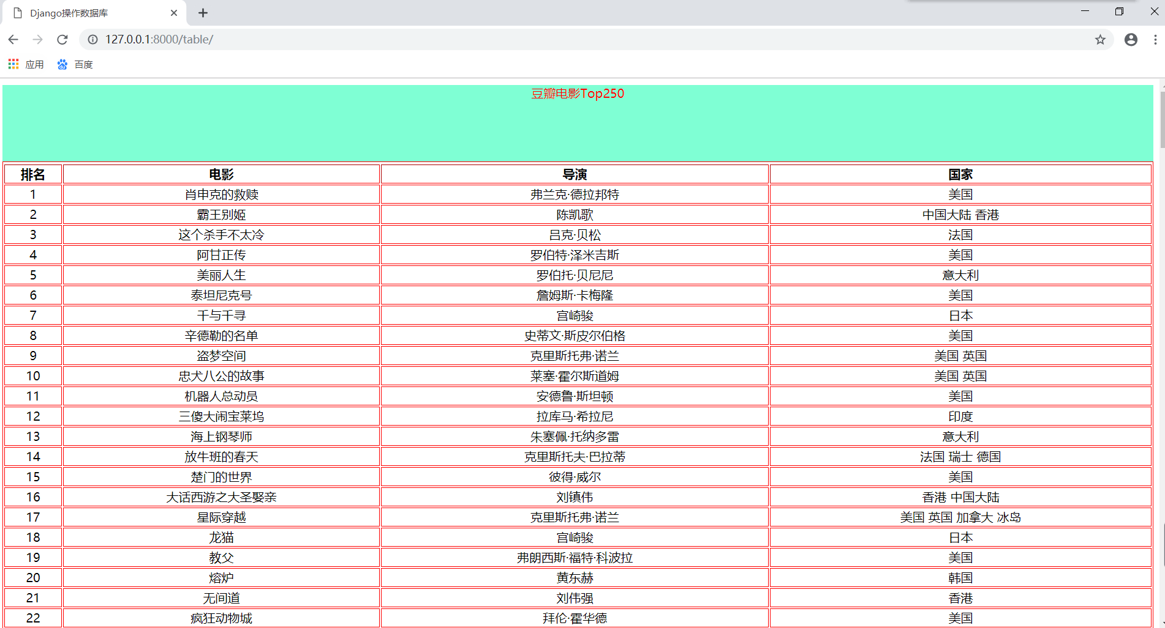
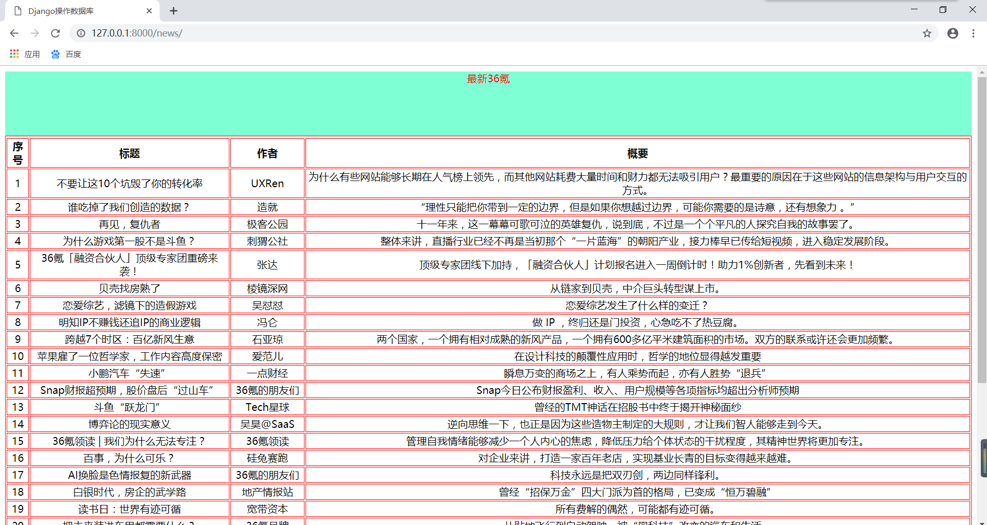
12306：
from selenium import webdriver
from selenium.webdriver.common.keys import Keys
from selenium.webdriver.common.by import By
from selenium.webdriver.support.ui import WebDriverWait
from selenium.webdriver.support import expected_conditions as EC
from selenium.webdriver.common.action_chains import ActionChains
import requests
import base64
import re
import time

class Demo():
def __init__(self):
self.coordinate=[[-105,-20],[-35,-20],[40,-20],[110,-20],[-105,50],[-35,50],[40,50],[110,50]]
def login(self):
login_url="https://kyfw.12306.cn/otn/resources/login.html"
driver = webdriver.Chrome()
driver.set_window_size(1200, 900)
driver.get(login_url)
account=driver.find_element_by_class_name("login-hd-account")
account.click()
userName=driver.find_element_by_id("J-userName")
userName.send_keys("15158652588")
password=driver.find_element_by_id("J-password")
password.send_keys("mkp011400")
self.driver=driver
def getVerifyImage(self):
try:

img_element =WebDriverWait(self.driver, 100).until(
EC.presence_of_element_located((By.ID, "J-loginImg"))
)

except Exception as e:
print(u"网络开小差,请稍后尝试")
base64_str=img_element.get_attribute("src").split(",")[-1]
imgdata=base64.b64decode(base64_str)
with open('verify.jpg','wb') as file:
file.write(imgdata)
self.img_element=img_element
def getVerifyResult(self):
url="http://littlebigluo.qicp.net:47720/"
response=requests.request("POST",url,data={"type":"1"},files={'pic_xxfile':open('verify.jpg','rb')})
result=[]
print(response.text)
for i in re.findall("<B>(.*)</B>",response.text)[0].split(" "):
result.append(int(i)-1)
self.result=result
print(result)
def moveAndClick(self):
try:
Action=ActionChains(self.driver)
for i in self.result:
Action.move_to_element(self.img_element).move_by_offset(self.coordinate[i][0],self.coordinate[i][1]).click()
Action.perform()
except Exception as e:
print(e.message())
def submit(self):
self.driver.find_element_by_id("J-login").click()
def __call__(self):
self.login()
time.sleep(3)
self.getVerifyImage()
time.sleep(1)
self.getVerifyResult()
time.sleep(1)
self.moveAndClick()
time.sleep(1)
self.submit()
time.sleep(10000)

Demo()()



