**Application of database**

The application of databases involves in various fields like business, healthcare, finance, and technology to organize and handle large amounts of information

● *Topic 2: Types of database models*

The purpose of a data model is to represent data and to make the data understandable.

* 1. **TYPES OF DATA MODEL**

There are four different types of data models

* Hierarchical data model
* Network data model
* Relational data model
* Object oriented data model

**In hierarchical model**, data is organised into tree-like structure with one-to-many relationship between two different types of data, for example, one department can have many courses, many professors and of-course many students.

**Example:**

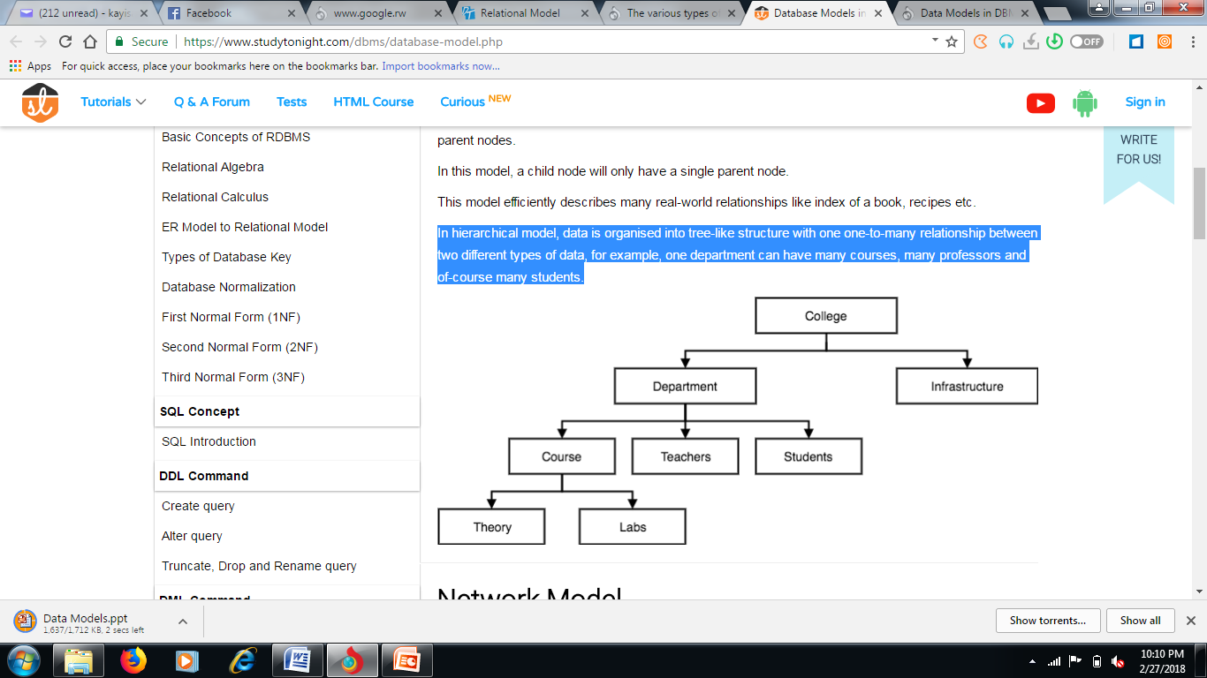

**Network data model**

A network database model allows multiple records to be linked to the same owner file. The model can be seen as an upside down tree where the branches are the member information linked to the owner, which is the bottom of the tree.

**Example:**

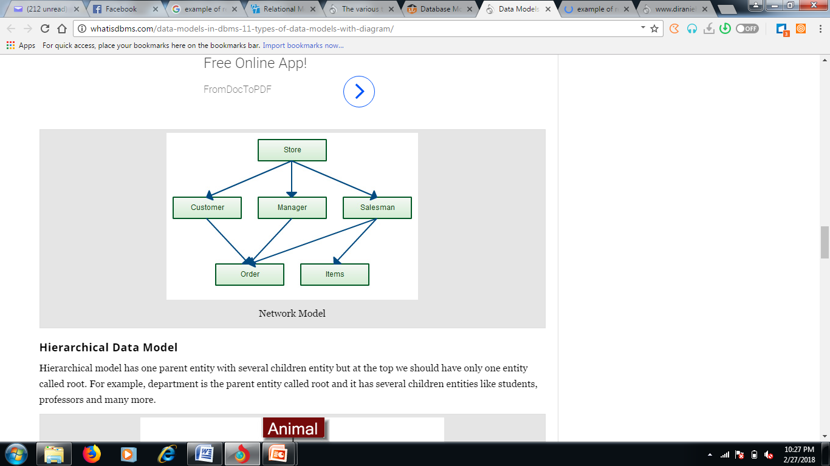

**A relational database**

A relational database is a [database](https://techterms.com/definition/database) model that stores data in [tables](https://techterms.com/definition/table), this storing is called as relation Relational model is the most popular model and the most used model.

Each row in a relation contains unique value and it is called as tuple, each column contains value from same domain and it is called as attribute.

**Example:**

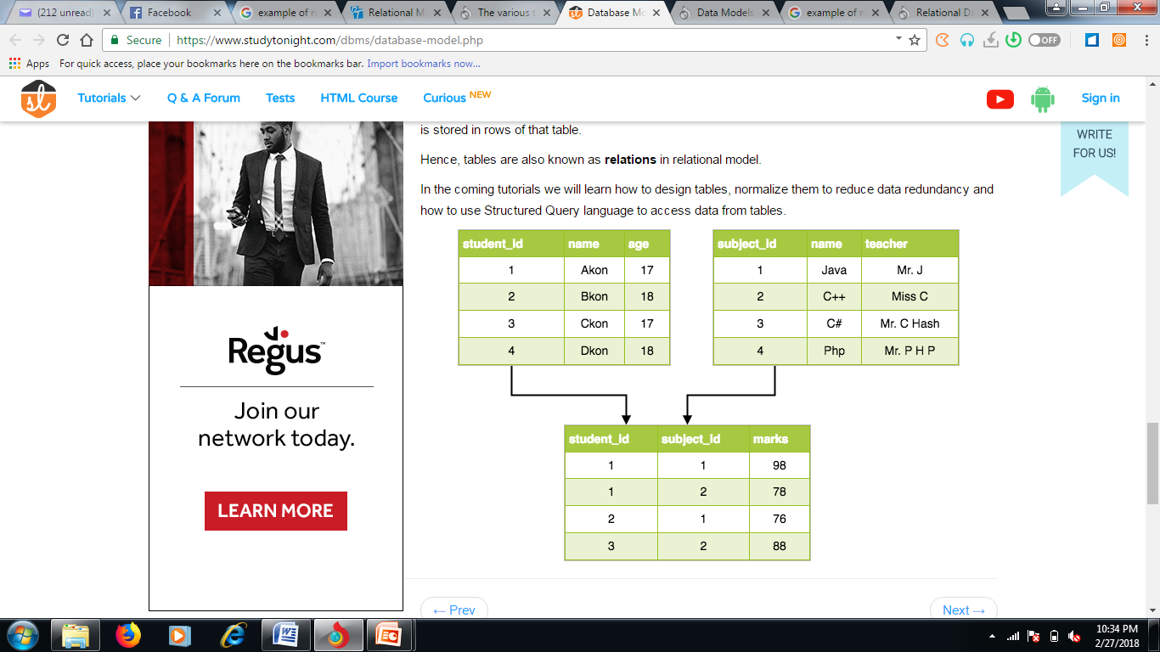

**Object oriented data model**

This model is the recent one, Data are stored into classes. The DBMS of this model are often called ODBMS, O for Object. But it is important to note that, even if ODBMS are the recent ones, they have not yet shown their proof.

● Topic 3:Database relationships

express the number of entities to which another entity can be associated via a relationship.

* + **One-to-One (1:1):** Each entity in one table relates to only one entity in another table (e.g., a person and their passport).
  + **One-to-Many (1: N):** One entity in one table relates to multiple entities in another table (e.g., a teacher and their students).
  + **Many-to-Many (N:N):** Many entities in one table relate to many entities in another table (e.g., students and courses).
  + Topic 3: Description of data dictionary

**A. Definition**

Data Dictionary consists of database metadata. It has records about objects in the database.

**What Data Dictionary consists of?**

Data Dictionary consists of the following information −

* Name of the tables in the database
* Constraints of a table i.e. keys, relationships, etc.
* Columns of the tables that related to each other
* Owner of the table
* Last accessed information of the object
* Last updated information of the object

During a computerization project (most for wide projects), the team in charge of the software design is not the same with the one in charge of programming.

To enable the team of programmers to be in phase with the logical model of data (LMD ) produced by the designing team, it’s essential to make a data dictionary which will help them to easily implement the database.

The data dictionary takes the fields of LMD and describes and organizes them into table.

The LMD is the database architecture. It is obtained using the CMD. It is the LMD which is implemented to have the database

These are the examples of data dictionary.

**Example1:** personal details of a student

**<StudentPersonalDetails>**

**Student_ID** **Student_Name** **Student_Address** **Student_City**

The following is the data dictionary for the above fields:

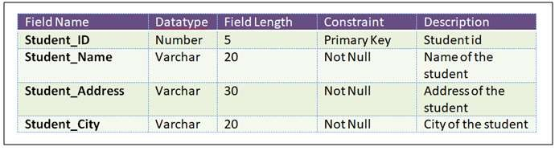

* + Topic 2:Types of requirements

**Functional and non-functional requirements**

Statements of services the system should provide how the system should react to particular inputs and how the system should behave in particular situations.

* + **Functional Requirements:** Specify what the database should do, such as storing employee data or supporting user authentication.
  + **Non-Functional Requirements:** Specify the performance, scalability, or reliability of the database, such as processing 5,000 transactions per second.

● Topic 1:Techniques and Methods to collect data

* + **Interview:** Gathers in-depth information by talking directly to stakeholders.
  + **Documentation:** Reviews existing documents and systems for requirements.
  + **Questionnaire:** Distributes forms to collect data from multiple users simultaneously.
  + **Observation:** Examines workflows and processes to identify data needs.