Deliverable 3 – Health Analytics Project Execution

# Clinical Question

Do patients that have been treated with Anagrelide have a higher risk of cancer, compared with a more conventional alternative, Hydroxyurea?

Note:

The original question was:

In patients undergoing treatment for thrombocythemia, does those that have been treated with Anagrelide has a higher risk of thrombosis, compared with a more conventional alternative, Hydroxyurea?

# Patient Counts

* [hxia40] patients taking Anagrelide

<http://gt-health-analytics-1.us-east-1.elasticbeanstalk.com/#/cohortdefinition/446>

* [hxia40] patients taking Hydroxyurea

<http://gt-health-analytics-1.us-east-1.elasticbeanstalk.com/#/cohortdefinition/449>

* [hxia40] cancer patients exposed to either drug

<http://gt-health-analytics-1.us-east-1.elasticbeanstalk.com/#/cohortdefinition/452>

Patient counts in both datasets:

|  |  |  |  |
| --- | --- | --- | --- |
| Cohort | Patients taking Anagrelide | Patients taking Hydroxyurea | Cancer patients exposed to either drug |
| CMSDESynPUF100k | 638 | 699 | 172 |
| CMSDESynPUF23m | 20,392 | 15,774 | 4,801 |

# Incidence Rates

Among patients taking Anagrelide, 125.39/1,000 patients in the 100k dataset and 129.18/1000 patients in the 23m dataset were diagnosed with cancer. The incidence rates per 1k years are 103.49 and 102.95. Among patients taking Hydroxyurea, 133.05/1000 in the 100k dataset and 138.92/1000 patients in the 23m dataset were diagnosed with cancer. The incidence rates per thousand years are 103.79 and 108.68. Results are shown as below:

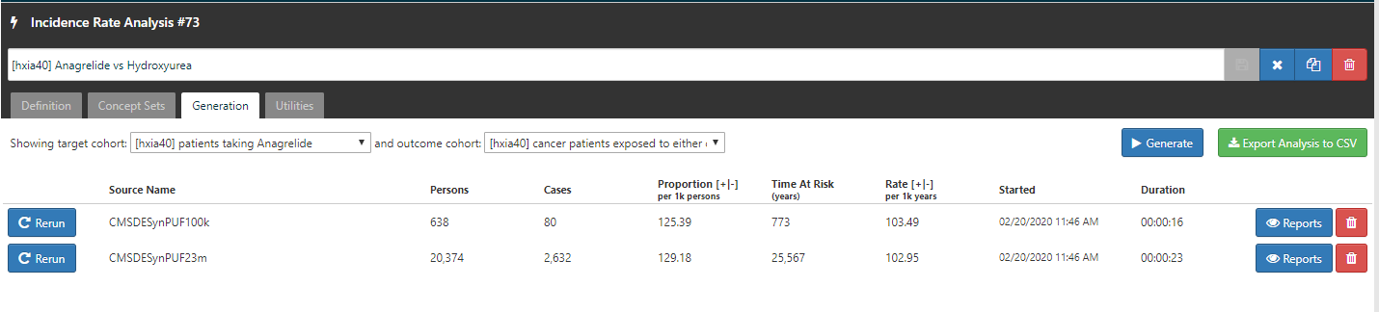

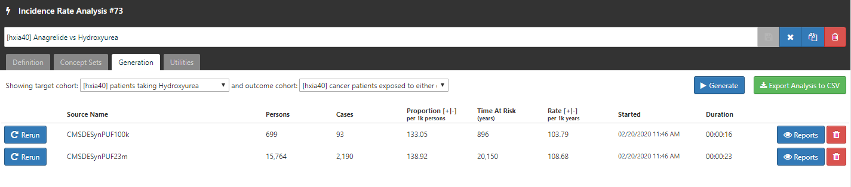

<http://gt-health-analytics-1.us-east-1.elasticbeanstalk.com/#/iranalysis/73>

# Cohort Characterization

<http://gt-health-analytics-1.us-east-1.elasticbeanstalk.com/#/cc/characterizations/65/design>