**Angiotensin converting enzyme inhibitors and risk of cancer**

Introduction

*What are ACE inhibitors?*

Angiotensin-converting enzyme (ACE) inhibitors are factors that prevent an enzyme from producing angiotensin II which subsequentially narrows down vessels. Since angiotensin II releases substances that raise blood pressure, ACE inhibitors also have the effect of lowering blood pressure (“Angiotensin-converting enzyme (ACE) inhibitors - Mayo Clinic,” n.d.). Examples of ACE inhibitors include Accupril (Quinapril), Aceon (Perindopril), Altace (Ramipril), Benazepril (Lotensin), Capoten (Captopril), Enalapril (Vasotec), Fosinopril (Monopril), Lisinopril (Prinivil, Zestril), Mavik (Trandolapril) and Moexipril (Univasc) (“Types of ACE Inhibitors for Heart Disease Treatment,” n.d.).

*When are they prescribed?*

ACE inhibitors are considered as “first-line therapy” for stage 1 hypertension (systolic pressure from 130-139mm Hg or diastolic pressure from 80-89mm Hg) (“High blood pressure (hypertension) - Diagnosis and treatment - Mayo Clinic,” n.d.). They are also used in the treatment of renal artery stenosis (RAS) which causes the release of renin and leads to renin-dependent hypertension. These inhibitors reduce arterial and venous pressures by dilating arterial and venous vessels via preventing the formation of angiotensin II (Dalal & Bridgeman, 2017). Moreover, ACE inhibitors demonstrated tissue protection of organs while achieving same control of blood pressure and are reported to improve kidney and heart function, as well as eye and peripheral nerve function, in patients with diabetes (Cordonnier, Zaoui, & Halimi, 2001). These effects are the result of the inhibition mechanism of ACE inhibitors on angiotensin II. They are also commonly used in the treatment for heart conditions such as heart failure, heart attack and stroke due to its effectiveness in reducing circulating level of angiotensin II and aldosterone (Kantner, 1992).

*Side Effects and Cancer Risk*

Side effects of taking ACE inhibitors may include cough, fatigue, dizziness, headache, loss of taste and so forth. Some studies showed these inhibitors may cause the swell of tissue in black population, women and smokers (Helmer, Slater, & Smithgall, 2018)(Martin, Foreman, Travis, Casson, & Coleman, 2008)(“Smoking May Negate Renal Protective Effects of ACE Inhibitors - MPR,” n.d.). The concern about the relation between ACE inhibitors and lung cancer is because of the buildup of bradykinin and substance P in the lung. These two chemicals are often found in the tissue of lung cancer patients and bradykinin is said to stimulate the growth of cancer cells (Wu et al., 2002). Recently, there have been some population-based cohort studies on the risk of lung cancer in patients with ACE inhibitors. One example is Hicks and the team’s work. They confirmed the association of ACE inhibitors to higher lung cancer risk, compared to angiotensin receptor blockers (Hicks et al., 2018). There are also studies focused on cancer risk (all kinds) associated with ACE inhibitors. Yi-Ying Chiang and the team demonstrated the irrelevance between them (Chiang, Chen, Tsai, & Tsai, 2014).

*Reasons and Hypothesis*

ACE inhibitors have been used widely in the treatment of high blood pressure (hypertension) or other conditions where hypertension is a complication. Although it has been shown that the short-term usage is relatively safe, there are still concerns regarding their long-term effects since long term treatment of hypertension is very common. Up to now, there is only a limited number of population-based cohort studies on this question. But I believe it is helpful to continue the work because ACE inhibitors are widely prescribed. Personally, I have a couple of friends who have family history of hypertension. They are taking or have the potential to take ACE inhibitors.

Based on my literature review on the question, I conducted population-based cohort studies with the provided claims datasets, using both Atlas and R package. My hypothesis was that, regular use of ACE inhibitors is not associated with an increased cancer risk, although there is concern regarding the lung cancer association (I cannot agree or disagree on lung cancer since there is no data in the provided datasets).

Methods

*Data Source*

This cohort study was designed to learn the relationship between long-term usage of ACEs inhibitors and occurrence of cancer. Patients were selected from CMS Data Claims Synthetic Public Use File (SynPUFs) (“Medicare Claims Synthetic Public Use Files (SynPUFs) | CMS,” n.d.). The DE-SynPUF was created with high similarity to real claims data, including beneficiary summary, inpatient claims, outpatient claims, carrier claims and prescription drug events. The whole dataset contains 2.33 million synthetic patients while the provided subsets (CMSDESynPUF100k and CMSDESynPUF23m) of this study were parts of its first release (2008-2010 Data Entrepreneurs’ SynPUF).

*Cohort Definitions*

The target cohort was defined as patients with a history of hypertension, taking ACE inhibitors and have at least one year of follow up. The comparator cohort was defined as patients with a history of hypertension, taking angiotensin receptor blockers (ARBs) and have at least one year of follow up. The outcome cohort was defined as patients who got a diagnosis of cancer after taking ACE inhibitors or ARBs. Patients who had a diagnosis of any cancer prior to taking ACE inhibitors or ARBs were excluded. For the outcome cohort, I defined the observation window to be 1-3 years before index start date, which means only patients who have been taking ACE inhibitors or ARBs for 1-3 years will be included. The “one year” was decided based on the study of Yi-Yang Chiang’s team (Chiang et al., 2014) and the “three years” was a restriction of the database.

ICD-10 codes for “hypertension” were determined as I10-I13 and I15 (“Concept: Hypertension - Measuring Prevalence,” n.d.). Codes for “ACE inhibitors” were determined as C09A and C09B (“Concept: Angiotensin Converting Enzyme (ACE) Inhibitors and Angiotensin Receptor Blocker (ARB) Prescriptions - Defined,” n.d.). Codes for “ARBs” were determined on Wikipedia as C09CA (“ATC code C09 - Wikipedia,” n.d.). With these codes in hand, I did research on Athena and finally selected concepts on Atlas with resulting codes. For concepts in “cancer” set, I sought on Atlas with the key words “cancer”, “tumor”, “maglinancy” and “carcinoma”, then selected conditions with satisfying number of records.

Links to the cohorts are as folllows:

[shuang379] hypertension patients with ACE inhibitors (Target):

<http://gt-health-analytics-1.us-east-1.elasticbeanstalk.com/#/cohortdefinition/632>

[shuang379] hypertension patients with ARBs (Comparator):

<http://gt-health-analytics-1.us-east-1.elasticbeanstalk.com/#/cohortdefinition/633>

[shuang379] hypertension patients with cancer (Outcome):

<http://gt-health-analytics-1.us-east-1.elasticbeanstalk.com/#/cohortdefinition/634>

*Characterization and Incidence Rates with Atlas*

Cohort characterization was performed with Atlas. A new characterization analysis was created in the Characterizations section at Atlas. Feature analyses were performed on condition era any time prior, demographic age group, demographics gender and drug era any time prior. The characterization was then executed against the CMSDESynPUF100k and CMSDESynPUF23m datasets.

The incidence rate was calculated as the ratio of persons in the target/comparator cohort who experienced the outcome cohort during the time at risk period. A new incidence analysis was created in the Incidence Rates section at Atlas. The start of the time at risk was defined as 1 day after cohort start for the target cohort and the end was defined as the cohort end date. The analysis was then executed against the CMSDESynPUF100k dataset and CMSDESynPUF23m datasets.

*Analysis with R package (Stretch)*

The cohort study was also conducted using the open-source OHDSI CohortMethod R package (“OHDSI/CohortMethod: An R package for performing new-user cohort studies in an observational database in the OMOP Common Data Model.,” n.d.) against CMSDESynPUF100k dataset. Propensity score was used to balance between the target and comparator cohorts. An expansive propensity score model, including all available covariates, was used and propensity score adjustment was performed. Results are presented with hazard rate, Kaplan-Meier curve, incidence rates, time at risk distribution and so forth.

Results

*Population Characteristics with Atlas*

The result of cohort generation performed with Atlas is listed in Table 1. Intuitively, the number of patients in outcome cohort should be smaller than the numbers of patients in either target or comparator cohort, which matches our results. Table 2 and table 3 list the characteristics of target and comparator cohorts in CMSDESynPUF100k and CMSDESynPUF23m, respectively. We can see, in both datasets, the two cohorts are comparable to each other, with similar ratios of type 2 diabetes mellitus, female, atrial fibrillation and so forth. This similarity ensures the rationality of the study.

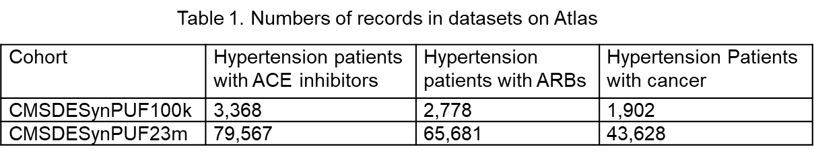

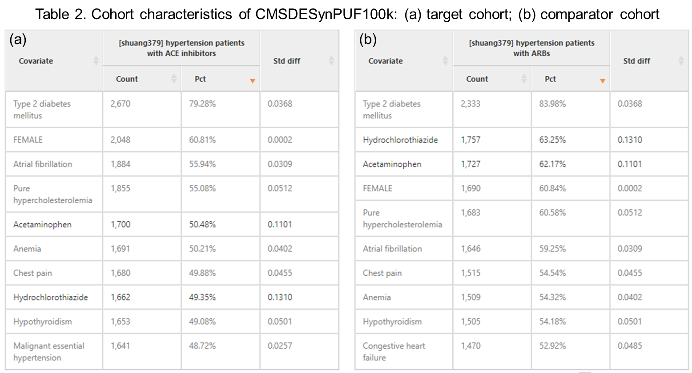

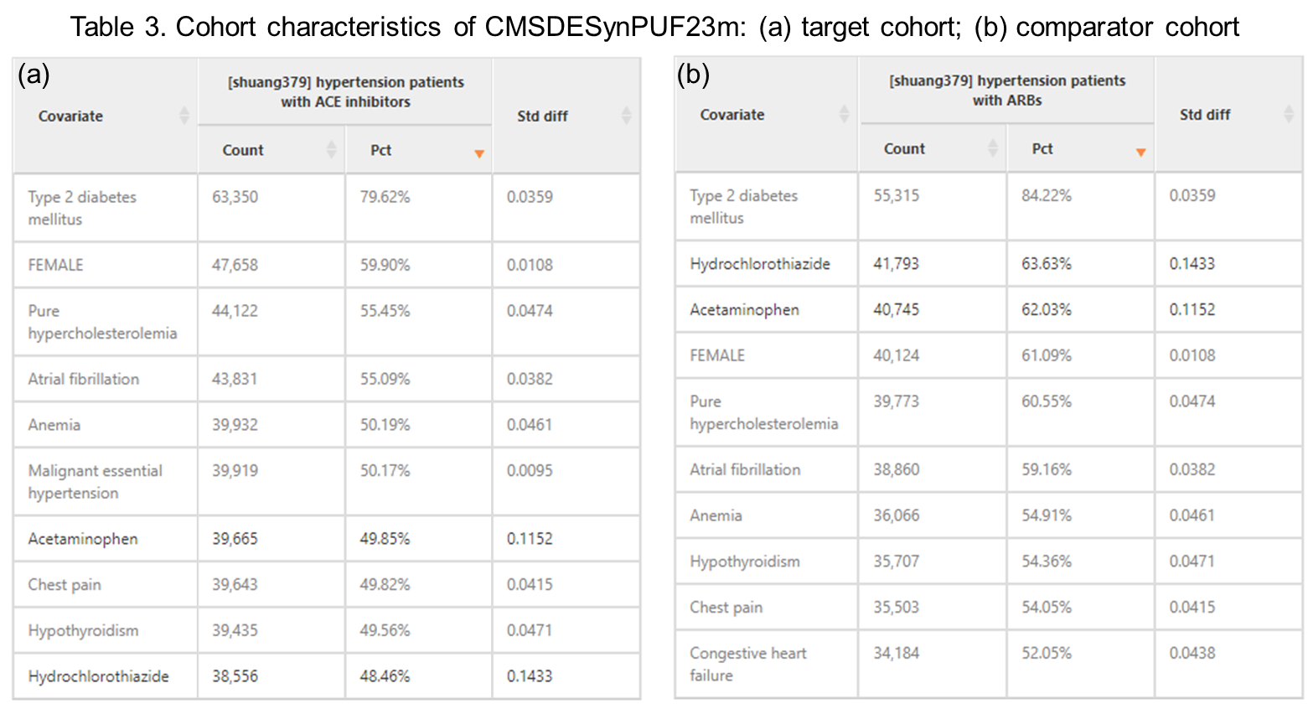

*Incidence Rates with Atlas*

According to the incidence analysis with Atlas, among patients exposed to ACE inhibitors, 130.43 out of 1,000 patients in the CMSDESynPUF100k dataset and 123.00 out of 1000 patients in the CMSDESynPUF23m dataset were diagnosed with cancer while incidence rates per thousand years are 75.09 and 70.04, respectively. Among patients exposed to ARBs, 155.44 out of 1000 in the CMSDESynPUF100k dataset and 152.01 out of 1000 patients in the CMSDESynPUF23m dataset were diagnosed with cancer while incidence rates per thousand years are 94.66 and 92.94, respectively. These numbers are visualized in Figure 1. We can see incidence of comparator cohort is higher than that of target cohort, in both datasets, regarding either proportion per 1k persons or rate per 1k years.

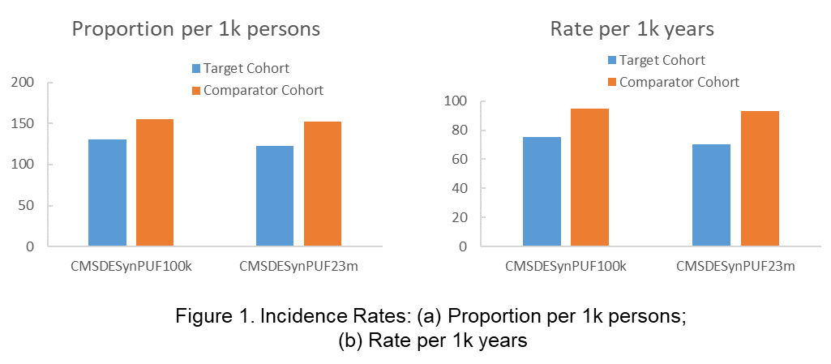

*Analysis Results with R package (stretch)*

Estimation study analysis with R package was performed against CMSDESynPUF100kn dataset. Figure 2 diagrams the selection of study subjects from the dataset. The starting numbers of patients are consistent with what has been listed in Table 1. Among these patients, 10 in target cohort and 30 in comparator cohort have prior diagnosed hypertension so they are filtered out. The final study populations are 3,358 for target cohort and 2,748 for comparator cohort.

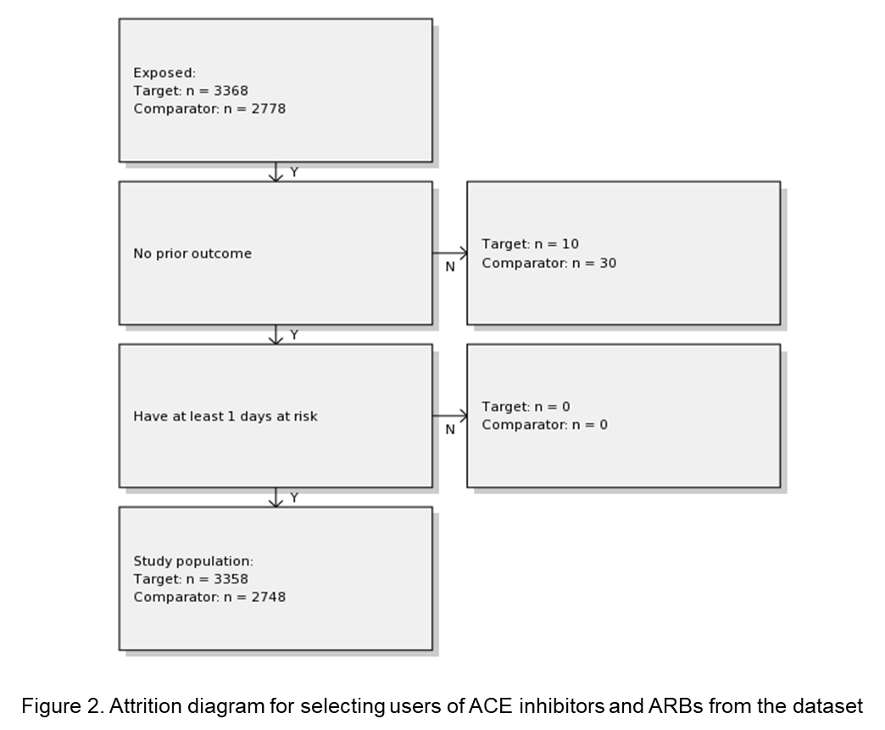

Table 4 lists part of all characteristics of target and comparator cohorts before and after propensity score adjustment. We can see these two groups are highly like each other. Figure 3 plots the preference score distributions and visualizes the similarity. The high overlap between two populations indicates the high similarity of subjects in the two cohorts in terms of their predicted probability of taking one medication over the other. Figure 4 plots Std. diff for all input features for the propensity score model. Generally, we consider Std. diff < 0.1 as well adjusted. We can see from the plot that a lot of features have Std. diff >0.1 before adjustment and the count is 1 after adjustment.

Table 5a shows the numbers of subjects, follow-up time, numbers of outcome events and event incidence rates per 1,000 years. We can see the incidence rates are consistent with what we have seen in Figure 1. Table 5b shows the time to be diagnosed as cancer for patients in both cohorts. There is only one day difference between all patients in the two cohorts to be diagnosed. Figure 5 plots Kaplan-Meier survival curves for both cohorts, showing survival as a function of time. We can see the survival probabilities are similar between the two cohort in the beginning, however, target cohort gains increasingly higher probability later. The overall hazard rate for target cohort compared to comparator cohort is 0.8 with lower bound of 0.7, higher bound of 0.92 and p value < 0.01.

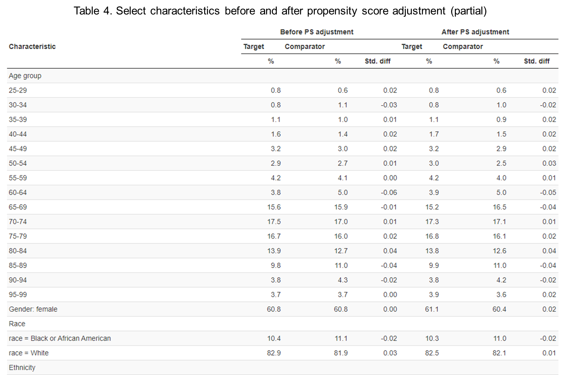

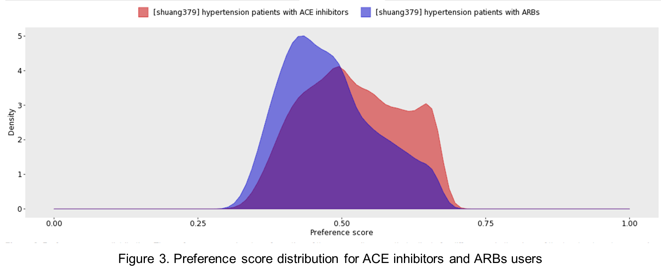

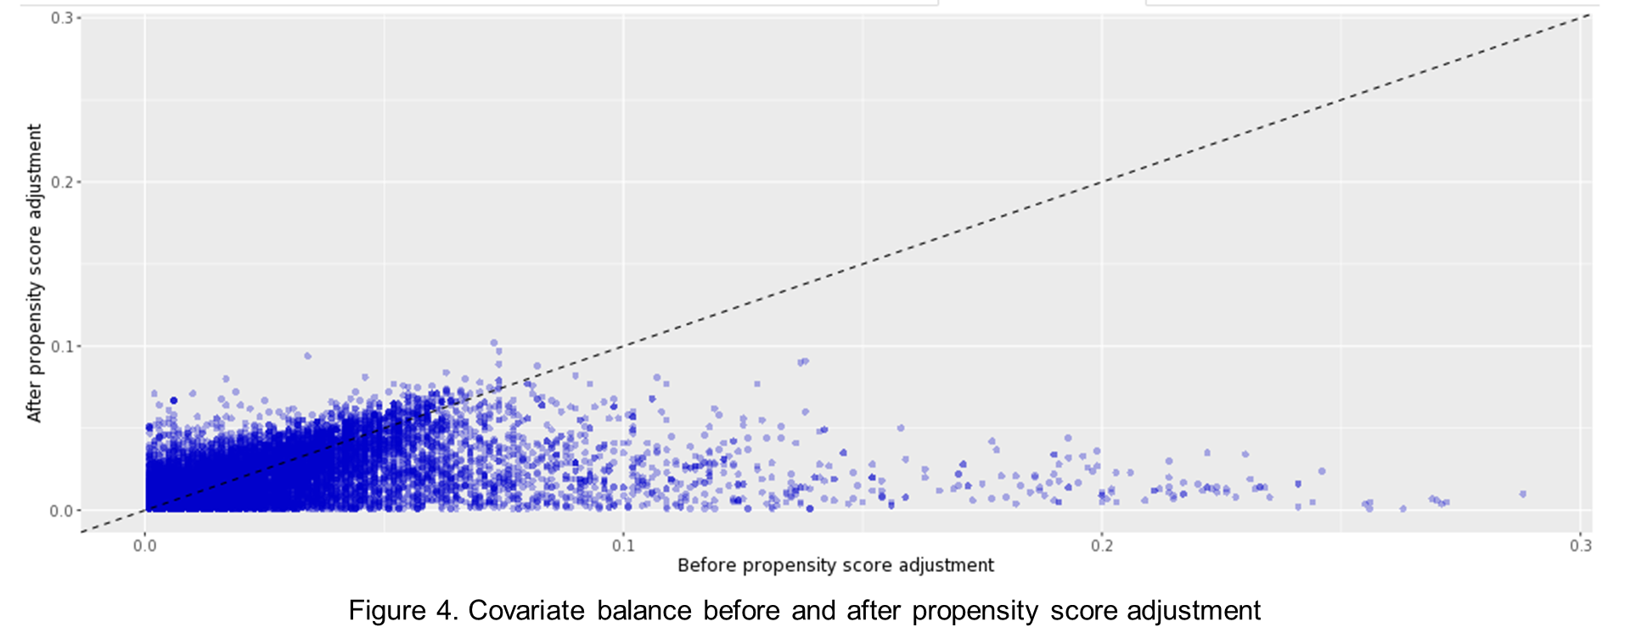

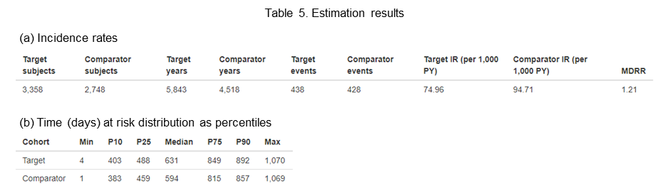

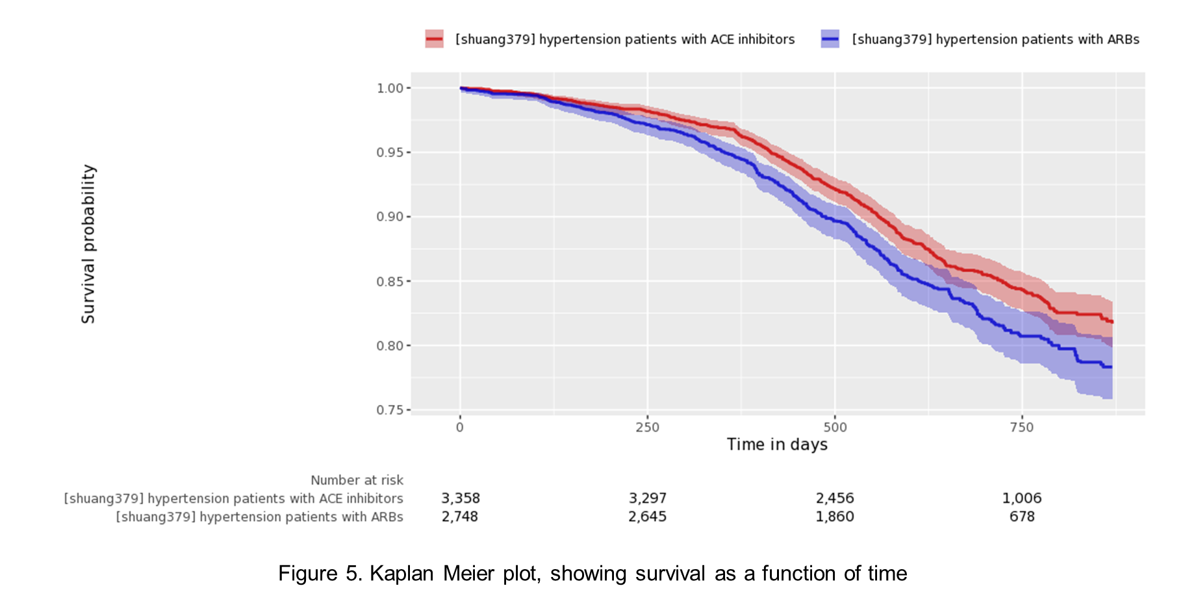

Discussion

One of the limitations of this study could be that not all related factors for cancer development were investigated. For example, general risk factors include smoking, lack of physical activity and obesity (Danaei, Vander Hoorn, Lopez, Murray, & Ezzati, 2005). Other factors may include alcohol use, environmental factors, occupational exposure and so forth (Weiderpass, 2010)(Li et al., 2009)(IARC, 2012). Many of these factors are hard to quantify.

The comparator cohort in this study was hypertension patients exposed to ARBs. However, a more accurate method to investigate the risk of ACE inhibitors could be defining comparator as group using placebo. The reason is that ARBs itself is a controversial medication. Some studies showed an increase risk of tumors in patients taking ARBs (Opelz & Döhler, 2011)(Sipahi, Debanne, Rowland, Simon, & Fang, 2014) while other studies showed ARBs are protective against cancer or improve cancer prognosis (Roldan, Song, Engle, & Dougherty, 2017)(Tanaka et al., 2012). In this study, the hazard rate is 0.8 with lower bound of 0.7, higher bound of 0.92 and p value < 0.01, for ACE inhibitors group/ARBs group. It means ACE inhibitors bring slightly or similar cancer risk as ARBs, however, we cannot draw convincing conclusion through this single study on how ACE inhibitors perform compared other hypertension medication.

This study evaluated the risk of all kinds of cancers. However, the effects of ACE inhibitors or ARBs on cancer development may be biased. For example, there are studies showing an increased risk of lung cancer related to ACE inhibitors. The concern about the relation between ACE inhibitors and lung cancer is because of the buildup of bradykinin and substance P in the lung. These two chemicals are often found in the tissue of lung cancer patients and bradykinin is said to stimulate the growth of cancer cells (Wu et al., 2002). Recently, there have been some population-based cohort studies on the risk of lung cancer in patients with ACE inhibitors. One example is Hicks and the team’s work. They confirmed the association of ACE inhibitors to higher lung cancer risk, compared to angiotensin receptor blockers (Hicks et al., 2018). Moreover, different ACE inhibitors or ARBs could have different influence on cancer development.

Conclusion

This study showed that the relative risk of cancer development was lower among patients exposed to ACE inhibitors than among patients exposed to ARBs, with restriction in the provided dataset.

References

Angiotensin-converting enzyme (ACE) inhibitors - Mayo Clinic. (n.d.). Retrieved February 2, 2020, from https://www.mayoclinic.org/diseases-conditions/high-blood-pressure/in-depth/ace-inhibitors/art-20047480

ATC code C09 - Wikipedia. (n.d.). Retrieved February 15, 2020, from https://en.wikipedia.org/wiki/ATC_code_C09#C09C_Angiotensin_II_receptor_blockers_(ARBs),_plain

Chiang, Y. Y., Chen, K. B., Tsai, T. H., & Tsai, W. C. (2014). Lowered Cancer Risk With ACE Inhibitors/ARBs: A Population-Based Cohort Study. *Journal of Clinical Hypertension*, *16*(1), 27–33. https://doi.org/10.1111/jch.12228

Concept: Angiotensin Converting Enzyme (ACE) Inhibitors and Angiotensin Receptor Blocker (ARB) Prescriptions - Defined. (n.d.). Retrieved February 15, 2020, from http://mchp-appserv.cpe.umanitoba.ca/viewConcept.php?printer=Y&conceptID=1473

Concept: Hypertension - Measuring Prevalence. (n.d.). Retrieved February 13, 2020, from http://mchp-appserv.cpe.umanitoba.ca/viewConcept.php?printer=Y&conceptID=1087

Cordonnier, D. J., Zaoui, P., & Halimi, S. (2001). Role of ACE Inhibitors in Patients with Diabetes Mellitus. *Drugs*, *61*(13), 1883–1892. https://doi.org/10.2165/00003495-200161130-00001

Dalal, K. S., & Bridgeman, M. B. (2017). Cardiovascular drugs. *Nursing*, *47*(11), 63. https://doi.org/10.1097/01.NURSE.0000524762.35753.23

Danaei, G., Vander Hoorn, S., Lopez, A. D., Murray, C. J. L., & Ezzati, M. (2005). Causes of cancer in the world: Comparative risk assessment of nine behavioural and environmental risk factors. *Lancet*, *366*(9499), 1784–1793. https://doi.org/10.1016/S0140-6736(05)67725-2

Helmer, A., Slater, N., & Smithgall, S. (2018). A Review of ACE Inhibitors and ARBs in Black Patients With Hypertension. *Annals of Pharmacotherapy*, *52*(11), 1143–1151. https://doi.org/10.1177/1060028018779082

Hicks, B. M., Filion, K. B., Yin, H., Sakr, L., Udell, J. A., & Azoulay, L. (2018). Angiotensin converting enzyme inhibitors and risk of lung cancer: Population based cohort study. *BMJ (Online)*, *363*, 1–8. https://doi.org/10.1136/bmj.k4209

High blood pressure (hypertension) - Diagnosis and treatment - Mayo Clinic. (n.d.). Retrieved February 2, 2020, from https://www.mayoclinic.org/diseases-conditions/high-blood-pressure/diagnosis-treatment/drc-20373417

IARC. (2012). Chemical agents and related occupations - Volume 100 F: A review of human carcinogens. *International Agency for Research on Cancer*, *Vol. 100F*(December), 628.

Kantner, T. R. (1992). ACE inhibitors in congestive heart failure. *Journal of Family Practice*, *35*(3), 305–314.

Li, F. X., Robson, P. J., Chen, Y., Qiu, Z., Lo Siou, G., & Bryant, H. E. (2009). Prevalence, trend, and sociodemographic association of five modifiable lifestyle risk factors for cancer in Alberta and Canada. *Cancer Causes and Control*, *20*(3), 395–407. https://doi.org/10.1007/s10552-008-9254-2

Martin, U., Foreman, M. A., Travis, J. C., Casson, D., & Coleman, J. J. (2008). Use of ACE inhibitors and ARBs in hypertensive women of childbearing age. *Journal of Clinical Pharmacy and Therapeutics*, *33*(5), 507–511. https://doi.org/10.1111/j.1365-2710.2008.00938.x

Medicare Claims Synthetic Public Use Files (SynPUFs) | CMS. (n.d.). Retrieved March 5, 2020, from https://www.cms.gov/Research-Statistics-Data-and-Systems/Downloadable-Public-Use-Files/SynPUFs

OHDSI/CohortMethod: An R package for performing new-user cohort studies in an observational database in the OMOP Common Data Model. (n.d.). Retrieved March 6, 2020, from https://github.com/OHDSI/CohortMethod

Opelz, G., & Döhler, B. (2011). Treatment of kidney transplant recipients with acei/arb and risk of respiratory tract cancer: A collaborative transplant study report. *American Journal of Transplantation*, *11*(11), 2483–2489. https://doi.org/10.1111/j.1600-6143.2011.03681.x

Roldan, C. J., Song, J., Engle, M. P., & Dougherty, P. M. (2017). Angiotensin-converting enzyme inhibitors and angiotensin receptor blockers modulate the function of myelinated fibers after chemotherapy: A quantitative sensory testing study. *Pain Physician*, *20*(4), 281–292. https://doi.org/10.36076/ppj.2017.292

Sipahi, I., Debanne, S. M., Rowland, D. Y., Simon, D. I., & Fang, J. C. (2014). *Angiotensin-receptor blockade and risk of cancer: meta-analysis of randomised controlled trials*. *11*(7), 627–636. https://doi.org/10.1016/S1470-2045(10)70106-6.Angiotensin-receptor

Smoking May Negate Renal Protective Effects of ACE Inhibitors - MPR. (n.d.). Retrieved February 2, 2020, from https://www.empr.com/home/news/smoking-may-negate-renal-protective-effects-of-ace-inhibitors/

Tanaka, N., Miyajima, A., Kikuchi, E., Matsumoto, K., Hagiwara, M., Ide, H., … Oya, M. (2012). Prognonstic impact of renin-angiotensin system blockade in localised upper-tract urothelial carcinoma. *British Journal of Cancer*, *106*(2), 290–296. https://doi.org/10.1038/bjc.2011.565

Types of ACE Inhibitors for Heart Disease Treatment. (n.d.). Retrieved February 2, 2020, from https://www.webmd.com/heart-disease/guide/medicine-ace-inhibitors#1

Weiderpass, E. (2010). Lifestyle and cancer risk. *Journal of Preventive Medicine and Public Health*, *43*(6), 459–471. https://doi.org/10.3961/jpmph.2010.43.6.459

Wu, J., Akaike, T., Hayashida, K., Miyamoto, Y., Nakagawa, T., Miyakawa, K., … Maeda, H. (2002). Identification of bradykinin receptors in clinical cancer specimens and murine tumor tissues. *International Journal of Cancer*, *98*(1), 29–35. https://doi.org/10.1002/ijc.10142