

Georgia Institute of Technology

Hui Xia (hxia40)

903459648

Report: Project 1

CS7646 Machine Learning for Trading, 2019 Spring

**Question 1: In Experiment 1, estimate the probability of winning $80 within 1000 sequential bets. Explain your reasoning.**

To estimate the probability of winning $80 with in 1000 sequential bets, the simple roulette simulator built for Experiment 1 was run for 1000 times. All of the runs end with the winning of $80. To investigate how likely for the gambler to win this $80, the simple roulette simulator was then run for 1000000 (a million) times. Again, all of the runs end with the winning of $80. Based on the experiment, I estimate the probability of winning $80 within 1000 sequential bets is 100%.

This estimation makes mathematical sense. Under the given roulette condition under Experiment 1 (i.e. the gambler has unlimited fund, double the bet after each lose, and reset the bet to $1 after each win), the gambler only need to win 80 times (from 1000 bets) to hit 80$ in winnings. Considering that the winning rate of each bet is 18 out of 38, the gambler’s winning is extremely likely to reach $80 within 1000 bets.

**Question 2: In Experiment 1, what is the estimated expected value of our winnings after 1000 sequential bets? Explain your reasoning.**

As the experiment result shown to answer **Question 1**, the probability for the gambler to win $80 within 1000 sequential bets is 100%. Thus, the estimated expected value of our winnings after 1000 sequential bets is 80 dollars:

$$80 × 100\% = 80$$

**Question 3: In Experiment 1, does the standard deviation reach a maximum value then stabilize as the number of sequential bets increases? Explain why it does (or does not).**

No. This is because that for each simulation, the standard deviation will reach maximum value when many lost bets happen in a short period. How much the gambler will lose at maximum, and when will the maximum loss happen, depends on random factor. Thus, the standard deviation does reach a maximum value, but on a random spin, and the standard deviation will not stabilize on its maximum, instead, it will always stabilize at 0 as the number of sequential bets increases, after the gambler’s winning hits $80.

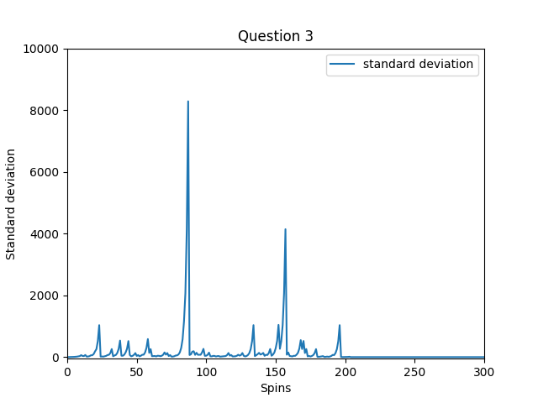

**Figure for Question 3:** The standard deviation of the winning under the condition of Experiment 1 does not stabilize at the maximum value, but rather stabilizes at 0 (around the 200th spin).

**Question 4: In Experiment 2, estimate the probability of winning $80 within 1000 sequential bets. Explain your reasoning.**

To estimate the probability of winning $80 with in 1000 sequential bets, while the gambler has a fund limit of $256, the simple roulette simulator built for Experiment 2 was run for 1000 times. In the 1000 simulations, 664 runs ended with the winning of $80, while 336 runs ended with the winning of $-256. Thus, the probability of winning $80 within 1000 (limited) sequential bets in Experiment 2 is 66.4%.

**Question 5: In Experiment 2, what is the estimated expected value of our winnings after 1000 sequential bets? Explain your reasoning.**

As the experiment result shown to answer **Question 4**, the probability for the gambler to win $80 within 1000 sequential bets is 66.4%. Thus, the estimated expected value of our winnings after 1000 sequential bets is -80.704 dollars:

$$80 × 66.4\%+\left(-256\right)× 33.6\% =-80.704$$

**Question 6: In Experiment 2, does the standard deviation reach a maximum value then stabilize as the number of sequential bets increases? Explain why it does (or does not).**

Yes. This is because that for each simulation, the value of the winning will always start from 0 dollars, where the standard deviation equal to 0, and end as either 80 dollars, or -256 dollars (as discussed under Question 4), where the standard deviation will take the maximum value. In other words, along the process of the winnings change from $0 to either $80 or $-256, the difference among the winnings from each simulation (i.e. the standard deviation) has a monotonical increase trend. Thus, in Experiment 2, the standard deviation does reach a maximum value, then stabilize as the number of sequential bets increases.

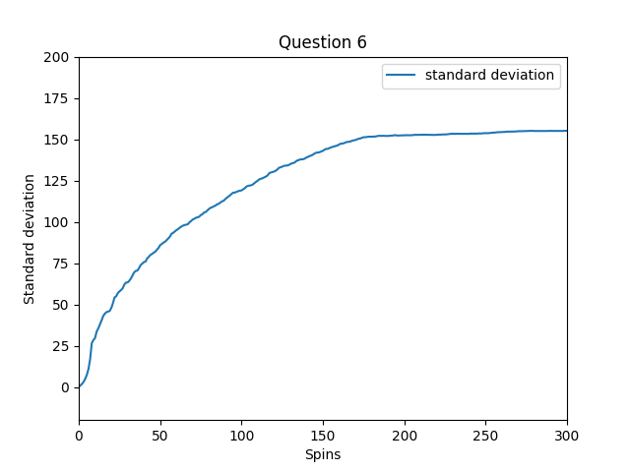

**Figure for Question 6:** The standard deviation of the winning under the condition of Experiment 2 does reach a maximum value, then stabilizes at the maximum value.

**Question 7: Include figures 1 through 5.**

Please see Figures 1-5 below.

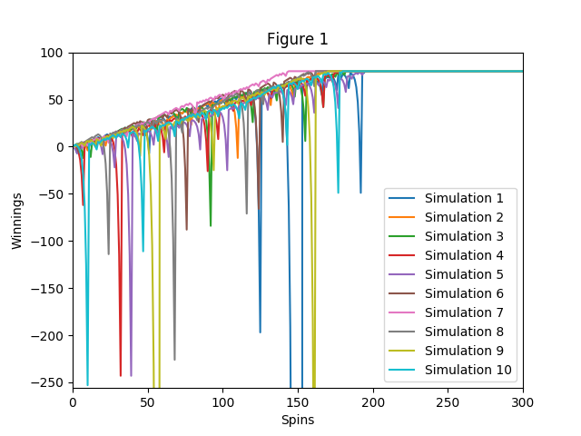

**Figure 1:** Run the simulator (for Experiment 1) 10 times and track the winnings, starting from 0 each time. Plot all 10 runs on one chart using matplotlib functions. The horizontal (X) axis range from 0 to 300, the vertical (Y) axis range from -256 to +100.

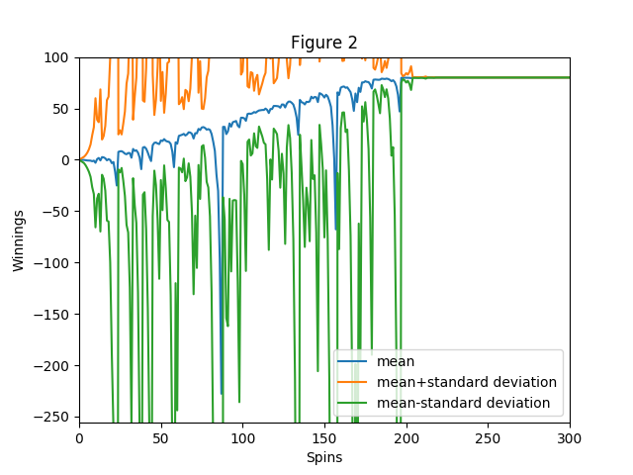

**Figure 2:** Run the simulator (for Experiment 1)1000 times. Plot the mean value of winnings for each spin using the same axis bounds as Figure 1. Add an additional line above and below the mean at mean+standard deviation, and mean-standard deviation of the winnings at each point.

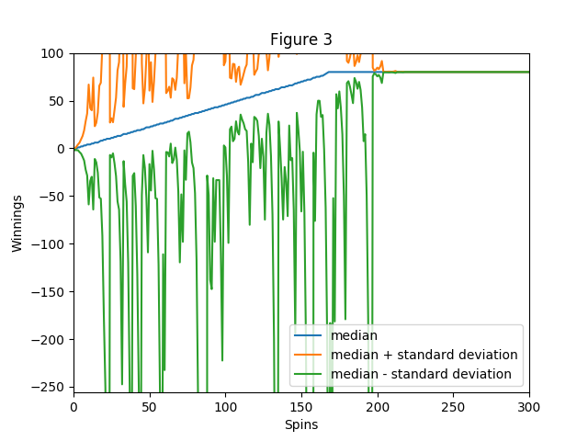

**Figure 3:** Run the simulator (for Experiment 1) 1000 times. Plot the median value of winnings for each spin using the same axis bounds as Figure 1. Add an additional line above and below the median at median+standard deviation, and median-standard deviation of the winnings at each point.

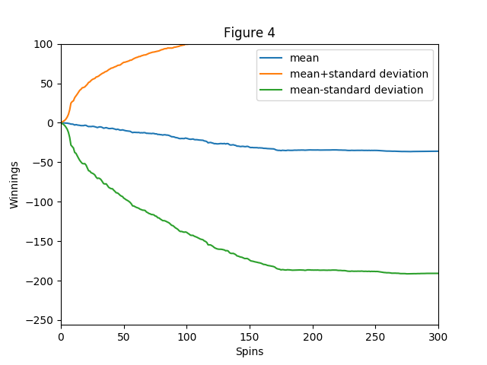

**Figure 4:** Run the simulator (for Experiment 2)1000 times. Plot the mean value of winnings for each spin using the same axis bounds as Figure 1. Add an additional line above and below the mean at mean+standard deviation, and mean-standard deviation of the winnings at each point.

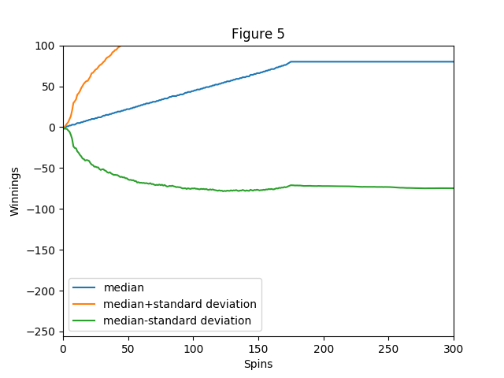

**Figure 5:** Run the simulator (for Experiment 2) 1000 times. Plot the median value of winnings for each spin using the same axis bounds as Figure 1. Add an additional line above and below the median at median+standard deviation, and median-standard deviation of the winnings at each point.