

Georgia Institute of Technology

Hui Xia (hxia40)

903459648

Report: Project 2

CS7646 Machine Learning for Trading, 2019 Spring

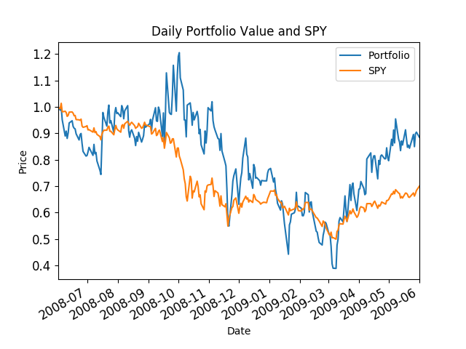

**Figure 1:** chart comparing the optimal portfolio with SPY using the following parameters: Start Date: 2008-06-01, End Date: 2009-06-01, Symbols: ['IBM', 'X', 'GLD', 'JPM'].