

Assignment 2: Randomized Optimization

CS7641 Machine Learning, 2019 Fall

Georgia Institute of Technology

Hui Xia (hxia40)

903459648

**Part 1. Algorithm optimization over different problems**

**1. Introduction**

An ‘engineering’ area about machine learning is to find the most suitable parameters for a given set of data. This process is happens in machine learning algorithm, and is usually referred as an optimization problem. In this part of the report, I will investigate the performance of four algorithms, i.e. randomized hill climbing (RHC), simulated annealing (SA), genetic algorithm (GA), and Mutual-Information-Maximizing Input Clustering (MIMIC) against the three randomize optimization problems. Both problems and algorithms are adopted using mlrose [ref]. As per required by the assignment, the three problems should highlight the advantages of GA, SA, and MIMIC, respectively. In this part of the report, I will firstly find optimal parameters for each algorithm against each of the problem, respectively, then compare the algorithms, and discuss their pros and cons.

**2. Experiment design**

2.1. Parameter optimization

To make fair comparisons among all algorithms, I will firstly configure their parameters in practical range, to ensure the performance of each algorithms as high as possible. As there are multiple parameters (e.g. max_iter) for each of the algorithms that controls how the algorithm performs, it is not realistic to scan over all combinations of them. Thus, I listed “typical” parameters for each of the algorithms in **Table 1**. For the parameter optimization, while keeping all the other parameters at default, for each of the problem (i.e. the Knapsack problem, or continuous-peaks problem), one of these parameter listed in **Table 1** is changed, and the resulted algorithm performance is plotted against the changing parameter. For each parameter, 50 different values are tested to find the optimal setting. The value of the parameter that grant the maximum fitness score (which will be defined and discussed in details in **Section 2.3**) will be used as the optimal.

**Table 1**. Algorithm and default parameters for optimization study.

|  |  |  |  |  |  |
| --- | --- | --- | --- | --- | --- |
| Algorithm | Hyperparameter | | | | |
| *max_attempt* | *max_iteration* | *pop_size* | *mutation_prob* | *keep_pct* |
| RHC | *10* | *10* |  |  |  |
| SA | *10* | *10* |  |  |  |
| GA | *10* | *10* | *0.1* | *0.1* |  |
| MIMIC | *10* | *10* | *0.1* |  | *0.1* |

2.2. Problems

As per target of this report, I will compare four algorithms using three different problems: I will highlight the advantage of SA using the traveling salesman problem (TSP), highlight GA sing the continuous peaks problem (Cpeaks), and highlight MIMIC using the Knapsack problem (KP). TSP is a NP-hard optimization problem, which is defined by to find the shortest route to travel through all of n “cities” on the map, starting and ending on the same city [ref]. The continuous peaks problem is derived from 4-peaks problem. In the Cpeaks problem, an array which is made by 0s and 1s is given, and a score is calculated as the longest contiguous bits of 0 or 1. Additionally, a reward is given when there are greater than T (Value of T is defined by user. In our experiment, T = 15% of the total length of the array) contiguous bits set to 0, and greater than T contiguous bits set to 1. Finally, KP is an optimization problem which defined as, given a set of n items, where item *i* has known weight 𝑤𝑖 and known value 𝑣𝑖; and maximum knapsack capacity, 𝑊, the KP problem strive to fit items that has the highest total value into an sack. While the total weight of the items cannot exceed the sack capacity W.

Among these three problems, the fitness function of the problems Cpeaks and KP target to obtain highest fitness score. However, the fitness function of TSP target to obtain lowest fitness score. To facilitate comparison, in this report, we plot the fitness score of TSP problem as the multiplicative inverse of the actual fitness core.

2.3. Evaluation of algorithm

Using the optimal parameters, the fitness score and the wall clock time for each of the optimization algorithm on each of the problems are plotted. For each problem, the algorithm with the highest fitness score will be considered as the most suitable algorithm. If more than one algorithms have similar (i.e. difference < 5%) fitness score, the algorithm that consume less time will be considered superior in performance. To highlight the randomness of the algorithm, the time and fitness score are evaluated 10 times, and the average and standard deviation of the 10 fitness score/time are presented.

It is worth mentioning that the four algorithms can be categorized into two groups: RHC and SA are “exploitation” algorithms (As the restarts is set to 0 for RHC. Although, SA defined a “temperature” function, which decays over time, that let the algorithm perform some explorations), which majorly focus on finding the best decision using given current-available information. On the other hand, GA and MIMIC are “exploitation and exploration” algorithms, which not only exploit given information, but also defined a chance (by mutation_prob and keep_pct for GA and MIMIC, respectively) to explore potentially worse options. Thus, RHC and SA can quickly perform many iterations of optimization in a short period of time, while GA and MIMIC are relatively computationally expensive. To make fair comparisons among algorithms, in the parameter optimization process (discussed in **Section 2.1**), I will try to use same parameters for RHC and SA, and try to use same parameters for GA and MIMIC.

**3. Results and Discussion**

3.1. Parameter optimization

As discussed in **Section 2.1**, while keeping all the other parameters at default, one of the parameters listed in **Table 1** is changed and plotted against the changing parameter. **Figure 1** demonstrate the plotted curve for the Cpeaks problem. For algorithms RHC and SA, the fitness score for both max_attempt and max_iteration plateau when their respective value is equal to or larger than 10. Additionally, max_attempt and mutation_prob/keep_pct do not affect the fitness score for GA and MMIC algorithms. For GA, max_iteration also plateaus when its value is equal to or larger than 10. Also, pop_size for both GA and MIMIC plateau when their respective value is equal to or larger than 50 and 100 respectively. As discussed in **Section 2.3**, I will use same parameters for GA and MIMIC, and let both GA and MIMIC use the pop_size value of 100.

Similar parameter optimization process was also applied to the problems TSP and KP. Due to the length limitations, I will not describe them in details. The optimized parameters can be found in **Table 2**.

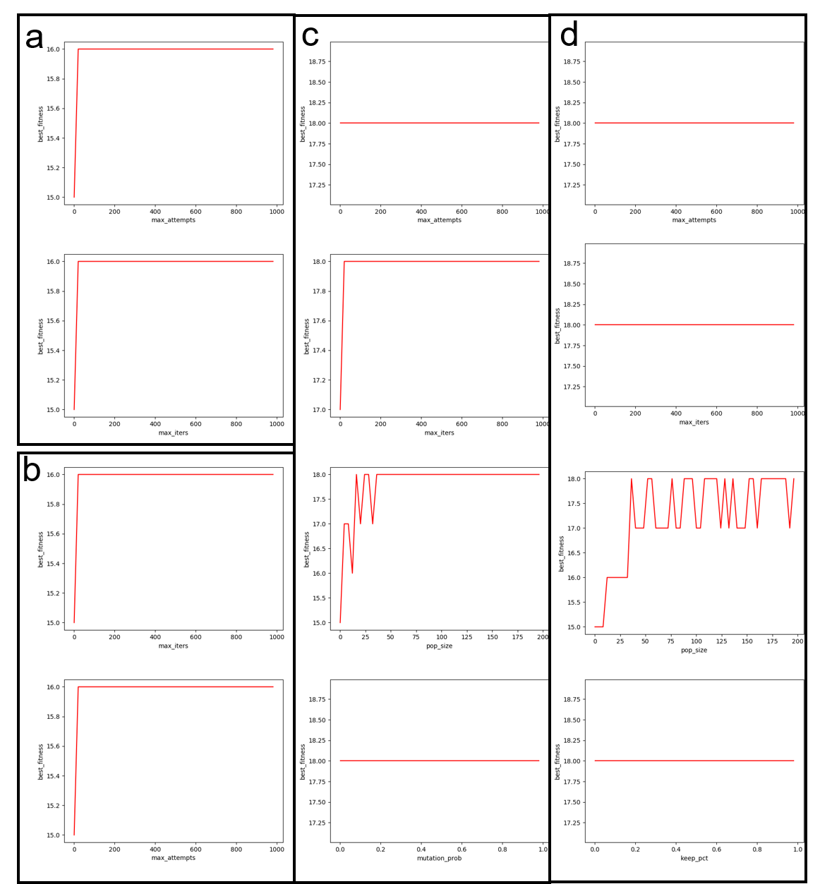

**Figure 1:** Parameter optimization for the continuous peaks problem. a) max_attempt and max_iteration for RHC. b) max_attempt and max_iteration for SA. c) max_attempt, max_iteration, pop_size and mutation_prob for GA. d) max_attempt, max_iteration, pop_size and keep_pct for MIMIC.

3.2. Algorithm comparison

Using the optimized parameters,four algorithms are compared by running time and fitness score. As shown in **Figure 2**, SA is highlighted when solving TSP, as it significantly (i.e. inter-algorithm difference larger than standard deviation) outperforms all other algorithm on both (highest) fitness score and (lowest) running time, on all sample sizes. It is noticeable that RHC performs worst in terms of fitness score, which is reasonable, as RHC lack the ability of exploration. For many scenarios, the best fitness score RHC can give out is actually derived from local optima, rather than the global optima. On the other hand, 8-city TRP is not very complex, i.e. the local optima is not very shallow, as the map of 8 cities is pretty much fixed. Thus, compared with GA and MIMIC, which iterates slowly, SA will have an advantage of being able to iterate many times quickly (in term of clock time) and find the global optima.

**Table 2**. Optimal parameters adopted for algorithm comparison study.

|  |  |  |  |  |  |
| --- | --- | --- | --- | --- | --- |
| Algorithm | Hyperparameter | | | | |
| *max_attempt* | *max_iteration* | *pop_size* | *mutation_prob* | *keep_pct* |
| TSP | | | | | |
| RHC | *20* | *50* |  |  |  |
| SA | *1* | *600* |  |  |  |
| GA | *10* | *10* | *100* | *0.1* |  |
| MIMIC | *10* | *10* | *100* |  | *0.1* |
| Cpeaks | | | | | |
| RHC | *10* | *10* |  |  |  |
| SA | *10* | *10* |  |  |  |
| GA | *10* | *10* | *100* | *0.05* |  |
| MIMIC | *10* | *10* | *100* |  | *0.05* |
| KP | | | | | |
| RHC | *10* | *10* |  |  |  |
| SA | *10* | *10* |  |  |  |
| GA | *10* | *10* | *100* | *0.1* |  |
| MIMIC | *10* | *10* | *100* |  | *0.1* |

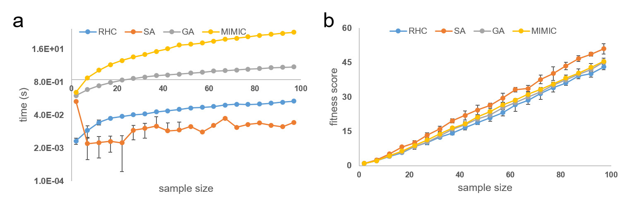**Figure 2.** Comparison of algorithms on TSP of various sample size. a) Algorithm performance on time. b) Algorithm performance on fitness score. n=10.

As shown in **Figure 3**, GA is highlighted when solving Cpeaks, as it significantly (i.e. inter-algorithm difference larger than standard deviation) outperforms all other algorithm with highest fitness score on most of the sample sizes. Compared with TSP, which has a given map of all cities, Cpeaks is a more “tricky” problem. Cpeaks requires the optimization algorithm to achieve higher score by creating the longest contiguous bits of 0 or 1, in any part of a bit array of given length. The lack of relationship between the actual value of a certain bit and the fitness score made the “exploitation”-focusing algorithms (i.e. RHC and SA) perform extremely poor. As shown in **Figure 3b**, as expected, although each iteration take very short amount of time, SA and RHC failed completely to find any way to improve their fitness score. The fact that any bit can be either 0 or 1 to achieve highest score generated enough noise to confuse RHC and SA. On the other hand, the “exploitation and exploration”-focusing algorithms (i.e. GA and MIMIC) obtained much better fitness scores.

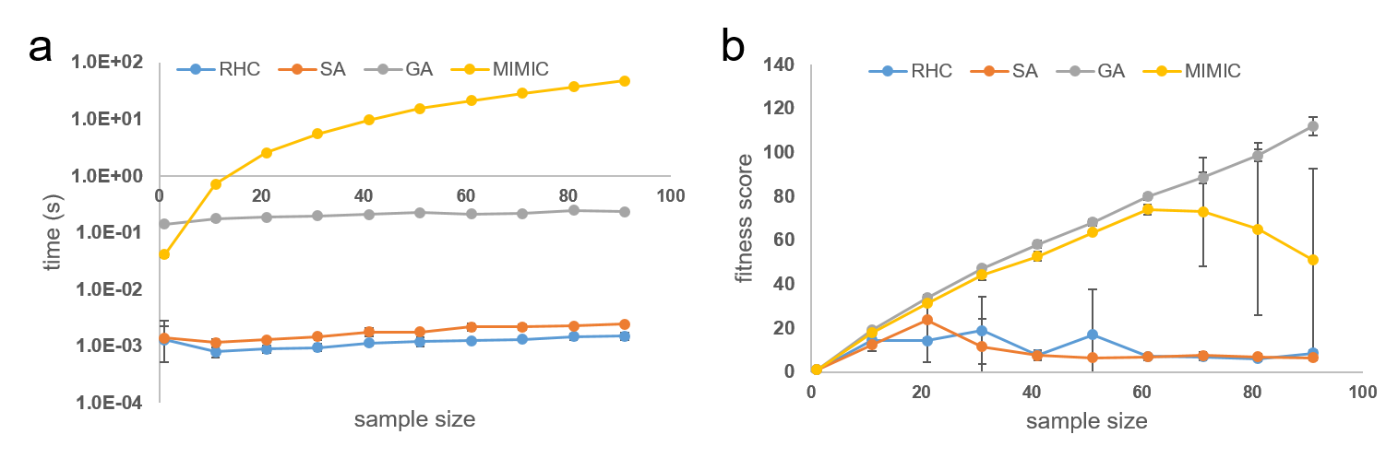

**Figure 3.** Comparison of algorithms on Cpeaks of various sample size. a) Algorithm performance on time. b) Algorithm performance on fitness score. n=10.

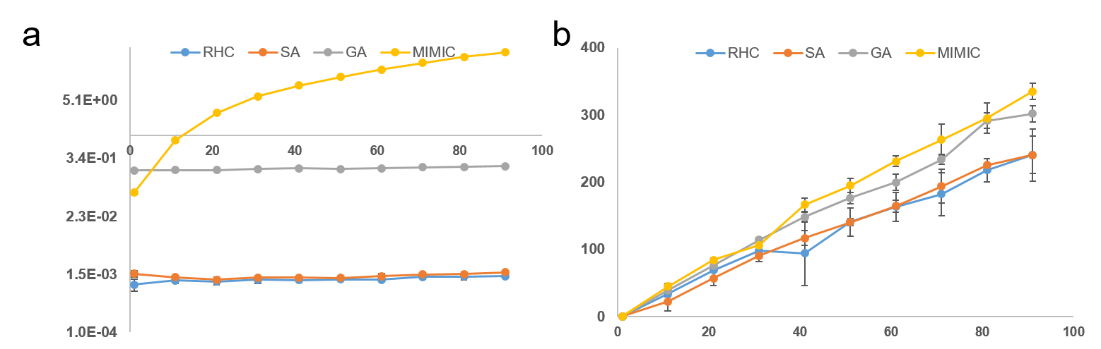

**Figure 4.** Comparison of algorithms on KP of various sample size. a) Algorithm performance on time. b) Algorithm performance on fitness score. n=10.

It is however worth to note that while GA and MIMIC perform similarly successful when the sample size is smaller than 60, GA outperformed MIMIC when using larger sample size. I reason that the downfall of MIMIC on larger sample size is actually due to MIMIC’s ability of adopting the structure of investigated data over generations. For example, in Cpeaks problem, a 5- bit array [0, 0, 0, 0, 0] will generate a much higher score compared with a 5- bit array [0, 0, 1, 0, 0], as the former contains a longer contiguous bits. In MIMIC algorithm, this observation will make the algorithm “remember" that using 0 on the 3rd bit will outperform than using 1. That is, the probably distribution on the 3rd bit of this array shifted toward of using “0”. However, remembering such information worth nothing, other than overfitting the data.

As a result, while GA outperforms MIMIC when optimizing for Cpeaks, in which remembering the structure of data always means overfitting and thus harmful for the optimization process. However, when optimizing for the Knapsack problem, remembering the structure of data (e.g. remember which item has more value per weight) is useful. Thus, MIMIC is highlighted when solving KP (**Fig. 4**), as it significantly (i.e. inter-algorithm difference larger than standard deviation) outperforms all other algorithm with highest fitness score on most of the sample sizes.

Other than the three problems that I have described above, I have also investigated other problems, such as OneMax, k-Max color, and flip-flop. In terms of fitness score, MIMIC usually performs well (if not best), while the running speed (per iteration) thereof cannot compete with RHC and SA. I realized that there is a trade-off between computational cost and time. MIMIC passes most information between iterations, thus is the most computational expensive algorithm, but performs best in terms of fitness. On the other hand, RHC and SA are computational in-expensive and runs fairly quickly, but in the cost of that they cannot handle complex optimization problems.

**4. Conclusion**

In this part of report, I have compared four different random optimization algorithms on three problems. The biggest lesson that I learned is, for all algorithms, these exists a trade-off between computational cost and running time. You have to sacrifice one side of the trade-off for the other side. After all, “there is no free lunch” [ref],

**5. Reference**