# **Cohort Report**

1. **Execute “01 - CreationArtefacts.sql” File using PGAdmin4, First run the create datable DDL, then run the other ones DDL.**

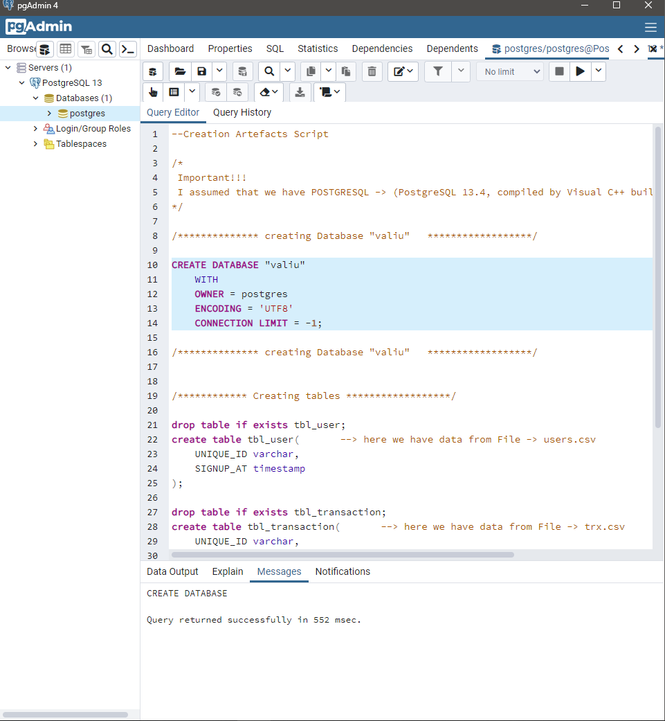

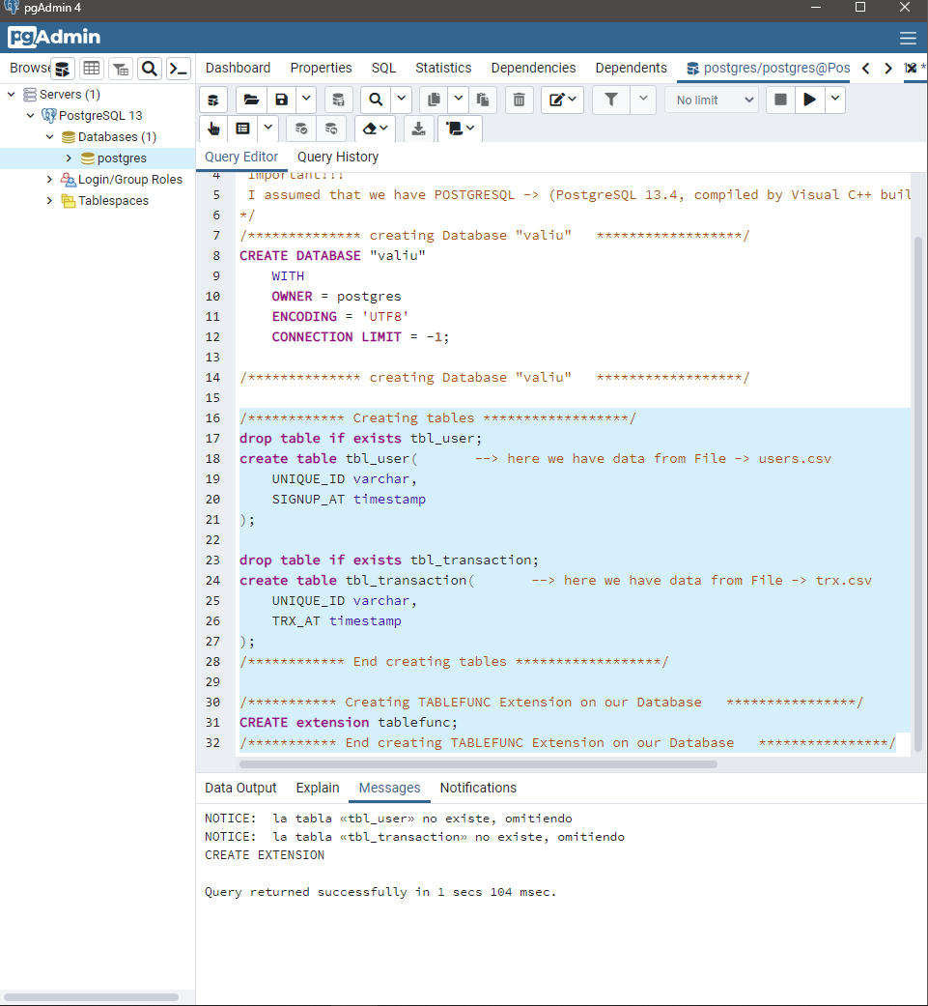

1. Import Data into tables:

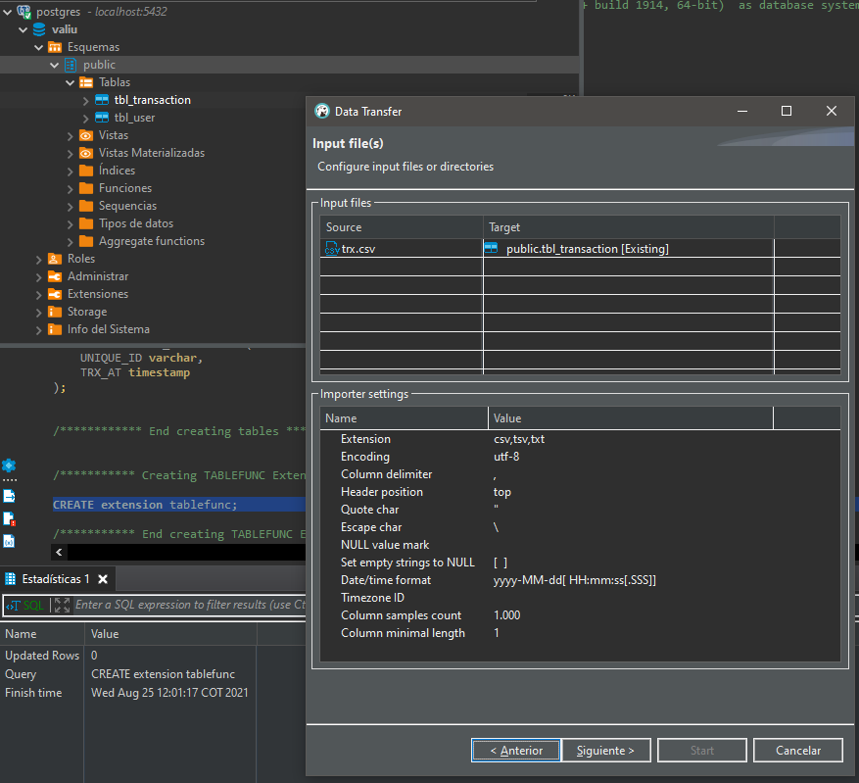

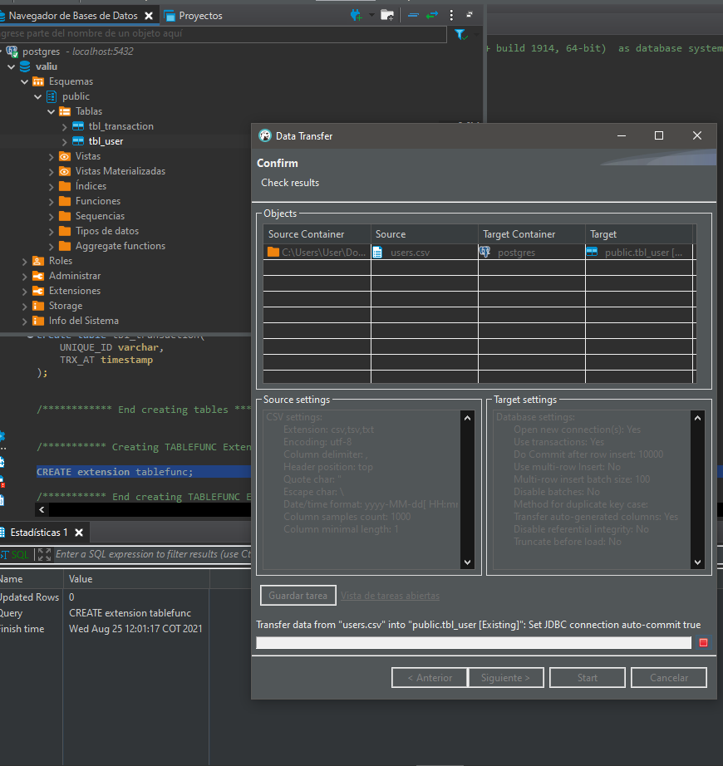

**Preview of data in the tables:**

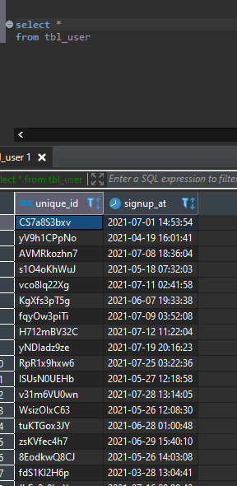

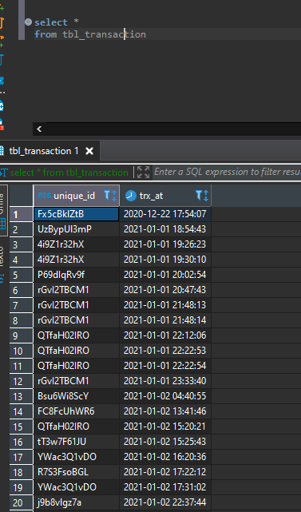

**3 – Open and Run “02 – StoreProcedureCohortReport.sql” file**

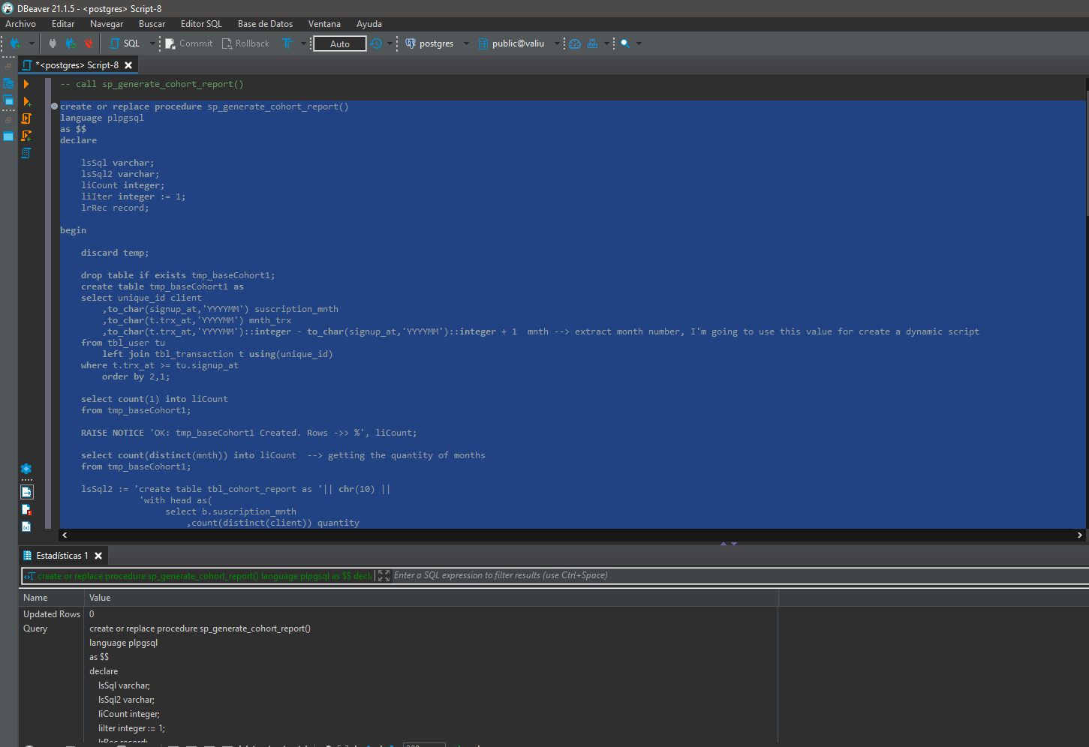

**4 – Call Store Procedure:**

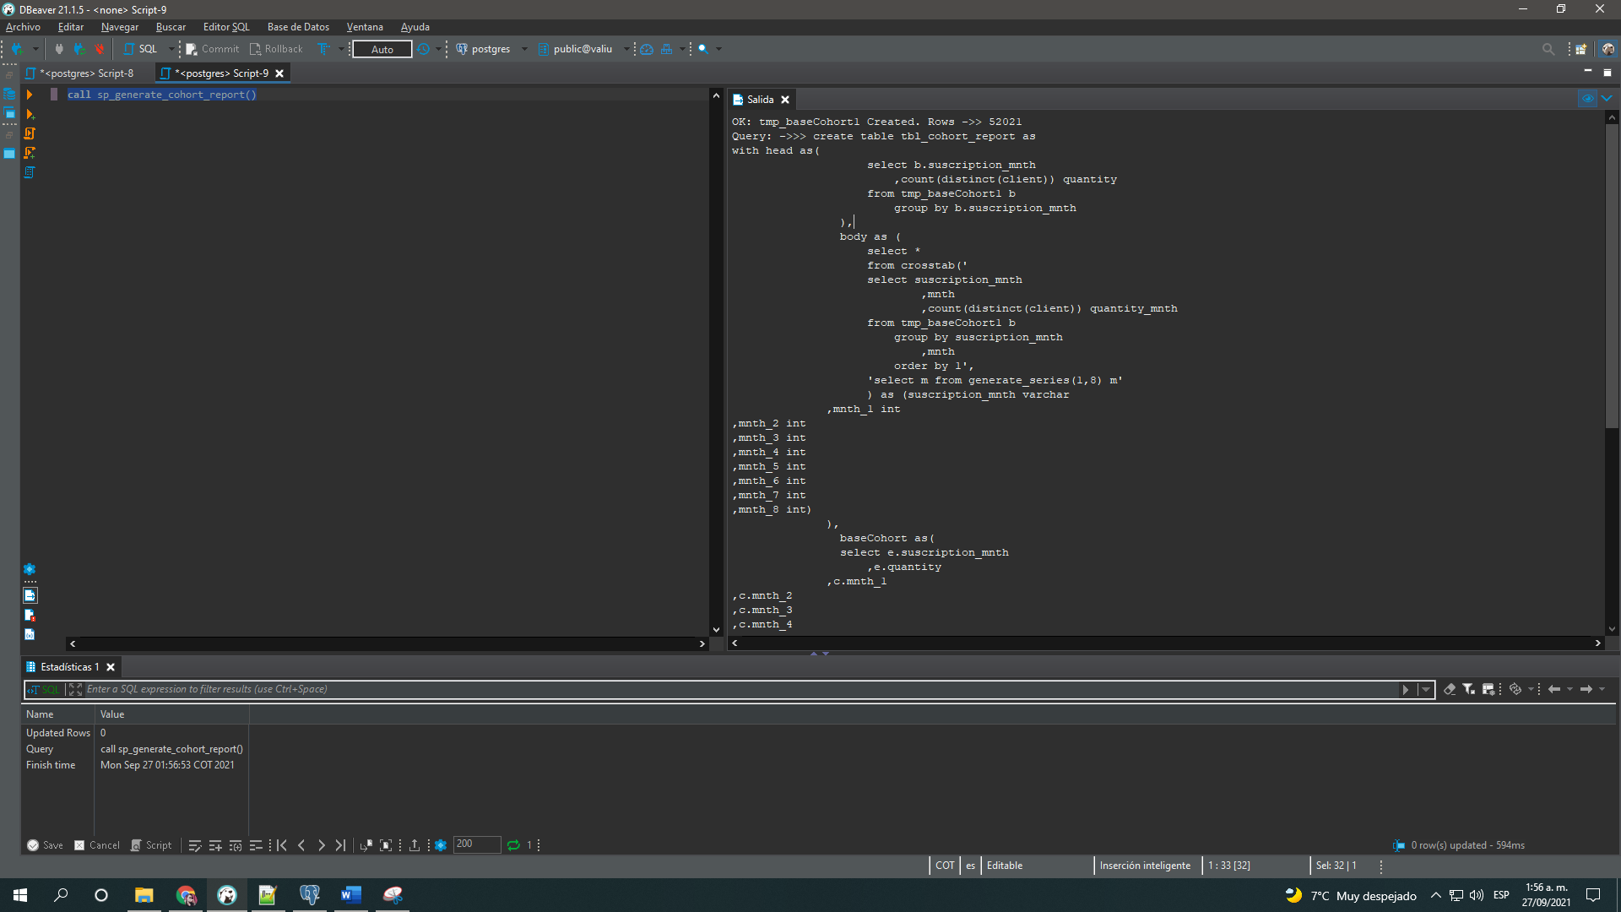

**5 – Select report Table**

