**DSA-(MINI PROJECT)**

* **Title : Automated Term Work Assessment System**

**✅ Introduction:**

**In academic institutions, term work assessment is a crucial part of the internal evaluation process. Traditionally, this process is manual and time-consuming, involving the collection and calculation of various student performance metrics. Our project proposes an automated system that evaluates students’ term work marks based on defined parameters like daily attendance, unit/prelim performance, student achievements, and mock practical results.**

**This system not only saves time and effort for faculty but also ensures a transparent, unbiased, and standardized evaluation process.**

**✅ Objective:**

**To design and develop a simple software tool that automatically computes the term work marks of students by taking inputs for key parameters and applying weighted logic to generate the final score.**

**✅ Key Parameters for Assessment:**

| **Parameter** | **Weightage (%)** | **Explanation** |
| --- | --- | --- |
| **Attendance** | **20%** | **Based on student's overall attendance percentage.** |
| **Unit Test / Prelim Marks** | **30%** | **Average of internal theory test scores.** |
| **Mock Practical** | **30%** | **Marks obtained in internal practical exams.** |
| **Student Achievements** | **20%** | **Extra-curricular or academic achievements, scored out of 10.** |

**✅ Technology Used:**

* **Programming Language: Python**
* **Interface: Command-line (can be upgraded to GUI)**
* **Database: None (for this mini version; data handled via runtime input)**
* **Optional Extensions: SQLite for storage, Tkinter for GUI, or CSV export for reports.**

**✅ Working of the System:**

1. **The user (teacher/admin) enters student details like name, roll number, attendance %, test scores, mock practical scores, and achievement rating.**
2. **The system uses a predefined weighted formula to calculate total term work marks.**
3. **The final score is displayed along with a report for each student.**

* **Calculation Logic:**

**\text{Total Term Work Marks} = \left(\frac{\text{Attendance %}}{100} \times 20\right) + \left(\frac{\text{Unit Test Avg %}}{100} \times 30\right) + \left(\frac{\text{Mock Practical %}}{100} \times 30\right) + \left(\frac{\text{Achievement Score}}{10} \times 20\right)**

**✅ Advantages:**

* **Fast and accurate assessment.**
* **Eliminates manual calculation errors.**
* **Easily extendable for institutional use.**
* **Transparent and standardized evaluation.**
* **Saves time for teachers.**

**✅ Limitations:**

* **No database storage in the current version.**
* **User must re-enter data every time.**
* **No GUI for user-friendly interaction (can be added).**

**✅ Future Scope:**

* **Integration with college ERP or attendance systems.**
* **Exporting reports to Excel or PDF.**
* **User authentication (faculty login).**
* **Web or mobile-based version for broader access.**
* **Adding graphs and analytics to show student performance trends.**

**✅ Flowchart :**

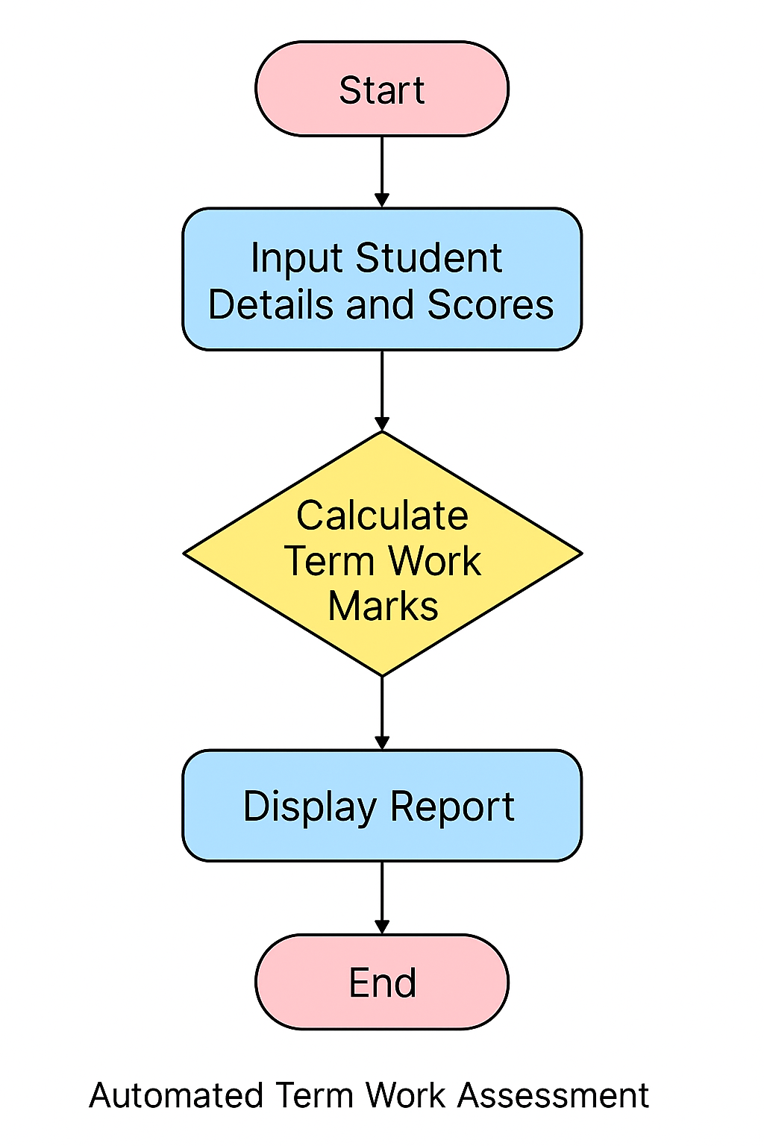

**✅ Conclusion:**

**The Automated Term Work Assessment System is a useful academic tool designed to bring ease and efficiency into student evaluations. This mini project demonstrates how automation can enhance traditional academic processes and lays the foundation for larger systems in education technology.**

**INPUT Code :**

**# Automated Term Work Assessment System**

**# Function to calculate term work marks**

**def calculate_term_work(attendance_percent, unit_test_avg, mock_practical_marks, achievement_score):**

**term_work_marks = (**

**(attendance_percent / 100) * 20 +**

**(unit_test_avg / 100) * 30 +**

**(mock_practical_marks / 100) * 30 +**

**(achievement_score / 10) * 20**

**)**

**return term_work_marks**

**# Function to display student report**

**def display_report(student_data):**

**print("\n===== Term Work Report =====")**

**print(f"Name: {student_data['name']}")**

**print(f"Roll No: {student_data['roll_no']}")**

**print(f"Attendance: {student_data['attendance']}%")**

**print(f"Unit Test Average: {student_data['unit_test_avg']}%")**

**print(f"Mock Practical Marks: {student_data['mock_practical']}%")**

**print(f"Achievement Score: {student_data['achievement_score']}/10")**

**print(f"Calculated Term Work Marks: {student_data['term_work_marks']:.2f} / 100")**

**print("=============================")**

**# Main code**

**def main():**

**print("=== Automated Term Work Assessment System ===")**

**student = {}**

**student['name'] = input("Enter Student Name: ")**

**student['roll_no'] = input("Enter Roll Number: ")**

**student['attendance'] = float(input("Enter Attendance Percentage (%): "))**

**student['unit_test_avg'] = float(input("Enter Unit Test Average Marks (%): "))**

**student['mock_practical'] = float(input("Enter Mock Practical Marks (%): "))**

**student['achievement_score'] = float(input("Enter Achievement Score (out of 10): "))**

**# Calculate term work marks**

**student['term_work_marks'] = calculate_term_work(**

**student['attendance'],**

**student['unit_test_avg'],**

**student['mock_practical'],**

**student['achievement_score']**

**)**

**# Display report**

**display_report(student)**

**if __name__ == "__main__":**

**main()**

**OUTPUT :**

**=== Automated Term Work Assessment System ===**

**Enter the number of students: 2**

**--- Enter details for Student 1 ---**

**Name: Aarya Shah**

**Roll No: 21**

**Attendance (%) : 90**

**Unit Test/Prelim Average Marks (%) : 80**

**Mock Practical Score (%) : 85**

**Achievements Score (out of 10) : 8**

**--- Enter details for Student 2 ---**

**Name: Rohan Mehta**

**Roll No: 22**

**Attendance (%) : 95**

**Unit Test/Prelim Average Marks (%) : 70**

**Mock Practical Score (%) : 75**

**Achievements Score (out of 10) : 9**

**=== Term Work Assessment Report ===**

**Roll No: 21 | Name: Aarya Shah | Term Work Marks: 85.1 / 100**

**Roll No: 22 | Name: Rohan Mehta | Term Work Marks: 81.0 / 100**