**Team 11**

**Password based Door Open System Using LPC2148**

**Objective And Motivation**

* Security is a prime concern in our day-to-day life. Everyone wants to be as secure as possible.
* Our doors serve as entrances to our homes and offices.
* They may also provide access to strangers, criminals and offenders.
* An access control for doors forms a vital link in a security chain.
* This is the sole purpose of door locks.
* The standard type of doorknob is easy to manipulate and provides weak protection.
* This is the prime objective to move from conventional locks to digital locks.
* The objective of this project in its simplest terms is to replace metallic keys by building a fully featured password enabled electronic security system prototype.
* Below are steps taken to achieve this purpose, thus;
  + Review of similar works on electronic door access key was carried out.
  + Determination/Selection of materials relevant to the project.
  + Hardware and Software design.
  + Construction/Packaging of the various components of the system.
  + Testing of the final project to ascertain its authenticity.

**Introduction**

* Many years ago, when security was less of a concern in the society, our forefathers comfortably used simple sleeping mats to cover the doors of their huts.
* They were not bothered at all by any event of a burglary attack because they had a system that wouldn’t allow that to happen.
* Everyone knew their neighbors and virtually everyone else in the village.
* Nowadays it has become almost impossible to achieve that kind of sanity and therefore various tools have been employed over the years to safeguard the lives and properties of its owners.
* The present electronic security system we now enjoy have unequivocally been around for a very long time, although it has gone through a series of evolutionary changes to cater for the needs and security concerns of the present generation.
* From using sticks to wedge doors to using mechanical locks, security systems have metamorphosed into using electronic equipment such as the microcontrollers which is intended to be used for this project to achieve a satisfactory security system.
* Nowadays, many devices’ operations are based on digital technology like a token-based digital identity device.
* One such device is Password Based Door Open System Using LPC2148.

**AIM**

* Unlike the traditional door lock system, keypad door locks do not have any need for physical keys.
* They are basically keyless; that is, anyone can lock or unlock them even without keys.
* Technically, they work like the ATMs. People only need to punch in their secret combination numbers in order to lock or unlock their doors.
* With this kind of entry system, people no longer have to worry about lost or stolen keys and they never have to bring keys with them everywhere they go or hide them in secret places to keep them away from the hands of unauthorized individuals.
* The secret numbers of the keypad door locks can be easily changed into another combination.
* When people feel that their current number combinations have been divulged to unauthorized individuals, they can always change the codes anytime.
* In addition, if the current owners of the house decide to sell the property or have the house rented to others, they can always just let the new people living there know about the access codes to the locks.
* There is no need to change locks at all.
* The aim of this project therefore, is to design and construct a keypad/password based electronic door access key that will be able to:
  + Eliminate the use of mechanical/metallic keys.
  + Prevent events of key misplacements.
  + Avoid excessive key duplication for everyone in the house.
  + Make the apartment where it is installed more difficult to break into.

**Problem Statement**

* One could attest to the fact that the metallic keys used to access mechanical door locks are very susceptible to getting lost, which would mean breaking the locks over and over again if there are more occurrences of such scenarios, moreover, such access keys can be duplicated by unauthorized users.
* Using an electronic door lock as said earlier would counteract the damning consequences of such repugnant occurrences.

**Application and Advantage**

* Can be used in various rooms like seminar hall, conference room, and study rooms in college.
* The project (password detector) can be used to automate the door locking process, so the user need not to carry the door lock keys along with them, they need to just remember the password and use it later to open the door.
* It will add good security.

**Significance**

* **Pick-proof:** Because there is no place for metallic keys with the electronic lock, it prevents break-ins because burglars are unable to pick or bump the lock. The methods used by criminals for breaking and entering are improving and the majority of criminals can pick an ordinary key lock.
* **No more keys:** One wouldn’t have to carry around a large set of keys and they will be less likely to be lost or stolen.
* **Control:** In a company building, one can control and restrict who goes into what part of the building. Additionally, residents and landlords of apartments and flats can control who can enter their room with one PIN code and it reduces the risk of anything getting stolen. It is incredibly easy to change the PIN code whenever you like.
* **Perfect for the elderly or disabled:** The extra investment into a door lock could bring massive advantages to those who are unable to get to the door quickly and/or who struggle with keys.

**Components Required**

* LPC2148 Development board
* LCD Module
* 4*3 Keypad
* DC Motor
* L293D (Motor Driver)

**Software Required**

* Keil IDE

**Block Diagram**

* This project consists of blocks as a microcontroller, a keypad, an LCD, a DC motor, and a motor driver.
* The keypad is an input device which helps to enter a password to open the door. Then, it gives the entered code signals to the microcontroller. The LCD is used to indicate devices for displaying the information.
* The DC motor moves the door to open and close and the motor driver drives the motor after receiving the code signals from the microcontroller.

**Microcontroller**

* A microcontroller is a compact integrated circuit designed to govern a specific operation in an embedded system.
* A typical microcontroller includes a processor, memory and input/output (I/O) peripherals on a single chip.

Keypad

* The keypad is an input device which helps to enter a password to open the door.
* Then, it gives the entered code signals to the microcontroller.
* A Matrix keypad is the most commonly used input device in many of the application areas like digital circuits, telephone communications, calculators, ATMs, and so on.
* A matrix keypad consists of a set of push-button or switches which are arranged in a matrix format of rows and columns.
* These keypads are available in configurations like 3×4 and 4×4 based on the application it is implemented for.

LCD

* The LCD is used to indicating devices for displaying the information.

DC Motor

* A DC motor in simple words is a device that converts electrical energy (direct current system) into mechanical energy. It is of vital importance for the industry today.
* The maximum output current of the microcontroller pin is 15mA at 3.3V.
* But the power requirements of most DC motors are out of reach of the microcontroller and even the back emf (electromotive force) which is produced by the motor may damage the microcontroller.
* Hence it is not good to interface the DC motor directly to the controller.
* So, use a motor driver circuit in between of DC motor and controller.
* The DC motor moves the door to open and close and the motor driver drives the motor after receiving the code signals from the microcontroller.

Buzzer

* It is final indicating devices for displaying the information and alarming.

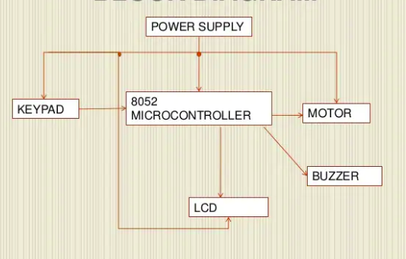

**Circuit Diagram**

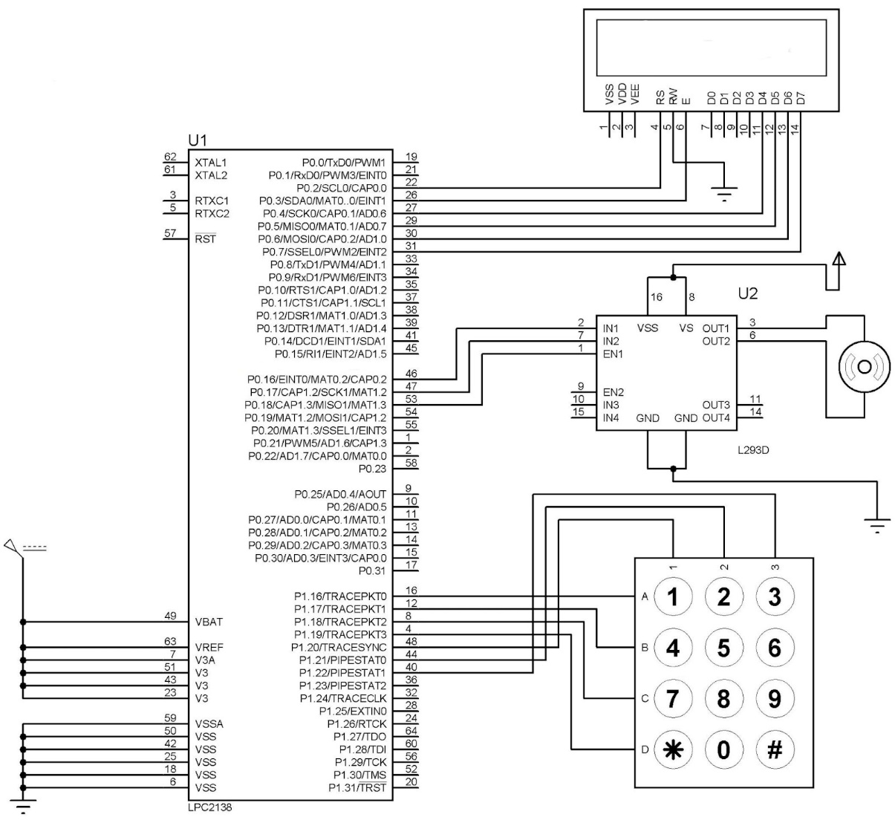

**LCD**

* RS – P0.2
* RW – GND
* EN – P0.3
* Data lines – P0.4 to P0.7 (4 Bit Mode)

**DC Motor (Motor Driver)**

* Input 1 – Port 0.16
* Input 2 – Port 0.17
* Enable 1 – P0.18

**Keypad**

* R1 – P1.16
* R2 – P1.17
* R3 – P1.18
* R4 – P1.19
* C1 – P1.20
* C2 – P1.21
* C3 – P1.22

**Working Principle**

**Keypad Interfacing**

* At the lowest level, keyboards are organized in a matrix of rows and columns.
* The CPU accesses both rows and columns through ports.
* When a key is pressed, a row and a column make a contact. otherwise, there is no connection between rows and columns.
* The status of each key can be determined by a process called Scanning.
* There are many methods depending on how you connect your keypad with your controller, but the basic logic is the same.
* Let’s assume that all the column pins (Col1 – Col4) are connected to the input’s pins and all the row pins are connected to the output pins of the microcontroller.
* In the normal case, all the column pins are pulled up (HIGH state) by internal or external pull-up resistors.
* Now we can read the status of each switch through scanning.
* A logic LOW is given to Row1 and others (Row2 – Row-4) HIGH.
* Now each Column is scanned and if any switch belongs to the 1st row is pressed the corresponding column will pull down (logic LOW) and we can detect the pressed key. This process is repeated for all rows.

**Serial**

* RX – P0.0
* TX – P0.1

**DC Motor Interfacing**

* Input 1 – Port 0.0
* Input 2 – Port 0.1
* Enable 1 – Directly giving 5v

**Forward**

* EN Pin High (En1 = 1 or En2 = 1)
* Input 1 or Input 3 Pin High (In1 = 1 or In3=1)
* Input 2 or Input 4 Pin Low (In2 = 0 or In4 = 0)

**Reverse**

* EN Pin High (En1 = 1 or En2 = 1)
* Input 1 or Input 3 Pin Low (In1 = 0 or In3=0)
* Input 2 or Input 4 Pin Low (In2 = 1 or In4 = 1)

**Limitation and Scope**

* This project would only feature a password-based electronic door access system.
* In other words, it only incorporates the hexadecimal keypad only for authentication.
* Other more advanced security features such as a fingerprint sensor, an iris scanner or a facial recognition camera would not be incorporated.

**Conclusion**

* Irrespective of the challenges encountered during the course of the entire process of the project, it can only be deduced that electronic door access can also be achieved at minimal cost.
* This project has also exposed the fact that metallic keys can possibly be phased out with zero to minimal effect on the old and/or sick people.
* One needs only to be able to remember just four digits which has the same digits as the ATM card codes.

**Thankyou!!**