計算理論 (期中考) 2008/11/21
(總分120，得分超過100分以100分計)

- (12%) Give the state diagram of a DFA for each of the following languages. In all parts Σ = {0, 1}.
(a) {w | w does not contain the substring 01 }
(b) {w | w does not contain the substring 1010 }
(c) {w | w has an even number of 0s and the number of 1s is a multiple of 3}
Ans:
(a)
DFA of
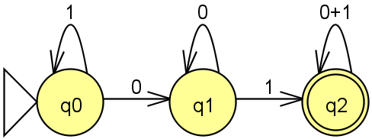
So the DFA of L is
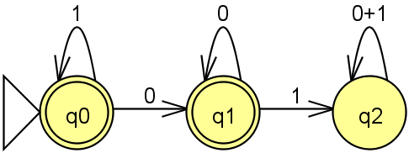
(b)
DFA of
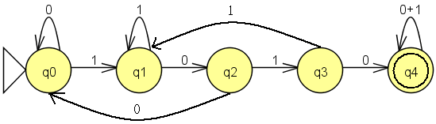

So the DFA of L is
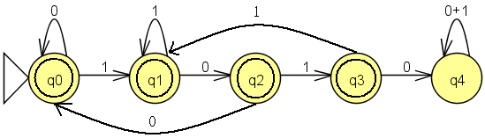
(c)
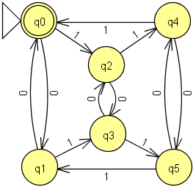
- (8%) Prove that every NFA can be converted to an equivalent one that has a single accept. Your need give (a) the state diagram and (b) the formal definition for the equivalent one.
Ans:
(a)
ε
ε
ε
q_{f}
(b)
Original NFA (Q , Σ , δ , q₀ , F )
New NFA (Q₁ , Σ , δ₁ , q₀ , {q_{f}})
Q₁ = Q∪{q_{f}}
δ₁( q , a ) =δ( q , a ) if q ∉ F or a ≠ε
δ₁( q , a ) =δ( q , a )∪{q_{f}} if q ∈ F and a =ε
- (8%) Let B and C be languages over Σ = {0, 1}. Define B α C = {w∈ B | for some y ∈ C, strings w and y contain equal numbers of 1s}. Show that the class of regular languages is closed under the operation α.
Ans: see textbook page 97 1.44
- (16%) Say that string x is a prefix of string y if a string z exists where xz = y and that x is a proper prefix of y if in addition x ≠ y. In each of the following parts we define an operation on a language A. Show that the class of regular languages is closed under that operation.
(a) NOPREFIX(A) = {w ∈ A | no proper prefix of w is a member of A}.
(b) NOEXTEND(A) = { w ∈ A | w is not the proper prefix of any string in A}.
Ans:
(a) see textbook page 96 1.40.a
(b)
Original NFA (Q , Σ , δ , q₀ , F )
New NFA (Q , Σ , δ , q₀ , F₁ )
∀q∈ F₁ , q∈ F and if q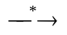q_{t} then q_{t} ∉ F.
- (16%) Prove that the following languages are not regular.
(a) { 0^{n} 1^{m} 0^{n} | m, n ≥ 0}
(b) {0^{m}1^{n} | m≠n}
(c) { w | w ∈ {0, 1}* is not a palindrome}
(d) { wtw | w, t ∈ {0, 1}⁺ }
Ans:
(a)
Choose w = 0^{p} 1^{q} 0^{p} , p is the pumping length.
Let w = xyz , where | xy | ≤ p , | y | ≥ 1.
Then y = 0^{k} , 1 ≤ k ≤ p. So xy²z = 0^{p+k} 1^{q} 0^{p} ∉ L
Therefore L is not regular.
(b)
If L={0^{m}1^{n} | m≠n} is regular then 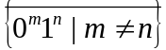 is regular.
But ∩{0^{m}1^{n} | m,n≥0} = {0^{m}1^{n} | m=n} is not regular, so L is not regular
(c)
Because the complement of L={ w | w ∈ {0, 1}* is not a palindrome}, which means { w | w ∈ {0, 1}* is a palindrome} is not regular, so L is not regular.
(d)
Choose w = 0^{p} 1 10^{p} 1, p is the pumping length.
Let w = xyz , where | xy | ≤ p , | y | ≥ 1.
Then y = 0^{k} , 1 ≤ k ≤ p. So xy²z = 0^{p+k} 1 1 0^{p} 1 ∉ L
Therefore L is not regular.
- (8%)
(a) Let B = {1^{k}y | y ∈ {0, 1}* and y contains at least k 1s, for k ≥ 1}. Show that B is a regular language.
(b) Let C = {1^{k}y | y ∈ {0, 1}* and y contains at most k 1s, for k ≥ 1}. Show that C isn't a regular language.
Ans:
(a)
B can be rewriten as {xy | x=1^{k} , y ∈ {0, 1}* and y contains at least k 1s, for k ≥ 1}. That is ∀w∈B w can be divided as two parts, first part x ∈ {1}⁺ , second part y∈ {0, 1}* and n₁(y) ≥ n₁(x).
Suppose B_{i} = { xy | x=1^{i} , y ∈ {0, 1}* and y contains at least i 1s}.
Obviously B = B₁∪B₂∪B₃∪B₄∪B₅∪…and B₁ ⊃ B₂ ⊃ B₃ ⊃ B₄ ⊃ B₅ ⊃ ….
Therefore B = B₁. And the DFA for B is same as B₁:
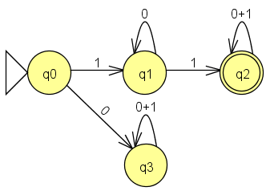
(b)
Choose w = 1^{p} 0 1^{p} , p is the pumping length.
Let w = xyz , where | xy | ≤ p , | y | ≥ 1.
Then y = 1^{k} , 1 ≤ k ≤ p. So xy⁰z = xz = 1^{p-k} 01^{p} ∉ L
Therefore L is not regular.
- (8%) Let Σ = {0, 1, +, =} and ADD = {x=y+z | x, y, z are binary integers, and x is the sum of y and z}. Show that ADD is not regular.
Ans:
Choose w =” 1^{p} =1^{p} + 0 “, p is the pumping length.
Let w = xyz , where | xy | ≤ p , | y | ≥ 1.
Then y = 1^{k} , 1 ≤ k ≤ p. So xy²z = “ 1^{p+k} = 1^{p} + 0 ” ∉ L
Therefore L is not regular.
- (20%) Give context-free grammars that generate the following languages. In all parts the alphabet Σ = {0, 1}.
(a) {w | w contains at least three 1s }
(b) {w | w starts and ends with the same symbol}
(c) {w | the length of w is odd}
(d) {w | the length of w is odd and its middle symbol is a 0}
(e) {w | w = w^{R}, that is, w is a palindrome}
Ans:
(a)
S→ A1A1A1A
A→ 0A | 1A | ε
(b)
S→ 0A0 | 1A1 | 0 | 1 | (ε) , ε可有可無
A→ 0A | 1A | ε
(c)
S→ 0S0 | 0S1 | 1S0 | 1S1 | 0 | 1
(d)
S→ 0S0 | 0S1 | 1S0 | 1S1 | 0
(e)
S→ 0S0 | 1S1 | 0 | 1 | ε
- (8%) Convert the following CFG into an equivalent CFG in Chomsky normal form.
A → BAB | B | ε
B → 00 | ε
Ans:
A → BAB | B | ε
B → 00 | ε
Remove B → ε =>
A → BAB | B | ε | BA | AB | A
B → 00
Remove A → A =>
A → BAB | B | ε | BA | AB
B → 00
Transform B → 00 =>
A → BAB | B | ε | BA | AB
B → CC
C → 00
Remove A → B =>
A → BAB | CC | ε | BA | AB
B → CC
C → 00
Transform A → BAB =>
A → BD | CC | ε | BA | AB
B → CC
C → 00
D → AB
- (16%) Give context-free grammars generating the following languages.
(a) The set of strings over the alphabet {a, b} with more a's than b's
(b) The complement of the language {a^{n}b^{n} | n ≥ 0}
(c) { w#x | w^{R} is a substring of x for w, x ∈ {0, 1}*}
(d) { x_{l}#x₂# ⋅⋅⋅ #x_{k} | k ≥ 1, each x_{i} ∈{a, b}*, and for some i and j, x_{i} = x_{j}^{R}}
Ans:
(a)
S → TaT
T → TT | aTb | bTa | a | ε
(b)
S → aT | Xb | YbYaY
T → aTb | aT | ε
X → aXb | Xb | ε
Y → aY | bY | ε
(c)
S → TX
T → 0T0 | 1T1 | #X
X → 0X | 1X | ε
(d)
S → T | XT | TY | XTY
T → aTa | bTb | a | b | ε | # | #X
X → aX | bX | #X | #
Y → Ya | Yb | Y# | #

