小型网站系统

B
y——lucky小组

目录：

目 录
1.人员分工
2.连接步骤
3.登陆界面
4.运行结果截图

- 人员分工

（1） 建立数据库表及协调整体工作：胡雪璇
（2）资源搜集整理：宫晓雪
（3）代码运行：高婷婷
（4）界面设计：李莹
（5）文档编辑：王兆鹏

二、JDBC连接SQLserver数据库的步骤：
1.下载SQLserver的JDBC驱动文件——
Microsoft JDBC Driver 4.0 for SQL Server
- 例如下载得到的文件是sqljdbc_4.0.2206.100_chs.exe，解压文 件，将压缩中的sqljdbc4.jar到eclipse-workspace\User_Message（新建的JavaWeb项目）\WebContent\WEB-INF\lib目录下。
3.加载JDBC驱动程序
4.创建连接对象
5.准备SQL语句
6.执行SQL语句
7.操作结果集对象
8.关闭JDBC对象

三、登录界面及其功能设计
1.对数据库操作方法的接口
代码
package com.jaovo.msg.dao;
import java.util.List;
import com.jaovo.msg.model.User;
public interface IUserDao
{
public void add(User user);
public void delete(int id);
public void update(User user);
public User load(int id);
public User load(String username);
public List<User> load();
}

2.实现接口的类
代码
package com.jaovo.msg.dao;
import java.sql.Connection;
import java.sql.PreparedStatement;
import java.sql.ResultSet;
import java.sql.SQLException;
import java.sql.Statement;
import java.util.ArrayList;
import java.util.List;

import com.jaovo.msg.Util.DBUtil;
import com.jaovo.msg.Util.UserException;
import com.jaovo.msg.model.User;
public class UserDaoImpl implements IUserDao
{
public void add(User user)
{
//获得连接的对象
Connection connection=DBUtil.getConnection();
//准备sql语句
String sql="select count(*) from t_user where username=?";
//创建语句传输对象
PreparedStatement preparedStatement=null;
ResultSet resultSet=null;
try
{
preparedStatement=connection.prepareStatement(sql);
preparedStatement.setString(1, user.getUsername());
//接收结果集
resultSet=preparedStatement.executeQuery();
//遍历结果集
while(resultSet.next())
{
if(resultSet.getInt(1)>0)
{
throw new UserException("用户已存在！");
}
}
sql="insert into t_user(username,nickname,password) values(?,?,?)";
preparedStatement=connection.prepareStatement(sql);
preparedStatement.setString(1, user.getUsername());
preparedStatement.setString(2, user.getNickname());
preparedStatement.setString(3, user.getPassword());
preparedStatement.executeUpdate();
//重写底层代码：
/*
sql="insert into t_user(id,username,userpassword,nickname)values('"+user.getId()+"','"+user.getUsername()+"','"+user.getPassword()+"','"+user.getNickname()+"')";
Statement stmt;
Connection con=DBUtil.getConnection();
stmt=con.createStatement();
stmt.executeUpdate(sql);
*/
//重写结束
}
catch (SQLException e)
{
e.printStackTrace();
}
finally
{
//关闭JDBC对象
DBUtil.close(resultSet);
DBUtil.close(preparedStatement);
DBUtil.close(connection);
}
}
public void delete(int id)
{
//获得连接的对象
Connection connection=DBUtil.getConnection();
//准备sql语句
String sql="delete from t_user where id=?";
//创建语句传输对象
PreparedStatement preparedStatement=null;
try
{

preparedStatement=connection.prepareStatement(sql);
preparedStatement.setInt(1, id);
preparedStatement.executeUpdate();

}
catch(SQLException e)
{
e.printStackTrace();

}
finally
{
DBUtil.close(preparedStatement);
DBUtil.close(connection);
}
}

public void update(User user)
{
//获得连接的对象
Connection connection=DBUtil.getConnection();
//准备sql语句
String sql="delete from t_user where id=?";
//创建语句传输对象
PreparedStatement preparedStatement=null;
try
{
preparedStatement=connection.prepareStatement(sql);
preparedStatement.setString(1, user.getUsername());
preparedStatement.setString(2, user.getNickname());
preparedStatement.setInt(3, user.getId());
preparedStatement.executeUpdate();
}
catch(SQLException e)
{
e.printStackTrace();
}
finally
{
DBUtil.close(preparedStatement);
DBUtil.close(connection);
}
}

public User load(int id)
{
//获得连接的对象
Connection connection=DBUtil.getConnection();
//准备sql语句
String sql="select * from t_user where id=?";
//创建语句传输对象
PreparedStatement preparedStatement=null;
ResultSet resultSet=null;
User user=null;
try
{
preparedStatement=connection.prepareStatement(sql);
preparedStatement.setInt(1, id);
resultSet=preparedStatement.executeQuery();
while(resultSet.next())
{
user=new User();
user.setId(id);
user.setUsername(resultSet.getString("username"));
user.setPassword(resultSet.getString("password"));
user.setNickname(resultSet.getString("nickname"));
}
}
catch(SQLException e)
{
e.printStackTrace();
}
finally
{
DBUtil.close(resultSet);
DBUtil.close(preparedStatement);
DBUtil.close(connection);
}
return user;
}

public User load(String username)
{
//获得连接的对象
Connection connection=DBUtil.getConnection();
//准备sql语句
String sql="select * from t_user where username=?";
//创建语句传输对象
PreparedStatement preparedStatement=null;
ResultSet resultSet=null;
User user=null;
try
{
preparedStatement=connection.prepareStatement(sql);
preparedStatement.setString(1, username);
resultSet=preparedStatement.executeQuery();
while(resultSet.next())
{
user=new User();
user.setId(resultSet.getInt("id"));
user.setUsername(username);
user.setPassword(resultSet.getString("password"));
user.setNickname(resultSet.getString("nickname"));
}
}
catch(SQLException e)
{
e.printStackTrace();
}
finally
{
DBUtil.close(resultSet);
DBUtil.close(preparedStatement);
DBUtil.close(connection);
}
return user;
}

public List<User> load()
{
//获得连接的对象
Connection connection=DBUtil.getConnection();
//准备sql语句
String sql="delete from t_user where id=?";
//创建语句传输对象
PreparedStatement preparedStatement=null;
ResultSet resultSet=null;
List<User> users=new ArrayList<User>();
User user=null;
try
{
preparedStatement=connection.prepareStatement(sql);
resultSet=preparedStatement.executeQuery();
while(resultSet.next())
{
user=new User();
user.setId(resultSet.getInt("id"));
user.setUsername(resultSet.getString("username"));
user.setNickname(resultSet.getString("nickname"));
user.setPassword(resultSet.getString("password"));
users.add(user);
}

}
catch(SQLException e)
{
e.printStackTrace();
}
finally
{
DBUtil.close(resultSet);
DBUtil.close(preparedStatement);
DBUtil.close(connection);
}
return users;
}
//检查密码是不是错误
public boolean check(User user)
{
boolean flag=false;
Connection connection=DBUtil.getConnection();
String sql="select * from t_user where username=?";
PreparedStatement preparedStatement = null;
ResultSet resultSet=null;
try
{
preparedStatement=connection.prepareStatement(sql);
preparedStatement.setString(1,user.getUsername());
resultSet=preparedStatement.executeQuery();
while(resultSet.next())
{
if(resultSet.getString("password").equals(user.getPassword().toString().trim()))
{
flag=true;
break;
}
}
}
catch (SQLException e)
{
e.printStackTrace();
}
return flag;
}
}

3.用户模型类
代码
package com.jaovo.msg.model;
public class User
{
private int id;
private String username;
private String nickname;
private String password;
public int getId()
{
return id;
}
public void setId(int id)
{
this.id = id;
}
public String getUsername()
{
return username;
}
public void setUsername(String username)
{
this.username = username;
}
public String getNickname()
{
return nickname;
}
public void setNickname(String nickname)
{
this.nickname = nickname;
}
public String getPassword()
{
return password;
}
public void setPassword(String password)
{
this.password = password;
}
}

4.工具类（用于连接数据库和关闭JDBC对象）
代码
package com.jaovo.msg.Util;
import java.sql.Connection;
import java.sql.DriverManager;
import java.sql.PreparedStatement;
import java.sql.ResultSet;
import java.sql.SQLException;

public class DBUtil
{
public static Connection getConnection()
{
try
{
//加载驱动
Class.forName("com.microsoft.sqlserver.jdbc.SQLServerDriver").newInstance();
System.out.println("驱动加载成功！");
}
catch(ClassNotFoundException | InstantiationException | IllegalAccessException e)
{
System.out.println("驱动加载失败！");
e.printStackTrace();
}
String user="sa";
String password="woshizcy0919";
String url="jdbc:sqlserver://127.0.0.1:1433;DatabaseName=User_DB";
Connection connection=null;
try
{
//创建链接对象connection
connection=DriverManager.getConnection(url, user, password);
System.out.println("数据库连接成功！");
}
catch(SQLException e)
{
System.out.println("数据库连接失败！");
e.printStackTrace();
}
return connection;
}

//关闭资源的方法
public static void close(Connection connection)
{
if(connection!=null)
{
try
{
connection.close();
}
catch (SQLException e)
{
e.printStackTrace();
}
}
}

public static void close(PreparedStatement preparedStatement)
{
if(preparedStatement !=null)
{
try
{
preparedStatement.close();
}
catch (SQLException e)
{
e.printStackTrace();
}
}
}

public static void close(ResultSet resultSet)
{
if(resultSet!=null)
{
try
{
resultSet.close();
}
catch (SQLException e)
{
e.printStackTrace();
}
}
}
}

5.异常抛出类
代码
package com.jaovo.msg.Util;
public class UserException extends RuntimeException
{
public UserException()
{
super();
}

public UserException(String message, Throwable cause, boolean enableSuppression, boolean writableStackTrace)
{
super(message, cause, enableSuppression, writableStackTrace);
}

public UserException(String message, Throwable cause)
{
super(message, cause);
}

public UserException(String message)
{
super(message);
}

public UserException(Throwable cause)
{
super(cause);
}
}
6.jsp界面代码
（1）登录界面
代码
<%@ page language="java" contentType="text/html; charset=UTF-8"
pageEncoding="UTF-8"%>
<!DOCTYPE html PUBLIC "-//W3C//DTD HTML 4.01 Transitional//EN" "http://www.w3.org/TR/html4/loose.dtd">
<html>
<head>
<meta http-equiv="Content-Type" content="text/html; charset=UTF-8">
<title>欢迎来到登录界面</title>
</head>
<body>
<%=request.getAttribute("error") %>
<form action="LoginCheck.jsp" method="post">
<table align="center" border="1" width="500">
<caption>用户登录</caption>
<tr>
<td>账号：</td>
<td>
<input type="text" name="username"/>
</td>
</tr>
<tr>
<td>密码：</td>
<td>
<input type="password" name="password">
</td>
</tr>
<tr align="center">
<td colspan="2">
<input type="submit" value="登录"/>
<input type="button" value="注册" onClick="window.location.href='addInput.jsp'"/>
</td>
</tr>
</table>
</form>
</body>
</html>

（2）登录验证界面
代码
<%@page import="com.jaovo.msg.Util.UserException"%>
<%@page import="com.jaovo.msg.dao.UserDaoImpl"%>
<%@page import="com.jaovo.msg.model.User"%>
<%@ page language="java" contentType="text/html; charset=UTF-8"
pageEncoding="UTF-8"%>
<!DOCTYPE html PUBLIC "-//W3C//DTD HTML 4.01 Transitional//EN" "http://www.w3.org/TR/html4/loose.dtd">
<html>
<head>
<title>用户身份验证</title>
</head>
<body>
<%
//接收客户端传递过来的参数
String username = request.getParameter("username");
String password = request.getParameter("password");
if(username == null || "".equals(username.trim())||password == null || "".equals(password.trim()))
{
request.setAttribute("error", "用户名和密码不能为空！");
%>
<jsp:forward page="Login.jsp"></jsp:forward>
<%
}
%>
<%
User user = new User();
user.setUsername(username);
user.setPassword(password);
UserDaoImpl userDao = new UserDaoImpl();
try
{
if(userDao.load(username)==null)
{
throw new UserException();
}
if(userDao.check(user)==true)
{
%>
登录成功!<br>
<%
}
else
{
%>
密码输入错误!<br>
<%
}
}
catch(UserException e)
{
%>
<h2 style="color:red ; font-size:50px">该用户名不存在</h2>
<%
}
%>
</body>
</html>

（3）用户注册界面
代码
<%@ page language="java" contentType="text/html; charset=UTF-8"
pageEncoding="UTF-8"%>
<!DOCTYPE html PUBLIC "-//W3C//DTD HTML 4.01 Transitional//EN" "http://www.w3.org/TR/html4/loose.dtd">
<html>
<head>
<title>用户添加页面</title>
</head>
<body>
<form action="add.jsp" method="get">
<table align="center" border="1" width="500">
<tr>
<td>用户名称 : </td>
<td>
<input type="text" name="username" />
</td>
</tr>
<tr>
<td>用户密码:</td>
<td>
<input type="password" name="password" />
</td>
</tr>
<tr>
<td>用户昵称:</td>
<td>
<input type="text" name="nickname" />
</td>
</tr>
<%=request.getAttribute("error") %>
<tr align="center">
<td colspan="2">
<input type="submit" value="提交" />
<input type="reset" value="重置" />
</td>
</tr>
</table>
</form>
</body>
</html>

（4）注册结果界面
代码
<%@page import="com.jaovo.msg.Util.UserException"%>
<%@page import="com.jaovo.msg.dao.UserDaoImpl"%>
<%@page import="com.jaovo.msg.model.User"%>
<%@ page language="java" contentType="text/html; charset=UTF-8" pageEncoding="UTF-8"%>
<!DOCTYPE html PUBLIC "-//W3C//DTD HTML 4.01 Transitional//EN" "http://www.w3.org/TR/html4/loose.dtd">
<html>
<head>
<title>用户添加页面</title>
</head>
<body>
<%
//接收客户端传递过来的参数
String username = request.getParameter("username");
String password = request.getParameter("password");
String nickname = request.getParameter("nickname");
if(username == null || "".equals(username.trim())||password == null || "".equals(password.trim())){
request.setAttribute("error", "用户名和密码不能为空！");
%>
<jsp:forward page="addInput.jsp"></jsp:forward>
<%
}
%>
<%
User user = new User();
user.setUsername(username);
user.setPassword(password);
user.setNickname(nickname);

UserDaoImpl userDao = new UserDaoImpl();
try{
userDao.add(user);
%>
注册成功!<br>
<a href="addInput.jsp">返回</a><br>
<a href="#">用户列表</a>
<%
}catch(UserException e){
%>
<h2 style="color:red ; font-size:50px">发生错误 : <%=e.getMessage() %></h2>
<%
}
%>
</body>
</html>

四、运行结果界面截图
（1）登录界面

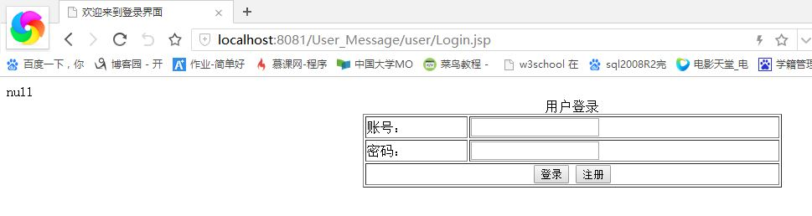
- 登录成功

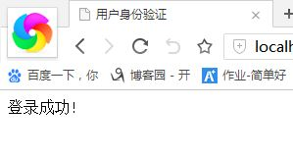
（3）用户名或密码为空
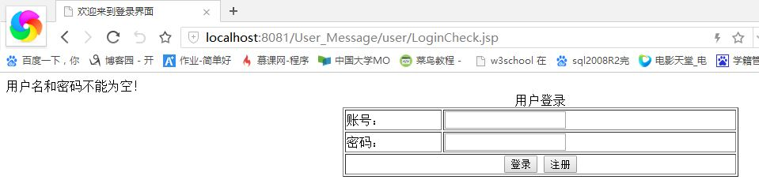
（4）用户名不存在
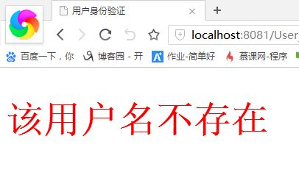
（5）密码错误
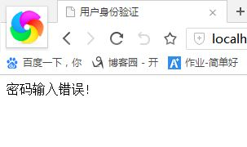
（6）注册界面
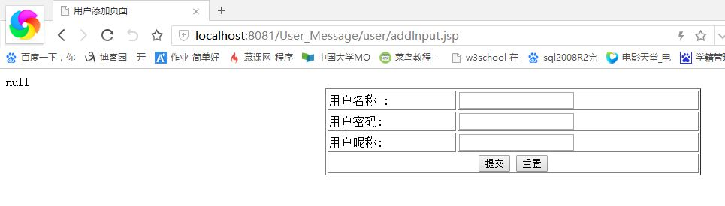

（7）注册成功
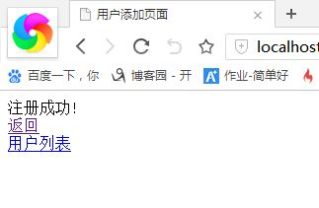
- 注册重复

