**实验报告11**

**学号：**117060400123 **姓名**：黄茜洋 **班级：**应统一班**指导老师：**林卫中**实验名称**：第九章实验

**实验要求：**1.了解科学计算的基本概念

2.了解数据可视化的概念

3.运用科学计算库进行矩阵分析和数值运算

4.运用数据绘图库进行坐标系绘制

**实验题目：**1. 解方程𝐴𝑥=𝑏

2. 绘制一副自己的人物肖像的手绘效果图

3.方波绘制

4.画圆

**算法实现：**

**1.**

import numpy as np

from numpy.linalg import inv

A = np.array([[1,0.5,5],[2.3,2,3],[4,1,1.7]])

b = np.array([[1,2,3]])

#b = np.array([[1],[2],[3]])

x = np.matmul(inv(A),np.transpose(b))

print(x)

2.

from PIL import Image

import numpy as np

vec_el = np.pi/2.2

vec_az = np.pi/4.

depth = 10. # (0-100)***********

im = Image.open('本人.jpg').convert('L')

a = np.asarray(im).astype('float')

grad = np.gradient(a)

grad_x, grad_y = grad

grad_x = grad_x*depth/100.

grad_y = grad_y*depth/100.

dx = np.cos(vec_el)*np.cos(vec_az)

dy = np.cos(vec_el)*np.sin(vec_az)

dz = np.sin(vec_el)

A = np.sqrt(grad_x**2 + grad_y**2 + 1.)

uni_x = grad_x/A

uni_y = grad_y/A

uni_z = 1./A

a2 = 255*(dx*uni_x + dy*uni_y + dz*uni_z)

a2 = a2.clip(0,255)

im2 = Image.fromarray(a2.astype('uint8'))

im2.save('本人HandDraw.jpg')

im2.show()

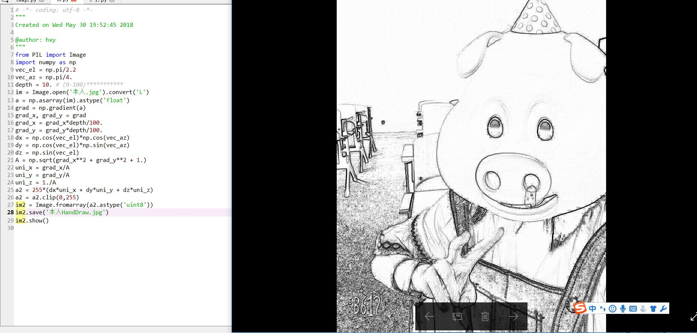

3. import numpy as np

import matplotlib.pyplot as plt

t = np.linspace(0, 2*np.pi, 100)

k = 1

y = np.zeros((t.shape[0],))

while k <= 20:

y = y + (4*np.sin((2*k-1)*t))/((2*k-1)*np.pi)

k = k + 1

plt.plot(t,y)

plt.show()

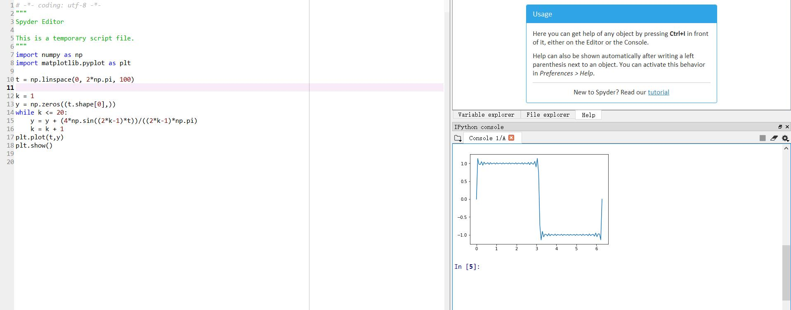

4. import numpy as np

import matplotlib.pyplot as plt

x = np.linspace(-1,1,1000)

y = np.linspace(-1,1,1000)

px = []

py = []

for xx in x:

for yy in y:

if np.abs(xx**2 + yy**2 - 1) <= 1e-3:

px.append(xx)

py.append(yy)

plt.scatter(px,py)

plt.axis('equal')

#plt.plot(px,py)

plt.show()

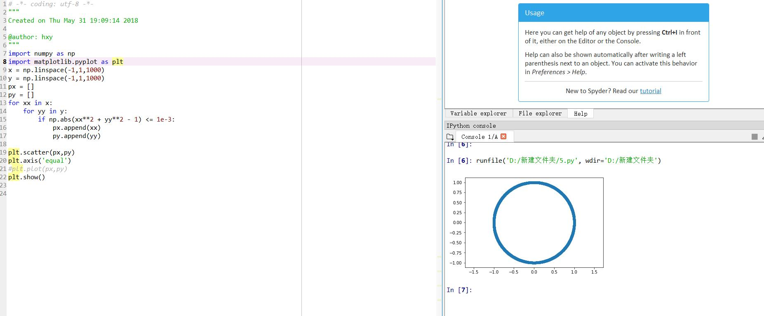

方法二：

import numpy as np

import matplotlib.pyplot as plt

t = np.linspace(0,2*np.pi,100)

x = np.sin(t)

y = np.cos(t)

plt.plot(x,y)

plt.axis('equal')

plt.show()

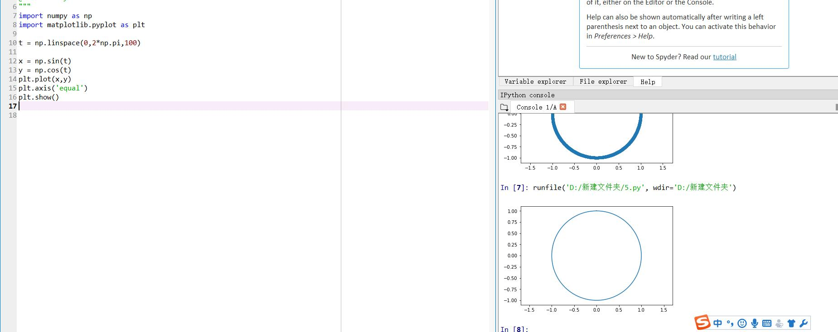

方法三：

import numpy as np

import matplotlib.pyplot as plt

x = np.linspace(-1,1,100)

y = np.sqrt(1-x**2)

z = -y

plt.plot(x,y,'r')

plt.plot(x,z,'r')

plt.axis('equal')

plt.show()

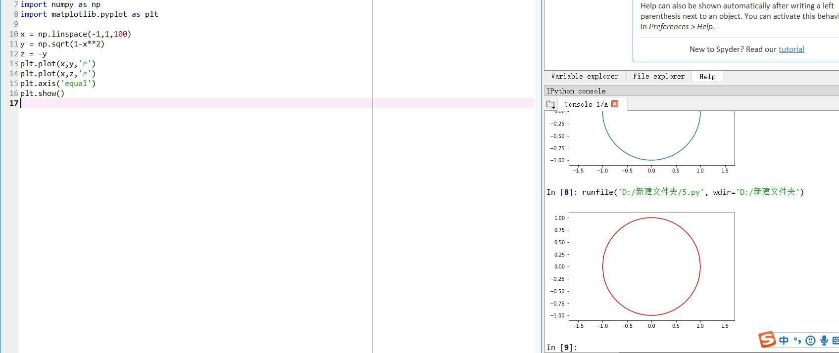

我学会了怎么去看文档说明，还学会了做雷达图，函数图，以及画圆和改变参数去看代码。