How to run Matlab code to plot results:
- Copy the folders as is.
- Run in the folder where the Matlab Script is.
- Select the data you want to look at
  - Voltage starts at 1pu, 1.1pu or 0.9 pu.
- You can check which P/Q specs to show by modifying the 2 lines right after
  - % Look at different P/Q combinations
I preselected 2 Pref/Qref specifications that would show the problem.

How to run PSCAD:
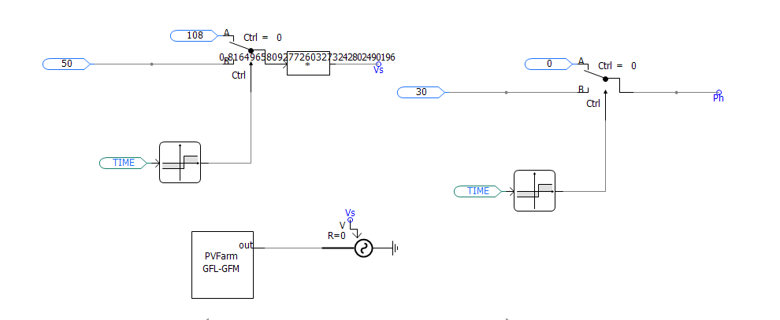
Left Branch controls the voltage.
- Voltage magnitude starts with top branch.
- After 1s, the voltage switches to bottom branch, simulating a fault.
Right branch controls the voltage phase.
- After 1s, the branch introduces a phase shift.
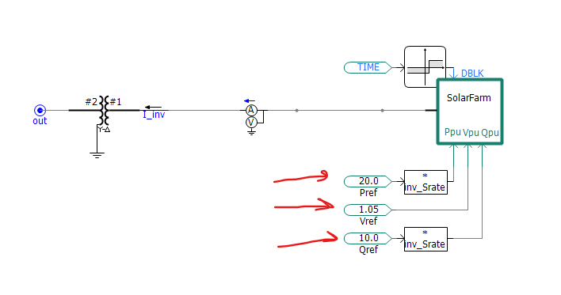
Change Pref, Qref, and Vref here.
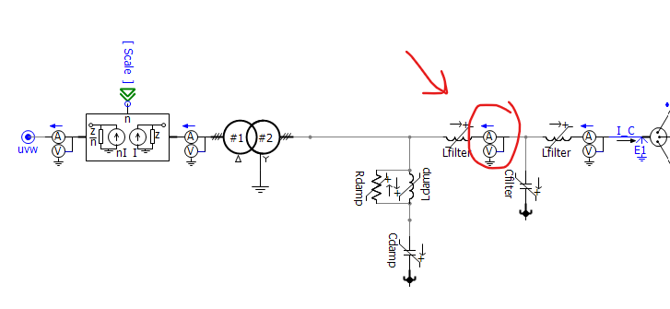
P, Q, V, I are recorded at this multimeter inside the solar farm.

