Chunk Tree Viewer
Heiberg, Harris, and Ball (2007) working at the Air Force Research Laboratory created a graphical representation for chunks in ACT-R. This extra describes an optional tool for the ACT-R Environment which will allows one to select a chunk and display a slightly modified version of their graphical representation for that chunk.
To use the tool, the “35a-chunk-tree.tcx” file found in the ACT-R Environment’s GUI/dialogs directory must be renamed to “35a-chunk-tree.tcl” before running the Environment. When it is enabled a button called “Chunk Tree” will be added to the Current Data section of the Control Panel.
Pressing that button will open a new chunktree window for the current model and any number of those windows may be open at a time. Here is what the window will look like after loading the siegler model from unit 5 of the ACT-R tutorial:
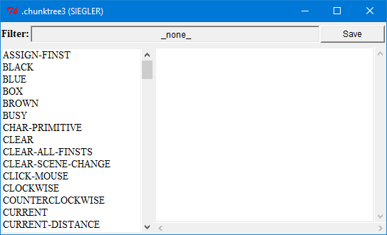
It functions similar to the Declarative viewer which is described in the ACT-R Environment’s manual. In the chunktree window the list on the left shows the names of all the chunks in the model (not just those in declarative memory) sorted alphabetically, and the filter button at the top can be used to restrict that list to only chunks which have a particular set of slots (where _none_ means no filter not having no slots). Selecting one of the chunks from the list will result in an image being generated to show the contents of that chunk. The chunk name will be displayed at the top of the window in green and then for each slot a line will be drawn below that name with the name of the slot written in blue italic text at the end of the line. Below the slot name the contents of the slot will be displayed. If the content is not a chunk then it will be displayed in black with nothing below it. If the content is a chunk, then it will be displayed in one of two ways. If it is a chunk which does not occur further up in the current branch of the tree then it will be displayed in green text with its slot contents displayed recursively below it. If it is a chunk which does occur further up in the current branch of the tree (a circular reference) then it will be displayed in red text and its slots will not be displayed.
Here is the display for the chunk f12 in the model which contains slots with chunks which contain slots with non-chunk values:
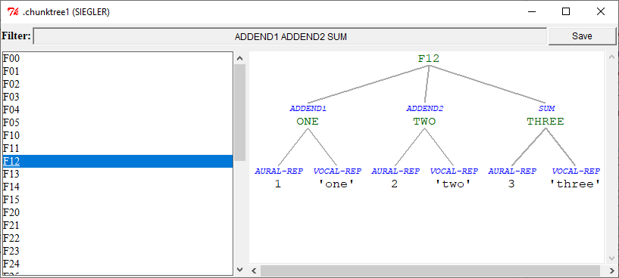
Here is the display for the chunk black which has itself as the value of its only slot:
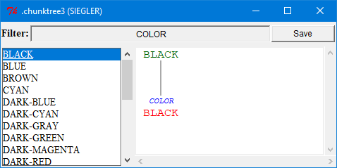
Pressing the “Save” button at the top right of the window will allow you to save an image of the chunk as an Encapsulated PostScript file. A file creation dialog will be opened and the image will be saved into the file which you provide.

References
Heiberg, A., Harris, J. & Ball, J. (2007). Dynamic Visualization of ACT-R Declarative Memory Structure. In Proceedings of the 8th International Conference on Cognitive Modeling. July 27-29, 2007, Ann Arbor, Michigan (pp. 233 - 234). Oxford, UK: Taylor & Francis/Psychology Press.

