Пояснительная записка к зачётному заданию
по курсу
«Статистические методы обработки информации»

Работу выполни:
Студент группы Б14-501
Попцов П. А.

НИЯУ МИФИ 2017
1. Задание

Реализовать алгоритм МНК для нелинейных объектов.

2. Теоретическое описание алгоритма

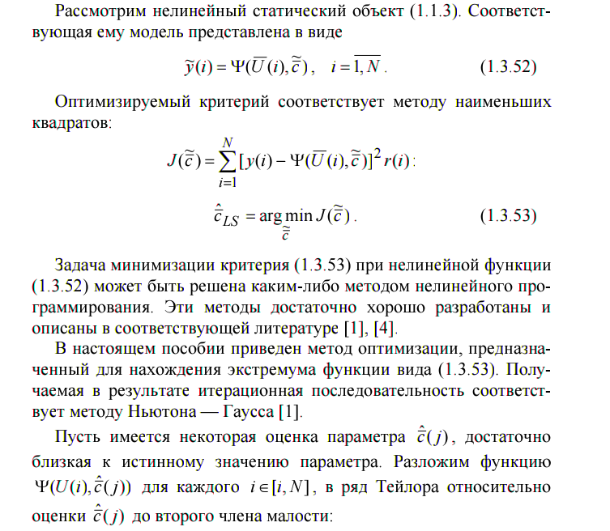

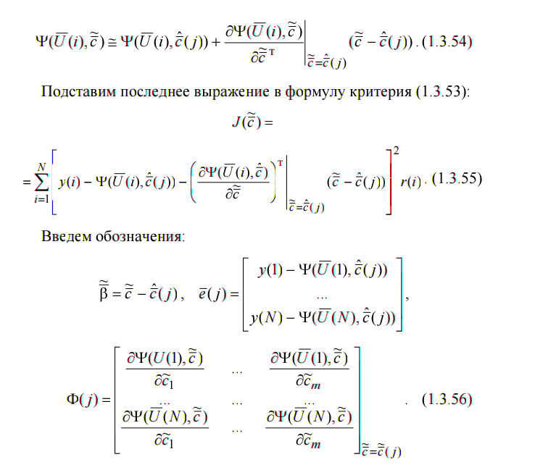
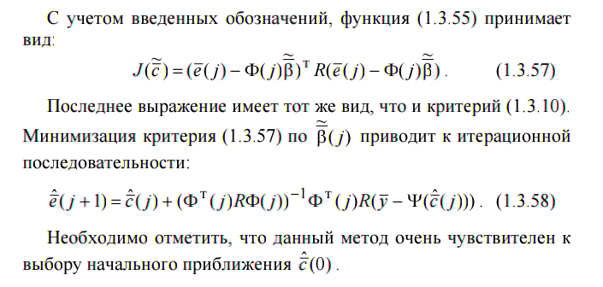
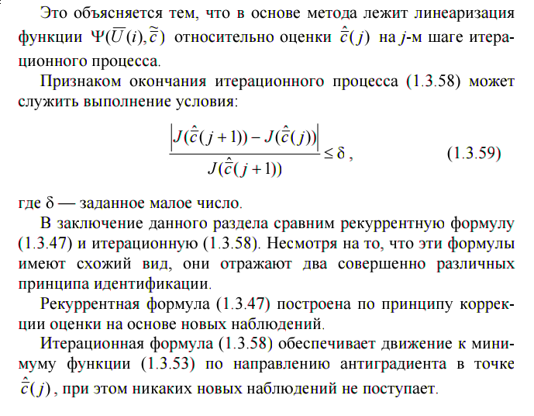

3. Листинг программы
from math import *
import numpy as np

#import matplotlib.pyplot as plt

#w_true = [ 1.0, 2.0, -1.0, pi, 5.0 ]
w_true = [ 0.01, 1.0, -pi, pi, 0.001 ]
input_params = [ [3.0, 0.1], [pi, 0.1], [1.0, 0.1], [e, 0.1] ]
input_dist = [ "normal", "normal", "normal", "normal" ]
#N_samples = 1000
#R_mat = []
#R_mat = np.identity(N_samples)
N_inputs = 4 # N_inputs = len(w_true)
N_samples = 30
R_mat = np.identity(N_samples)
N_iter = 100

global Debug_tmp
Debug_tmp = None
Doc = lambda obj: print(obj.__doc__)
IsList = lambda obj: "list" in str(type(obj))

def f(w, u):
y = w[0]*exp(-u[0]**w[1])*sin(w[2]*u[1]) + cos(w[3]/u[2])\
+ w[4]*log(u[3])
return y

f_t = lambda u: f(w_true, u)

test_dfw_0 = lambda w, u: exp(-u[0]**w[1])*sin(w[2]*u[1])
test_dfw_1 = lambda w, u: -w[0]*exp(-u[0]**w[1])*sin(w[2]*u[1])\
*(u[0]**w[1])*log(u[0])
test_dfw_2 = lambda w, u: w[0]*exp(-u[0]**w[1])*cos(w[2]*u[1])*u[1]
test_dfw_3 = lambda w, u: -sin(w[3]/u[2])*(1.0/u[2])
test_dfw_4 = lambda w, u: log(u[3])

Test_dfw_a = [ test_dfw_0, test_dfw_1, test_dfw_2, test_dfw_3, test_dfw_4]

def dfw(w, u, n, func = f):
h = 1e-06
w1 = np.copy(w)
w2 = np.copy(w)
# w1[n] = w[n] + h
# w2[n] = w[n] - h
# df = (func(w1, u) - func(w2, u))/(2.0*h)
w1[n] = w[n] - h
w2[n] = w[n] - 2*h
df = (3.0*func(w, u) - 4.0*func(w1, u) + func(w2, u))/(2.0*h)
return df

def dfw2(w, u, n, dwf_a = Test_dfw_a):
df = dwf_a[n](w, u)
return df

def gen_u_(sz, params = [ 0.0, 1.0 ], dist = "normal"):
if params == None:
params = [ 0.0, 1.0 ]
if dist == None:
dist = "normal"
cmd = "np.random." + dist + "(" + str(params[0]) + ", " +\
str(params[1]) + ", " + str(sz) + ")"
u_ = eval(cmd)
return u_

def gen_u(sz, params_a = None, dist_a = None):
N_samples = sz[0]
N_inputs = sz[1]
if params_a == None:
params_a = N_inputs*[None]
if dist_a == None:
dist_a = N_inputs*[None]
U = []
tmp = []
for i in range(0, N_inputs):
tmp = gen_u_(N_samples, params_a[i], dist_a[i])
U.append(tmp)
U = np.array(U)
return U.T

def calc_ft(w = w_true, U = [], func = f_t):
if U == []:
return []
N_samples = len(U)
Y = []
for u in U:
Y.append(func(u))
Y = np.array(Y)
return Y

def calc_f(w, U = [], func = f):
if U == []:
return []
N_samples = len(U)
Y = []
for u in U:
Y.append(func(w, u))
Y = np.array(Y)
return Y

def calc_df(w = w_true, U = [], n = -1, func = f):
if U == [] or n == -1:
return []
N_samples = len(U)
DY = []
for u in U:
DY.append(dfw(w, u, n, func))
DY = np.array(DY)
return DY

def calc_Phi_t_(w = w_true, u = [], func = f):
if u == []:
return u
N_params = len(w)
df = []
for i in range(0, N_params):
df.append(dfw(w, u, i, f))
df = np.array(df)
return df

def calc_Phi_t(w = w_true, U = [], func = f):
if U == []:
return U
N_params = len(w)
N_samples = len(U)
DF = []
tmp = []
for u in U:
tmp = calc_Phi_t_(w, u, f)
DF.append(tmp)
DF = np.array(DF)
return DF

def calc_Phi_(w, u = [], func = f):
if u == [] or w == []:
return u
N_params = len(w)
df = []
for i in range(0, N_params):
df.append(dfw(w, u, i, f))
df = np.array(df)
return df

def calc_Phi(w, U = [], func = f):
if U == [] or w == []:
return U
N_params = len(w)
N_samples = len(U)
DF = []
tmp = []
for u in U:
tmp = calc_Phi_(w, u, f)
DF.append(tmp)
DF = np.array(DF)
return DF

def calc_Phi2_(w, u = [], func = f):
if u == [] or w == []:
return u
N_params = len(w)
df = []
for i in range(0, N_params):
df.append(dfw2(w, u, i))
df = np.array(df)
return df

def calc_Phi2(w, U = [], func = f):
if U == [] or w == []:
return U
N_params = len(w)
N_samples = len(U)
DF = []
tmp = []
for u in U:
tmp = calc_Phi2_(w, u, f)
DF.append(tmp)
DF = np.array(DF)
return DF

def calc_e_vec(w_params, Y_t = [], U_values = [], func = f):
if U == []:
return []
if Y_t == []:
Y_t = calc_ft(w = w_true, U = U_values)
N_samples = len(U_values)
Y_ = calc_f(w = w_params, U = U_values)
E = Y_t - Y_
return E

def calc_w_next(w_prev, Func, U_values, Y_exp):
Epsilon = 1.0/10.0**256
Phi = calc_Phi(w = w_prev, U = U_values, func = Func)
Y_vec = Y_exp
Psi_vec = calc_f(w = w_prev, U = U_values, func = Func)
w_new = np.array(w_prev)
Res = np.dot(np.dot(Phi.T, R_mat), Phi)
if abs(np.linalg.det(Res)) == 0.0:
return (Phi, w_new, Psi_vec, "stop")
Res = np.dot(np.linalg.inv(Res), Phi.T)
Res = np.dot(np.dot(Res, R_mat), Y_vec - Psi_vec)
w_new = w_new + Res
return w_new

def calc_w_next2(w_prev, Func, U_values, Y_exp):
Epsilon = 1.0/10.0**256
Phi = calc_Phi2(w = w_prev, U = U_values, func = Func)
Y_vec = Y_exp
Psi_vec = calc_f(w = w_prev, U = U_values, func = Func)
w_new = np.array(w_prev)
Res = np.dot(np.dot(Phi.T, R_mat), Phi)
if abs(np.linalg.det(Res)) == 0.0:
return (Phi, w_new, Psi_vec, "stop")
Res = np.dot(np.linalg.inv(Res), Phi.T)
Res = np.dot(np.dot(Res, R_mat), Y_vec - Psi_vec)
w_new = w_new + Res
return w_new

def show_inputs_info():
print("_"*80)
print("INPUTS INFO:")
print("Num of inputs: ", N_inputs)
print("Num of samples: ", N_samples)
print("Max iterations: ", N_iter)
for i in range(0, N_inputs):
Str_f = ""
Str_f += input_dist[i][0].upper()
Str_f += str(tuple(input_params[i]))
print("%d: U%d = %s" % (i, i, Str_f))
print("_"*80)

'''
def nonlin_mls(w_start):
w_begin = w_start
global Debug_tmp
U_values = gen_u((N_samples, N_inputs), input_params, input_dist)
Y_true = calc_ft(U = U_values)
w_current = w_begin
Str_f = (len(w_begin)*("%.4f "))[:-1]
print("True params:\t%s" % Str_f % tuple(w_true))
print("Init params:\t%s" % Str_f % tuple(w_begin))
for i in range(0, N_iter):
print("Iteration:[%d]\t%s" % (i, Str_f % tuple(w_current)))
w_new = calc_w_next(w_current, f, U_values, Y_true)
if w_new[-1] == "stop":
Debug_tmp = w_new
w_new = []
break
w_current = w_new
if Debug_tmp != None:
Phi_d, w_new_d, Psi_vec_d, _ = Debug_tmp
'''

def nonlin_mls(w_start, Print = 2):
if Print > 0:
print("_"*80)
w_begin = w_start
global Debug_tmp
U_values = gen_u((N_samples, N_inputs), input_params, input_dist)
Y_true = calc_ft(U = U_values)
w_current = w_begin
Str_f = (len(w_begin)*("%.6f "))[:-1]
if Print > 0:
print("True params:\t%s" % Str_f % tuple(w_true))
print("Init params:\t%s" % Str_f % tuple(w_begin))
LastIterIndex = 0
for i in range(0, N_iter):
if Print == 2:
print("Iteration:[%d]\t%s" % (i, Str_f % tuple(w_current)))
w_new = calc_w_next(w_current, f, U_values, Y_true)
if w_new[-1] == "stop":
Debug_tmp = w_new
w_new = []
break
LastIterIndex = i
w_current = w_new
AbsError = np.abs(np.array(w_true) - np.array(w_current)).tolist()
if Print > 0:
print("Last iter:\t[%d]\nCurrent params:\t%s" % (LastIterIndex, Str_f % tuple(w_current)))
print("Abs errors:\t%s" % (Str_f % tuple(AbsError)))
print("Squared sum error:%.6f" % (sum([ AbsErr**2 for AbsErr in AbsError ])/len(w_true)))
if Debug_tmp != None:
Phi_d, w_new_d, Psi_vec_d, _ = Debug_tmp
if Print > 0:
print("_"*80)

def nonlin_mls2(w_start, Print = 2):
if Print > 0:
print("_"*80)
w_begin = w_start
global Debug_tmp
U_values = gen_u((N_samples, N_inputs), input_params, input_dist)
Y_true = calc_ft(U = U_values)
w_current = w_begin
Str_f = (len(w_begin)*("%.6f "))[:-1]
if Print > 0:
print("True params:\t%s" % Str_f % tuple(w_true))
print("Init params:\t%s" % Str_f % tuple(w_begin))
LastIterIndex = 0
for i in range(0, N_iter):
if Print == 2:
print("Iteration:[%d]\t%s" % (i, Str_f % tuple(w_current)))
w_new = calc_w_next2(w_current, f, U_values, Y_true)
if w_new[-1] == "stop":
Debug_tmp = w_new
w_new = []
break
LastIterIndex = i
w_current = w_new
AbsError = np.abs(np.array(w_true) - np.array(w_current)).tolist()
if Print > 0:
print("Last iter:\t[%d]\nCurrent params:\t%s" % (LastIterIndex, Str_f % tuple(w_current)))
print("Abs errors:\t%s" % (Str_f % tuple(AbsError)))
print("Squared sum error:%.6f" % (sum([ AbsErr**2 for AbsErr in AbsError ])/len(w_true)))
if Debug_tmp != None:
Phi_d, w_new_d, Psi_vec_d, _ = Debug_tmp
if Print > 0:
print("_"*80)

def corr_w_b(w_start, delta_w):
if IsList(delta_w):
return [ w_start[i] + delta_w[i] for i in range(0, len(w_start)) ]
else:
return [ w_start[i] + delta_w for i in range(0, len(w_start)) ]

#w_true = [ 1.0, 2.0, -1.0, pi, 5.0 ]
#w_begin1 = [ 0.8, 1.7, -1.2, 3.0, 4.5 ]
#w_begin2 = [ 1.2, 2.3, -0.8, 3.5, 5.5 ]
#w_begin3 = [ 1.0, 1.0, 1.0, 1.0, 1.0 ]

show_inputs_info()

#w_true = [ 0.01, 1.0, -pi, pi, 0.001 ]
w_begin4 = [ 0.1, 0.5, -2.5, 3.0, 0.01 ]
w_begin5 = [ 0.0, 1.5, -3.8, 3.5, 0.09 ]
w_begin6 = [ 0.03, 0.8, -pi + pi/12.0, pi - pi/12.0, 0.05 ]
w_begin7 = [ 0.5, 0.5, -4.0, 3.2, 0.03 ]
dw = 0.01
delta_w = len(w_true)*([ dw ])

nonlin_mls(w_begin4, Print = 1)
nonlin_mls(w_begin5, Print = 1)
nonlin_mls(w_begin6, Print = 1)
nonlin_mls(w_begin7, Print = 1)

if Debug_tmp != None:
Phi_d, w_new_d, Psi_vec_d, _ = Debug_tmp

4. Скриншоты работы программы
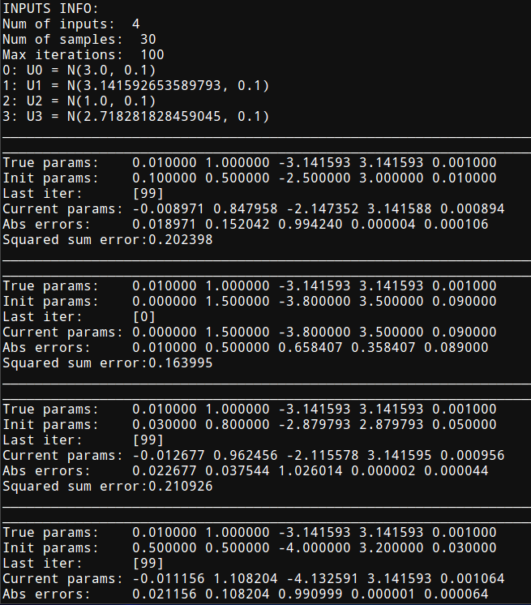

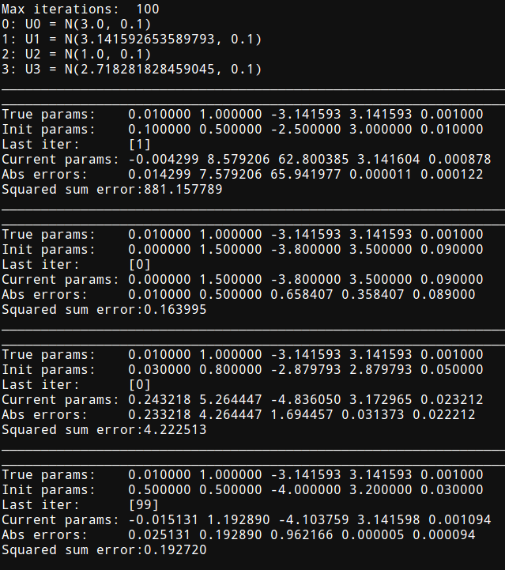

5. Заключение
В результате выполнения работы был реализован алгоритм метода МНК для нелинейных объектов средствами языка программирования Python. В результате проведенных численных экспериментов по работе данного алгоритма была выявлена плохая сходимость начальных значений итерационной формулы к истинным значениями параметров. Это объясняется особенностями численного метода вычисления частных производных (большой погрешностью, которая быстро возрастает) и также слабой обусловленностью получившейся матрицы Phi*Phi^T (лучше использовать алгоритм Алгоритм Левенберга — Марквардта ).

