***3.1***

train

1 3200

0 3200

Name: label, dtype: int64

validation

1 800

0 800

Name: label, dtype: int64

test

1 1000

0 1000

Name: label, dtype: int64

overfit

1 25

0 25

Name: label, dtype: int64

***4.4***

Provide the training loss and accuracy plot for the overfit data in your Report.

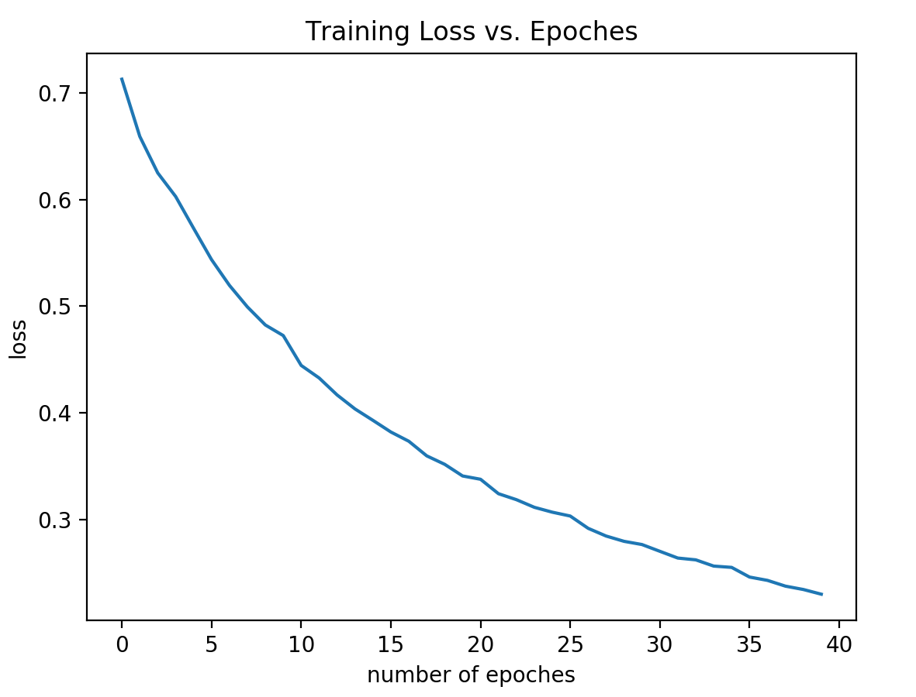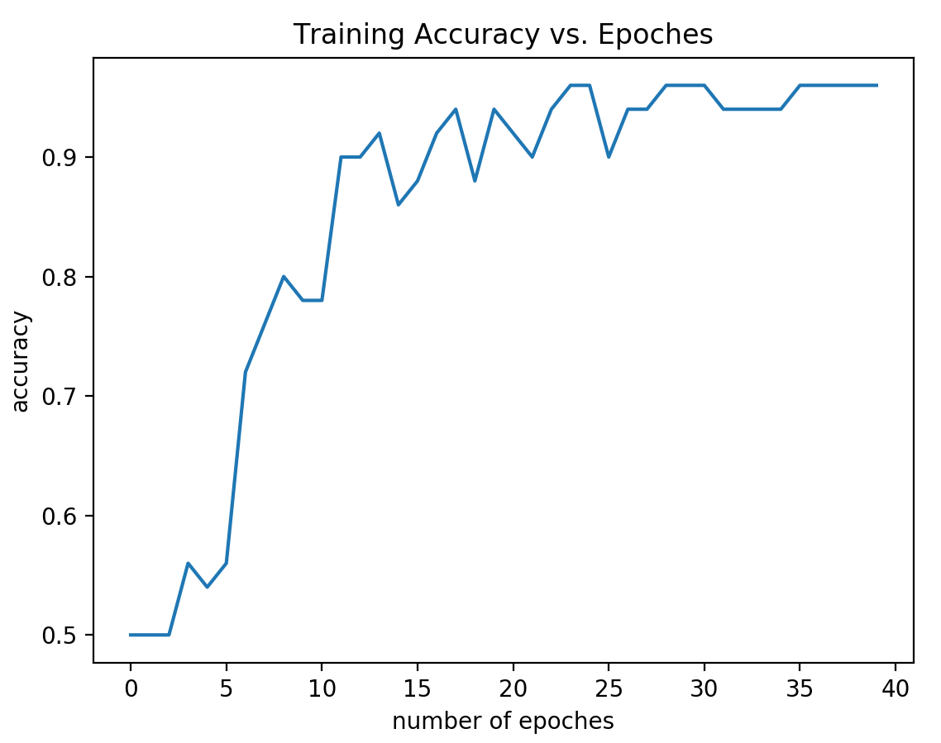

***4.5***

Give the **training** and **validation** **loss** and **accuracy** curves vs. **epoch** in your Report, and report the **final** **test** **accuracy**. Evaluate the test data and provide the accuracy result in your Report.

Hyperparameters as required. Baseline Model.

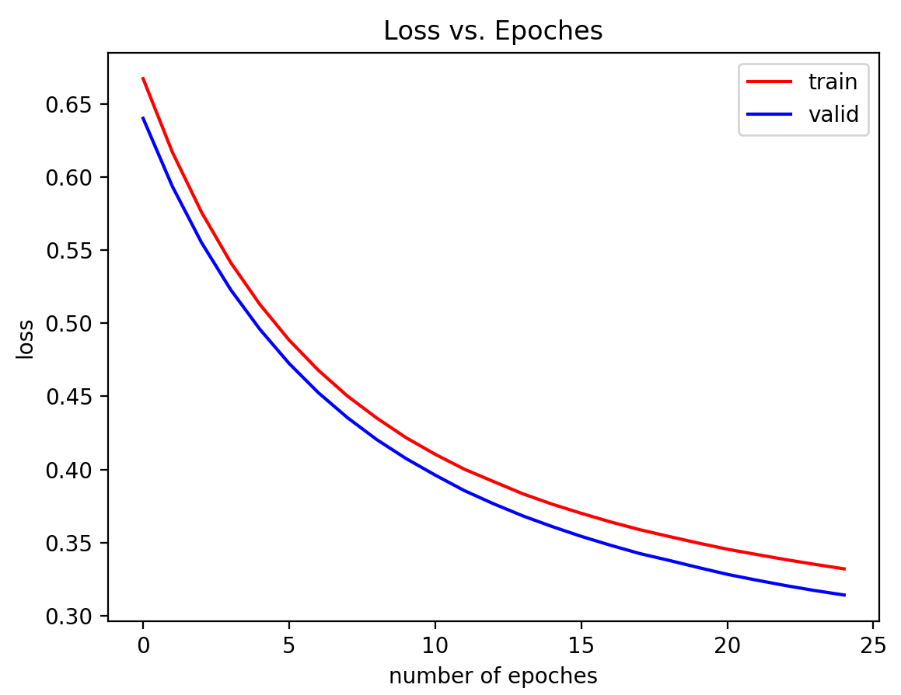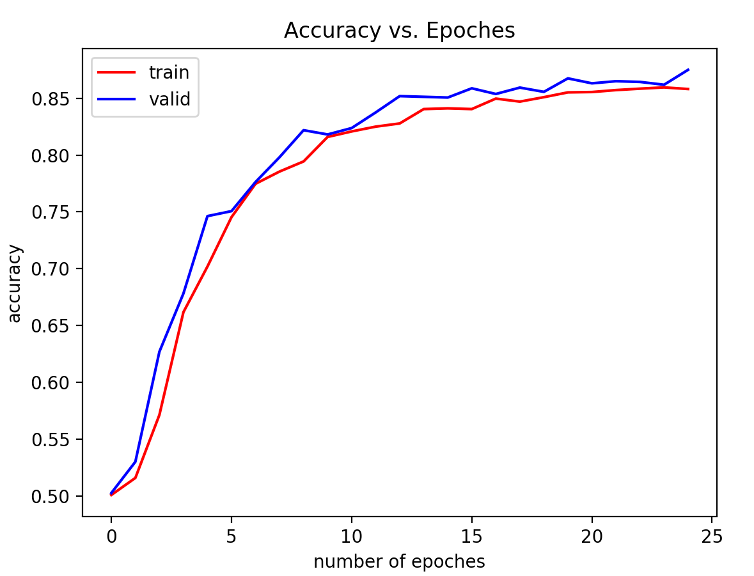

Final Test Accuracy 0.876953125

***5.1***

Overfit:

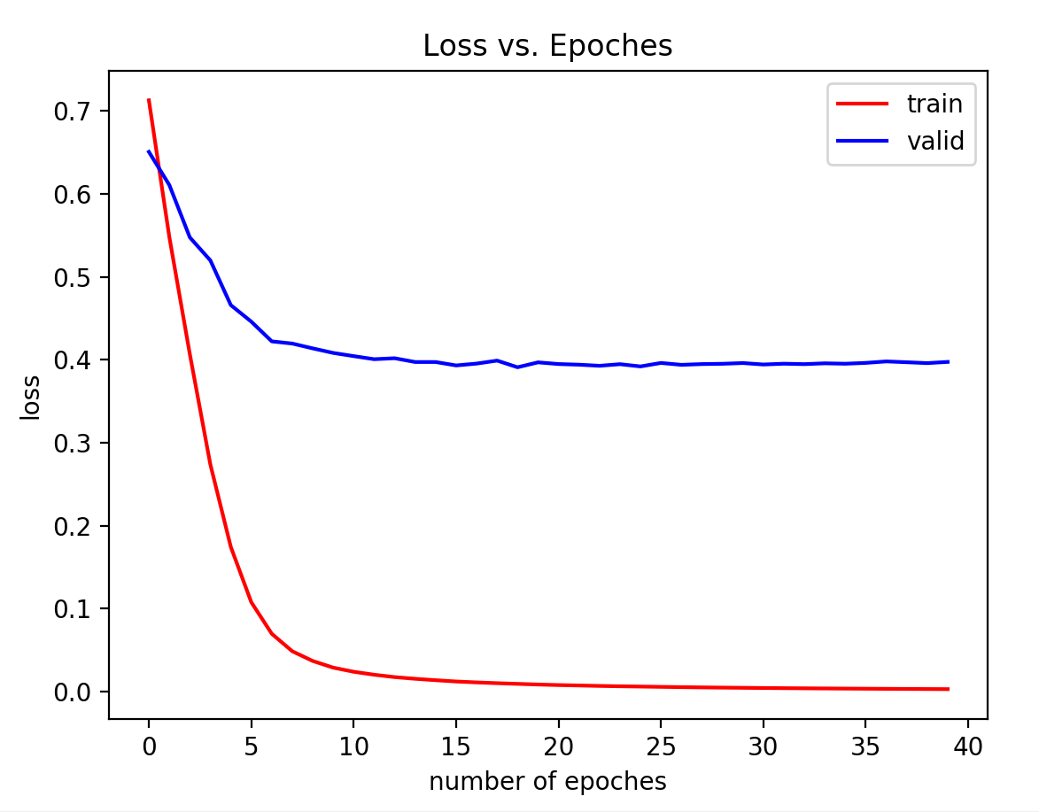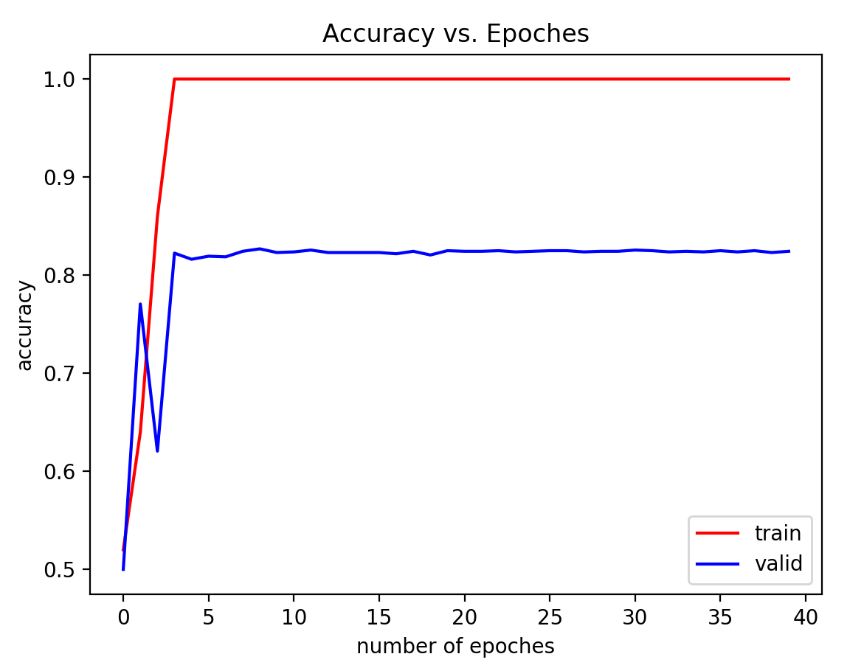

Full training:

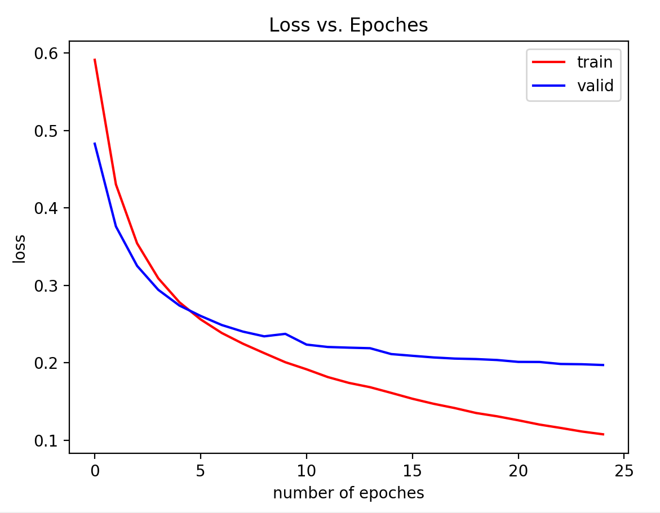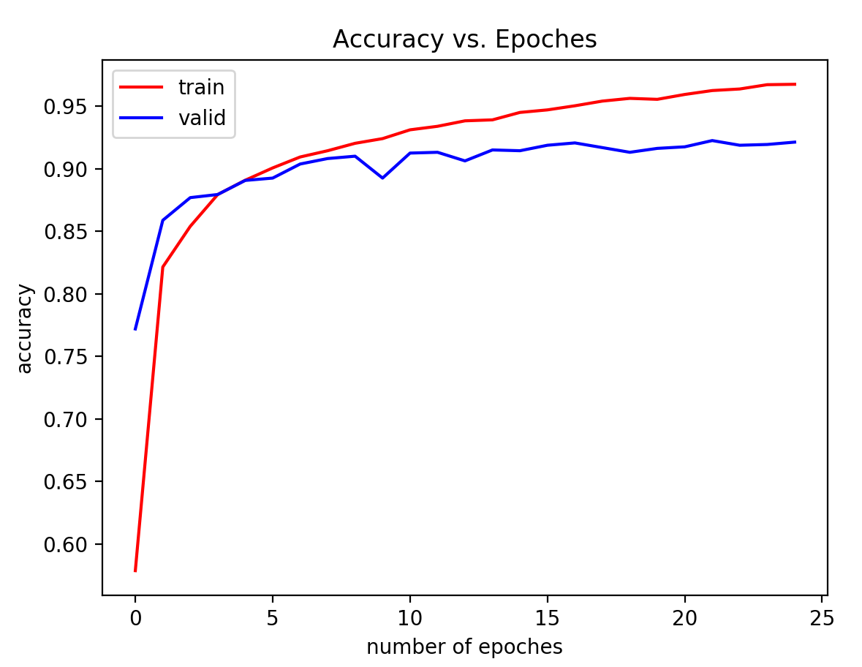

Final Test Accuracy 0.9130859375

***6.1***

Overfit (please ignore the validation line)

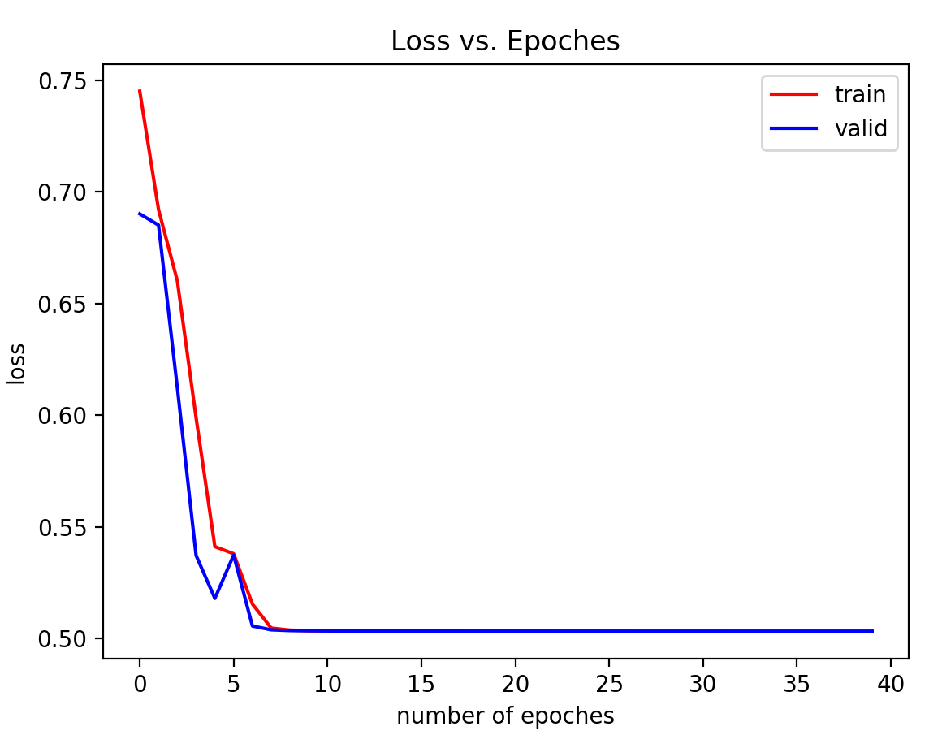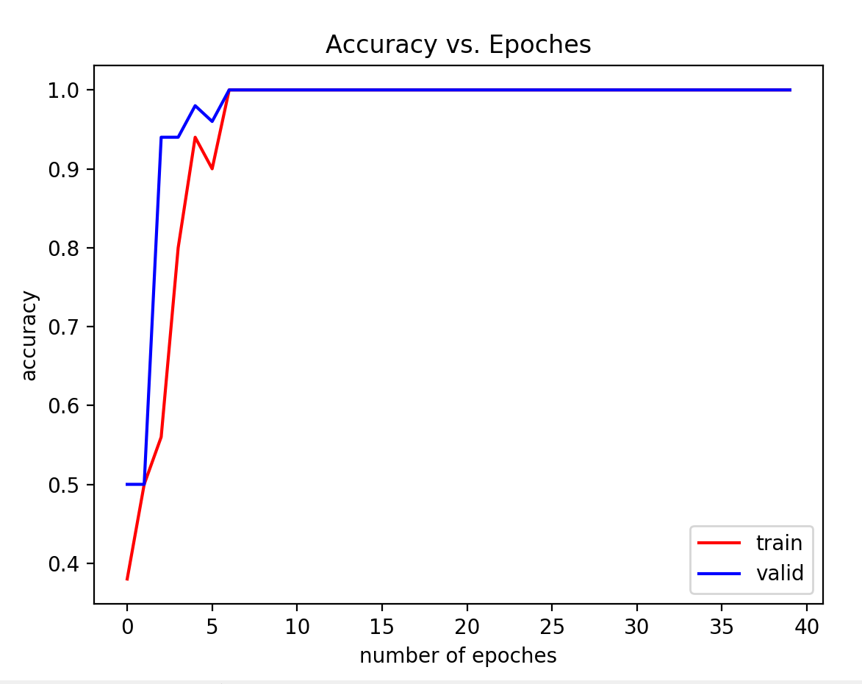

Full training set:

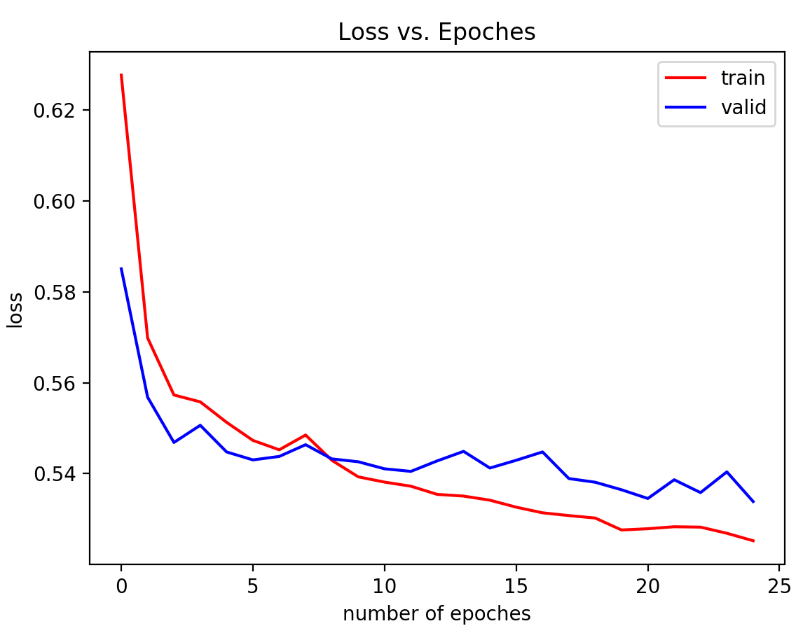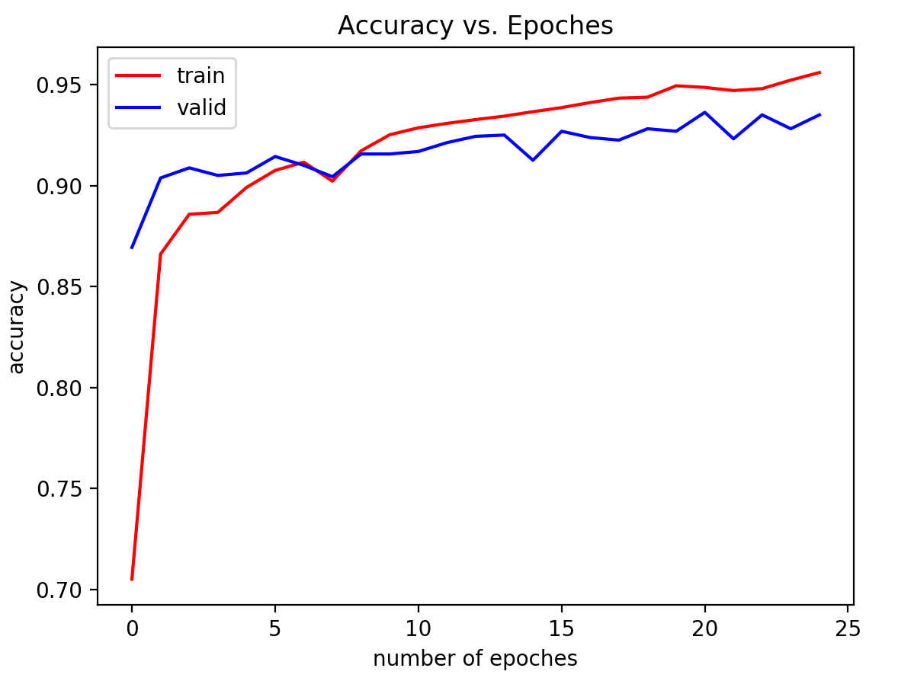

Final Test Accuracy 0.9365234375

***7.***