Thank you for attending this experiment. This experiment consists of four sessions on separate days. If this is not your last session, experimenter will arrange the time and date for the next session after you finished the session today. Each session will take about an hour.

The procedure of the experiment is illustrated as follow:

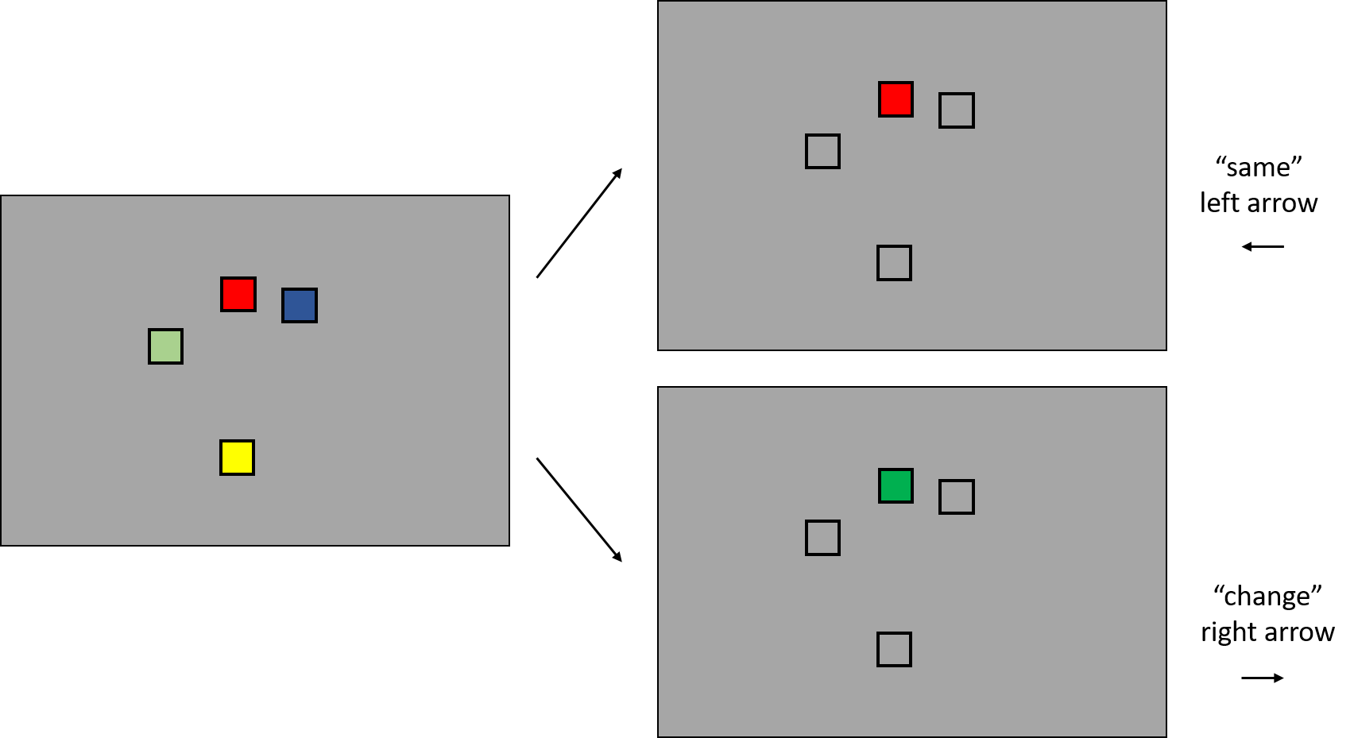

At the beginning of each trial, you will see several colors in different frames. Your task is to remember the colors and the corresponding frames. After the colors disappeared, a testing color will appear in one of the frame. Your task is to determine if the test color is the same as the color presented previously at the same frame. If the test color is the “same” as the color presented previously at the same frame, press the left arrow key on the keyboard. If the test color is different from the color presented at the same frame previously, press the right arrow key on the keyboard to indicate “change”. Please press the left or right arrow key as fast as possible and be as accurate as possible.

Before the actual testing trials begin, there will be ten practice trials. Please use the practice trials to familiar with the procedure and the response method. If you have any question, please inform the experimenter.

Once the session is finished, please inform the experimenter.