Thank you for attending this experiment. This experiment consists of four sessions on separate days, and this is the first session. Today’s session will take about an hour. Experimenter will arrange the time and date for the next session after you finished the session today.

The procedure of the experiment is illustrated as follow:

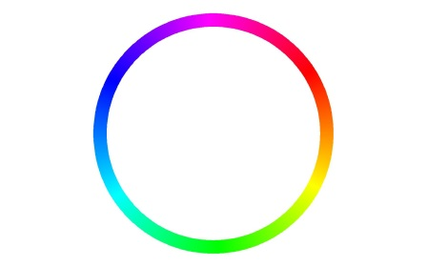

At the beginning of each trial, you will see several colors in different frames. Your task is to remember the colors and the corresponding frames. After the colors disappeared, several frames will appear, and one frame is thicker than the others. your task is to **recall the color at the location of the thicker frame by clicking on the color wheel.** You can respond by clicking left or right mouse button. Please press the left mouse key as fast as possible and be as accurate as possible.

Before the actual testing trials begin, there will be ten practice trials. Please use the practice trials to familiar with the procedure and the response method. If you have any question, please inform the experimenter.

Once the session is finished, please inform the experimenter.

Thank you for attending this experiment. This experiment consists of four sessions on separate days, and this is the second session. Today’s session will take about an hour. Experimenter will arrange the time and date for the next session after you finished the session today.

The procedure of the experiment is illustrated as follow:

Press **left** mouse button

Press **right** mouse button

At the beginning of each trial, you will see several colors in different frames. Your task is to remember the colors and the corresponding frames. After the colors disappeared, a testing color will appear in one of the frame. Your task is to determine if the test color is the same as the color presented previously at the same frame. If the test color is the “same” as the color presented previously at the same frame, press the left mouse key on the mouse. If the test color is different from the color presented at the same frame previously, press the right mouse key on the mouse to indicate “change”. Please press the left mouse key as fast as possible and be as accurate as possible.

Before the actual testing trials begin, there will be ten practice trials. Please use the practice trials to familiar with the procedure and the response method. If you have any question, please inform the experimenter.

Once the session is finished, please inform the experimenter.

Thank you for attending this experiment. This experiment consists of four sessions on separate days, and this is the third/fourth session. Today’s session will take about an hour. Experimenter will arrange the time and date for the next session after you finished the session today.

The procedure of the experiment is illustrated as follow:

Press **left** mouse button

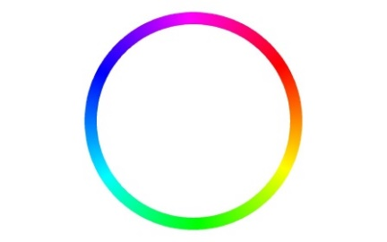

At the beginning of each trial, you will see several colors in different frames. Your task is to remember the colors and the corresponding frames. After the colors disappeared, either a color patch will appear or a thicker frame will appear. If a color patch appeared, your task is to determine if the test color is the same as the color presented previously at the same frame. If the test color is the “same” as the color presented previously at the same frame, press the left mouse key on the mouse. If the test color is different from the color presented at the same frame previously, press the right mouse key on the mouse to indicate “change”. If a thicker frame appeared, your task is to **recall the color at the location of the thicker frame by clicking on the color wheel.** You can respond by clicking left or right mouse button. Please press the left or right arrow key as fast as possible and be as accurate as possible.

Before the actual testing trials begin, there will be ten practice trials. Please use the practice trials to familiar with the procedure and the response method. If you have any question, please inform the experimenter.

Once the session is finished, please inform the experimenter.