Thank you for attending the experiment. This experiment takes about 50 minutes.

The experiment procedure is as follow:

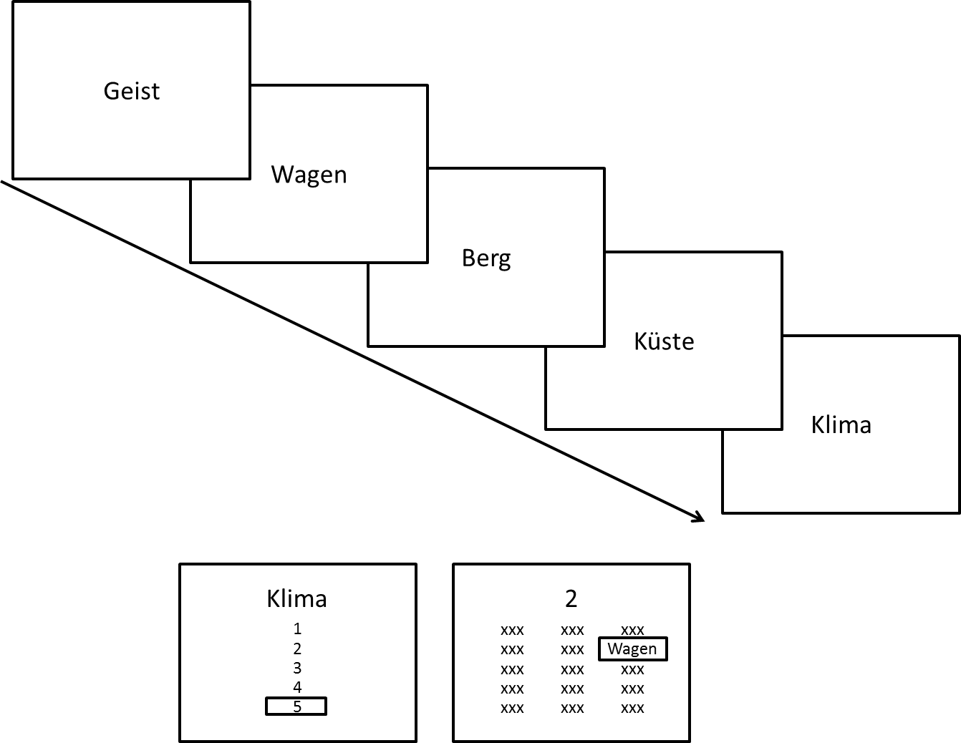

At the beginning of each trail, five words appear sequentially. Please pay attention to the words and the order. After six words were presented, a response probe will appear. **If the probe is a word**, please **select the order of the probe** in the list. **If the probe is a number**, please **select the word appeared in that order**.

You don’t have to hurry the response, but please try to make the response **as accurate as possible**.

Before the actual testing, there will be few practice trials. If you have any question, please ask the experimenter.