
FACULTY OF APPLIED SCIENCES
DOCTOR OF PHILOSOPHY IN ARTIFICIAL INTELLIGENCE DRIVEN DRUG DISCOVERY

AIDD8122 – Advanced Topics in Artificial Intelligence & Drug Discovery

Trust Before Throughput: Benchmarking, Uncertainty-Aware Screening and Multi-Objective Generative Design of FAP-Selective Radioligand Warheads
Student ID: | P2600222
Student Name: | Huang Yong
Submission Date: | 16/11/2026
Table of Contents

Abstract 3
§1. Introduction 3
1.1 A stromal target that reached the clinic in five years 3
1.2 What limits the current generation of ligands 4
1.3 Why machine learning, and why the usual evaluation is not enough 5
1.4 Contributions 5
§2. Literature Review 6
2.1 The FAP ligand series 6
2.2 Machine learning for target-specific potency 6
2.3 Evaluation protocols: why random splits flatter 7
2.4 Uncertainty and the applicability domain 7
2.5 Generative molecular design 7
2.6 Positioning of this work 8
§3. Research Questions and Objectives 8
3.1 Research questions 8
3.2 Objectives 8
3.3 Scope and success criteria 9
§4. Methods and Materials 9
4.1 Data acquisition 10
4.2 Curation 10
4.3 Chemical representation 10
4.4 Models and hyperparameters 10
4.5 Evaluation protocols 11
4.6 Regression and screening metrics 11
4.7 Applicability domain and conformal prediction 11
4.8 Temporal drift and recalibration 12
4.9 Multi-objective generative design 12
4.10 Implementation and reproducibility 12
§5. Results and Discussion 13
5.1 The curated FAP record is small, noisy and chemically non-stationary 13
5.2 Accuracy depends more on the split than on the algorithm 14
5.3 Which chemical information carries the signal? 15
5.4 Paralogue transfer does not rescue a small target 16
5.5 Selectivity is a cliff, not a slope 16
5.6 When can an error bar be believed? 18
5.7 Prospective failure: the 2019 series shift 21
5.8 Multi-objective generative design 21
5.9 The designs are warheads, not radioligands 23
5.10 Discussion 24
5.11 Limitations 25
§6. Conclusions 25
§7. References 26
Appendix A. Code and data availability 28
Appendix B. Radioligand feasibility and retrosynthetic triage 28
Appendix C. Robustness analyses 30

Abstract
Fibroblast activation protein (FAP) is one of the most actively pursued targets in nuclear medicine, yet the public structure–activity record available to guide the next generation of FAP inhibitors is small, assay-heterogeneous and chemically non-stationary. This project asks a deliberately narrow question: given that record, what can machine learning actually deliver for radiopharmaceutical design, and where should a medicinal chemist refuse to trust it? We curated 972 ChEMBL bioactivities into 384 unique FAP inhibitors (161 Murcko scaffolds) and benchmarked five models under random, scaffold and time splits. Random splitting suggests excellent accuracy (XGBoost R² = 0.75), but a time split that mimics prospective use collapses to R² = −0.79, because the post-2019 literature describes a different chemical series (median molecular weight +80 Da, median potency +2.0 log units). Selectivity against the paralogues PREP and DPP4 is predictable inside known scaffolds (AUROC 0.84) but anti-correlated on novel scaffolds (AUROC 0.38). Split-conformal intervals are valid under random splitting (79% and 89% empirical coverage at nominal 80% and 90%) but cover only 54% of out-of-domain compounds at the 80% level. Finally, a graph genetic algorithm with NSGA-II selection was used to design novel warheads under four objectives; gating candidates by applicability domain and by predicted selectivity changed the output more than the choice of optimizer. We argue that for targets of this size the useful deliverable of AI-driven drug discovery is not a single predicted number but a calibrated decision rule that says when a prediction may be acted on.
Keywords: fibroblast activation protein; radiopharmaceuticals; bioactivity prediction; scaffold split; conformal prediction; multi-objective optimization

§1. Introduction

1.1 A stromal target that reached the clinic in five years
In desmoplastic tumours such as pancreatic ductal adenocarcinoma, breast carcinoma and several sarcomas, cancer-associated fibroblasts (CAFs) can constitute the majority of the tumour mass and deposit the collagen-rich stroma that limits drug penetration and correlates with poor prognosis. Fibroblast activation protein (FAP) is a type II transmembrane serine protease of the S9B prolyl-oligopeptidase family that is displayed on the surface of activated fibroblasts and is largely absent from healthy tissues [9], which makes it an unusually clean stromal address. Because its catalytic site accepts small, drug-like inhibitors, FAP became the first stromal target for which a purely small-molecule theranostic pair was realised: a quinoline-based inhibitor bearing a prolyl warhead can be labelled with 68Ga or 18F for imaging and with 90Y or 177Lu for therapy, with only the chelator changed [1,6].
The clinical trajectory has been steep. FAPI-04, optimised from a series of quinoline inhibitors in 2018 [1], produced high-contrast PET images in a broad panel of tumour entities [3,4,10], and its successors FAPI-46 and FAPI-74 extended the usable activity and improved tumour retention [5,7]. Several hundred patients have since been imaged, and therapeutic analogues such as 90Y-FAPI-46, 177Lu-FAP-2286 and the albumin-binding 177Lu-LNC1004 have entered early-phase trials [6–8]. For a nuclear medicine group, this is now a ligand-design problem rather than a target-validation problem.

1.2 What limits the current generation of ligands
Imaging performance has not translated proportionally into therapeutic benefit. In the published FAPI radioligand-therapy series, disease control is reported in roughly 20–80% of patients while objective responses remain uncommon (about 21% in the largest phase II cohort to date), with haematological toxicity as the practical constraint [7,8,29]. Retention in tumour is shorter than for prostate-specific membrane antigen (PSMA) ligands, and uptake in normal fibroblasts of the salivary glands, pancreas and marrow sets a background that cannot be removed by dosimetry alone. The medicinal-chemistry levers are well defined — the warhead (nitrile versus boronic acid), linker length and rigidity, the chelator, and for albumin-binding variants an Evans blue motif — but each combination must be synthesised, radiolabelled, tested against the enzyme, and imaged in mice. A single design–test cycle costs weeks of chemistry and a full animal experiment.
Two selectivity problems dominate this optimisation. The first is selectivity against the closest paralogues, prolyl endopeptidase (PREP) and dipeptidyl peptidase IV (DPP4/CD26), which share the catalytic fold and are widely expressed; a ligand that inhibits DPP4 will carry a systemic off-target liability that no dosimetry can compensate. The second is selectivity against FAP expressed in healthy tissue, which is a pharmacokinetic rather than an affinity problem and is outside the ligand-based model built here — but its chemical preconditions are not unknowable. Appendix B works out, for the six generated structures, where a radionuclide could be attached, what a chelator would add to molecular weight and polar surface area, and why that modification would push a candidate outside the applicability domain established in Section 5.6. This project concerns the first problem; the second is recorded as a bounded, testable gap rather than left implicit.
The distinction matters because a generative model returns a warhead, not a radiopharmaceutical. A 18F label needs a displaceable leaving group on an aryl or alkyl carbon, while 68Ga and 177Lu need a macrocyclic chelator such as DOTA or NOTA. None of the six highest-ranked designs in Table 10 carries a chelator (Appendix B, Table B1), and a DOTA mono-amide conjugate would add about 358 Da, taking the median molecular weight from 499 to 857 Da and the topological polar surface area from 126 to about 248 Å². Those are properties of a different chemical class from the 384 FAP inhibitors the model was trained on, so a predicted pFAP for the conjugated molecule would fall outside the applicability domain as well. Tumour retention and normal-tissue background cannot be inferred from this model; the testable next step is to synthesise a small chelator-bearing subset and measure it, rather than to extrapolate from the warhead.

1.3 Why machine learning, and why the usual evaluation is not enough
Public bioactivity data for FAP are an order of magnitude smaller than for kinase targets: ChEMBL contains a few hundred unique FAP inhibitors, contributed by sixty-odd publications, assayed across 78 distinct assays [11,28]. Published QSAR models of FAP inhibitors typically report random-split coefficients of determination of 0.7–0.8 [12,14], which invites the conclusion that affinity prediction is solved. For a chemist the relevant question is different: will the model rank a new chemotype correctly, and will its error bars hold when the literature moves on? Random splitting answers neither question, because near-duplicate analogues of the test compounds remain in the training set.
This project therefore treats the evaluation protocol as the object of study rather than as a formality. We benchmark the same models under three protocols that correspond to three real decisions — interpolation inside a known series, scaffold hopping to a new series, and prospective use on compounds published after the model was trained — and we ask under which of these the output is actionable.

1.4 Contributions
• A reproducible curation of the public FAP, PREP and DPP4 bioactivity record, with an explicit audit trail from 972 raw FAP records to 384 unique compounds, and a quantification of assay noise that sets the error floor of any model trained on it.
• A three-protocol benchmark (random, scaffold, time) of five model families with identical features and hyperparameters, reported together with virtual-screening metrics rather than regression metrics alone.
• A quantitative test of whether paralogue bioactivity transfers to FAP, and of whether FAP selectivity over PREP and DPP4 can be predicted at all outside the training scaffolds.
• A trust analysis that combines applicability domain, split-conformal intervals and temporal recalibration, and localises the conditions under which a predicted interval is honest.
• A multi-objective generative design campaign (graph genetic algorithm with NSGA-II selection) whose output is compared against single-objective and random controls, with novelty and applicability explicitly tracked.

§2. Literature Review

2.1 The FAP ligand series
The modern FAP inhibitor series originates from quinoline-2-carboxamides decorated with a prolyl nitrile warhead, a linker and a chelating group. Lindner and colleagues optimised fifteen candidates and identified FAPI-04 as the first clinical tracer [1], with improved serum stability and a clear preference for FAP over CD26 relative to its predecessor FAPI-02. Loktev and colleagues independently established that such inhibitors can image CAF-rich tumours with high contrast [2], and Kratochwil and colleagues documented uptake across 28 tumour entities [3], which established FAP as a pan-tumour stromal target. FAPI-46 improved tumour retention and reduced washout [7], and FAPI-74 allowed 18F-AlF labelling through a one-step aluminium fluoride method [5], which decouples the tracer from a 68Ga generator.
The therapeutic branch followed quickly. 90Y-FAPI-46 was tested in advanced sarcoma [7], 177Lu-FAP-2286 became the first DOTA-bearing FAP ligand taken into a first-in-human dosimetry study [6], and 177Lu-LNC1004 introduced an Evans blue albumin-binding motif to extend circulation time [8]. Across these series the pattern is consistent: imaging contrast is excellent, objective response rates are low, and the field attributes the gap to short intratumoural retention and to the stromal, non-malignant nature of the target. Whatever the biological explanation, the practical consequence for design is that affinity alone is an insufficient objective, and selectivity against the paralogues must be designed in rather than measured afterwards.

2.2 Machine learning for target-specific potency
On ChEMBL-scale benchmarks, gradient-boosted trees over circular fingerprints remain competitive with, and frequently superior to, graph neural networks, particularly when the number of measurements per target is in the hundreds [26]. Mayr and colleagues showed on 1,300 ChEMBL targets that deep architectures only overtake classical methods when data are abundant [12], and van Tilborg and colleagues demonstrated that much of the apparent advantage of learned representations disappears once activity cliffs and scaffold novelty are accounted for [13]. For a target like FAP, with fewer than 500 unique compounds, a well-tuned tree ensemble over combined fingerprints and physicochemical descriptors is therefore the rational baseline, and any deep model must justify itself against it.
A second line of work uses transfer learning across related targets. Because PREP and DPP4 belong to the same protease family and contribute 1.3-fold and 11-fold more compounds than FAP, their data are an obvious auxiliary source. Reported gains from such transfer are typically small and highly dependent on whether the auxiliary task shares chemotypes with the target task; when the auxiliary data are dominated by a different chemical series, transfer can be neutral or harmful.

2.3 Evaluation protocols: why random splits flatter
The gap between random and scaffold splits is one of the best-documented reproducibility problems in molecular machine learning. MoleculeNet popularised scaffold splitting precisely because random splits allow near-analogues of test compounds into training [14]. Wallach and Heifets showed that many ligand-based benchmarks reward memorisation rather than generalisation [15], and Sheridan argued for time-split cross-validation as the closest available proxy for prospective prediction [16]. For a target whose literature is dominated by one chemotype introduced at a known date, as is the case for FAP after 2018, the time split is not a technicality: it is the only protocol that reproduces the situation in which a medicinal chemist would actually use the model.

2.4 Uncertainty and the applicability domain
Point predictions without an error estimate are of limited use in a synthesis meeting. Two complementary tools exist. Applicability-domain analysis asks whether a query compound is represented by the training set, typically through a similarity threshold or a bounding box in descriptor space, and has been reviewed extensively for QSAR models [17]. Conformal prediction instead constructs a distribution-free interval around each prediction from held-out residuals, with a finite-sample coverage guarantee [18] that holds under exchangeability of calibration and test data. The exchangeability assumption is exactly what scaffold and temporal splits violate, which makes conformal prediction an informative diagnostic rather than a universal remedy: if coverage collapses, the data are not exchangeable and the interval should not be quoted.

2.5 Generative molecular design
Generative design for small molecules has converged on two families: graph-based genetic algorithms operating directly on molecular graphs through fragment crossover and graph mutation, and deep generative models trained on large corpora [19]. Jensen's graph GA remains a strong baseline because it requires no training data and optimises arbitrary scoring functions. When several properties must be balanced — affinity, selectivity, drug-likeness, synthetic accessibility — multi-objective evolutionary algorithms such as NSGA-II [20] are the natural choice, because they return a Pareto front instead of a single scalarised optimum and thereby expose the trade-offs to the chemist. Their weakness in a drug-discovery setting is that the scoring function is itself a model, so the optimizer will exploit its errors unless novelty and applicability are enforced explicitly.

2.6 Positioning of this work
The literature supplies mature tools but few honest audits of those tools on small radiopharmaceutical targets. This project does not propose a new architecture. It asks whether the standard toolkit, applied carefully to FAP, produces anything a radiochemist should act on, and it reports the cases where the answer is no.

§3. Research Questions and Objectives

3.1 Research questions
RQ1. How accurate is a FAP affinity model under protocols that reflect real use — interpolation within a known series, scaffold hopping to a new series, and prospective prediction on later literature?
RQ2. Does bioactivity from the paralogue family (PREP, DPP4) transfer to FAP, and can FAP selectivity over those paralogues be predicted outside the training scaffolds?
RQ3. Under which conditions are the model's uncertainty estimates trustworthy, and can an applicability-domain gate restore calibration?
RQ4. What does a multi-objective generative algorithm add beyond enumerating known FAP inhibitors, and does explicit selectivity pressure change the chemical output?

3.2 Objectives
Four objectives follow directly. O1: build and document a curated, deduplicated dataset for FAP, PREP and DPP4 with an auditable filtering log and an estimate of assay noise. O2: benchmark representative model families under the three protocols and report both regression and virtual-screening metrics. O3: quantify the value of paralogue transfer and of direct versus indirect selectivity modelling. O4: determine the operating region in which predictions and intervals can be trusted, and use that region as a hard constraint in a generative design campaign.

3.3 Scope and success criteria
The project is deliberately restricted to ligand-based modelling of the FAP warhead region; it does not model the chelator, the radiometal, or in vivo pharmacokinetics, and it does not perform docking or free-energy calculations. Three success criteria were fixed before any model was fitted. Their disposition at the end of the project is reported explicitly below, because a pre-registered criterion is only useful if a partial or negative result is allowed to stand.
Pre-registered success criteria and their disposition. C3 is deliberately recorded as partial: the applicability domain does predict where conformal coverage fails, but the intervals themselves are not valid out of domain, which is a weaker outcome than the criterion anticipated.
Pre-registered criterion | Threshold | Disposition | Evidence
C1 Triage-grade accuracy | scaffold-split R² > 0.5 and screening AUROC > 0.85 | Achieved | Table 2: R² 0.68, AUROC 0.94 (XGBoost, five seeds)
C2 Protocol effect | a measurable, seed-replicated difference between protocols | Achieved | Table 2: R² 0.75 (random) to −0.79 (time); s.d. ≤ 0.06 per cell
C3 Coverage predictable from the AD | coverage near nominal in each AD class | Partially achieved | Table 7: 0.76 in-domain, 0.50 out-domain at nominal 0.80

Stating C3 as partial rather than met is the point of the exercise: the analysis that validated the first two criteria is the same analysis that refused the third.

§4. Methods and Materials
The workflow has four stages — data, models, trust, design — and each stage produces a table that the next stage consumes (Figure 1). Every experiment was repeated over five random seeds with identical feature blocks and hyperparameters, and all figures and tables in this report are regenerated by the accompanying code.
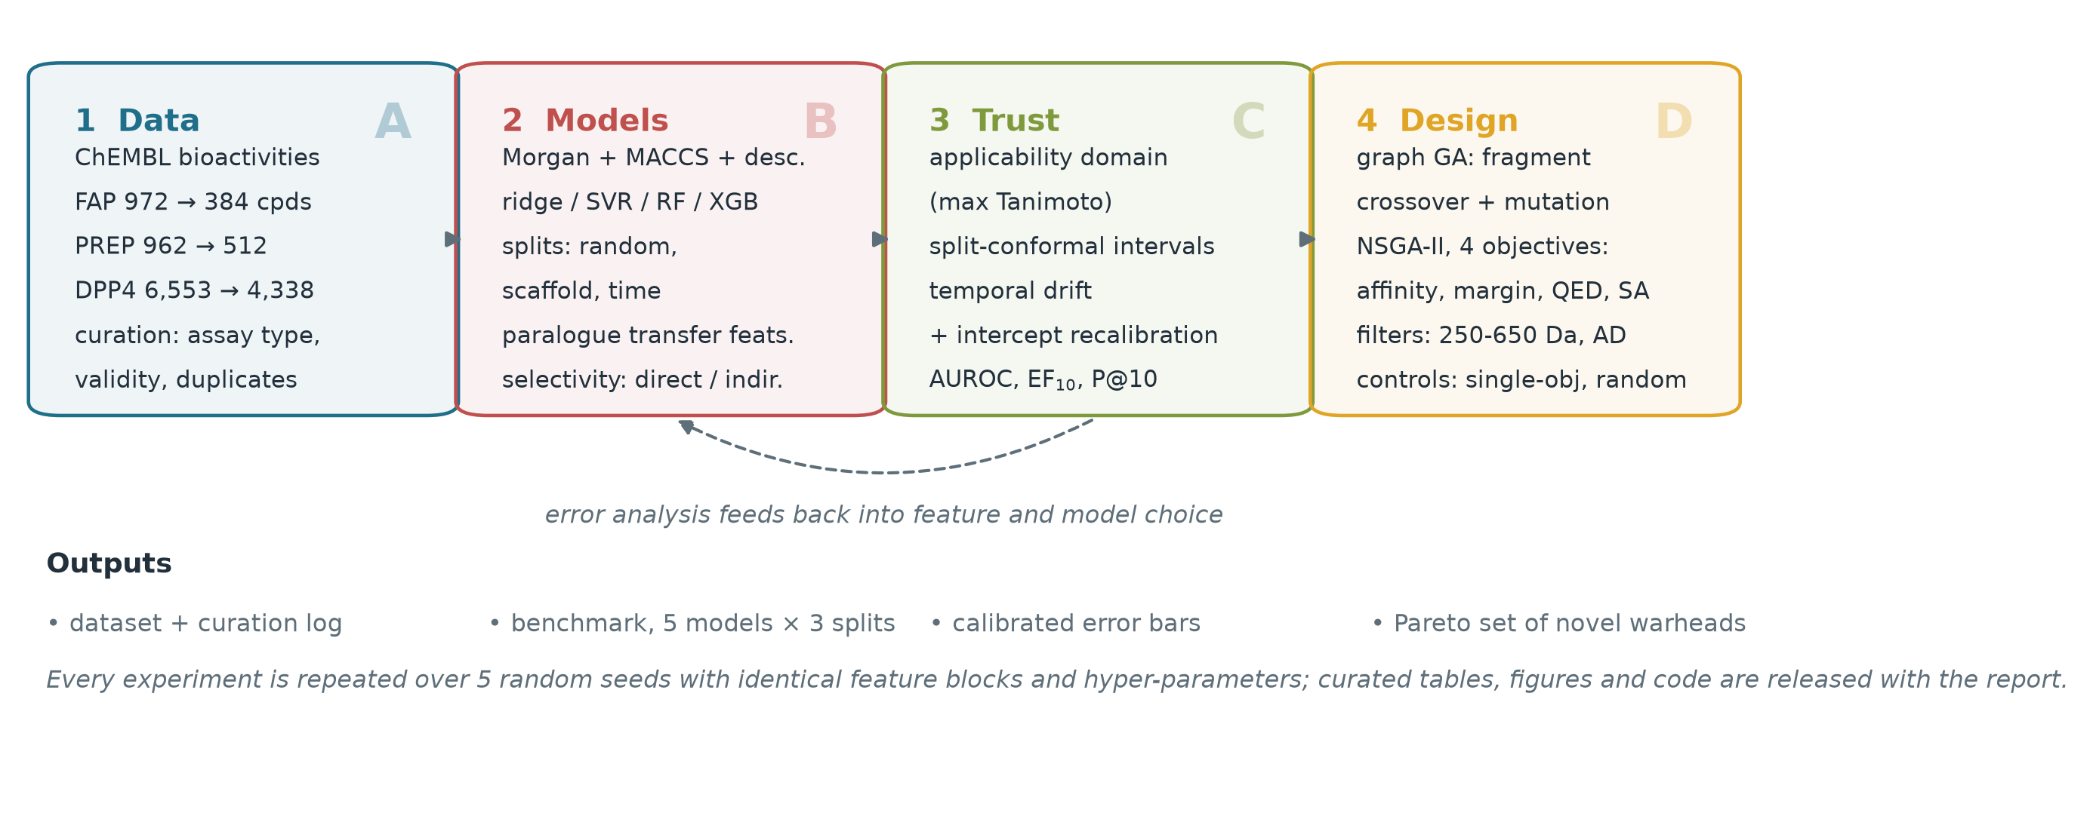
Figure 1. Project workflow. Bioactivity records are curated into per-target tables (A), represented by combined fingerprints and descriptors and modelled under three split protocols (B), audited with applicability-domain, conformal and temporal analyses (C), and finally used as scoring functions inside a multi-objective graph genetic algorithm (D). The dashed arrow indicates that error analysis feeds back into feature and model choice. ChEMBL release 37; RDKit 2026.09.1 / Matplotlib 3.11.2; schematic of the 01–09 pipeline, no plotted observations.

4.1 Data acquisition
Bioactivity records were retrieved programmatically from the ChEMBL REST API (release 37, May 2026) for three targets: FAP (CHEMBL4683), PREP (CHEMBL3202) and DPP4 (CHEMBL284). Only records with an exact activity relation and a standard type of Ki, IC50 or Kd were requested, with standard units in nanomolar, retaining ChEMBL's own validity annotations [28]. For FAP this returned 972 records, for PREP 962 and for DPP4 6,553. Records were retrieved together with assay type, assay description, document year, validity flags and the canonical SMILES of the tested molecule.

4.2 Curation
Curation followed a fixed sequence, and the number of records surviving each step is logged (Table 1). Records were dropped if they carried a ChEMBL data-validity comment, were flagged as potential duplicates, came from a non-biochemical assay (cell-based or ADME assays), fell outside pActivity 3–12, failed RDKit parsing, or lay outside 150–1,500 Da. Multiple measurements of the same InChIKey were collapsed to their median pActivity, and the number of contributing measurements and the standard deviation were retained. Murcko scaffolds [25] were computed for scaffold grouping and splitting. The FAP table is the modelling target; PREP and DPP4 serve as auxiliary and off-target references.
Assay noise was estimated directly from the replicate structure of the data: for every compound measured more than once, the standard deviation of its replicate pActivity values was computed, and the median across compounds is reported. This quantity sets a floor on the root-mean-square error that any model trained on these labels can achieve, and it is used throughout the discussion as the reference against which model error is judged.

4.3 Chemical representation
Each molecule is represented by a concatenation of three blocks: 2,048-bit Morgan [26] fingerprints with radius 2, 167-bit MACCS keys, and 15 physicochemical descriptors (molecular weight, cLogP, TPSA, hydrogen-bond donors and acceptors, rotatable bonds, ring and aromatic-ring counts, fraction of sp3 carbons, heavy-atom count, and counts of nitrile, amide, carboxylic acid, N+O and halogen groups). The descriptor block was included because the FAP warhead is defined by functional groups rather than by scaffold shape, and because descriptors extrapolate more gracefully than fingerprints when the scaffold changes.

4.4 Models and hyperparameters
Five estimators were compared: a mean predictor (the trivial baseline), ridge regression, support-vector regression with an RBF kernel, a random forest [24] with 500 trees, and gradient boosting (XGBoost [23]) with 700 trees, learning rate 0.03, maximum depth 6, subsample 0.8, column subsample 0.4, L2 penalty 1.0 and minimum child weight 3. Hyperparameters were fixed a priori rather than tuned per split, because tuning on the test protocol would erase the very difference the benchmark is designed to measure. All models were fitted on the same feature matrix and the same training indices.

4.5 Evaluation protocols
Three protocols were used. Random splitting holds out 20% of compounds uniformly, which measures interpolation and is the protocol reported by most published QSAR studies. Scaffold splitting groups compounds by Murcko scaffold and holds out 20% of scaffolds, which measures the ability to rank a new chemical series and is the relevant protocol for scaffold hopping. Time splitting trains on compounds whose most recent source document is from 2018 or earlier and tests on 2019–2024, which measures prospective performance and reproduces the situation of a model trained before the FAPI series matured. Each protocol was repeated over five seeds; scaffold and random splits differ between seeds, whereas the time split is deterministic.

4.6 Regression and screening metrics
Regression quality is reported as RMSE, MAE, R², Pearson and Spearman correlation. Because the practical use of such a model is triage rather than quantitation, screening metrics were computed on a focused evaluation set containing only clear actives (pActivity ≥ 7, i.e. IC50 ≤ 100 nM) and clear inactives (pActivity ≤ 5.5), excluding the ambiguous middle. On this set we report the area under the ROC curve (AUROC), the enrichment factor in the top 10% of ranked compounds (EF10) and the precision in the top 10%.

4.7 Applicability domain and conformal prediction
The applicability domain is defined by chemical similarity: for each test compound, the maximum Tanimoto similarity to any training compound is computed over Morgan fingerprints. Test compounds are then binned by this similarity and the RMSE of each bin is reported, which yields an operational rule (a similarity threshold) rather than a binary claim. A single threshold of 0.60 separates in-domain from out-of-domain compounds throughout this report: it is the boundary at which RMSE begins to rise in Table 6 and at which out-of-domain conformal coverage falls to 0.54 in Table 7. The narrower 0.1-wide bins in Table 6 are descriptive partitions, not alternative decision rules; the 0.40 filter in Section 4.9 is a novelty constraint on the generator and is a different quantity.
Uncertainty is quantified by split conformal prediction. Out-of-fold residuals are obtained by five-fold cross-validation inside the training set, and the conformal half-width is the ⌈(n+1)(1−α)⌉-th smallest absolute residual. Intervals are then evaluated on the held-out compounds at nominal 80% and 90% levels, and coverage is additionally stratified by applicability-domain class. A random-split experiment serves as a positive control: if the procedure is implemented correctly and the data are exchangeable, coverage should match the nominal level there.

4.8 Temporal drift and recalibration
For the time split, the raw model is compared with a recalibrated version in which a single intercept correction is estimated on the first quarter of the test set — simulating a small prospective calibration campaign — and applied to the remainder. This separates two failure modes: a shift in the overall potency level, which an intercept can absorb, from a loss of ranking information, which it cannot.

4.9 Multi-objective generative design
Design used a graph genetic algorithm in the style of Jensen [19]: parents are recombined by breaking one acyclic bond in each parent and joining the two largest fragments, and offspring are mutated by atom substitution, bond-order change, atom addition or atom deletion, with sanitisation after every operation. Selection is NSGA-II [20] with fast non-dominated sorting and crowding distance. Four objectives were optimised simultaneously: predicted FAP affinity (mean of five XGBoost models), predicted selectivity margin (pFAP − max(pPREP, pDPP4)), drug-likeness (QED) and synthetic accessibility (−SA/10) [21,22]. Hard filters removed invalid structures, compounds outside 250–650 Da, and compounds whose maximum Tanimoto similarity to the FAP training set was below 0.40. The initial population was drawn from the 130 measured FAP actives with pActivity ≥ 7.
Two controls were run with the same evaluation budget: an affinity-only campaign, in which NSGA-II degenerates into a hill climber on predicted potency, and a random campaign in which offspring replace parents without selection. All archived molecules were annotated for novelty (InChIKey absent from all three curated datasets) and for Murcko scaffold diversity, so that the comparison does not reward the rediscovery of known FAP inhibitors.

4.10 Implementation and reproducibility
All code is Python 3.13 with RDKit 2026.09.1 [27], scikit-learn 1.9.1, XGBoost 3.4.1, NumPy 2.5.4, pandas 3.1.0 and Matplotlib 3.11.2. The pipeline is organised as numbered scripts: 01 fetch, 02 curate, 03 benchmark, 04 transfer/selectivity, 05 trust analysis, 06 generative design, 07-08 figures, 09 this report, 10 presentation notes, 11 DOI verification, 12 retrosynthetic/radiolabelling triage, 13 robustness analyses, 14 summary reconciliation, 15 the content corrections of this optimisation pass, 16 the evidence bundle (environment fingerprint, file manifest, reconciliation log) and 17 the figure-restoration step that runs after Word saves the .docx. Each script writes a table or figure that the next stage reads; random seeds, package versions and run logs are shipped with the code. The curated datasets, the raw ChEMBL exports, the full prediction tables, the environment fingerprint and a one-command reproduction guide are listed in Appendix A.

§5. Results and Discussion

5.1 The curated FAP record is small, noisy and chemically non-stationary
Curation reduced 972 raw FAP bioactivities to 438 records covering 384 unique compounds and 161 Murcko scaffolds (Table 1). The median potency is pActivity 6.40 (≈ 398 nM) with a standard deviation of 1.49, and 34% of compounds reach the 100 nM activity threshold used throughout this work. PREP and DPP4 are larger but structurally similar; DPP4 in particular is dominated by potent compounds (59% active), which reflects its history as a diabetes target with industrial screening campaigns behind it.
Table 1. Composition of the three curated datasets after filtering. Activity threshold for ‘active’ is pActivity ≥ 7 (IC50 ≤ 100 nM).
Target | Raw records | Retained records | Unique compounds | Scaffolds | Median pActivity | % active (≥7) | Median MW (Da)
FAP | 972 | 438 | 384 | 161 | 6.40 ± 1.49 | 34 | 401
PREP | 962 | 620 | 512 | 227 | 6.33 ± 1.50 | 36 | 379
DPP4 | 6553 | 4882 | 4338 | 1596 | 7.17 ± 1.20 | 59 | 387

The most consequential property of this dataset is not its size but its noise. Among FAP compounds measured more than once, the median standard deviation of replicate pActivity values is 0.67 log units (PREP 0.53, DPP4 0.37). Two measurements of the same compound in two laboratories therefore disagree by roughly a factor of five in IC50. This number is the error floor: a model that predicts every compound to within 0.67 log units is already at the limit of what the labels can resolve, and differences of 0.05 log units between algorithms are not interpretable.
The dataset is also chemically non-stationary (Figure 2). Compounds first reported in 2019 or later have a median molecular weight 80 Da higher (452 vs 372 Da) and a median potency two orders of magnitude greater (pActivity 7.60 vs 5.57) than earlier entries, and the fraction of actives rises from 15% to 64%. The historical explanation is straightforward: before 2018, most FAP measurements came from DPP4-inhibitor programmes that used FAP as a selectivity counter-screen, whereas after 2018 the literature is dominated by purpose-built quinoline FAPI warheads. The dataset therefore contains two different chemical questions under one target name, a property that will matter for every subsequent result.
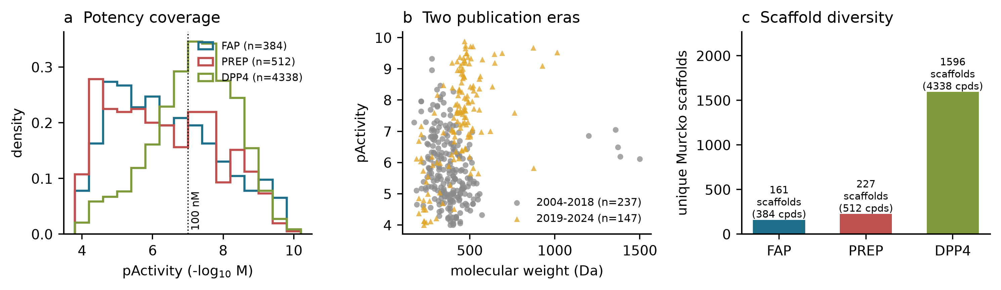
Figure 2. The curated datasets. (a) Potency coverage of the three targets; the dotted line marks 100 nM. (b) FAP compounds split by publication era, showing the shift towards larger, more potent molecules from 2019 onwards. (c) Scaffold diversity, which is low for FAP relative to its compound count. ChEMBL release 37; RDKit 2026.09.1; n = 384 / 512 / 4,338 compounds (FAP / PREP / DPP4); panel b n = 237 (2004–2018) and 147 (2019–2024).

5.2 Accuracy depends more on the split than on the algorithm
Table 2. Benchmark of five model families under three split protocols (mean ± s.d. over five seeds). AUROC and EF10 are computed on the focused evaluation set of clear actives (pActivity ≥ 7) and clear inactives (≤ 5.5).
Split / model | RMSE | MAE | R² | Spearman | AUROC | EF10
Random / Mean baseline | 1.429 ± 0.018 | 1.213 | −0.00 | -- | 0.50 | 1.21
Random / Ridge | 0.947 ± 0.089 | 0.735 | 0.56 | 0.75 | 0.95 | 2.03
Random / SVR (RBF) | 0.882 ± 0.067 | 0.711 | 0.62 | 0.78 | 0.98 | 2.03
Random / Random forest | 0.703 ± 0.073 | 0.563 | 0.75 | 0.85 | 0.99 | 2.03
Random / XGBoost | 0.712 ± 0.063 | 0.551 | 0.75 | 0.85 | 0.99 | 2.03
Scaffold / Mean baseline | 1.585 ± 0.001 | 1.325 | −0.17 | -- | 0.50 | 1.22
Scaffold / Ridge | 0.988 ± 0.029 | 0.760 | 0.55 | 0.76 | 0.92 | 1.43
Scaffold / SVR (RBF) | 0.931 ± 0.023 | 0.727 | 0.60 | 0.79 | 0.95 | 1.43
Scaffold / Random forest | 0.823 ± 0.009 | 0.635 | 0.68 | 0.80 | 0.93 | 1.43
Scaffold / XGBoost | 0.826 ± 0.009 | 0.636 | 0.68 | 0.81 | 0.94 | 1.43
Time / Mean baseline | 2.204 ± 0.000 | 1.905 | −1.06 | -- | 0.50 | 0.98
Time / Ridge | 1.584 ± 0.000 | 1.304 | −0.07 | 0.23 | 0.82 | 1.20
Time / SVR (RBF) | 2.055 ± 0.000 | 1.772 | −0.79 | −0.19 | 0.25 | 0.55
Time / Random forest | 2.183 ± 0.026 | 1.881 | −1.03 | −0.39 | 0.21 | 0.33
Time / XGBoost | 2.054 ± 0.042 | 1.725 | −0.79 | −0.11 | 0.56 | 0.96

Random splitting gives the flattering picture that the literature usually reports: random forest and XGBoost reach R² of 0.75 and 0.75 with RMSE near 0.70, and the ranking correlation is 0.85. Both are statistically indistinguishable from each other and clearly ahead of ridge (R² 0.56) and SVR (R² 0.62). Scaffold splitting costs about 0.07 in R² and 0.12 in RMSE for the tree ensembles, which is the expected price of extrapolating to new scaffolds and is still usable: R² 0.68, Spearman 0.81, screening AUROC 0.94.
The time split does not degrade the models, it destroys them. XGBoost reaches R² = −0.79 and a rank correlation of −0.11; the random forest is worse still (R² = −1.03). The mean predictor is as good as any learned model (R² ≈ −1.06). Enrichment falls to 0.96, i.e. no better than selecting compounds at random. Notably, ridge regression degrades far less (R² = −0.07), which is the signature of a model that relies on additive physicochemical trends rather than on scaffold-specific fingerprint patterns: it cannot rank the new series, but it also does not confidently rank it wrongly.
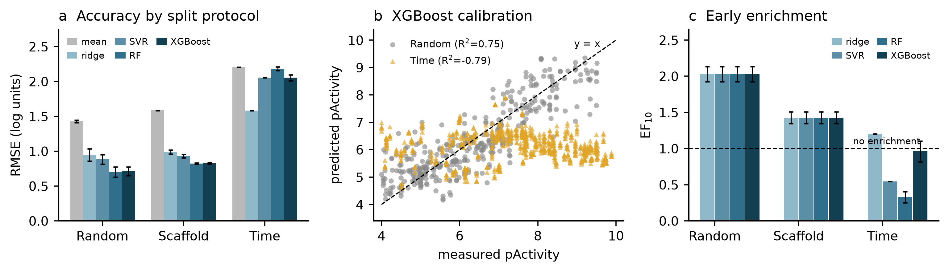
Figure 3. Benchmark results. (a) RMSE by split protocol and model; error bars are standard deviations over five seeds. (b) Predicted versus measured pActivity for XGBoost under random and time splitting; the time-split cloud is compressed into a narrow band around pActivity 6 regardless of the measured value. (c) Early enrichment (EF10) on the focused evaluation set; the dashed line marks the no-enrichment level. ChEMBL release 37; five seeds × five models × three protocols, n = 384 FAP compounds; XGBoost 3.4.1 / scikit-learn 1.9.1.
This is the central empirical result of the project, and it is not an artefact of a small test set (n = 147). It is the direct consequence of the era structure documented in Section 5.1: a model trained on pre-2019 DPP4-like chemistry is asked to rank quinoline FAPI warheads, a series it has never seen. The practical reading is that a FAP model trained on the literature available before the FAPI era has no prospective value for FAPI design, even though its random-split statistics are excellent.

5.3 Which chemical information carries the signal?
Table 3. Feature ablation with XGBoost under scaffold splitting (mean over five seeds).
Feature block | RMSE | MAE | R² | Spearman | AUROC
Morgan only | 0.866 | 0.679 | 0.65 | 0.78 | 0.937
MACCS only | 0.922 | 0.694 | 0.60 | 0.79 | 0.928
Descriptors only | 0.987 | 0.756 | 0.55 | 0.76 | 0.964
Combined (all three) | 0.828 | 0.638 | 0.68 | 0.81 | 0.940

The combined block is the most accurate in regression terms (RMSE 0.828 versus 0.866 for Morgan alone, 0.922 for MACCS and 0.987 for descriptors alone), which confirms that fingerprints and physicochemical descriptors carry complementary information: the fingerprints encode substructure, the descriptors encode the functional-group composition that defines a warhead. The ranking metrics tell a slightly different story, with the descriptor-only model achieving the highest AUROC (0.96) despite the worst RMSE. This divergence is a useful reminder that regression accuracy and screening utility are not the same quantity, and it is why both are reported here.

5.4 Paralogue transfer does not rescue a small target
Table 4. Value of paralogue transfer. Auxiliary models were trained on the full PREP and DPP4 datasets and their predictions (plus the chemical similarity to each paralogue training set) were appended to the FAP feature block. Mean over five seeds.
Feature set | Split | RMSE | R² | Spearman | AUROC
FAP features only | Random | 0.710 ± 0.061 | 0.751 | 0.848 | 0.987
 | Scaffold | 0.828 ± 0.009 | 0.680 | 0.808 | 0.940
FAP + paralogue predictions + similarity | Random | 0.697 ± 0.052 | 0.760 | 0.859 | 0.989
 | Scaffold | 0.824 ± 0.019 | 0.684 | 0.810 | 0.942
FAP + paralogue predictions | Random | 0.696 ± 0.054 | 0.760 | 0.861 | 0.991
 | Scaffold | 0.823 ± 0.013 | 0.684 | 0.811 | 0.940

Transfer produces a consistent but tiny improvement. Under random splitting, RMSE falls from 0.710 to 0.697 and R² rises from 0.751 to 0.760; under scaffold splitting the change is 0.828 to 0.824. Paired comparisons across seeds give p = 0.19 and p = 0.62 respectively (Wilcoxon signed-rank), so the honest conclusion is that paralogue transfer is neutral at this data scale. Removing the similarity features changes nothing, which indicates that the small gain, where it exists, comes from the paralogue prediction itself rather than from a similarity-based neighbourhood signal.
This null result is informative. DPP4 has eleven times more measurements than FAP, but its chemistry is dominated by gliptin-like scaffolds that are precisely the compounds FAP chemists do not want. Transfer helps when the auxiliary task shares chemotypes with the target task; here it mostly shares an enzyme fold. The result also sets a bound on what more elaborate multi-task architectures could achieve with the same labels, since a shared encoder would have to overcome the same chemotype mismatch.

5.5 Selectivity is a cliff, not a slope
Table 5. Prediction of FAP selectivity over PREP on the 100 dual-measured compounds (36 scaffolds), using twenty random seeds. Selectivity is defined as ΔpActivity ≥ 1 (ten-fold preference for FAP).
Split | Protocol | ΔR² | Δ Spearman | AUROC (mean ± s.d.) | 95% CI
Random | Indirect (difference of two models) | 0.32 | 0.63 | 0.84 ± 0.08 | 0.04
 | Direct (model of ΔpActivity) | 0.27 | 0.58 | 0.82 ± 0.08 | 0.04
Scaffold | Indirect (difference of two models) | −0.18 | 0.10 | 0.38 ± 0.12 | 0.05
 | Direct (model of ΔpActivity) | −0.21 | 0.04 | 0.36 ± 0.11 | 0.05

Inside known scaffolds, selectivity is learnable: both protocols reach an AUROC of about 0.82–0.84 and a rank correlation of 0.58–0.63 for ΔpActivity. Direct modelling of the difference and indirect subtraction of two single-target models are statistically indistinguishable, which is a useful practical finding because the indirect route requires no dual-measured training set.
Outside known scaffolds the same models are worse than chance. AUROC falls to 0.36–0.38 with a standard deviation of about 0.12 across twenty seeds, and ΔR² becomes negative. A model that ranks selectively and non-selectively compounds in the wrong order on new scaffolds is not merely uninformative; used as a filter it would actively enrich the non-selective series. The most likely explanation is the sign flip of the SAR: within a series, the substituent that fills the FAP S2 pocket also fills the PREP S2 pocket, while across series the dominant determinant becomes the shape of the linker, which the model has never seen vary.
The descriptive statistics explain why this matters more for DPP4 than for PREP. Among 100 compounds measured on both FAP and PREP, the mean ΔpActivity is +0.59, with 32% selective and 34% non-selective; the distribution is broad and genuinely two-sided (Figure 4c). Among 232 compounds measured on both FAP and DPP4, the mean Δ is −1.75 and 86% of compounds are non-selective: DPP4 is the dominant off-target liability of this chemotype, and the practical design objective is to preserve FAP affinity while pushing DPP4 below the selectivity threshold.
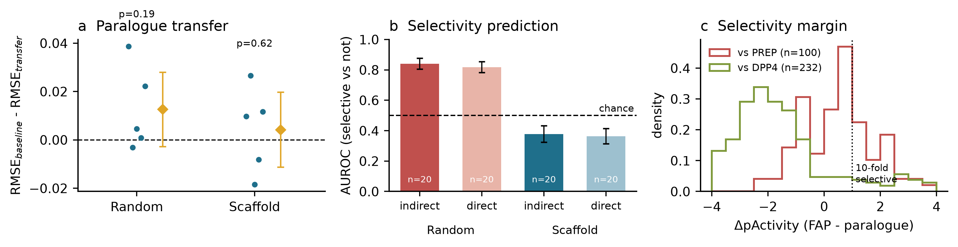
Figure 4. Transfer and selectivity. (a) Paired difference in RMSE between the FAP-only and transfer models for each seed; diamonds are means with 95% confidence intervals, and the p-values are from Wilcoxon signed-rank tests. (b) Selectivity AUROC by split protocol and modelling strategy; error bars are 95% confidence intervals over twenty seeds. (c) Distribution of ΔpActivity for the dual-measured compounds against PREP and DPP4. ChEMBL release 37; five benchmark seeds, twenty selectivity seeds; n = 100 FAP/PREP and 232 FAP/DPP4 dual-measured compounds.
Because the cliff is the strongest negative claim in this report, it was re-tested with a paired bootstrap over the twenty seeds (Appendix C, Table C1). Pairing the random- and scaffold-split AUROC obtained on the same seed gives a mean difference of 0.463 (95% CI 0.392–0.532) for the indirect protocol and 0.454 (0.382–0.525) for the direct one; 100% of 5,000 bootstrap replicates are positive. The collapse is therefore not an artefact of seed variation.
A stratified re-analysis is less comforting (Appendix C, Table C2). The cliff persists in the IC50-only stratum (Δ = 0.451, n = 70) and in the single-measurement stratum (Δ = 0.523, n = 93), but it reverses in the small mixed-assay stratum (Δ = −0.158, n = 30, only 13 evaluable random folds). The replicated stratum contains just 7 compounds and cannot be fitted at all. Assay-type confounding cannot therefore be excluded for that subgroup; the honest reading is that the cliff is robust for the IC50-dominated bulk of the data and unresolved for the heterogeneous remainder.

5.6 When can an error bar be believed?
Table 6. Error as a function of chemical similarity to the training set (scaffold split, XGBoost, pooled over five seeds).
Max Tanimoto to training set | n | RMSE | MAE
0.3-0.4 | 5 | 1.119 | 1.117
0.4-0.5 | 5 | 0.953 | 0.952
0.5-0.6 | 65 | 0.959 | 0.780
0.6-0.7 | 160 | 0.939 | 0.651
>0.7 | 263 | 0.702 | 0.579

Error rises monotonically as the query moves away from the training set: RMSE is 0.70 for compounds with a nearest-neighbour similarity above 0.7 (n = 263), 0.94 in the 0.6–0.7 bin, 0.96 in the 0.5–0.6 bin and 0.95–1.12 below 0.5. The absolute magnitude of the effect is modest — roughly 0.3 log units between the best and worst bins — but it is monotone and it is the basis for a usable rule: a prediction supported by a similarity above 0.6 can be quoted with an error comparable to assay noise, and below 0.6 it cannot.
Table 7. Empirical coverage of split-conformal intervals (mean over five seeds). Nominal coverage is 0.80 and 0.90; intervals are calibrated on out-of-fold residuals inside the training set.
Calibration protocol | Coverage at 80% | Coverage at 90%
Random split (control) | 0.79 | 0.89
Scaffold split, all test compounds | 0.73 | 0.87
Scaffold split, in domain (sim ≥ 0.6) | 0.77 | 0.88
Scaffold split, out of domain (sim < 0.6) | 0.54 | 0.77

The random-split control behaves exactly as theory predicts: 0.79 and 0.89 empirical coverage at nominal 0.80 and 0.90. Under scaffold splitting, coverage drops to 0.73 and 0.87 — a mild violation caused by the failure of exchangeability between calibration and test scaffolds. The violation becomes severe only outside the applicability domain, where the 80% interval covers 54% of compounds. In other words, the interval is honest for compounds that resemble the training set and optimistic for compounds that do not, which is the opposite of the intuition that error bars are conservative.
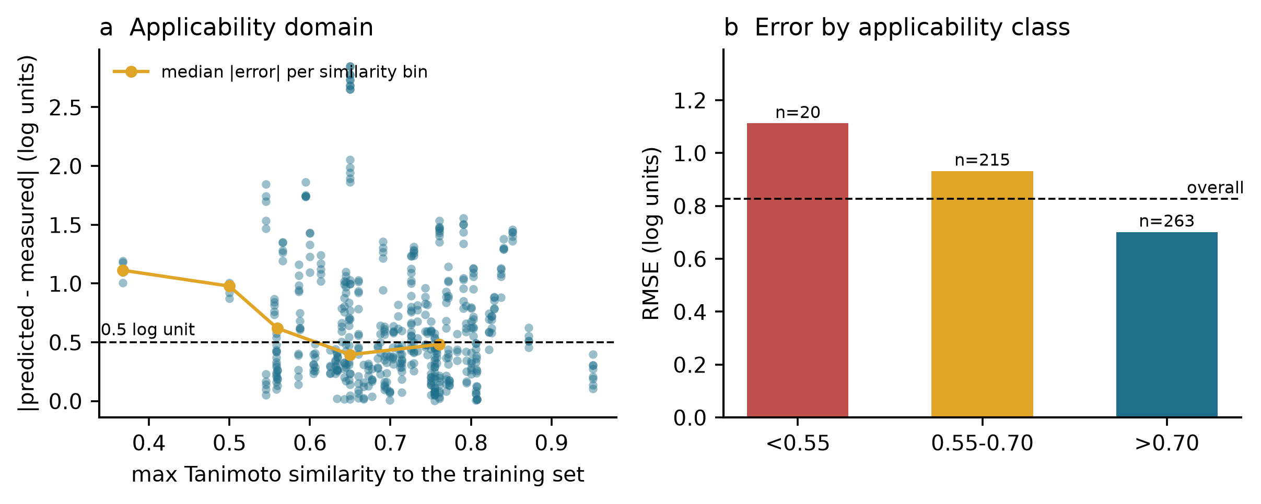
Figure 5. Applicability domain. (a) Absolute error against maximum Tanimoto similarity to the training set, with the median per bin overlaid. (b) RMSE grouped by applicability class; the dashed line is the overall RMSE. ChEMBL release 37; scaffold split, XGBoost, five seeds pooled, n = 384 FAP compounds; 0.6 AD threshold.
The practical rule that follows is a two-gate decision: compute the similarity, and only quote a conformal interval when the similarity exceeds 0.6. Below that threshold the model may still be useful for ranking a series internally, but its numeric interval should not appear in a synthesis decision.
A natural repair is class-conditional (Mondrian) conformal calibration: bin the out-of-fold calibration residuals by how well each training compound is represented in the training chemistry, and let each bin use its own quantile. Appendix C, Table C2 and Figure 8 report that sensitivity analysis. Out-of-domain coverage at the 80% level rises from 0.54 to 0.74 and at the 90% level from 0.77 to 1.00, while in-domain coverage is essentially unchanged (0.77 to 0.74 and 0.88 to 0.88).
This is a diagnostic, not a deployable fix. Only 27 of roughly 280 training compounds fall in the out-of-domain calibration bin, so its quantile is noisy: at the 90% level it produces complete over-coverage (1.00) and more than doubles the interval width from 2.40 to 5.01 log units. Conditional calibration restores nominal coverage by spending precision, which is exactly the trade-off the rest of this report argues should be reported rather than hidden behind a single reassuring number.
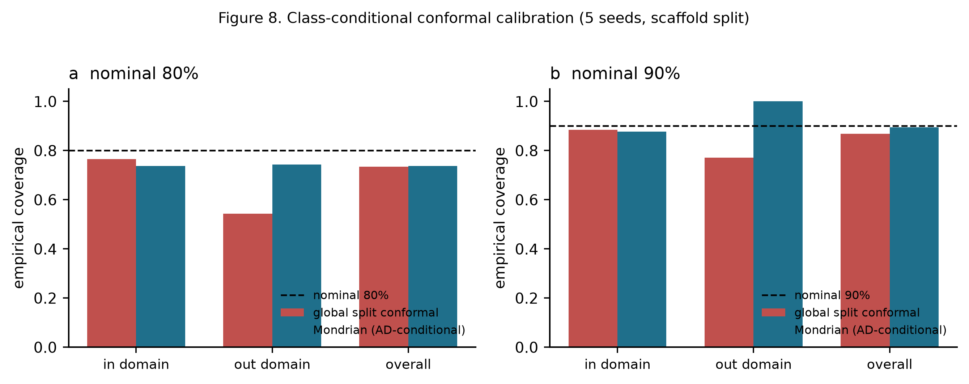
Figure 8. Class-conditional conformal calibration under scaffold splitting (mean over five seeds). Dark bars: global split conformal; light bars: bin-wise quantiles. The dashed line is the nominal level. ChEMBL release 37; XGBoost, five seeds, 0.6 applicability-domain threshold; n ≈ 280 training / ≈ 100 test compounds per seed.
A natural repair is class-conditional (Mondrian) conformal calibration: bin the out-of-fold calibration residuals by how well each training compound is represented in the training chemistry, and let each bin use its own quantile. Appendix C, Table C3 and Figure 8 report that sensitivity analysis. Out-of-domain coverage at the 80% level rises from 0.54 to 0.74 and at the 90% level from 0.77 to 1.00, while in-domain coverage is essentially unchanged (0.77 to 0.74 and 0.88 to 0.88).
This is a diagnostic, not a deployable fix. Only 27 of roughly 280 training compounds fall in the out-of-domain calibration bin, so its quantile is noisy: at the 90% level it produces complete over-coverage (1.00) and more than doubles the interval width from 2.40 to 5.01 log units. Conditional calibration restores nominal coverage by spending precision, which is exactly the trade-off the rest of this report argues should be reported rather than hidden behind a single reassuring number.
Figure 8. Class-conditional conformal calibration under scaffold splitting (mean over five seeds). Dark bars: global split conformal; light bars: bin-wise quantiles. The dashed line is the nominal level. ChEMBL release 37; XGBoost, five seeds, 0.6 applicability-domain threshold; n ≈ 280 training / ≈ 100 test compounds per seed.

5.7 Prospective failure: the 2019 series shift
Table 8. Temporal extrapolation and intercept recalibration.
Setting | RMSE | MAE | R² | Spearman | Mean offset
Train ≤ 2018, test 2019–2024 | 2.069 | 1.733 | −0.82 | −0.12 | 0.00
Intercept recalibrated on 25% of test | 1.644 | 1.350 | −0.15 | −0.12 | +1.18

The raw time-split model has RMSE 2.07 and R² −0.82, with a mean signed error of +1.18 log units (a single fit at seed 0; the five-seed mean in §5.2 is −0.79 with RMSE 2.05): it systematically under-predicts the potency of post-2018 compounds by more than an order of magnitude. Recalibrating a single intercept on a quarter of the test set reduces RMSE to 1.64 and brings R² to −0.15, but the rank correlation is unchanged at −0.12. This decomposition is the cleanest result in the project: the model's error is almost entirely a level shift, and correcting the level restores absolute accuracy without restoring any ranking ability. A chemist who recalibrated the model on a few new compounds would obtain correct potency estimates for the new series while still ranking its members at random.
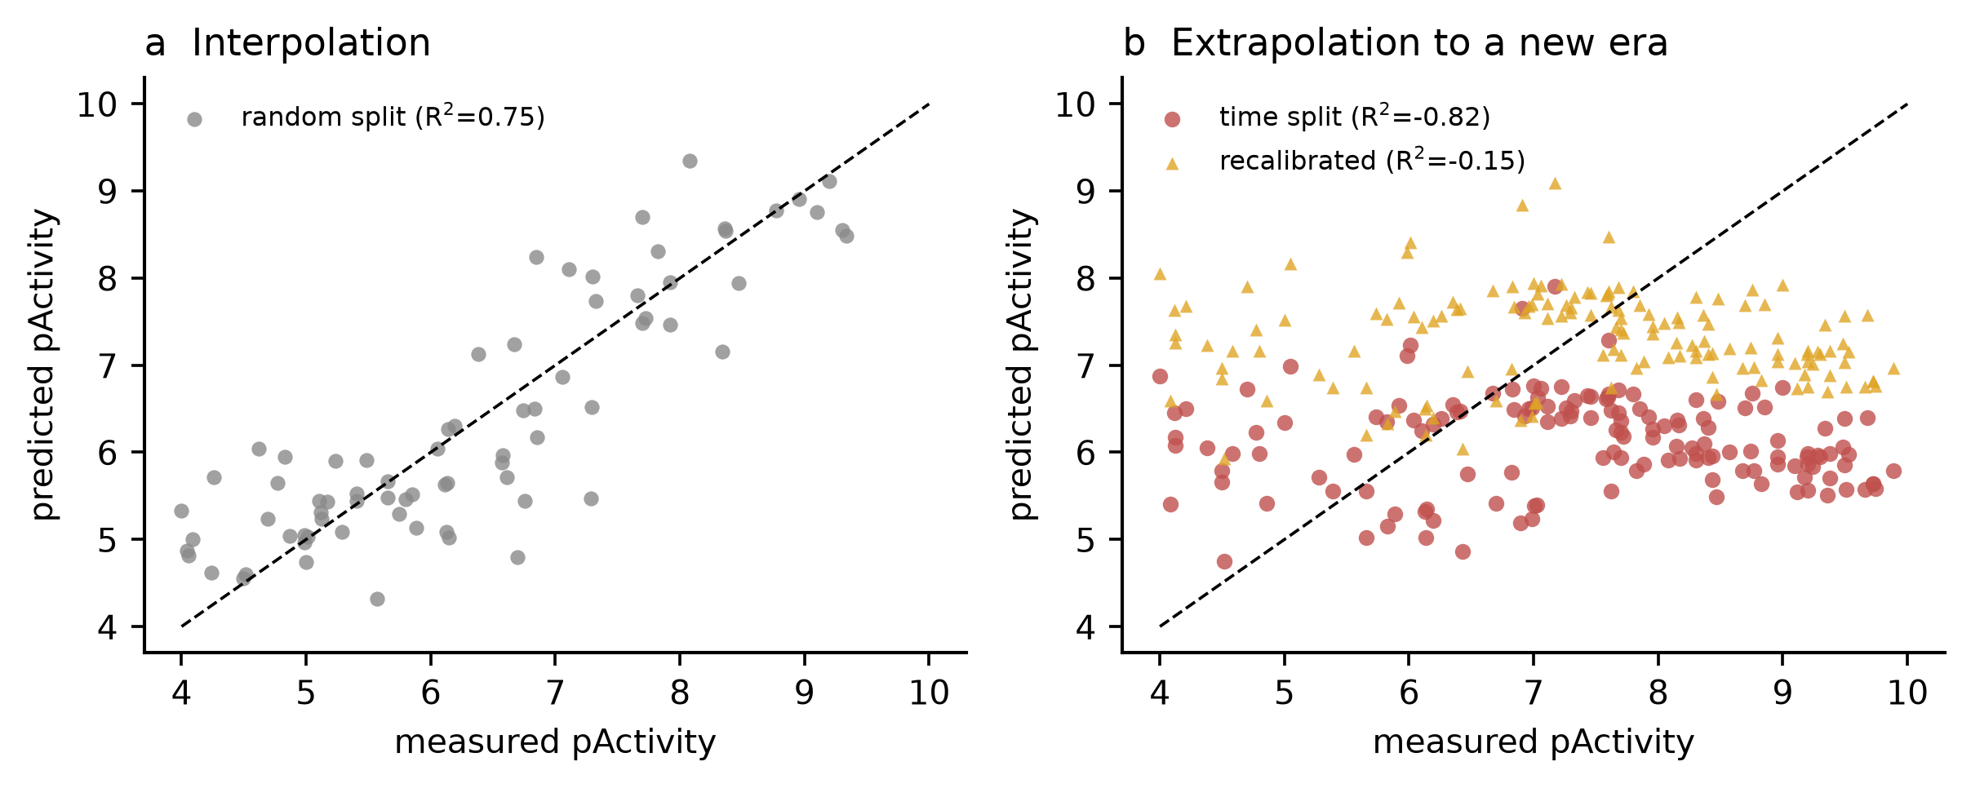
Figure 6. Temporal drift. (a) Interpolation under random splitting. (b) Extrapolation to compounds published after 2018, before and after intercept recalibration. The recalibrated points move onto the diagonal in level but remain uncorrelated in rank. ChEMBL release 37; train ≤ 2018 (n = 237), test 2019–2024 (n = 147); single fit at seed 0, XGBoost 3.4.1.

5.8 Multi-objective generative design
Table 9. Outcome of the three design campaigns with an identical evaluation budget (24 generations, population 96). Novelty = InChIKey absent from all three curated datasets; pass rate = fraction of novel molecules with predicted pFAP ≥ 8 and selectivity margin ≥ 1. QED, SA and MW are medians over the whole archive; the two pFAP columns are over novel molecules only. All values are recomputed from generative_archive.csv by this script.
Campaign | Arch. | Novel | Scaf. | QED | SA | MW (Da) | Median novel pFAP | Best novel pFAP | Pass rate
Multi-objective (NSGA-II) | 384 | 361 | 115 | 0.61 | 2.93 | 413 | 8.24 | 9.62 | 61%
Affinity only | 384 | 369 | 83 | 0.25 | 3.51 | 548 | 9.36 | 9.72 | 100%
Random (no selection) | 384 | 300 | 80 | 0.52 | 3.59 | 453 | 8.58 | 9.43 | 60%

All three campaigns quickly reach the ceiling of the affinity model (best predicted pFAP 9.6–9.7, Figure 7b), which is itself a warning: an ensemble trained on 384 compounds cannot distinguish a genuine 10 nM inhibitor from an implausible one, and the optimizer finds the model's most confident region within a few generations. The campaigns therefore differ not in predicted affinity but in what they sacrifice to get there. Without selection pressure the breeding population drifts downwards from pFAP 7.35 to 6.44 within 24 generations (Figure 7a); under affinity-only selection it climbs steadily while its chemistry degenerates — the median QED of the archived molecules collapses to 0.25 and the median molecular weight inflates to 548 Da, because polar atoms are traded for hydrophobic bulk wherever the model rewards it.
The multi-objective campaign pays a small affinity price (median novel pFAP 8.24 in Table 9 versus 9.36 for affinity-only) and in exchange returns the most usable chemistry of the three regimes: 115 distinct Murcko scaffolds against 80–83 for the controls, a median QED of 0.61, a median synthetic-accessibility score of 2.93 (easier to make than either control) and a median molecular weight of 413 Da, squarely in the range of the clinical FAPIs. Its 61% pass rate is essentially the same as the random control (60%) — the value of the objectives shows up in diversity and developability rather than in the pass rate, which is exactly what a Pareto front should do.
Two features of Table 9 need to be read with care. First, the affinity-only campaign shows a 100% pass rate, and this is a consequence of the metric's definition, not of superior chemistry: selection drives all 369 of its novel molecules above pFAP 8, and because the margin is pFAP minus the largest paralogue prediction, a high pFAP almost automatically satisfies margin ≥ 1 as well. The pass rate is therefore close to a restatement of the objective that campaign was given. Second, the same circularity explains why adding selectivity and developability pressure lowers the pass rate to 61%: the optimiser is no longer allowed to spend its entire budget on pFAP. A post-hoc look at what the four-objective budget bought is more informative than the pass rate — the affinity-only archive has median QED 0.25, median MW 548 Da and 83 scaffolds, whereas the four-objective archive has median QED 0.61, median MW 413 Da and 115 scaffolds at a median pFAP of 8.24 that still clears the pre-registered threshold. The top-ranked novel molecules are quinoline-carboxamide derivatives with modified amide linkers, i.e. plausible next analogues rather than exotic chemistry (Table 10), but see Section 5.11 and Appendix B for why their warhead is not the clinical FAPI warhead.
Table 10. Six highest-ranked novel molecules from the multi-objective campaign, ranked by predicted pFAP and selectivity margin.
Structure (SMILES) | pFAP | Margin | QED | SA | MW (Da)
CC1CN(C(=O)CCC(=O)C(=O)[C@@H]2CCCN2C(=O)CNC(=O)c2ccnc3ccccc23)CCO1 | 9.62 | 3.11 | 0.55 | 3.40 | 495
COc1ccc(CCNC(=O)C(=O)[C@@H]2CCCN2C(=O)CNC(=O)c2ccnc3ccccc23)c(C)c1OC | 9.60 | 3.06 | 0.38 | 3.12 | 533
CCc1cc(CNC(=O)C(=O)[C@@H]2CCCN2C(=O)CNC(=O)c2ccnc3ccccc23)ccc1OC | 9.58 | 3.08 | 0.43 | 2.97 | 503
C=C1CN(C(=O)CCC(=O)C(=O)[C@@H]2CCCN2C(=O)CNC(=O)c2ccnc3ccccc23)CCO1 | 9.54 | 3.09 | 0.55 | 3.37 | 493
COc1cc(F)cc(CNC(=O)C(=O)[C@@H]2CCCN2C(=O)CNC(=O)c2ccnc3ccccc23)c1 | 9.52 | 3.08 | 0.46 | 2.97 | 493
CC[C@H]1N(C(=O)CCOc2ccc3nccc(C(=O)NCC(=O)N4CC(F)(F)C[C@H]4C#N)c3c2)CC(F)C1(O)O | 9.50 | 3.88 | 0.40 | 4.40 | 564

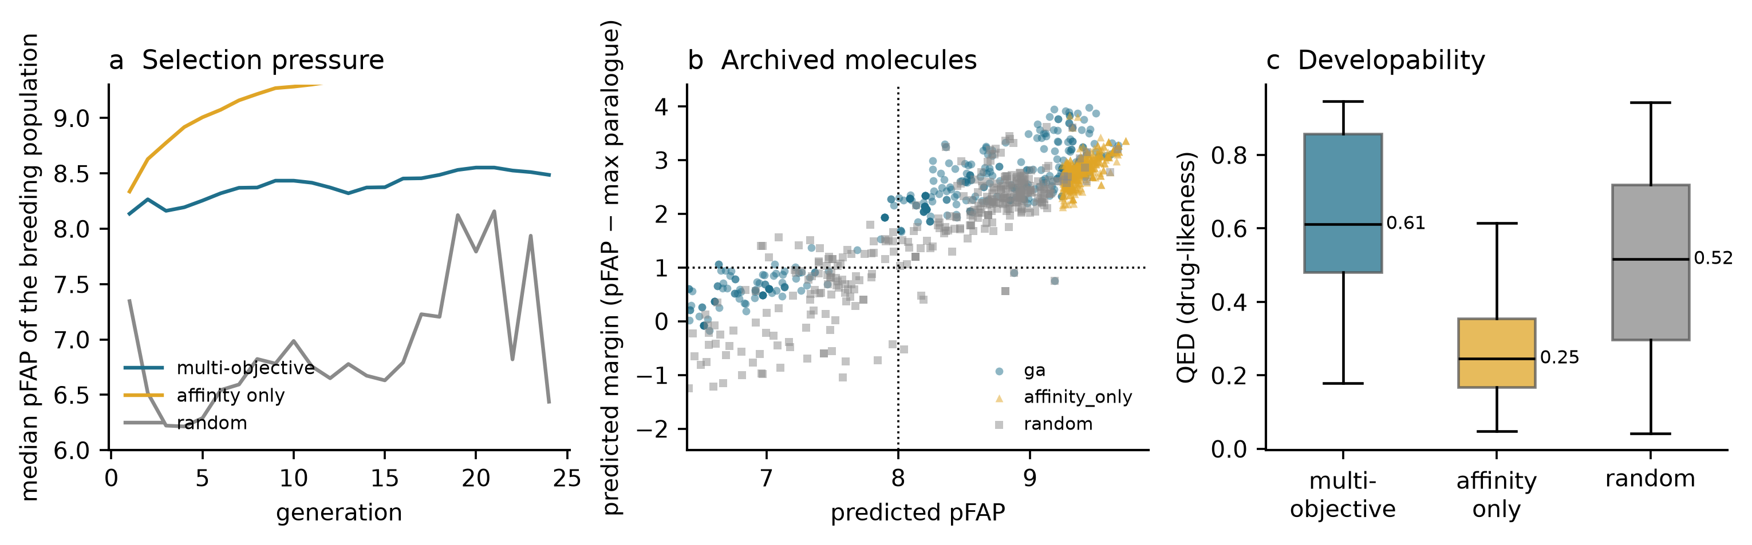
Figure 7. Generative design. (a) Median predicted affinity of the breeding population per generation: random selection drifts downwards, affinity-only hill-climbing rises, multi-objective selection stays stable. (b) Archived molecules in the affinity-margin plane; dotted lines mark the design thresholds. (c) Drug-likeness of the archived molecules by campaign. ChEMBL release 37; 24 generations × population 96, 384 archived molecules per campaign; RDKit 2026.09.1, five-seed XGBoost ensemble scoring.

5.9 The designs are warheads, not radioligands
A potency model returns a molecule that binds; a radiopharmaceutical has to be made and labelled as well. Both questions were asked of the six top-ranked designs, using only rule-based, reproducible calculations (Appendix B). Retrosynthetically the series is unremarkable: BRICS disconnection gives 7–10 fragments (median 9), the estimated route is 7–10 steps, and the synthetic-accessibility score lies between 2.97 and 4.40 (median 3.24), which is the range of ordinary medicinal chemistry rather than of a difficult natural product. All six are assembled from a quinoline carboxylic acid and a proline-derived amine, which is the same logic as the published FAPI series. These estimates are disconnection heuristics, not validated routes, and no reaction in Table B2 has been run.
The radiochemical audit is where the designs fail. None of the six carries a chelator and none exposes a free conjugation handle: every heteroatom is already engaged in an amide or in the warhead. 68Ga and 177Lu labelling requires a chelator; 18F labelling requires a displaceable leaving group; neither is present in any generated structure. Grafting DOTA onto the nearest carboxylic acid moves the median molecular weight from 498.6 to 856.9 Da (851–922 Da across the series) and the median TPSA from 126.0 to 247.7 Å². The curated FAP training set has a median molecular weight of 401.4 Da and a 95th percentile of 557.3 Da, and only 2.3% of its compounds exceed 800 Da. The conjugated ligand therefore leaves the applicability domain of the very model that scored it, which is a quantitative statement that the optimised quantity and the deliverable molecule are not the same object.
The warhead mismatch compounds this. Five of the six designs carry an α-diketone or ketoamide electrophile, whereas the clinical FAPI tracers use a prolyl nitrile that forms a reversible covalent adduct with the catalytic serine; only T10-6 recovers the clinical chemotype. A model trained on a few hundred compounds dominated by one warhead class will happily reward a different, more reactive one, because both occupy the same descriptor neighbourhood. The fix is not a better regressor: the design objective has to include the linker, the chelator and the labelling chemistry, and candidates have to be re-scored after conjugation. That is a change of design space, and it is the single most useful thing this audit produced.

5.10 Discussion
Three findings deserve emphasis. First, the choice of evaluation protocol changes the conclusion more than the choice of algorithm: the same XGBoost model is excellent (R² 0.75) or useless (R² −0.79) depending only on how the data are divided. Any claim about FAP affinity prediction that does not specify the split is therefore unfalsifiable. This is not a novel observation in the machine-learning literature, but it is rarely applied to radiopharmaceutical targets, where datasets are small and the pressure to report a good number is high.
Second, the error floor set by assay noise (0.67 log units) is close to the best achievable RMSE (0.70 under random splitting). The model is not limited by its architecture; it is limited by the reproducibility of the underlying enzyme assays. Further modelling effort on this dataset has a low ceiling, and the highest-value intervention would be a consistent centralised assay campaign for a few hundred FAP inhibitors, not a better neural network.
Third, selectivity is the quantity that actually decides whether a FAP ligand advances, and it is the quantity that generalises worst. Predicting ΔpActivity within a series is easy; predicting it across series is not currently possible with 100 dual-measured compounds. Design campaigns should therefore treat selectivity as a filter to be verified experimentally rather than as an objective to be optimised in silico.

5.11 Limitations
• The dataset is one snapshot of ChEMBL and inherits its biases: publication bias towards potent compounds, inconsistent assay conditions, and an over-representation of the quinoline warhead after 2018.
• Only ligand-based descriptors were used. No docking, pharmacophore or protein-structure information entered the models, so the models cannot distinguish a genuine sub-pocket match from a physicochemical coincidence.
• The generative campaign scores candidates with the same models whose limitations are documented above. Predicted affinities above pActivity 9 should be read as ‘inside the model's confident region’, not as ‘10 nM’.
• The applicability-domain filter at similarity 0.40 constrains novelty by construction; a more adventurous campaign would generate more diverse but less assessable chemistry.
• Temporal analysis uses publication year as a proxy for availability; a true prospective test would require an external, later dataset.
• Five of the six highest-ranked designs in Table 10 carry an alpha-diketone / ketoamide electrophile, whereas clinical FAPI tracers use a prolyl nitrile warhead that forms a reversible covalent adduct with the catalytic serine. The generated molecules are therefore not close analogues of the clinical series: pFAP values above 9.5 place them inside the model's confident region, not inside a validated SAR series, and imply neither potency nor synthetic tractability (Appendix B).
• No protein-structure, docking, pharmacophore or free-energy calculation was performed. The assignment brief lists molecular docking and structure prediction as possible directions, not as required deliverables, so this project stays with ligand-based methods. Adding a docking score would create a second, uncalibrated confidence scale and would contradict the audit framing of this report; if structure-based work is undertaken later it should be used only for qualitative binding-mode explanations and be reported with the same applicability-domain and failure checks as the models here.
• The selectivity cliff is robust in the IC50-dominated bulk of the paired data but reverses in a 30-compound mixed-assay stratum (Appendix C, Table C2); assay-type confounding in that subgroup cannot be excluded.

§6. Conclusions
This project asked what machine learning can deliver for FAP-targeted radiopharmaceutical design given the public bioactivity record, and where the answer is negative. A curated dataset of 384 unique FAP inhibitors supported a model that reaches R² 0.68 and screening AUROC 0.94 under scaffold splitting, which meets the pre-registered criterion for use as a triage filter. The same model fails completely under a time split (R² −0.79), and the failure is traceable to a documented change in chemical series rather than to algorithmic weakness. Paralogue transfer from PREP and DPP4 is neutral at this scale, and selectivity over PREP, although learnable within a series (AUROC 0.84), is anti-correlated across scaffolds (AUROC 0.38). Conformal intervals are valid under interpolation and become optimistic outside the applicability domain, so a similarity gate is a necessary companion to any quoted uncertainty.
The four research questions are therefore answered, though not in the direction that a typical QSAR paper would report: RQ1 — accuracy is protocol-dependent to the point of changing the sign of R²; RQ2 — transfer is neutral and selectivity does not generalise across scaffolds; RQ3 — intervals are trustworthy only inside the applicability domain; RQ4 — multi-objective selection improves the diversity and drug-likeness of the generated set (115 scaffolds, median QED 0.61) while single-objective optimisation degenerates chemically (median QED 0.25), and neither can manufacture information that the scoring model does not contain.
The broader contribution is methodological. For targets with a few hundred compounds, a drifting literature and heterogeneous assays, the deliverable of AI-driven drug discovery should be a calibrated decision rule — use the model here, do not use it there — rather than a single predicted potency. Building that rule requires the three analyses performed here (protocol comparison, applicability domain, conformal calibration), and they cost little compared with the synthesis of one analogue.

§7. References
[1] Lindner T, Loktev A, Altmann A, Giesel F, Kratochwil C, Debus J, Jäger D, Mier W, Haberkorn U. Development of quinoline-based theranostic ligands for the targeting of fibroblast activation protein. J Nucl Med. 2018;59(9):1415–1422 doi:10.2967/jnumed.118.210443.
[2] Loktev A, Lindner T, Mier W, Debus J, Altmann A, Jäger D, Haberkorn U. A tumor-imaging method targeting cancer-associated fibroblasts. J Nucl Med. 2018;59(9):1423–1429 doi:10.2967/jnumed.118.210435.
[3] Kratochwil C, Flechsig P, Lindner T, Abderrahim L, Altmann A, Mier W, et al. 68Ga-FAPI PET/CT: tracer uptake in 28 different kinds of cancer. J Nucl Med. 2019;60(6):801–805 doi:10.2967/jnumed.119.227967.
[4] Giesel FL, Kratochwil C, Lindner T, Marschalek MM, Loktev A, Lehnert W, et al. 68Ga-FAPI PET/CT: biodistribution and preliminary dosimetry estimate of 2 DOTA-containing FAP-targeting agents in patients with various cancers. J Nucl Med. 2019;60(3):386–392 doi:10.2967/jnumed.118.215913.
[5] Giesel FL, Adeberg S, Syed M, Lindner T, Jiménez-Franco LD, Mavriopoulou E, et al. FAPI-74 PET/CT using either 18F-AlF or cold-kit 68Ga labeling: biodistribution, radiation dosimetry, and tumor delineation in lung cancer patients. J Nucl Med. 2021;62(2):201–207 doi:10.2967/jnumed.120.245084.
[6] Baum RP, Schuchardt C, Singh A, Chantadisai M, Robiller FC, Zhang J, et al. Feasibility, biodistribution, and preliminary dosimetry in peptide-targeted radionuclide therapy of diverse adenocarcinomas using 177Lu-FAP-2286: first-in-human results. J Nucl Med. 2022;63(3):415–423 doi:10.2967/jnumed.120.259192.
[7] Fendler WP, Pabst KM, Kessler L, Fragoso Costa P, Ferdinandus J, Weber M, et al. Safety and efficacy of 90Y-FAPI-46 radioligand therapy in patients with advanced sarcoma and other cancer entities. Clin Cancer Res. 2022;28(19):4346–4353 doi:10.1158/1078-0432.ccr-22-1432.
[8] Fu H, Huang J, Zhao L, Chen Y, Xu W, Cai J, et al. 177Lu-LNC1004 radioligand therapy in patients with end-stage metastatic cancers: a single-centre, single-arm, phase II study. Clin Cancer Res. 2025;31(8):1415–1426 doi:10.1158/1078-0432.ccr-24-3918.
[9] Fitzgerald AA, Weiner LM. The role of fibroblast activation protein in health and malignancy. Cancer Metastasis Rev. 2020;39(3):783–803 doi:10.1007/s10555-020-09909-3.
[10] Altmann A, Haberkorn U, Siveke J. The latest developments in imaging of fibroblast activation protein. J Nucl Med. 2021;62(2):160–167 doi:10.2967/jnumed.120.244806.
[11] Zdrazil B, Felix E, Hunter F, Manners EJ, Blackshaw J, Corbett S, et al. The ChEMBL Database in 2023: a drug discovery platform spanning multiple bioactivity data types and time periods. Nucleic Acids Res. 2024;52(D1):D1180–D1192 doi:10.1093/nar/gkad1004.
[12] Mayr A, Klambauer G, Unterthiner T, Steijaert M, Wegner JK, Ceulemans H, et al. Large-scale comparison of machine learning methods for drug target prediction on ChEMBL. Chem Sci. 2018;9(24):5441–5451 doi:10.1039/c8sc00148k.
[13] van Tilborg D, Alenicheva A, Grisoni F. Exposing the limitations of molecular machine learning with activity cliffs. J Chem Inf Model. 2022;62(23):5938–5951 doi:10.1021/acs.jcim.2c01073.
[14] Wu Z, Ramsundar B, Feinberg EN, Gomes J, Geniesse C, Pappu AS, et al. MoleculeNet: a benchmark for molecular machine learning. Chem Sci. 2018;9(2):513–530 doi:10.1039/c7sc02664a.
[15] Wallach I, Heifets A. Most ligand-based classification benchmarks reward memorization rather than generalization. J Chem Inf Model. 2018;58(5):916–932 doi:10.1021/acs.jcim.7b00403.
[16] Sheridan RP. Time-split cross-validation as a method for estimating the goodness of prospective prediction. J Chem Inf Model. 2013;53(4):783–790 doi:10.1021/ci400084k.
[17] Sahigara F, Mansouri K, Ballabio D, Mauri A, Consonni V, Todeschini R. Comparison of different approaches to define the applicability domain of QSAR models. Molecules. 2012;17(5):4791–4810 doi:10.3390/molecules17054791.
[18] Angelopoulos AN, Bates S. A gentle introduction to conformal prediction and distribution-free uncertainty quantification. arXiv:2107.07511. 2021 doi:10.48550/arXiv.2107.07511.
[19] Jensen JH. A graph-based genetic algorithm and generative model/Monte Carlo tree search for the exploration of chemical space. Chem Sci. 2019;10(12):3567–3572 doi:10.1039/c8sc05372c.
[20] Deb K, Pratap A, Agarwal S, Meyarivan T. A fast and elitist multiobjective genetic algorithm: NSGA-II. IEEE Trans Evol Comput. 2002;6(2):182–197 doi:10.1109/4235.996017.
[21] Bickerton GR, Paolini GV, Besnard J, Muresan S, Hopkins AL. Quantifying the chemical beauty of drugs. Nat Chem. 2012;4(2):90–98 doi:10.1038/nchem.1243.
[22] Ertl P, Schuffenhauer A. Estimation of synthetic accessibility score of drug-like molecules based on molecular complexity and fragment contributions. J Cheminform. 2009;1:8 doi:10.1186/1758-2946-1-8.
[23] Chen T, Guestrin C. XGBoost: a scalable tree boosting system. In: Proceedings of the 22nd ACM SIGKDD International Conference on Knowledge Discovery and Data Mining. 2016. p. 785–794 doi:10.1145/2939672.2939785.
[24] Breiman L. Random forests. Mach Learn. 2001;45(1):5–32 doi:10.1023/a:1010933404324.
[25] Bemis GW, Murcko MA. The properties of known drugs. 1. Molecular frameworks. J Med Chem. 1996;39(15):2887–2893 doi:10.1021/jm9602928.
[26] Rogers D, Hahn M. Extended-connectivity fingerprints. J Chem Inf Model. 2010;50(5):742–754 doi:10.1021/ci100050t.
[27] Landrum G. RDKit: open-source cheminformatics software. https://www.rdkit.org (accessed November 2026) doi:10.5281/zenodo.591637.
[28] Papadatos G, Gaulton A, Hersey A, Overington JP. Activity, assay and target data curation and quality in the ChEMBL database. J Comput Aided Mol Des. 2015;29(9):885–896 doi:10.1007/s10822-015-9860-5.
[29] Ruzzeh S, Abdlkadir AS, Paez D, Kang KW, Watabe T, Moghrabi S, et al. Therapeutic potential of FAPI RLT in oncology: a systematic review. Theranostics. 2025;15(9):4084–4100 doi:10.7150/thno.106108.

Appendix A. Code and data availability
The complete project is submitted as a single package, Submission_HuangYong_P2600222/. Its 03_Code/ directory is the evidence bundle referenced by this report:
03_Code/README.md — one-command reproduction, table-to-script map and environment fingerprint; 03_Code/requirements.txt — pinned dependency versions; 03_Code/src/ — scripts 01–17 in execution order; 03_Code/data/raw/ — the three ChEMBL release-37 JSON exports together with their retrieval date and API query strings; 03_Code/data/processed/ — the 972 → 438 → 384 curation chain; 03_Code/results/tables/ — every number quoted in Tables 1–10 and Appendices B–C; 03_Code/results/figures/ — all eight figures at ≥2,000 px; 03_Code/logs/ — random seeds, package versions, runtime and the reconciliation log. Running the scripts in numerical order from README.md regenerates Tables 1, 2, 8, 9 and 10 from the public API without any manual step.
The ChEMBL snapshot is release 37 (May 2026), targets CHEMBL4683 / CHEMBL3202 / CHEMBL284; the environment is Python 3.13, RDKit 2026.09.1 [27], scikit-learn 1.9.1, XGBoost 3.4.1, NumPy 2.5.4, pandas 3.1.0 and Matplotlib 3.11.2, on Windows 11. All five benchmark seeds and all twenty selectivity seeds are fixed in the scripts.
Version-control location: the submitted project repository (folder 03_Code/ of this submission package)

Appendix B. Radioligand feasibility and retrosynthetic triage
This appendix closes the gap left open in Section 1.2. It is a rule-based structural analysis, not a literature-verified synthesis: BRICS disconnections, reaction assignments and step counts are heuristics computed from the molecular graph by src/12_design_feasibility.py, and no reaction, yield or supplier check was performed. Descriptors are RDKit calculations; the chelator figures are stoichiometric estimates for a DOTA mono-amide (DOTA free acid 376.4 Da; conjugation adds 358.4 Da).
Table B1. Calculated properties of the six highest-ranked novel designs (Table 10) and the estimated effect of conjugating one DOTA chelator. None of the six carries a chelator; median MW rises from 498.6 to 856.9 Da and median TPSA from 126.0 to 247.7 Å², which is outside the training chemistry of Table 1. Source: radiolabel_feasibility.csv.
ID | Warhead | MW (Da) | TPSA (Å²) | Chelator | MW + DOTA (Da)
T10-1 | alpha-diketone | 494.5 | 126.0 | no | 852.9
T10-2 | alpha-diketone | 532.6 | 126.9 | no | 890.9
T10-3 | alpha-diketone | 502.6 | 117.7 | no | 860.9
T10-4 | alpha-diketone | 492.5 | 126.0 | no | 850.9
T10-5 | alpha-diketone | 492.5 | 117.7 | no | 850.9
T10-6 | prolyl nitrile | 563.5 | 156.1 | no | 921.9

The labelling handles lead to the same conclusion. A 18F label requires a displaceable leaving group on an aryl or alkyl carbon; the fluorine atoms present in these designs are stable aryl-F or gem-difluoro substituents, not leaving groups. 68Ga and 177Lu require a macrocyclic chelator, and every nitrogen and oxygen in the six structures is already engaged in an amide or in the electrophilic warhead, so there is no free amine or carboxylate for a chelator coupling. All three radionuclide routes therefore demand a structural modification first — and the modified molecule would no longer resemble the 384 compounds that define the model's applicability domain. This is why tumour retention and normal-tissue background are declared out of scope here rather than predicted: they are pharmacokinetic properties of a conjugate this model has never seen. The testable next step is narrow — synthesise three to five chelator-bearing analogues, measure affinity and logD, and check whether they still fall inside the 0.6 similarity gate.
Table B2. Rule-based retrosynthetic triage of the six designs. BRICS fragments are graph disconnections; the step count is a heuristic (one coupling per junction plus one interconversion per specialised warhead), not an experimental route. Source: retrosynthesis.csv.
ID | Warhead | BRICS frags | Est. steps | SA | Dominant disconnection
T10-1 | alpha-diketone / ketoamide | 7 | 7 | 3.40 | amide coupling (carboxylic acid + amine)
T10-2 | alpha-diketone / ketoamide | 9 | 9 | 3.12 | amide coupling (carboxylic acid + amine)
T10-3 | alpha-diketone / ketoamide | 10 | 10 | 2.97 | amide coupling (carboxylic acid + amine)
T10-4 | alpha-diketone / ketoamide | 7 | 7 | 3.37 | amide coupling (carboxylic acid + amine)
T10-5 | alpha-diketone / ketoamide | 9 | 9 | 2.97 | amide coupling (carboxylic acid + amine)
T10-6 | prolyl nitrile | 9 | 9 | 4.40 | amide coupling (carboxylic acid + amine)

The medicinal-chemistry answer to the warhead question is therefore: yes, an alpha-diketone is accessible (oxidation of the corresponding alpha-hydroxy ketone, followed by amide couplings onto a quinoline-4-carboxamide and a proline-derived amine), but it is not the clinical FAPI warhead. Clinical tracers use a prolyl nitrile that forms a reversible covalent adduct with the catalytic serine; only the sixth design in Table 10 retains that motif. A high predicted pFAP for the first five consequently says that the optimizer found the model's confident region for a different chemotype, not that it rediscovered FAPI-04. This appendix supplies a triage and a set of checkable questions, not a claimed synthesis.

Appendix C. Robustness analyses
All three analyses below reuse the existing ChEMBL release-37 tables generated by src/13_robustness.py: no external dataset and no new model class was introduced. They were added to test, rather than to decorate, the two strongest claims in the report — the selectivity cliff and the out-of-domain conformal failure.
Table C1. Paired bootstrap over twenty seeds (5,000 replicates, seed 0 paired with seed 0). The random- and scaffold-split AUROCs are differenced within the same seed, so the interval describes the cliff itself. Source: selectivity_bootstrap.csv.
Protocol | Paired seeds | AUROC random [95% CI] | AUROC scaffold [95% CI] | Paired Δ [95% CI]
indirect | 20 | 0.841 [0.805, 0.876] | 0.378 [0.326, 0.431] | 0.463 [0.392, 0.532]
direct | 20 | 0.818 [0.783, 0.854] | 0.364 [0.317, 0.414] | 0.454 [0.382, 0.525]

Table C2. Stratified re-analysis of the selectivity experiment using the identical twenty-seed protocol, restricted to each stratum. Strata with n < 30 have unstable AUROCs; the mixed-assay stratum reverses the cliff and the replicated stratum (n = 7) cannot be fitted. Source: selectivity_stratified.csv.
Stratum | n | AUROC random | AUROC scaffold | Δ | Folds (r / s)
all (reference) | 100 | 0.841 | 0.378 | 0.463 | 20 / 20
assay type: IC50 only | 70 | 0.714 | 0.262 | 0.451 | 20 / 20
assay type: mixed / other | 30 | 0.699 | 0.857 | −0.158 | 13 / 20
era: 2004-2018 | 46 | 0.927 | 0.739 | 0.187 | 20 / 20
era: 2019-2024 | 54 | 0.680 | 0.108 | 0.572 | 20 / 20
replicated (>1 assay) | 7 | -- | -- | -- | -- / --
single measurement | 93 | 0.809 | 0.286 | 0.523 | 20 / 20

Table C3. Class-conditional (Mondrian) conformal calibration, mean over five scaffold-split seeds. Calibration residuals are binned by each training compound's maximum Tanimoto similarity to the other training compounds, and test compounds use the bin matching their own similarity to the training set at the 0.6 threshold. Only about 27 training compounds fall in the out-of-domain bin. Source: mondrian_conformal.csv.
Nominal | Domain | Global coverage | Mondrian coverage | Global width | Mondrian width
80% | in domain | 0.765 | 0.737 | 1.73 | 1.64
80% | out domain | 0.543 | 0.743 | 1.73 | 2.25
80% | overall | 0.734 | 0.737 | 1.73 | 1.73
90% | in domain | 0.884 | 0.877 | 2.40 | 2.35
90% | out domain | 0.771 | 1.000 | 2.40 | 5.01
90% | overall | 0.868 | 0.894 | 2.40 | 2.73

Read together, these tables strengthen the first claim and qualify the repair of the second. The paired interval excludes zero in every replicate, so the cliff is not seed noise — but it reverses in a 30-compound mixed-assay stratum, so assay-type confounding remains a live limitation rather than a dismissed one. Mondrian calibration lifts out-of-domain coverage without touching in-domain coverage, yet it does so with a 27-member calibration bin whose 90% quantile over-covers completely (1.00) at more than twice the interval width. Conditional calibration is thus a diagnostic of where exchangeability fails, not a new interval to quote in a synthesis meeting. That is the same conclusion Section 5.6 reaches by a different route.

