# OpenCL优化思路（一）

为了充分利用寄存器资源，核函数中将尽量加载更多数据。例如，对于uchar类型，4通道图像，一个128位的寄存器可以处理4个像素，为了充分利用寄存器，可以将数据转成float4或int4类型，然后分解成4个uchar4来处理。参考以下代码，该程序完成的功能彩色4通道图像反相，注意程序中核函数的实现及主程序中global_size的设置。

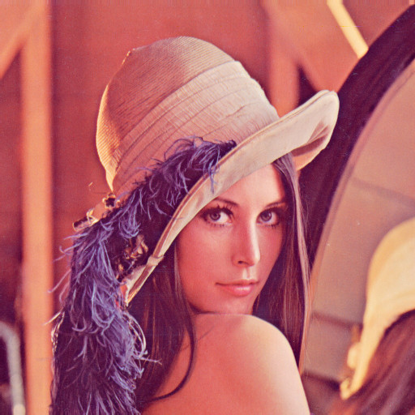 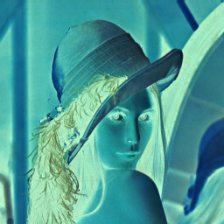

## 低效实现

### 1.1 核函数

|  |
| --- |
| __kernel void inv(__global uchar4* srcImg, __global uchar4* dstImg, int height, int width)  {  int2 point = (int2) (get_global_id(0), get_global_id(1));  if (point.x < width && point.y < height)  {  uchar4 pixel = srcImg[point.y * width + point.x];  uchar4 val;  val.x = 255 - pixel.x;  val.y = 255 - pixel.y;  val.z = 255 - pixel.z;  val.w = 255 - pixel.w;  dstImg[point.y * width + point.x] = val;  }  } |

### 1.2 主函数

|  |
| --- |
| // inv_cl_low.cpp : Defines the entry point for the console application.  //  #include "stdafx.h"  #include <opencv2/highgui.hpp>  #include <opencv2/core.hpp>  #include <opencv2/imgproc.hpp>  #include <CL/cl.hpp>  #include <fstream>  #include <string>  int main(int argc, char *argv[])  {  std::string filename = "lena512.jpg";  int normSize = 2048;  int local_size_x = 8;  int local_size_y = 1;  if (argc > 1)  {  filename = std::string(argv[1]);  }  if (argc > 2)  {  normSize = std::atoi(argv[2]);  }  if (argc > 3)  {  local_size_x = std::atoi(argv[3]);  local_size_y = std::atoi(argv[3]);  }  if (argc > 4)  {  local_size_y = std::atoi(argv[4]);  }  cl_int err = 0;  cv::Mat image = cv::imread(filename.c_str());  if (!image.data)  {  printf("read image failed!\n");  return -1;  }  printf("load image success!\n");  cv::resize(image, image, cv::Size(normSize, normSize));  cv::cvtColor(image, image, CV_BGR2BGRA);  std::vector<cl::Platform> platforms;  err = cl::Platform::get(&platforms);  if (err<0)  {  printf("get platforms failed!\n");  return -1;  }  cl::Platform platform = platforms[1];  std::vector<cl::Device> devices;  err |= platform.getDevices(CL_DEVICE_TYPE_GPU, &devices);  if (err<0)  {  printf("get devices failed!\n");  return -1;  }  cl::Device device = devices.front();  cl::Context context(devices);  std::ifstream file("functions.cl");  std::string src(std::istreambuf_iterator<char>(file), (std::istreambuf_iterator<char>()));  cl::Program::Sources sources(1, std::make_pair(src.c_str(), src.length() + 1));  cl::Program program(context, sources);  err |= program.build("-cl-std=CL1.2");  if (err<0)  {  printf("build program failed!\n");  return -1;  }  cl::Kernel kernel(program, "inv");  int pix_num = image.cols * image.rows;  uchar *res_data = new uchar[pix_num * 4];  memset(res_data, 0, pix_num);  cl::Buffer inputBuf(context, CL_MEM_READ_ONLY | CL_MEM_COPY_HOST_PTR, sizeof(uchar) * pix_num * 4, (void*)image.data);  cl::Buffer outputBuf(context, CL_MEM_WRITE_ONLY | CL_MEM_USE_HOST_PTR, sizeof(uchar) * pix_num * 4, (void*)res_data);  err |= kernel.setArg(0, inputBuf);  err |= kernel.setArg(1, outputBuf);  err |= kernel.setArg(2, image.rows);  err |= kernel.setArg(3, image.cols);  if (err<0)  {  printf("set kernel argment failed!\n");  return -1;  }  cl::Event event;  cl::CommandQueue queue(context, device, CL_QUEUE_PROFILING_ENABLE);  int g_x = (image.cols + local_size_x - 1) / local_size_x * local_size_x;  int g_y = (image.rows + local_size_y - 1) / local_size_y * local_size_y;  int l_x = local_size_x;  int l_y = local_size_y;  printf("global size: (%d, %d), local size: (%d, %d)\n", g_x, g_y, l_x, l_y);  err = queue.enqueueNDRangeKernel(kernel, cl::NullRange, cl::NDRange(g_x, g_y), cl::NDRange(l_x, l_y), NULL, &event);  if (err<0)  {  printf("excute kernel failed!\n");  return -1;  }  queue.finish();  cl_ulong start = event.getProfilingInfo<CL_PROFILING_COMMAND_START>();  cl_ulong end = event.getProfilingInfo<CL_PROFILING_COMMAND_END>();  printf("Elapsed time: %f ms\n", (end - start) / 1000000.0);  queue.enqueueReadBuffer(outputBuf, CL_TRUE, 0, sizeof(uchar) * pix_num * 4, res_data);  if (err<0)  {  printf("read buffer failed!\n");  return -1;  }  cv::Mat out(cv::Size(image.cols, image.rows), CV_8UC4, res_data);  cv::imwrite("lena_inv.jpg", out);  system("pause");  return 0;  } |

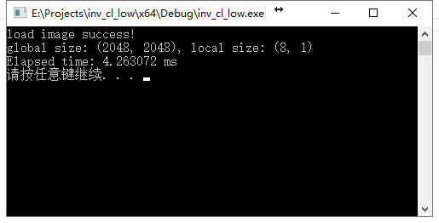

从结果看，处理2048 * 2048的图像，Local_Size设置为(8,1)，程序处理时间需要4.263ms。

## 高效实现

### 2.1 核函数

|  |
| --- |
| __kernel void inv(__global int4* srcImg, __global int4* dstImg, int height, int width)  {  int2 point = (int2) (get_global_id(0), get_global_id(1));  int4 src = srcImg[point.y * width + point.x];  uchar4* p_src = (uchar4*)&src;  uchar4 p_dst[4];  p_dst[0].x = 255 - p_src[0].x;  p_dst[0].y = 255 - p_src[0].y;  p_dst[0].z = 255 - p_src[0].z;  p_dst[0].w = 255 - p_src[0].w;  p_dst[1].x = 255 - p_src[1].x;  p_dst[1].y = 255 - p_src[1].y;  p_dst[1].z = 255 - p_src[1].z;  p_dst[1].w = 255 - p_src[1].w;  p_dst[2].x = 255 - p_src[2].x;  p_dst[2].y = 255 - p_src[2].y;  p_dst[2].z = 255 - p_src[2].z;  p_dst[2].w = 255 - p_src[2].w;  p_dst[3].x = 255 - p_src[3].x;  p_dst[3].y = 255 - p_src[3].y;  p_dst[3].z = 255 - p_src[3].z;  p_dst[3].w = 255 - p_src[3].w;  dstImg[point.y * width + point.x] = *(int4*)(p_dst);  } |

### 2.2 主函数

|  |
| --- |
| // inv_cl_high.cpp : Defines the entry point for the console application.  //  #include "stdafx.h"  #include <opencv2/highgui.hpp>  #include <opencv2/core.hpp>  #include <opencv2/imgproc.hpp>  #include <CL/cl.hpp>  #include <fstream>  #include <string>  int main(int argc, char *argv[])  {  std::string filename = "lena512.jpg";  int normSize = 2048;  int local_size_x = 8;  int local_size_y = 1;  if (argc > 1)  {  filename = std::string(argv[1]);  }  if (argc > 2)  {  normSize = std::atoi(argv[2]);  }  if (argc > 3)  {  local_size_x = std::atoi(argv[3]);  local_size_y = std::atoi(argv[3]);  }  if (argc > 4)  {  local_size_y = std::atoi(argv[4]);  }  cl_int err = 0;  cv::Mat image = cv::imread(filename.c_str());  if (!image.data)  {  printf("read image failed!\n");  return -1;  }  printf("load image success!\n");  cv::resize(image, image, cv::Size(normSize, normSize));  cv::cvtColor(image, image, CV_BGR2BGRA);  std::vector<cl::Platform> platforms;  err = cl::Platform::get(&platforms);  if (err<0)  {  printf("get platforms failed!\n");  return -1;  }  cl::Platform platform = platforms[1];  std::vector<cl::Device> devices;  err |= platform.getDevices(CL_DEVICE_TYPE_GPU, &devices);  if (err<0)  {  printf("get devices failed!\n");  return -1;  }  cl::Device device = devices.front();  cl::Context context(devices);  std::ifstream file("functions.cl");  std::string src(std::istreambuf_iterator<char>(file), (std::istreambuf_iterator<char>()));  cl::Program::Sources sources(1, std::make_pair(src.c_str(), src.length() + 1));  cl::Program program(context, sources);  err |= program.build("-cl-std=CL1.2");  if (err<0)  {  size_t len;  printf("Error: Failed to build program executable!\n");  std::string log = program.getBuildInfo<CL_PROGRAM_BUILD_LOG>(device);  printf("%s\n", log.c_str());  return -1;  }  cl::Kernel kernel(program, "inv");  int pix_num = image.cols * image.rows;  uchar *res_data = new uchar[pix_num * 4];  memset(res_data, 0, pix_num);  cl::Buffer inputBuf(context, CL_MEM_READ_ONLY | CL_MEM_COPY_HOST_PTR, sizeof(uchar) * pix_num * 4, (void*)image.data);  cl::Buffer outputBuf(context, CL_MEM_WRITE_ONLY | CL_MEM_COPY_HOST_PTR, sizeof(uchar) * pix_num * 4, (void*)res_data);  err |= kernel.setArg(0, inputBuf);  err |= kernel.setArg(1, outputBuf);  err |= kernel.setArg(2, image.rows);  err |= kernel.setArg(3, image.cols / 4);  if (err<0)  {  printf("set kernel argment failed!\n");  return -1;  }  cl::Event event;  cl::CommandQueue queue(context, device, CL_QUEUE_PROFILING_ENABLE);  int g_x = (image.cols / 4 + local_size_x - 1) / local_size_x * local_size_x;  int g_y = (image.rows + local_size_y - 1) / local_size_y * local_size_y;  int l_x = local_size_x;  int l_y = local_size_y;  printf("global size: (%d, %d), local size: (%d, %d)\n", g_x, g_y, l_x, l_y);  err = queue.enqueueNDRangeKernel(kernel, cl::NullRange, cl::NDRange(g_x, g_y), cl::NDRange(l_x, l_y), NULL, &event);  if (err<0)  {  printf("excute kernel failed!\n");  return -1;  }  queue.finish();  cl_ulong start = event.getProfilingInfo<CL_PROFILING_COMMAND_START>();  cl_ulong end = event.getProfilingInfo<CL_PROFILING_COMMAND_END>();  printf("Elapsed time: %f ms\n", (end - start) / 1000000.0);  queue.enqueueReadBuffer(outputBuf, CL_TRUE, 0, sizeof(uchar) * pix_num * 4, res_data);  if (err<0)  {  printf("read buffer failed!\n");  return -1;  }  cv::Mat out(cv::Size(image.cols, image.rows), CV_8UC4, res_data);  cv::imwrite("lena_inv.jpg", out);  system("pause");  return 0;  } |

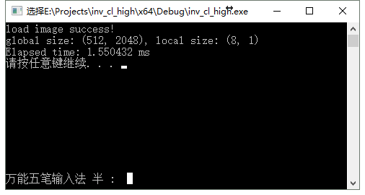

从结果上看，同样处理2048 * 2048的图像，Local_Size设置为(8,1)，程序处理的时间为1.550ms，速度为原来3倍多。

## 3 注意

### 3.1 避免多次访问全局内存

尽量避免多次访问全局内存，如以下核函数，采用了同样的思路进行优化，但速度反而比优化前慢很多：

|  |
| --- |
| __kernel void inv(__global float4* srcImg, __global float4* dstImg, int height, int width)  {  int2 point = (int2) (get_global_id(0), get_global_id(1));  if (point.x * point.y < height * width)  {  __global uchar4* src = (__global uchar4*)(srcImg + point.y * width + point.x);  __global uchar4* dst = (__global uchar4*)(dstImg + point.y * width + point.x);  for (int i = 0;i < 4;i++)  {  dst[i].x = 255 - src[i].x;  dst[i].y = 255 - src[i].y;  dst[i].z = 255 - src[i].z;  dst[i].w = 255 - src[i].w;  }  }  } |

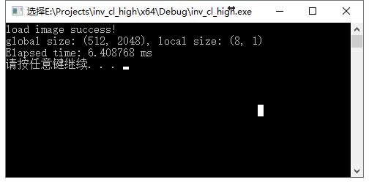

### 3.2 global_size的设置

优化后的程序中，由于4个uchar4被看作一个int4类型，因此图像的宽相当于只有原来的1/4，而高度不变。另外，在程序中，图像大小最好与global_size大小相同，若不同，将其扩展到global_size大小，以避免在核函数中对越界的判断。